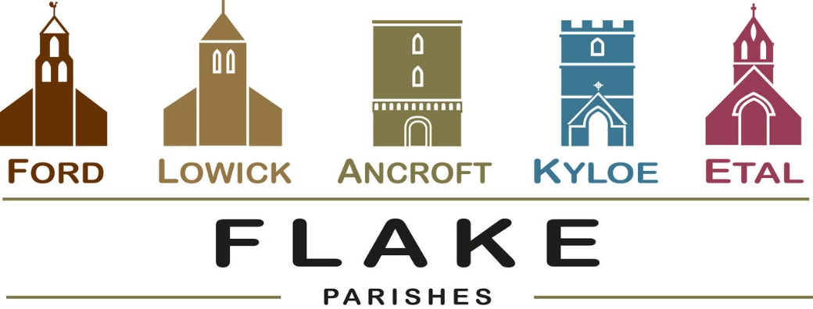
A very warm welcome to you, especially if you are visiting.
Please take this sheet home with you and use it as a basis for prayer.
Sunday June 14th 2026
Lowick 9.15 Holy Communion
Ford 11am Holy Communion
Sunday June 21st 2026
Lowick 9.15 Holy Communion
Ford 11am Holy Communion
Sunday June 28th 2026
Lowick 9.15 Holy Communion
Ford 11am Holy Communion
Sunday July 5th 2026
Lowick 9.15 Holy Communion
Ford 11am Holy Communion

Revd Charlotte Osborn (Vicar) 01289 388591 ceosborn@mail.com 07957 367457
Revd Alex Firman (Assistant Curate) 07935 732811
alex_firman@hotmail.co.uk
Our other licensed clergy
Revd Margaret Sentamu 077871 204745, Canon Nick Sagovsky,
Revd Marion Penfold 01289 305664

Ancroft Leigh Yorke 07716 116739
Etal Andrew Joicey 01890 820540
Ford Kathleen Holmes 07951 099668
Lowick John Dickson 07967 343211

During June we depart from the lectionary readings to focus on Paul’s letter of encouragement to the church at Colossae as it wrestled as we do today with establishing the supremacy of Christ over and above all that would compete for first place in our lives.

- Monday 15th June
Lowick Vicarage 7pm-8.30pm Homegroup Colossians 2/3
- WednesdaY 13th June
12noon
Holy Island Vicaarge
Deanery Development Group
7.30pm Lowick Vicarage Lowick PCC
- Saturday 4th July
Men’s Breakfast, Lowick White Swan


Rota Revisions- following our APCM’s we are updating the rotas and welcome any new readers, intercessors, flower arrangers, bellringers, welcomers, etc.
Training will be provided and if you would like to offer your services, please speak to Alex or Charlotte.

For our prayers


Annabel Wailes Fairbairn and John Kirkwood
who marry at Ancroft on Saturday

All who suffer in body, mind or spirit, especially Heather Piper, George Hall, Gail Calder, Don and Sam Quilty, Alison Murray.
All who have recently died. We pray for those who mourn, and for all who mark anniversaries of death at this time of year.

