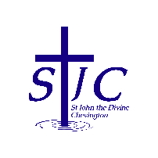
St John the Divine Welcome to our service today
Chevington 14th June 2026
Second Sunday after Trinity

What’s on  = . = . = . = . = . = . = . = . = . = . = . = . = . = . = . = . = . = . = .  Summer Fair – June 27th  Our Summer Fair will be from 10am on Saturday June 27th in the Community Centre.  We need raffle and tombola prizes and bottles please.  You can leave items in the church kitchen or bring them to the Community Centre on Friday June 26th after 3pm when we will be setting up.  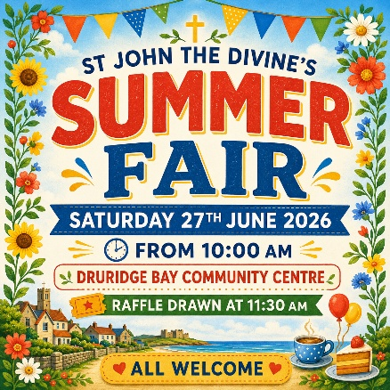  = . = . = . = . = . = . = . = . = . = . = . = . = . = . = . = . = . = . = .  Two birthdays this week!  Many happy returns to Michelle Armstrong (16th) and Sheila Orgill (18th).  = . = . = . = . = . = . = . = . = . = . = . = . = . = . = . = . = . = . = .  Change of service time – July 5th onwards  Please remember that from Sunday July 5th our service time will change to 9am while St Cuthbert’s service will move to 10:30am.  = . = . = . = . = . = . = . = . = . = . = . = . = . = . = . = . = . = . = .  Coquet Churches Together – Popup Praise  Sunday 19th July.  Speak to Sheila if you’d like to get involved as CCT are looking for poems, readings or other contributions. |  | This week, we remember  We pray this week for all those who live in Brandling Way, Ladyburn Way and The Pines and for the staff and residents of Elpha Lodge.  And from our memorial book  = . = . = . = . = . = . = . = . = . = . = . = . = . = . = . = . = . = . =  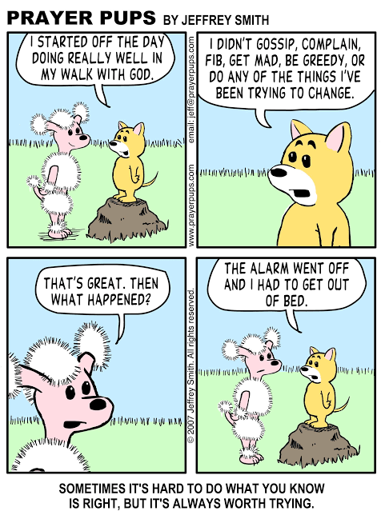  = . = . = . = . = . = . = . = . = . = . = . = . = . = . = . = . = . = . =  Church contacts  Priest in charge Revd Rachael Dines - 07763 211901  Churchwarden Sheila Orgill (also Parish Safeguarding Officer) – 07484 825203  Reader Cynthia Bishop – 07498 182350
  Sunday June 14th  9:00am Holy Communion  10:30am Holy Communion  4:00pm Café Church | St Cuthbert’s  St John’s  Coquet Tea Rooms
  Thursday June 18th  2:00pm Third Thursday | St John’s
  Sunday June 21st  9:00am Holy Communion  10:30am Holy Communion | St Cuthbert’s  St John’s
  John James | Harkins | 1916
  Thomas | Harper | 1917
  Don | Johnson | 2011
  Simon David | Little | 2020
  Patrick James | Maddix | 1995
  Adam | Patterson | 2006
  Edd | Patterson | 2006
  Joseph | Scott | 1916
  James | Simpson | 1978
  Robert | Skelton | 1915
  John | Westle | 1916

