Acrise Church News: July 2026
Services for July
Sunday 5th July Holy Communion BCP
Sunday 12th July Matins BCP
Sunday 19th July Morning Prayer CW
Sunday 26th July Service of the Word

Family Service for Fathers’ Day on 21st June
This was a new service which recognised Father’s Day but in the context of family life based on the Christian values of love and peace. There are many different types of family, and all were celebrated. Near the end of the service Janet gave a special blessing to fathers and grandfathers present, and thanks were given for what they do. There were also candles to light on the altar for departed fathers/grandfathers.
The service was much enjoyed and a happy occasion. Thanks to Janet for initiating the idea and taking the lead, to Joan and John for organising the activity based on families, to Irene for the hymns, to the readers and the refreshment team.
At the end of the service the children took turns to ring the church bell.
The next Family Service will be Harvest Festival on Sunday 27th September.

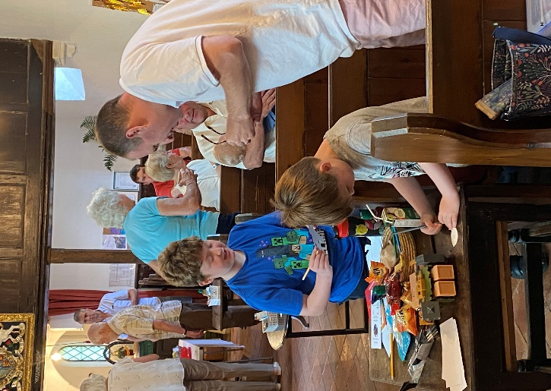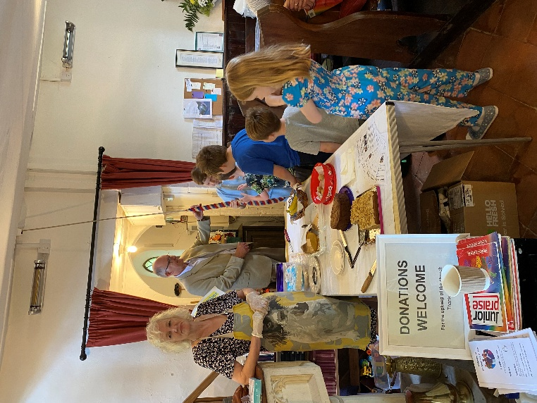
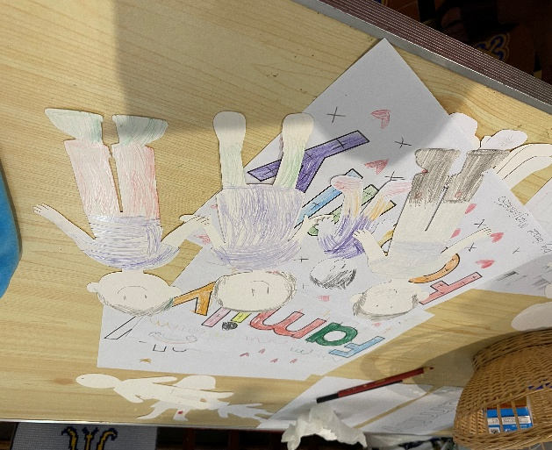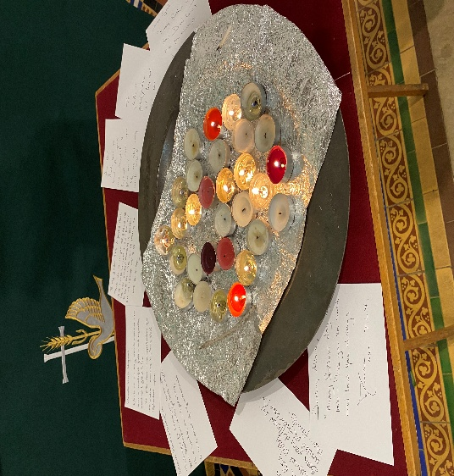

Admission of Churchwardens
On Tuesday 9th June a few of us went to support our churchwardens from the benefice at the ‘Archdeacons’ Visitations’, a service which churchwardens attend each year to be officially admitted to their position. Mike and Lyle from Lyminge and Simon from Acrise were supported by Sue, Mike and Richard.
We thank them for taking on this demanding role for the coming year. To quote from the service sheet:
‘Churchwardens when admitted are officers of the Bishop. They are foremost in representing the laity and in co-operating with the incumbent or priest-in-charge. They are to use their best endeavours to encourage the parishioners in the practice of true religion and to promote peace and unity among them. They must maintain decency in the church and churchyard, especially in the time of divine worship. They are required to appear before the Bishop, or her representative, and to make a declaration in their presence before being admitted to office.’


Many thanks to Richard for organising this event at his home in Hawkinge
Starts this Saturday!
Acrise Festival
Of Flowers and Music
Saturday 1st August 10.00am – 5.00pm
Flowers in the church and music on the green. Church records will be displayed. There will be a variety of stalls, raffle, tombola, children’s games, and pony rides.
Refreshments, including ploughmen’s lunches, will be available.
Volunteers Needed
On Tuesday 28th July from 10.00am we will be spring cleaning the church and tidying the paths, graveyard and parking area.
On Friday 31st August from 10.00am the church will be decorated with flowers and the site will be prepared for the Saturday. Any help with site preparation will be welcome.
On Saturday 1st August if you could help do a shift running a stall, helping with refreshments or parking, that would be much appreciated.
Donations
We would also be grateful for donations of cakes, biscuits and savouries, good quality bric a brac; any home grown produce for the produce stall.
If anyone could donate foliage or flowers from their gardens and leave them at the church on the morning of 31st August, we would be grateful.
Donations of Raffle and Tombola prizes would be a great help.

Contact
Please contact Sue on 01303844640 (sue1954prebble@gmail.com) if you could volunteer on any of the dates, could make a donation, or give a raffle prize.
Jean Grieb is organising tombola prizes so please give any tombola prizes to her. She can be contacted on 01303892364.


St Martin’s Church
CT8 8JX
  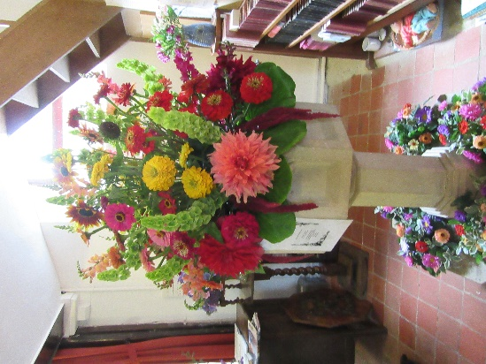ACRISE FESTIVAL
Flowers, Music, stalls
Raffle and tombola, refreshments, including Ploughmen’s Lunches
Games and pony rides
Free parking and entry
Disability access
Saturday 1st August 2026
10.00am – 5.00pm
Please bring cash
Acrise Environmental Group
Pond Dipping at the Winterage Lane/White Lodge Pond
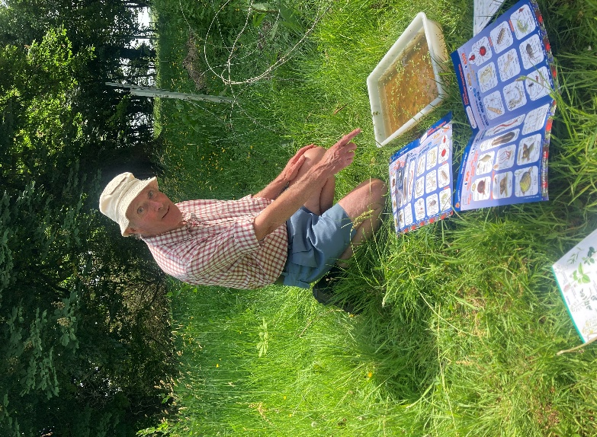
Seven people took part in this on Saturday 30th May at 2.00pm. As we had been experiencing a period of dry hot weather we were not expecting to find much. However, Alfie Gay from White Cliffs Counryside who guided us, found that there was more water in the pond than appeared, as the grass at the Winterage Lane end was actually protecting an area of water and this was helped by the shade of overhanging trees.
Alfie took some water from this area to put into trays and we examined these samples with the help of identification sheets. We found pond snails, seven small newts, one full grown newt, a number of tadpoles and possibly a crested newt.
We discussed whether it would be best to concentrate on restoring this one pond, by digging out about a metre to get rid of mud, sludge and some grass without harming the underlying clay.
There may be one more pond dipping this summer and a possible talk from Mark Williams from Canterbury Archaeological Trust in the autumn.
The photo shows our organiser, District Councillor Stepen Scoffham, with a tray and identification sheets.

Shepway foodbank: Folkestone Rainbow Centre
If you can support the foodbank please leave items at the back of the church or in the porch if the church is shut.
Most needed items are: white sauce, curry sauce, custard, long life milk and juice, pickles, coffee, cooking oil, noodles, mayonnaise.

Ride and Stride
to raise money for Kent Churches will be on Saturday 12th September
Details to come nearer the time.

