July
2026

Calendar of Events July 2026
Day | Time | Activity | Place
1st | 10.30am  11.00am | Celtic Prayers  Community Coffee | Church  The Crown
2nd | 9.00am  7.00pm | Parish Breakfast  House Group | Garden Centre  Harvard
3rd | 10.00am | Toddlers | Church Hall
4th
5^{tth} | 9.00am  10.30am | Holy Communion  Holy Communion | Little Casterton  Great Casterton
6th
7th
8th | 10.30am  11.00am | Celtic Prayers  Community Coffee | Church  The Crown
9th
10th | 10.00am | Toddlers | Church Hall
11th
12th | 10.30am | Café Church | Church Hall
13th
14th | 9.00am | Primary School Service | Great Casterton
15th | 10.30am  11.00am  2.00pm | Celtic Prayers  Community Coffee  PCC Meeting | Church  The Crown  Church Hall
16th | 7.00pm | House Group | Harvard
17th | 10.00am | Toddlers | Church Hall
18th | 12.00 noon | Saturday Live | Great Casterton
19th | 9.00am  10.30am | Holy Communion  Holy Communion | Little Casterton  Great Casterton
20th
21st
22nd | 10.30am  11.00am | Celtic Prayers  Community Coffee | Church  The Crown
23rd
24th
25th
26 | 9.00am  10.30am | Holy Communion  Morning Praise | Pickworth  Great Casterton
27th | 2.00pm | Book Club | Sue Stretton’s
28th | 7.30pm | Parish (Parson’s) Pints | The Crown
29th
30th/31st

FOUR CHURCHES NEWS
Parishes of Great and Little Casterton, Pickworth and Tickencote

Church Of England Prayers of Love and Faith

The formation of a new Benefice consisting of Ryhall, Essendine, Pickworth, Little Casterton and Great Casterton and Tickencote is being actively discussed and, at a meeting of all the Churchwardens, Archdeacon Alison asked that each PCC confirm that the Church of England's "Prayers of Love and Faith” could be used in their churches. At a meeting on 4th June the PCC of Great Casterton and Tickencote, after careful consideration and reading the full document on the C of E website, agreed that they could.
The Prayers of Faith and love are a collection of prayers designed to offer support, blessing, and affirmation for any couple, including those in same-sex relationships, as they seek God's guidance and presence in their commitment to one another. These prayers do not constitute a marriage ceremony, but rather a pastoral response allowing clergy to bless and pray with couples following a civil marriage or partnership.
The prayers typically include expressions of thanksgiving for love and companionship, petitions for God's blessing upon the couple, requests for strength, guidance, and faithfulness in their relationship, and intercessions for the wider community and church. The language used aims to be inclusive, compassionate, and affirming, reflecting the Church's intention to acknowledge and celebrate loving relationships while maintaining its current doctrinal position on marriage. In summary, the Archbishop’s speech added a vital moral dimension to the national conversation on AI, urging us to be as innovative in our ethics as we are in our technology.
Peter
If you wish to read the full document setting out all the prayers and guidance on their use go to. www.churchofengland.org and enter Prayers of Love and Faith in the search box.

June Gardening
June can be a busy month, but these tasks are pleasant to do when the sun’s shining and the insects are buzzing.
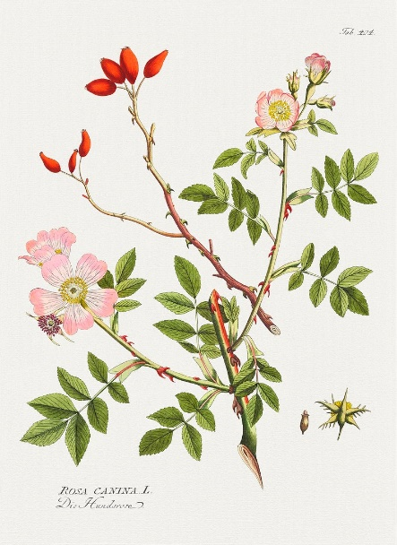
It’s critical to keep mulching your borders and, indeed, anywhere you have bare earth. It can suppress unwanted growth, and most importantly, an extra layer of organic matter will help keep moisture in the soil for longer. If you use a natural fertiliser as a mulch, or homemade compost, you’ll also feed the soil.
Climbers may need support. Thinking vertically when planting can open up so much more space for plants, more visual interest, and loads more habitats for more diverse wildlife too! Some native climbers to consider include ivy, honeysuckle (woodbine), wild hops (these grow fast – you have been warned!), traveller’s joy (old man’s beard) and dog roses.

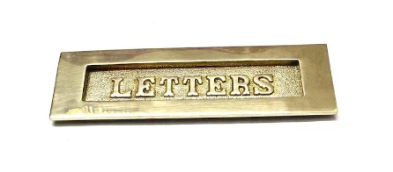
Letter Boxes
Delivering the Parish Newsletter recently I was following/being followed by a Postman. As I bent down to yet another very low letter box, the Postman shared his wish that they shouldn’t be allowed. Low letter boxes, flaps with a curve, inside covers and dogs waiting quietly to strike were shared dislikes. So, if you do change your front door please remember the postman and all the others who deliver items to you and do not have a low letter box. Or even better don’t have one but install a post box which are so easy to use.

The Archbishop of Canterbury’s
Lords Speech on Artificial Intelligence
In church a few weeks ago, the Rev Bob Mackrill recommended to the congregation the Archbishop of Canterbury’s speech to the House of Lords on artificial intelligence which was both timely and thought-provoking.
The speech can be found on the Archbishop’s web site, www.archbishopofcanterbuury.org search AI speech to the Lords in the search section to fine it. By addressing AI, she demonstrated a clear awareness of the profound ways in which technology is shaping society and the moral challenges it presents.
What stood out was her call for a balance between innovation and ethics. The Archbishop emphasised the need for AI development to be guided by principles that respect human dignity, fairness, and the common good. This perspective resonates deeply in a world where technology often outpaces legislation and ethical discourse.
Equally important was her reminder that AI should serve humanity rather than the other way round. Her speech encouraged lawmakers not just to consider the economic or technical aspects of AI, but also its social and spiritual impact. The Archbishop’s words serve as a call to ensure that, as we embrace the future, we do not lose sight of compassion, justice, and the values that bind our communities together.
Rev Bob also recommended Pope Leo’s slightly longer message on the same topic which can be found on www.vatican.va as The message of his Holiness Pope Leo XIV for the 60th World Day of Social Communications.

Quote of the Month
Answer from last month - Oscar Wilde said "Be yourself, everyone else is taken."
This month's quote: Who said this? "Our greatest glory is not in never falling, but in getting up every time we do".

You couldn’t make it up!
In Greenville, South Carolina, a man named Al Palanza, received a letter from the county department of social services that was addressed to his recently deceased brother.
It read: “Your food stamps will be stopped effective March 1992 because we received notice that you passed away. May God bless you.
You may reapply there is a change in your circumstances.”

Word Challenge
How many words can you make of 3 letters or more from the word "Celebrations?

“I would like to be remembered as a person who wanted to be free… so that other people would also be free”
---- CIVIL RIGHTS ACTIVIST ROSA PARKS

July Around the World
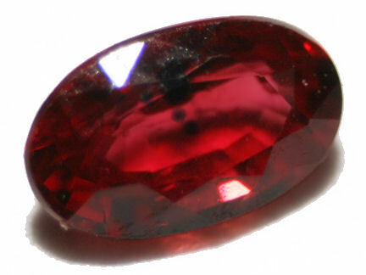
July is the middle of summer in the northern hemisphere. It sees the great migration (Kenya & Tanzania) of wildebeest and zebra into the Masai Mara where the herds make their dramatic, frenzied crossings of the crocodile-infested Mara River. The Gion Festival gets into full swing in Kyoto Japan, historically featuring massive, traditional wooden floats being pulled through the streets, and in the Arctic the polar ice retreats making this the prime month for expedition cruising and spotting polar wildlife in Svalbard or Greenland. If whale watching is your thing, then July sees the humpback whales migrate to the cool waters of the Austral Islands to calve and nurse and are well-worth visiting. Rubies are the gemstone associated with July, for passion, love, power, and courage. The larkspur and the water lily are the official birth flowers.

Memories and Reflections of the life of John (Tim) Holt
Tim was born on 20th January 1940 at 36 Melbourne Road, Stamford. He had one younger brother, George, who still lives in the house where they were born.
Tim died on 6th April 2026.
Tim went to Stamford School and afterwards was apprenticed to Blackstone’s Engineering as a Mechanical Design Engineer. After his apprenticeship he moved to Newall’s Engineering in Peterborough.
In 1965 he married Valerie and was blessed with two children - Richard and Tracey. In the 1970s the family moved to Easton-on-the-Hill. In 1983 he moved to Cambridge Road with his family; his son Richard started work around the same time they moved there setting off in Easton-on-the-Hill and returning home in the evening to Stamford.
Tim and Valerie moved to Toll Bar Great Casterton in 1991.
Tim was a very practical and handy person, and in the 1970s during the three-day week, took on any kind of work to support his growing family. He was generous and extremely willing to help any person in need. He decide to build a boat in his garage just to see if it was possible and he was successful. His other hobbies included classic British Motorcycle restoration.
Unfortunately, Tracey developed early onset dementia in the late 2000’s and Tim and Valerie took on the care of their granddaughter Eloise in about 2009.
Tim started bell ringing at Great Casterton Church in the 2010’s after visiting a church fete with Eloise. He started ringing for Sunday services in November of that year and was soon to enlist his granddaughter, Eloise, into the hobby in early 2012.
Eloise, at twelve years old, was soon out pacing her granddad and continued to ring when she went to York University to study Physics.
With Eloise at university, Tim decided to take up a course at the Open University in Physics in 2021 and was surprised that for him it was free of charge, and the first couple of years went well. After starting the third year he had to give it up through ill health.
Tim has been a stalwart member of the Great Casterton Church bellringing band and congregation. He became our representative at the Rutland Branch committee bringing back titbits of information from the meetings.
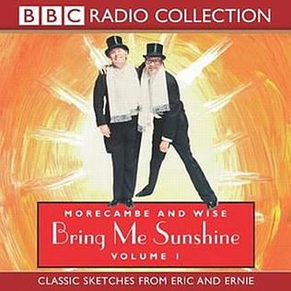
Tim loved the Two Ronnies, Morecombe and Wise and Monty Python to name just a few of his favourite comedians from that classic era. The final tribute at Tim’s funeral was ‘Bring Me Sunshine’ which I think was a fitting tribute to a fun loving and happy man. It was a great privilege to have known him.

Ann Archer
(Tower Captain
at Great Casterton Church)

Talents
Apart from occasional mentions we read about talents in three places in the Bible. The first is in the list of gifts made towards the building of the first temple and is followed by the words “of silver” or “of gold”. Just what was that weight and value is the subject of many learned guesses, but the one I like the best is “The load that a man could reasonably carry”. Others say about 38kg, but there are several different figures proposed.
The second is in the gospels where Matthew 25 records Jesus’ parable about the men who were loaned different numbers of talents and what they did with them. Now we usually think of these talents as sums of money – in Luke’s account the investment could have been several years’ wages. There were well defined investment banks even in those days which would sell shares in projects and pay interest. However the word Jesus used “talanton” can mean “that which is weighed out or apportioned to anyone” so could apply to the Chambers definition of the word talent as “Any natural or special gift or aptitude”.
The third is in 1 Corinthians 12-14 where Paul lists examples of nine of the “gifts” that different people may be given. Then he gives that amusing illustration of parts of a body which might consider each bit of anatomy to be more important than others. In some translations the word “talent” is used instead of “gift”. Perhaps the subject for another month. Paul here says that the greatest gift is love.
Money talents
The profits achieved by the servants who were loaned two or five talents were given to the master. They were commended equally. It was the lazy one who did not use his loan and so thus suffered. This parable is one of a series about God’s final judgement of people. The thought is to use what ability or resource a person has got to the benefit of the master. My favourite definition is appropriate for abilities too.
The inference is that Solomon’s temple was very grand as there were gifts of three thousand talents of gold and at least seventeen thousands of refined silver. Part of this was from David’s own treasury and probably about 20% from public gifts. We read that “the people gave willingly”. The idea seems to have been that the place where people could go to learn about God should be of the highest quality. It was reckoned as one of the wonders of the world for less than a hundred years before they started using bits to buy off invaders before what was left was broken up by unwelcomed visitors about four hundred years later. Whilst the total weights of precious metals in the construction are given, no weights are quoted for the individual bowls, plates and candlesticks. It just leaves us with the impression that everything was of the best for God. Most of the metals and the jewels were bought with the profits of trading with other nations. Remember, Jesus was in business as a carpenter until he was thirty. He is realistic about skills, money and profit margins.
Gift talents
There are different types/amounts of talents or gifts given or loaned to people. These can be the abilities/skills to do things as well as the opportunities. Jesus told his story of the different numbers of talents given to three people in that week between the triumphal entry into Jerusalem and the Passover supper. It is one of His critical lessons to those who were to spread the gospel (good news) around the world. The capital sums/talents/gifts are freely given or loaned, not earned. But they were to be used to the best effects. All profits made were to the benefit of the master who had provided the “gifts”, not kept by the beneficiaries. The talents given to the three men (remember Jesus ran a small business until he was thirty) was what they could reasonably manage with their skills. The one who had had doubled his investment of five got the same response as the two gifts bloke and both received the same thanks. “Well done you good and faithful servant”. Reward was not proportional to result. But the man who did not use his allowance is condemned for not using either his loaned talent or even his own given abilities. A few weeks later after Pentecost the eleven disciples and others were each apportioned areas of the known world by lots to establish fellowships. Thomas got India and the East and founded Christian churches there.
Questions
Everyone should ask themselves what talents/gifts they might have and then use them. Talents as aptitudes or abilities or resources may need working on to be most effective. Martha with a gift for catering complained that Mary was not helping, but Jesus said that Mary’s gift of sitting listening was the better. In Jesus’ teaching everyone has some talents. They are not all the same, but they are all to be used.
Bob

Update for Social Events Autumn 2026

September 27th - Harvest lunch after church. (12.00 noon)
£10pp BYO alcohol

October 16th - Quingo Quiz (change of date) - 6.30 pm –
£10pp - Bar available.

November 14th - Either Barn Dance or Ladies Play Reading - tbc.

December 5th - Christmas Raffle and coffee morning.
From 10.30. Raffle drawn at about 11.30 am.

“If any faculty of our nature may be called more wonderful than the rest, I do think it is memory. There seems something more speakingly incomprehensible in the powers, the failures, the inequalities of memory, than in any other of our intelligences.” JANE AUSTEN –Mansfield Park

North Churchyard: Almost Time to Make Hay


For those of us who love wildflowers, painful decisions are needed in July and August as this is the time to cut our developing wildflower meadow in the north graveyard. Meadows are left to grow long for 3 to 4 months during the spring and summer and then cut with scythe or strimmer and raked up. The difficulty arises in that there are always lovely flowers still there when the cut comes, and it is hard to cut them down. Especially as we are just beginning to see flowering plants establishing in the graveyard
To help with this dilemma, we need to remember that we are copying traditional haymaking, which takes place when grass is still green, vigorous and full of nutrients for stock to eat, but also when the weather is likely to be dry enough to make hay successfully.
But what about the seeds, dropping to the ground for next year’s flowers? If we cut down flowers, maybe there won’t be seeds? Actually, most species within a traditional meadow are perennial, so they continue to grow from year to year regardless of seeding. This explains why the wildflowers persist in short mown grass in churchyards, providing the grass cuttings are removed so the soil doesn’t become too rich for them.
So, what about the Ox eye Daisies then, these will be left in patches for later, but the rest will be cut in July cut, raked and ready for the hopefully autumn fungi. Until then enjoy the swaying grass seed heads.
Peter

USEFUL TELEPHONE NUMBERS
Priest in Charge Vacancy
Benefice Safeguarding Officer Carol Maynard 01780 755687
Great Casterton Hall Bookings Steve Cunninngham 07810 404748
Newsletter Mary Sproson 01780 762933
Church Wardens:
Great Casterton Peter Bryan 07507 299436
Geoffrey Archer 07803 423010
Little Casterton Tony Dolby 01780 766897
Pickworth Charles Gilman 01780 411017
Goldie Barwell 01780 410272

Have You Ever Visited? Tring Museum
The Natural History Museum at Tring is the private museum of Lionel Walter, 2nd Baron Rothschild; today it is under the control of the Natural History Museum, London. It houses one of the finest collections of stuffed mammals, birds, reptiles and insects in the United Kingdom. It is a truly remarkable visit- a stunning Victorian treasure trove of zoological wonders - and is known for being family friendly. It features an incredible and slightly eccentric collection of well-preserved animals including some now extinct species. Tring itself is a small and pretty market town with a TV famous antiques sales room and a number of cafes and quaint shops. Overall a day-trip to Tring makes a great day out. The museum is free to visit; open Tuesdays to Sundays and Bank Holiday Mondays but check the website before visiting to ensure opening hours.

Parish of Great Casterton and Tickencote
Church of St Peter and St Paul, Great Casterton

Following the retirement of the Rev. Don McGarrigle our parish is now in a period of ‘vacancy’ (also known as an interregnum). During this time, all the life and worship of the Church continues under the oversight of our Churchwardens and the Rural Dean.
Churchwardens:
Peter Bryan: 07507 299436
Geoffrey Archer: 07803 423010
They are working closely with the Diocese to begin the process of finding our new priest.

Please direct any enquiries about the Church or services:
Baptisms, Weddings, Funerals etc., directly to the Churchwardens.
Thank you.

All enquiries regarding
All Saints Little Casterton and All Saints Pickworth
During the vacancy should be directed to the Church Wardens

Little Casterton Tony Dolby 01780 766897
Pickworth Charles Gilman 01780 411017
Goldie Barwell 01780 410272


Church Projects

Moving on from our heating project we are now fund raising to renew the
church hall kitchen which needs updating to meet current standards.
You can help by coming along to and supporting our social events where all
monies raised will go towards church projects, or you can make a one off or
regular donation by using our QR code.

We are very grateful for any support you can give us.

Saturday Lunchtime Live
June 20th 2026
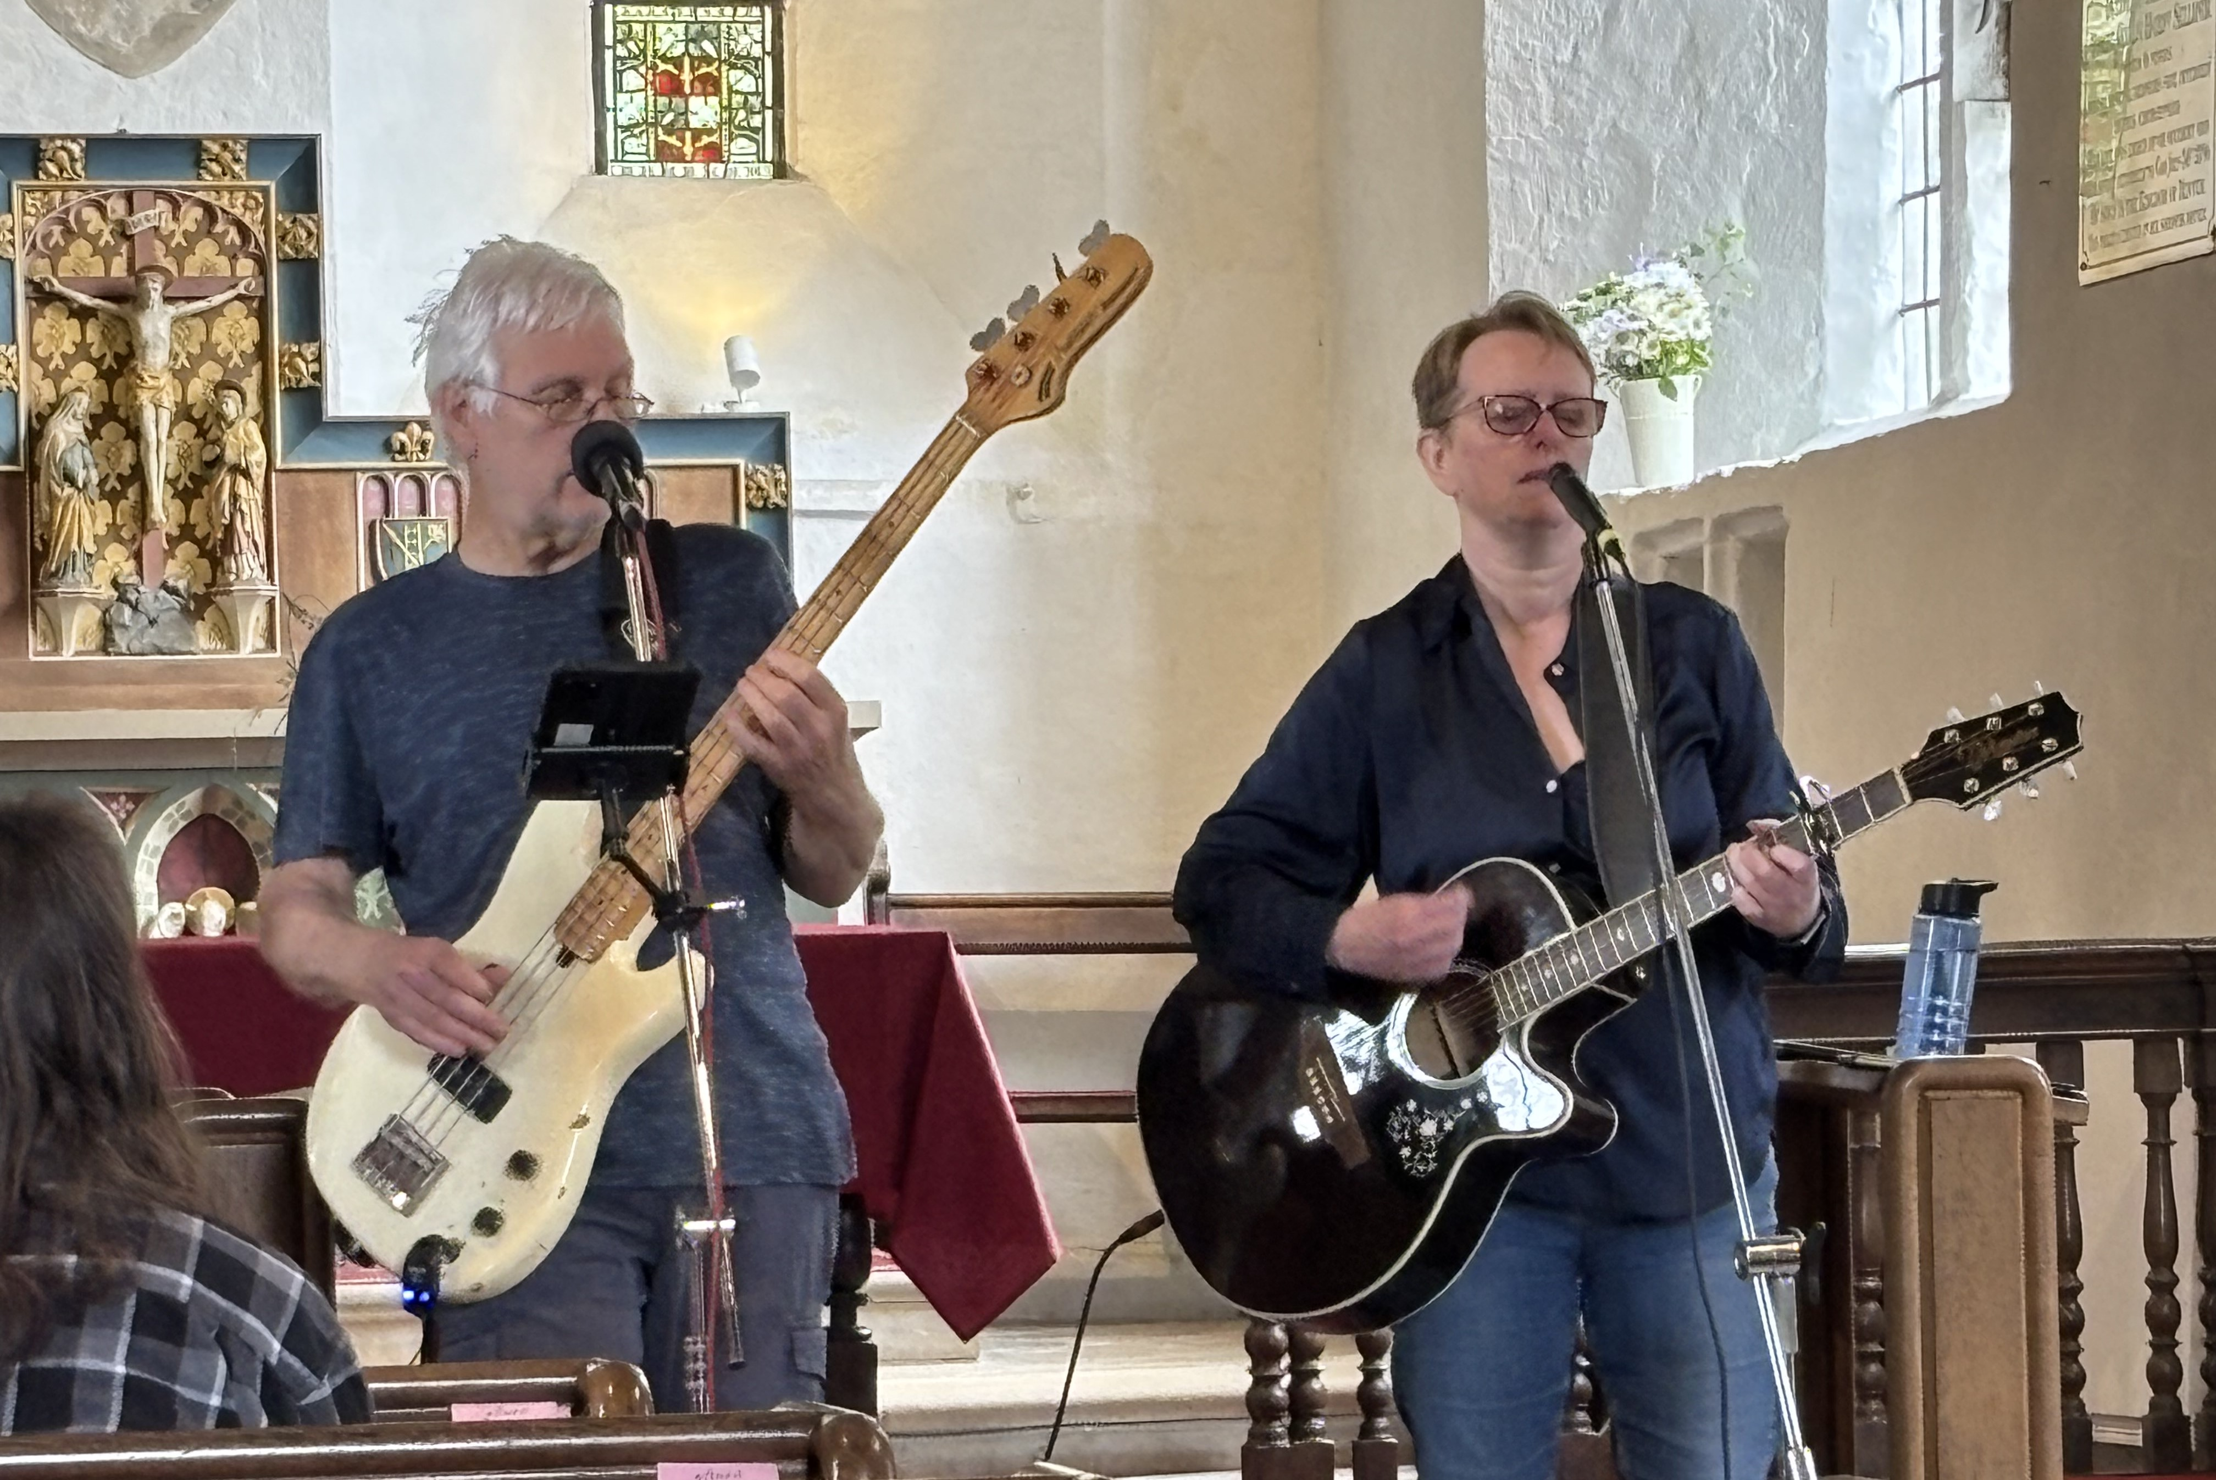
Tim Knight returned at his own request to sing with us on Saturday. He brought yet another of his musical friends to join with him, a young lady called Chantel.
This very new combination called themselves ’Zebra Diary’.
Many of the songs that they sang were Chantel’s own compositions.

Starting today with Manic Monday, originally unsuccessfully recorded by Prince in 1984, was a hit for The Bangles in 1985, followed by more eighties hits with Time After Time (Cyndi Lauper) and Rio (Duran Duran).

Back in time to the seventies we heard songs from Elton John - Sorry Seems to be the Hardest Word, Queen - Funny How Love is and Patti Smith -Because the Night.

These songs were intermingled with sixties music including Don’t Let Me be Misunderstood (Animals) and twenty first century artists, Beyoncé - If I Were a Boy, Tracy Chapman - Baby Can I Hold You and Coldplay - The Scientist.

Another amazing set for a full hour of entertainment by Tim and Chantel. A disappointingly small audience however managed to raise almost £70 with gift aid envelopes.

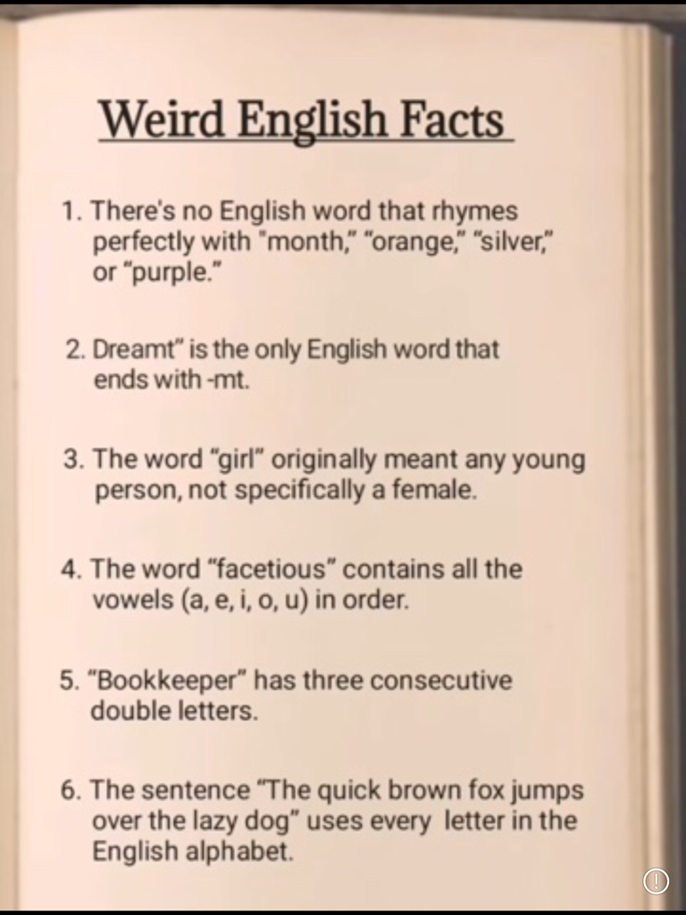

You come from dust and you will return to dust.
That’s why I don’t dust.
It could be someone I know.
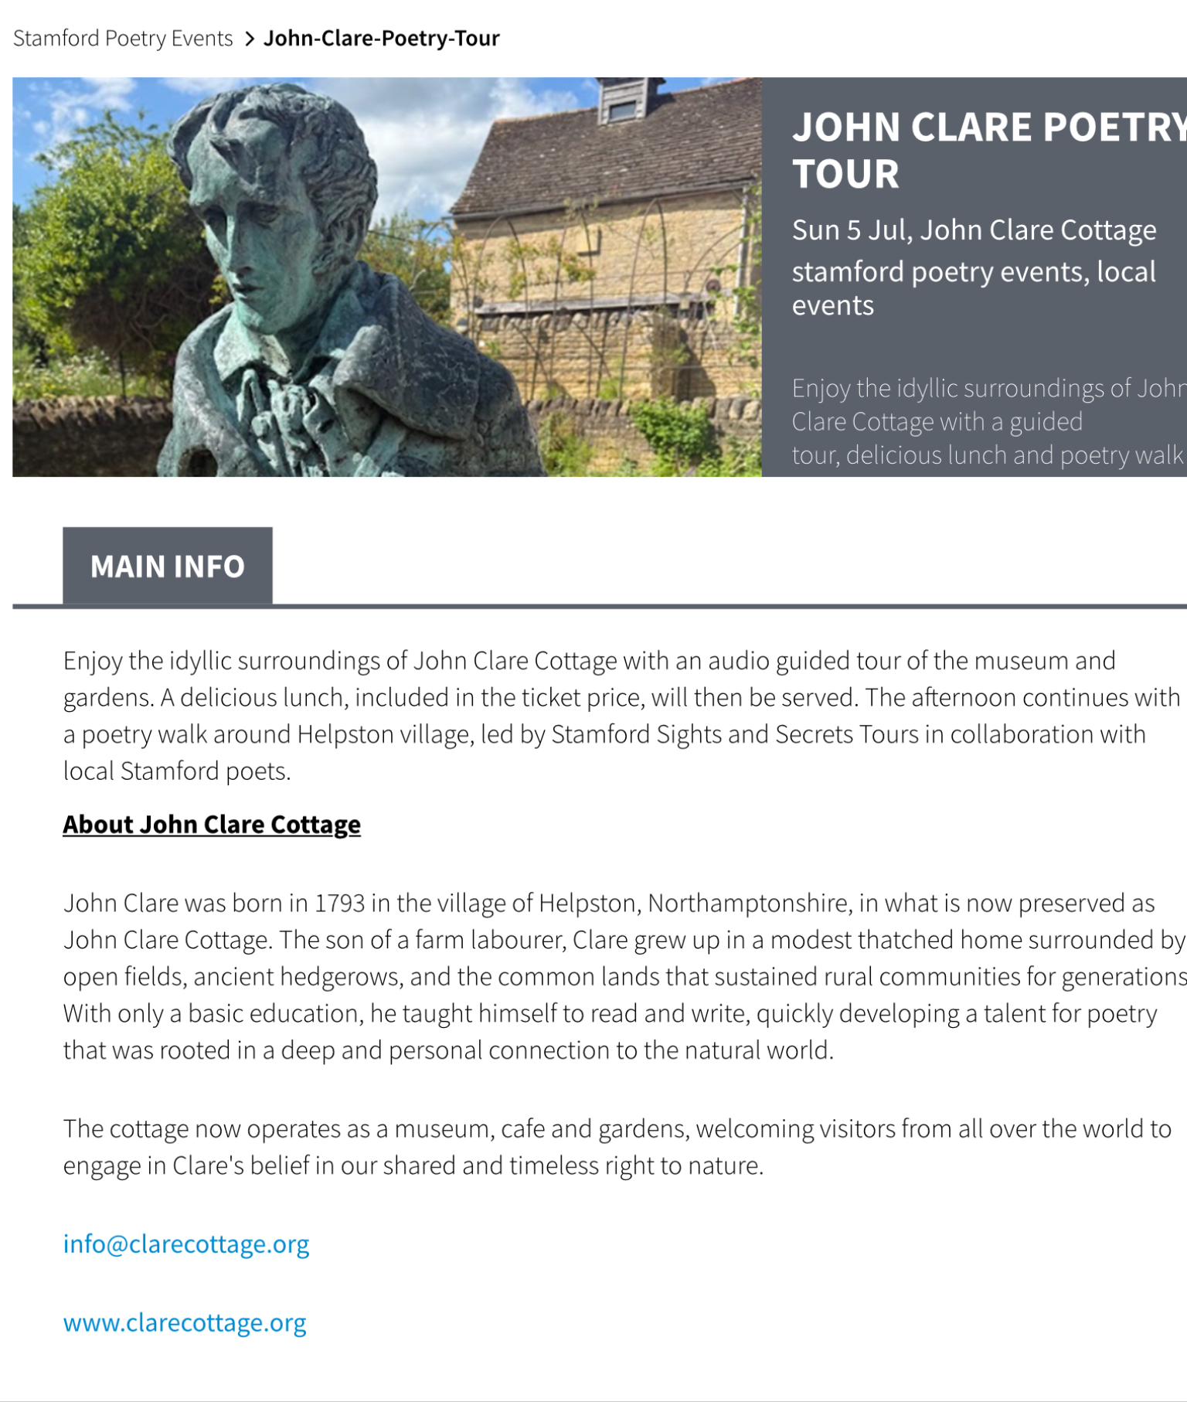

As many of you will know John Clare was married in Great Casterton Parish church and he and his new bride held their wedding reception in The Crown, so this may be of interest to some.
For more information follow the links at the bottom of the page. Stamford Arts Centre also have tickets for sale - £30 - which includes the tour and a lunch.
If the tour is not for you, the centre is well worth a visit at other times.

Info@clarecottage.org www.clarecottage.org
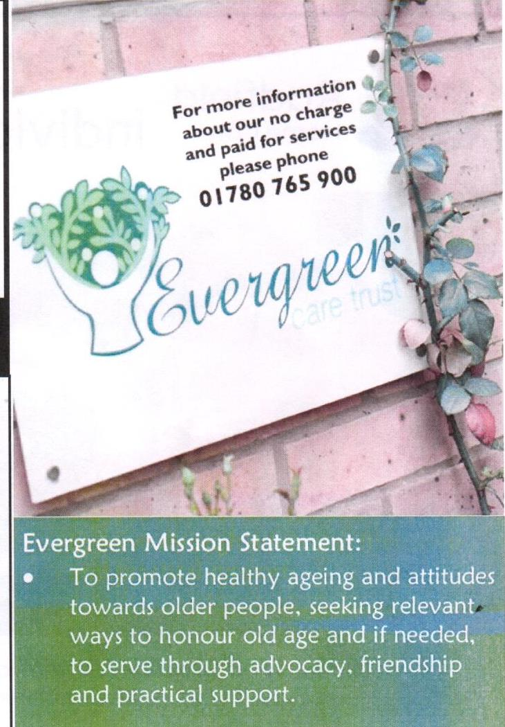


Have you ever considered advertising here?
If you run a small business, offer a service or run a club, then why not advertise here at very reasonable rates?
For more information please contact
Mary Sproson - email: stpeter.stpaul@outlook.com



FOR HIRE
Great Casterton church hall is available for hire for children’s parties and/or other events. For more details contact Steve Cunningham Email:stephenmichaelcunningham@gmail.com
Phone: 07810 404748


The Crown - Great Casterton

A welcoming family local – Food served daily.
Selection of fine beverages including real ales.
Open daily: Mon-Sat 11.00am to 11.00pm
Sunday 12 noon to 11.00pm
Telephone: 01780 753838

