TODAY’S SERVICE
11.00am: | Sung Eucharist
Presider: | Revd Maggie
Preacher: | Fr Alaric
New English Hymnal:
Introit | 232
Gradual | 239
Offertory | 336
Communion | 300
Recessional | 391
At the end of the service ‘THE ANGELUS’ will be said or sung. The words may be found inside the front cover of the NEH.
THIS WEEK
Wednesday 24th |  | 10am – 12 noon – Church open
Friday 26th |  | 10.00am: Holy Communion
Sunday 28th |  | NO SERVICE AT ST GEORGE TOMBLAND- see additional note
SERVICES & EVENTS AT ST GEORGE COLGATE
Tuesday 23rd |  | 8.30am: BCP Holy Communion
Wednesday 24th |  | 9.40am: Morning Prayer  10.30am - 1.00pm: Hot Spot Coffee Morning. All welcome.
SUNDAY 28th |  | 9.30am – Sung Eucharist
ECO CHURCH NOTE - War and conflict do huge damage to the environment, both because of the fuel and other resources used by the military, and because of the damage to buildings and infrastructure, which must then be rebuilt. Concrete and steel have a very high carbon footprint. We need to do everything in our power to end the global conflicts that are currently ongoing, and to take steps to resolve emerging conflicts without military intervention, not just because we care about peace and justice, but also for the sake of the planet and the dear creatures with whom we share our home. Please write to your MP if you feel the government is not taking the right approach.
SUNDAY, 28th JUNE
DIACONATE ORDINATION OF SAM RUDDOCK
AT NORWICH CATHEDRAL - 10:30am.
To permit those who wish to attend the ordination from Sam's home parish, there will be no Sunday service at St George Tombland this day.
St George Colegate and St Giles-on-the-Hill
will follow their regular Sunday schedule.
Please remember Sam and all those
to be ordained at Petertide in your prayers!

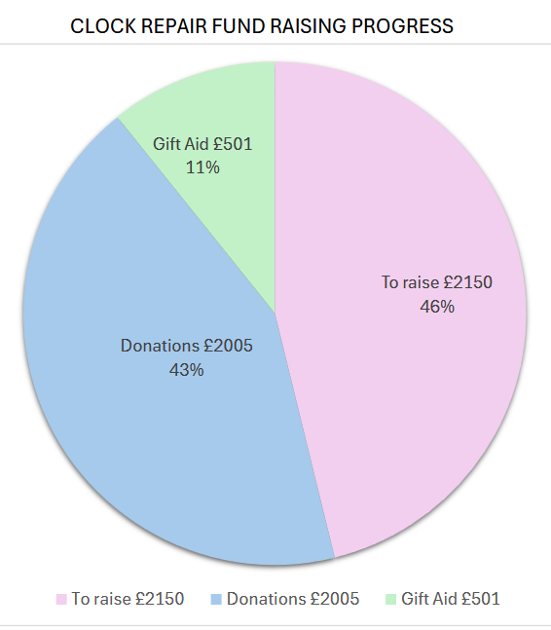
We are making progress with fundraising
for the clock repair.
Thank you to everyone who has donated.
-------------------------------------------------------------------------
THE NEW TESTAMENT GREEK GROUP will next meet on Saturday 11th JULY for lunch and reading.
This isn't just about study; It's a good occasion for discussion and fellowship. Absolute beginners are welcome, and individual help is available.
Details from Stephen, 622146,
or email: stephenfromstgeorge@outlook.com

