TODAY’S SERVICE
11.00am: | Sung Eucharist
Presider: | Revd Melissa
Preacher: | Revd Melissa
New English Hymnal:
Introit | 483
Gradual | 343
Offertory | 148
Communion | 294
Recessional | 345
At the end of the service ‘THE ANGELUS’ is sung or said. Words may be found in the front of the New English Hymnal.
THIS WEEK
Wednesday 10th |  | 10am – 12 noon – Church open
Friday 12th |  | 10.00am: Holy Communion
Sunday 14th |  | 11.00am: Sung Eucharist -TRINITY II
SERVICES & EVENTS AT ST GEORGE COLGATE
Tuesday 9th |  | 8.30am: BCP Holy Communion
Wednesday 10th |  | 9.40am: Morning Prayer  10.30am - 1.00pm: Hot Spot Coffee Morning. All welcome.
SUNDAY 7th |  | 9.30am – Sung Eucharist
Also, on Sunday 7th June at 5:00pm LGBTQIA+ Inclusive Church Communion Service at St Luke’s Church followed by a shared supper. All welcome.

ECO CHURCH NOTE
Travelling to the continent by train can be a lot of fun. A good place to look for ideas and advice is “The Man in Seat 61”.
Easily found by a simple search on the internet.

FR JOHN’S MEMORIAL SCREEN - update
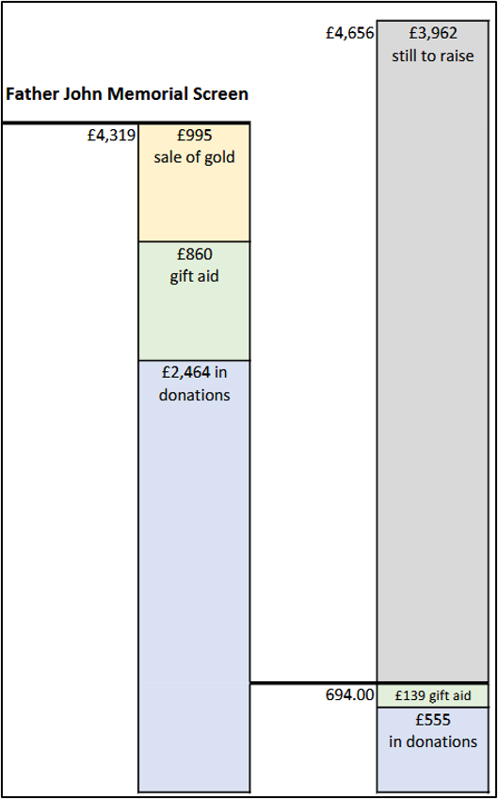
A HUGE ‘THANK YOU’ to all who have given so generously to help us reach our target for Father John’s Memorial Screen.
The total cost is £14,000 and with these donations and funds already held of £9,448.90 from The Friends and The Rotary Club we now have £13,768.
If anyone else would like to make a donation, we are still looking for £232 to cover every penny without using church funds.

