GARAGE SALE & RAFFLE
12, Harvest Way, Hawkinge, Folkestone,
CT18 7PE
Saturday 27th JUNE to Saturday 4th JULY 2026 inclusive
Bric-a-brac, books, plants, TV’s, puzzles, furniture, crockery and much more…
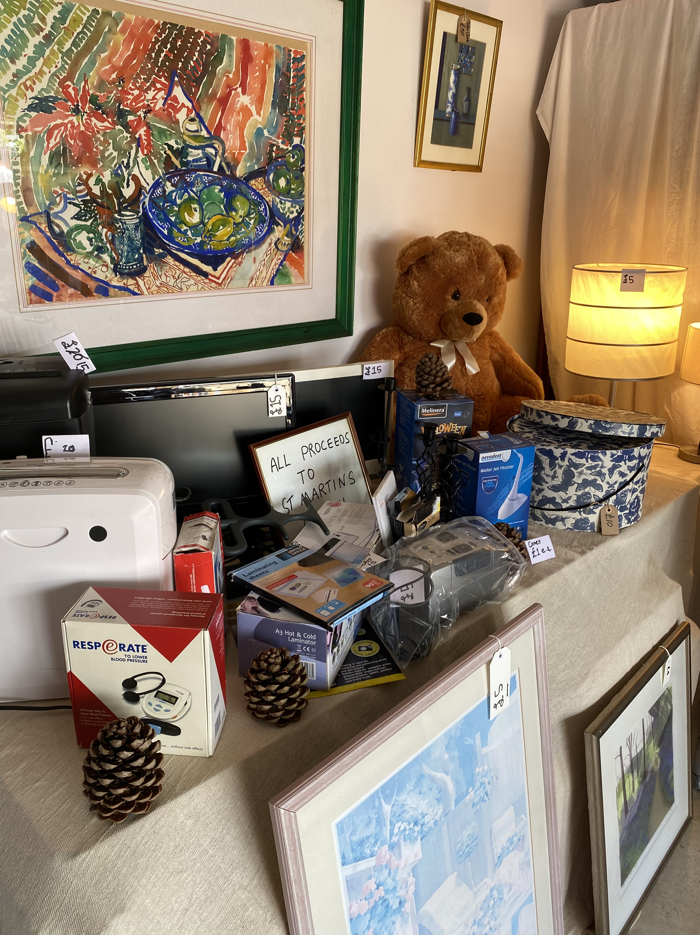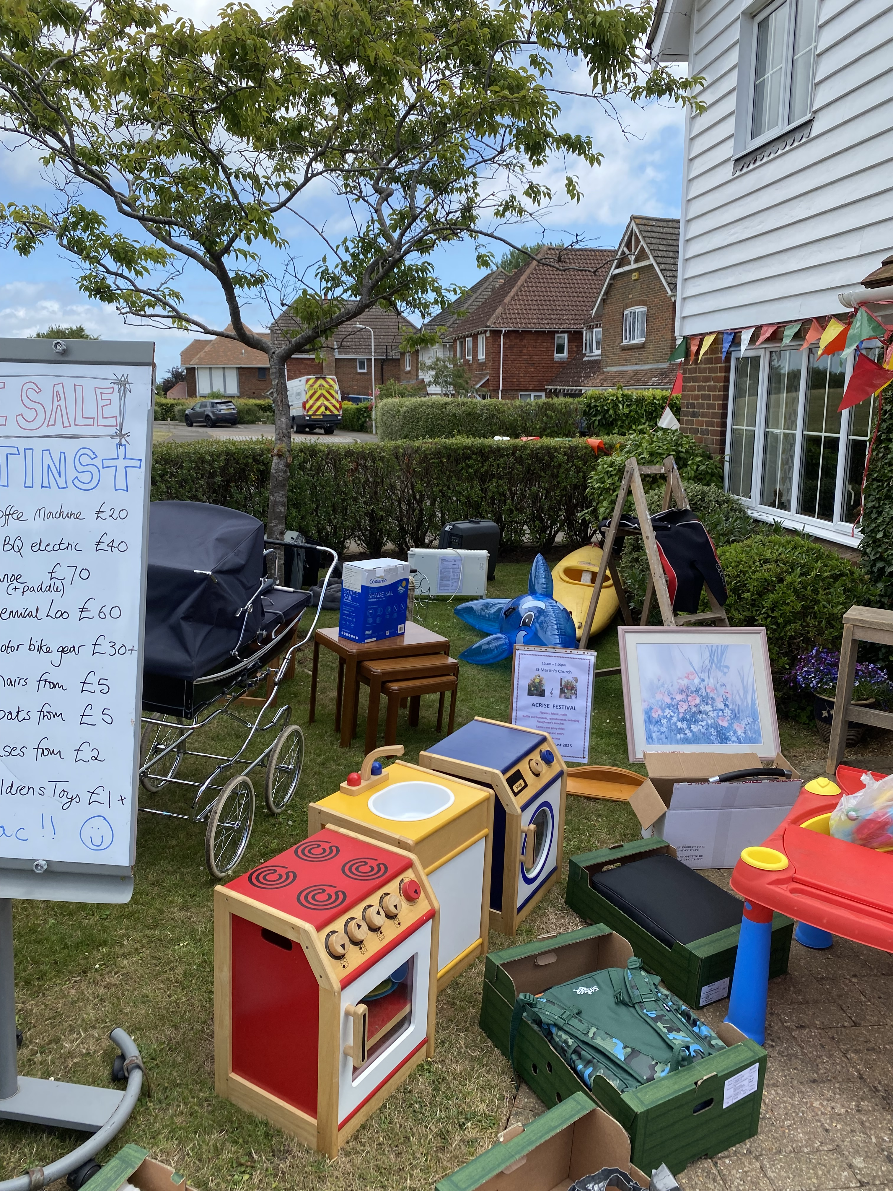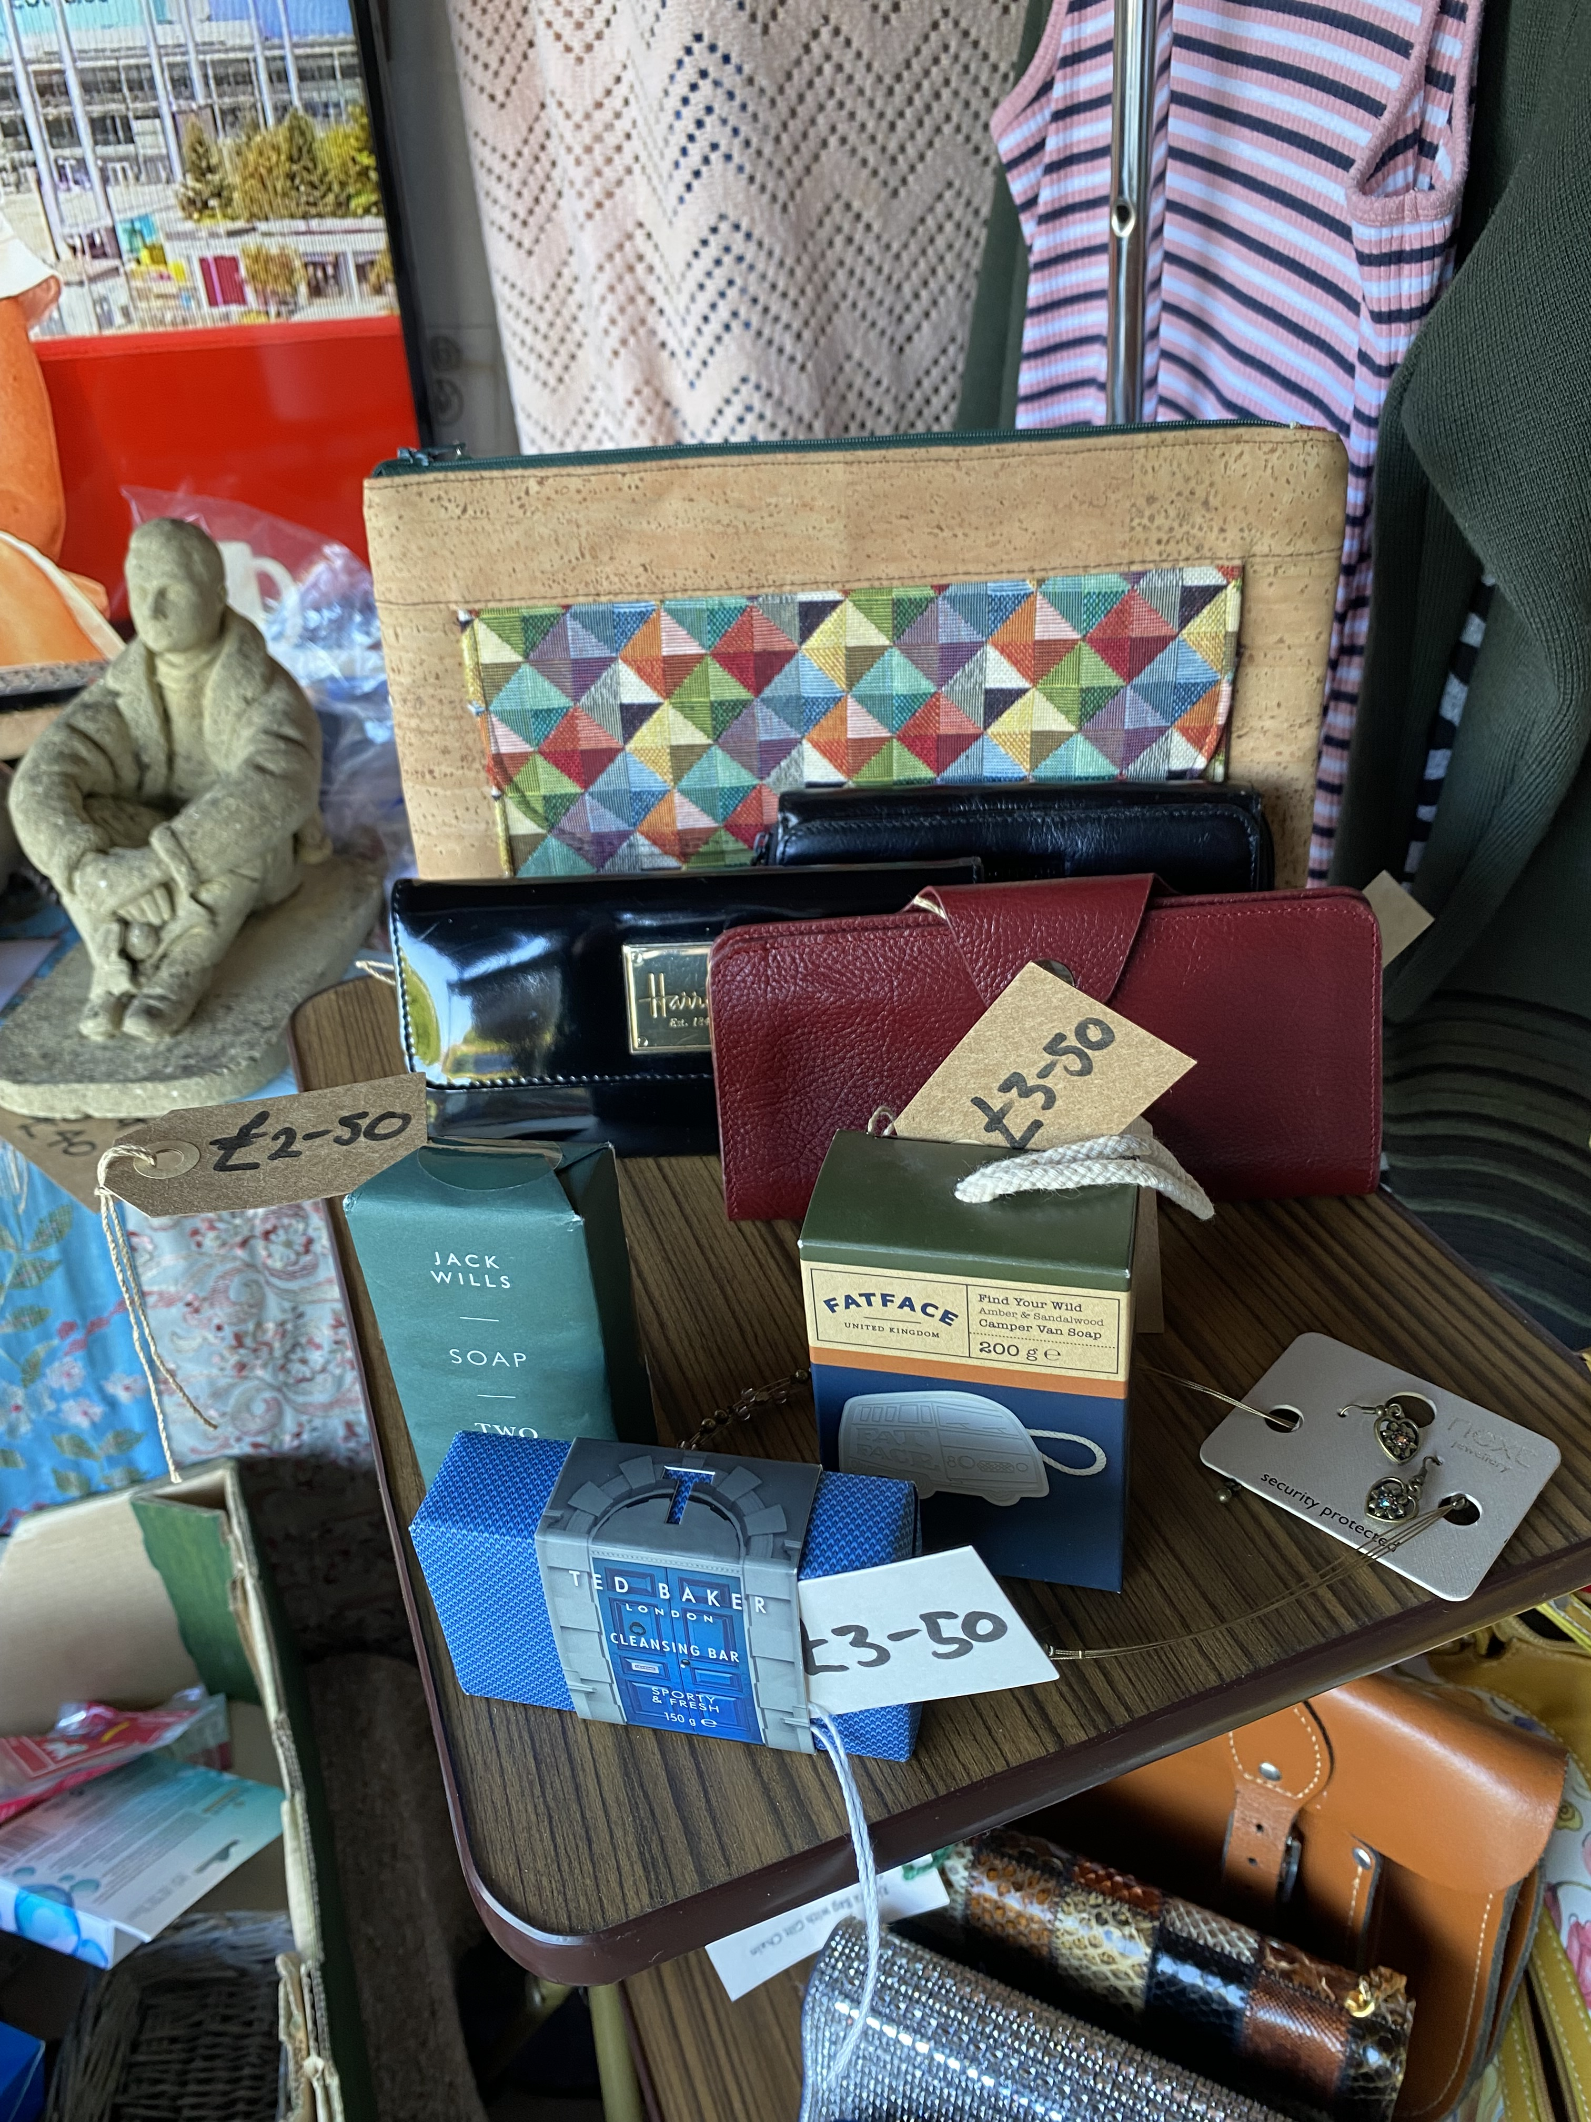
Open all week; from 8 a.m. to 8 p.m. every day !
The raffle will be drawn on the final day, 4th July, 2026
at 11:30 a.m. at Richard’s garage (address as above).
All proceeds towards St Martin’s Church Acrise.
All donations for the sale and the raffle gratefully received – particularly quality items/nearly new, large and small.
Please call Richard on 01303 893584 or
07919 393302 for details.

