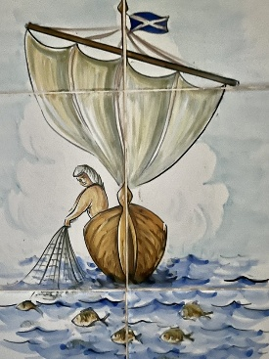
Rota St. Andrew’s Church Puerto Pollensa
July 2026
5th July | 12th July | 19th July | 26th July
Fifth Sunday after Trinity  (Green)  Zechariah 9:9-12  Romans 7;15-25  Matthew 11:16-19,25-end | Sixth Sunday after Trinity  (Green)  Isaiah 55:10-13  Romans 8:1-11  Matthew 13:1-9, 18-23 | Seventh Sunday after Trinity  (Green)  Isaiah 44:6-8  Romans 8:12-25  Matthew 13;24-30, 36-43 | Eight Sunday after Trinity  (Green)  1 Kings 3:5-12  Romans 8:26-end  Matthew 13:31-33, 44-52
Holy Communion  11am | Holy Communion 11am | Holy Communion  11am | Holy Communion 11am
40 Years of the Anglican Church in Puerto Pollensa!
This year we will be celebrating our 40th anniversary of Anglican Worship here in Puerto Pollensa.
Do you have any memories from any point in the last 40 years which you would like to share? Do let me know!
Revd. Sara
chaplain@standrewspuertopollensa.org

