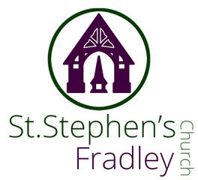
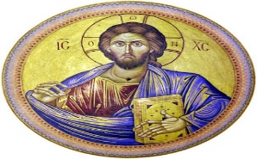
BULLETIN
28th June 2026 Fourth Sunday after Trinity
10.30am Family Communion
Welcome to our Worship today. If you are visiting for the first time, please introduce yourself so that we may welcome you personally. Refreshments are served after 3. the service
ST. STEPHEN’S CHURCH IS OPEN 10am-3pm daily for Private Prayer and Reflection
Collect  Gracious Father,  by the obedience of Jesus  you brought salvation to our wayward world:  draw us into harmony with your will,  that we may find all things restored in him,  our Saviour Jesus Christ.  Readings  Jeremiah 28:5-9 Romans 8:1-11  Matthew 10: 40-end  Post Communion  Eternal God,  comfort of the afflicted and healer of the broken,  you have fed us at the table of life and hope:  teach us the ways of gentleness and peace,  that all the world may acknowledge  the kingdom of your Son Jesus Christ our Lord.  ROBERT DERRY RIP  Robert sadly passed away recently and his funeral and burial will take place at St. Stephen’s on Monday 6th July at 2.00pm. Please remember Marian and her family in your prayers  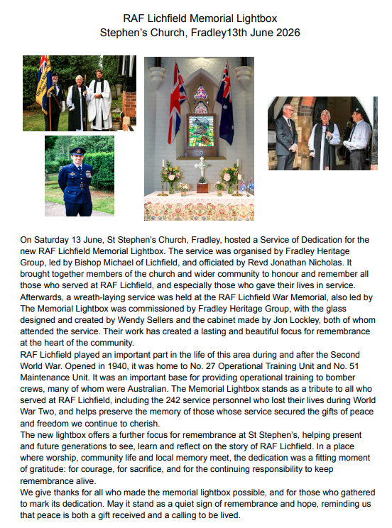  Join in the Poppy Project  Following the success of the Common Threads (on display in the Cathedral until 5 July), we are delighted to be working in partnership with The Fabric Vault once again to create thousands of handmade poppies for a special – and hopefully record breaking - installation for Remembrance 2027.  Whether you knit, crochet, sew or embroider, we would love you to get involved. Pick up a Poppy Project from the Cathedral Gift Shop or come along to our next Poppy Stitch sessions on Friday 19 June, 10.00-12.00 and 18.15-19.45  To find out more and see future Poppy Stitch dates, visit www.lichfield-cathedral.org/poppy
  
  Enjoy a classic strawberry tea for £5.00
  and visit our Craft Stall while you are here.
  All Welcome
  Diary Dates
  June
  Sunday 28th
  10.30am Family Communion
  Monday 29th
  10-11am Craft Group
  Tuesday 30th
  7-9pm Community Choir rehearsal
  Forthcoming Dates
  29th Lichfield Cathedral
  6-830pm Archdeacon Visitation Servic
  Flower Arranging
  DEMONSTRATION by Jan Latham-Gain
  Thursday 9th July 2026
  7:30 pm
  Tickets £5
  Prosecco & cakes
  Raffle
  Contact Carole for tickets
  on 07813 620622
  Lichfield Cathedral
  The Dementia Champions Team warmly invite you to a Dementia Friendly Songs of Praise Service on Wednesday 1st July at 10.45am. There will be plenty of opportunity to sing hymns chosen by some of those who attended our last service, and we will be joined by pupils from Years 5 and 6 from Lichfield Cathedral School. The service will last approximately 40 minutes and refreshments will be served afterwards in the North Transept. For further information or to reply to this invitation please email us at dementia.friendly@lichfield-cathedral.org We look forward to seeing you.
  Please note this service will not be streamed.
Notices for inclusion in the bulletin please email me by Tuesday of each week
Officeststephenfradley@gmail.com Please take bulletin away with you
If you would like to support St Stephen’s Church at this time donations can be made via our Just Giving Page. We are grateful for donations large or small
https://www.justgiving.com/fundraising/ststephensfradley
Contact us
Priest in Charge: Rev. Jonathan Nicholas vicar@alrewasallsaints.church 01283 384 000 Mobile:07920239190
Churchwardens Marian Derry 01283 79157Katie Williams07776182760warden.ststephens.fradley@gmail.com
St Stephen’s Administrator: Di Cooper 07930162991 officeststephenfradley@gmail.com
Find us on ACNY https://www.achurchnearyou.com/church/4123/
Facebook www.facebook.comststephensfradley

