The Winterbournes and Compton Valence

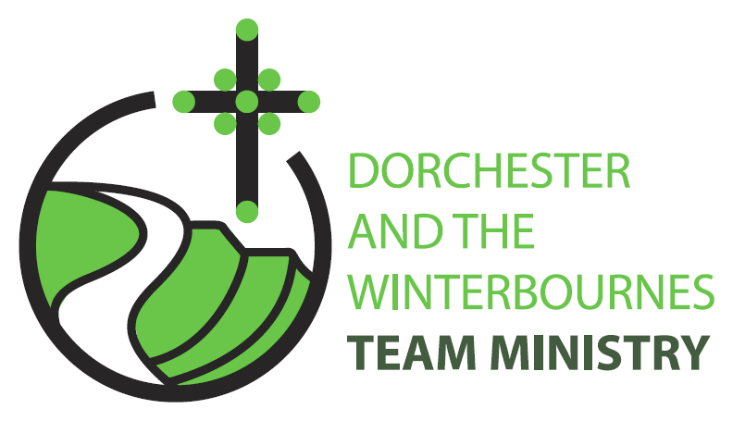

Trinity 1
7th June 2026

Welcome to this service in the Ordinary Season. We rejoice today in God’s Good News that ‘The kingdom of heaven has come near!’ We reflect on what this means for our ministry in the Winterbourne Valley and at Compton Valence. In our prayers we continue to pray for communities afflicted by war and for the continued peace processes in Iran and Israel and Ukraine.

Collect
Faithful Creator,
whose mercy never fails:
deepen our faithfulness to you
and to your living Word,
Jesus Christ our Lord.
All: Amen

Reading: Exodus 19: 2-8a

² They had journeyed from Rephidim, entered the wilderness of Sinai, and camped in the wilderness; Israel camped there in front of the mountain. ³ Then Moses went up to God; the Lord called to him from the mountain, saying, ‘Thus you shall say to the house of Jacob, and tell the Israelites: ⁴ You have seen what I did to the Egyptians, and how I bore you on eagles’ wings and brought you to myself. ⁵ Now therefore, if you obey my voice and keep my covenant, you shall be my treasured possession out of all the peoples. Indeed, the whole earth is mine, ⁶ but you shall be for me a priestly kingdom and a holy nation. These are the words that you shall speak to the Israelites.’
⁷ So Moses came, summoned the elders of the people, and set before them all these words that the Lord had commanded him. ⁸ The people all answered as one: ‘Everything that the Lord has spoken we will do.’

This is the word of the Lord.
All: Thanks be to God.

Gospel Reading: Matthew 9: 35- 10:8

Hear the Gospel of our Lord Jesus Christ according to Matthew.
All: Glory to you, O Lord.

35 Then Jesus went about all the cities and villages, teaching in their synagogues, and proclaiming the good news of the kingdom, and curing every disease and every sickness.
36 When he saw the crowds, he had compassion for them, because they were harassed and helpless, like sheep without a shepherd.
37 Then he said to his disciples, The harvest is plentiful, but the labourers are few;
38 therefore ask the Lord of the harvest to send out labourers into his harvest.
10 Then Jesus summoned his twelve disciples and gave them authority over unclean spirits, to cast them out, and to cure every disease and every sickness.
2 These are the names of the twelve apostles: first, Simon, also known as Peter, and his brother Andrew; James son of Zebedee, and his brother John;
3 Philip and Bartholomew; Thomas and Matthew the tax-collector; James son of Alphaeus, and Thaddaeus;
4 Simon the Cananaean, and Judas Iscariot, the one who betrayed him.
5 These twelve Jesus sent out with the following instructions: Go nowhere among the Gentiles, and enter no town of the Samaritans,
6 but go rather to the lost sheep of the house of Israel.
7 As you go, proclaim the good news, The kingdom of heaven has come near.
8 Cure the sick, raise the dead, cleanse the lepers, cast out demons. You received without payment; give without payment.

This is the Gospel of the Lord.
All: Praise to you, O Christ.

Post Communion Prayer
Loving Father,
we thank you for feeding us at the supper of your Son:
sustain us with your Spirit,
that we may serve you here on earth
until our joy is complete in heaven,
and we share in the eternal banquet
with Jesus Christ our Lord.
All: Amen

NOTICES:
Fundraising event for The Winterbourne Valley Churches: Open Garden @ 3 Park Farm Close Sunday 14th June 1pm-5pm
Come along and support Phil and Roeli as they host this wonderful event. Home-made teas and sausage rolls, lots of activities for children. Adults £5 Children FREE

Dorchester Choral Society: A celebration of American music: Saturday 27th June 5.30pm, St Martin’s Church
Come along for a wonderful evening celebrating the 250th anniversary of American Independence. Refreshments will be served before the concert. Donations welcome on the night towards the Church.

PRAYERS FOR THE WEEK

We pray to God the Father,
who has reconciled all things to himself in Christ

For peace among the nations,
that God may rid the world of violence and let peoples grow in justice and harmony. We pray for the peace process between US and Iran, that talks may be fruitful and bring a lasting peace. We pray that Russia will cease its aggression and seek reconciliation with Ukraine.

For those who serve in public office,
that they may work for the common good. We pray from Valdimir Putin, Volodymyr Zelensky, Donald Trump, Benjamin Netanyahu, the leadership in Iran, Hezbollah, Hamas and the Houthis rebels. We pray for the work of our local Parish Councils and for Emma Sleightholme (headteacher) and all the staff at Winterbourne Valley First School

For Christian people everywhere,
that we may joyfully proclaim and live our faith in Jesus Christ. We pray for The Winterbourne Churches as we seek to understand God’s will for us as a community of faithful Christians. We also pray that God will show us how to secure our financial future.

For those who suffer from hunger, sickness or loneliness,
that the presence of Christ may bring them
health and wholeness. Especially we pray for Bruce Robertson and Maggie, Andreas, Clare Rootham, Mandy Reed, John Reed, Di Honeybun, Ann Quarrie, Stoffel, Margaret and Baby Wren

For those who have recently died and those bereaved by their passing. Especially we pray for Malcolm Mitchell and Marjorie Duckworth who have died recently and for those whose year’s mind occurs this month: Roger Axford, Brian Thompson, Phyllis Dight, Pamela Crumbleholme, and Alistair Ball

We commend ourselves, and all for whom we pray,
to the mercy and protection of God.

