
SPIRE & LIGHT United Churches
United Benefice of St Keverne, St Ruan with St Grade & St.Wynwallow (The Lizard)

*If you do not wish to receive these notices, please let your Churchwarden know*

14th June 2026

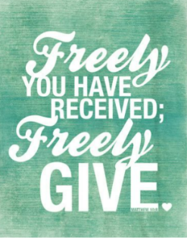
Readings
Exodus 19:2 – 8a
Psalm 100
Romans 5:1-8
Matthew 9:35 – 10:8

9.30am – Morning Prayer - St.Peter’s, Coverack
9.30am – Holy Communion - St.Ruan, Ruan Minor
11am – Holy Communion – St.Keverne
11.15am – Café Church – St.Wynwallow, The Lizard
6pm – Evensong – St.Grade

Next week – Sunday June 21st
9.30am – Holy Communion - St.Peter’s, Coverack
9.30am – Morning Prayer - St.Wynwallow, The Lizard
11am – Morning Prayer – St.Keverne
11.15am – Family Service – St.Ruan, Ruan Minor




The Prayer Spot
We pray for the Deanery that we belong to and we thank you for the faithful people you have brought together here. Remind us that we have each been brought to faith by Our Saviour Jesus Christ.
Lord Jesus, we thank you for your presence in our lives and the love you give us to share with others. Keep us strong in our faith and close to you.
Help us to be always there for others in their time of need, you have given us each gifts to use to reach out to others and to give comfort to those around us.
Heavenly Father we live in a world slowly destroying itself, through greed, hatred, and with no concern for others. Remind us that we can bring love, care and understanding into the world, by reaching out into our communities and showing your love to all we meet. Loving God, be with us always. Remind us that we are brothers and sisters in Christ Jesus, that God is ever present in our lives, through his wonderful Holy Spirit that he has given to you as a free gift to us all.
Mighty God, everything you do reveals your Majesty. Open our eyes to see what you are doing in our lives. Let us marvel at your good gifts and your wise provision. Your acts are amazing Lord. We cannot comprehend the number of blessings you pour out to us from day to day. As we gather today around your name, we pray that you will fill our hearts, our minds and our souls. Transform us Lord and make us more like you. Through Jesus Christ our Lord. Amen
God bless you all. Samuel Buchanan

The Diocese of Truro’s Prayer Diary for this week

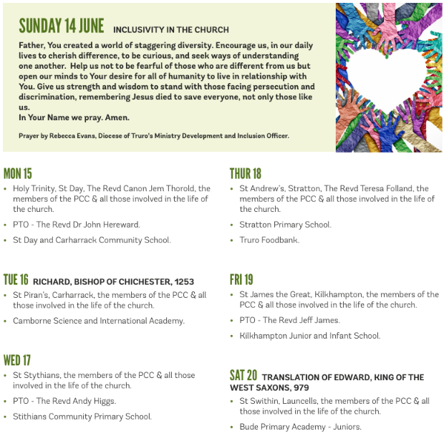

On the Way Prayers

“June is busting out all over!” – Father we thank you for the incredible variety of your seasons, the beauty of this place you have chosen for us, and for all those people we know and love who make our life here more enjoyable and fulfilling.

We also give thanks for the course that Heidi is running – to help us become more confident talking about our faith. It is so lovely to come together from across the Deanery to share something really special. Let us pray that we can all become more confident about our faith so that we can spread the good news to others.

Our thanks now turn to those who minister to us – our clergy, particularly those retired clergy who give so much to our Deanery and who help us develop our faith in all sorts of different ways. Our lay ministers work hard to keep our service patterns going and we thank them for their dedication. Now we pray that we can fill the vacant posts in our ministry team, with people prepared to help make us all more fruitful and sustainable. We continue to pray that people are being called to come and help us on our journey.

Living and Loving God, the God of all our journeying, we give you thanks and praise that you are always ‘On the Way’ with us, walking step by step along the pilgrim path. God within us, God beside us, God behind us, God before us.
New-life giving, energy-breathing God, the God who loves to surprise us, open our hearts, our minds, our lives to all the new possibilities that will lie ahead
on the way in the months and years to come. Help us to listen together to your Spirit’s voice, calling, “This is the way – walk in it.”

Let us now pray for anyone or anything that needs the support and comfort of our collective prayers. Lord, we know that you are with us, listening to our prayers for these people and things – may they feel your presence in their lives – even if they don’t believe and give them peace. Help us to always pray, every day, for those who most need our prayers.

Lord your world seems in turmoil – let us pray for peace. We pray for the football World Cup; that through sport, nations may come together in unity and understanding. May football, as it can do, bring people together in happy times. May our lives be blessed by the knowledge that you are going with us, that you are always with us and with those we love. Amen

