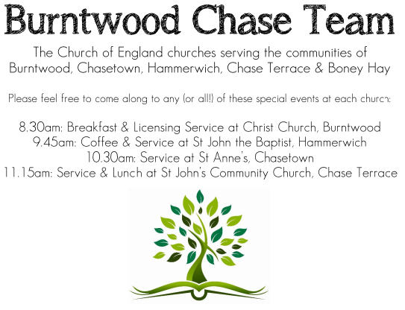
CHRIST CHURCH
Registered Charity Nos. 1217129

SERVICE ON SUNDAY 17th May 2026 at 10am

Holy Communion

7th Sunday of Easter

Readings:
Acts 1: 6-14

⁶ So when they had come together, they asked him, ‘Lord, is this the time when you will restore the kingdom to Israel?’ ⁷ He replied, ‘It is not for you to know the times or periods that the Father has set by his own authority. ⁸ But you will receive power when the Holy Spirit has come upon you; and you will be my witnesses in Jerusalem, in all Judea and Samaria, and to the ends of the earth.’ ⁹ When he had said this, as they were watching, he was lifted up, and a cloud took him out of their sight. ¹⁰ While he was going and they were gazing up towards heaven, suddenly two men in white robes stood by them. ¹¹ They said, ‘Men of Galilee, why do you stand looking up towards heaven? This Jesus, who has been taken up from you into heaven, will come in the same way as you saw him go into heaven.’
¹² Then they returned to Jerusalem from the mount called Olivet, which is near Jerusalem, a sabbath day’s journey away. ¹³ When they had entered the city, they went to the room upstairs where they were staying, Peter, and John, and James, and Andrew, Philip and Thomas, Bartholomew and Matthew, James son of Alphaeus, and Simon the Zealot, and Judas son of James. ¹⁴ All these were constantly devoting themselves to prayer, together with certain women, including Mary the mother of Jesus, as well as his brothers.
John 17: 1-11
After Jesus had spoken these words, he looked up to heaven and said, ‘Father, the hour has come; glorify your Son so that the Son may glorify you, ² since you have given him authority over all people, to give eternal life to all whom you have given him. ³ And this is eternal life, that they may know you, the only true God, and Jesus Christ whom you have sent. ⁴ I glorified you on earth by finishing the work that you gave me to do. ⁵ So now, Father, glorify me in your own presence with the glory that I had in your presence before the world existed.
⁶ ‘I have made your name known to those whom you gave me from the world. They were yours, and you gave them to me, and they have kept your word. ⁷ Now they know that everything you have given me is from you; ⁸ for the words that you gave to me I have given to them, and they have received them and know in truth that I came from you; and they have believed that you sent me. ⁹ I am asking on their behalf; I am not asking on behalf of the world, but on behalf of those whom you gave me, because they are yours. ¹⁰ All mine are yours, and yours are mine; and I have been glorified in them. ¹¹ And now I am no longer in the world, but they are in the world, and I am coming to you. Holy Father, protect them in your name that you have given me, so that they may be one, as we are one.

COLLECT FOR TODAY
O God the King of glory,
you have exalted your only Son Jesus Christ
with great triumph to your kingdom in heaven:
we beseech you, leave us not comfortless,
but send your Holy Spirit to strengthen us
and exalt us to the place
where our Saviour Christ is gone before,
who is alive and reigns with you,
in the unity of the Holy Spirit,
one God, now and for ever.

WHAT’S GOING ON
Upcoming Services and Events
Wednesday 20th May Morning Prayer 9.30am
Sunday 24th May Morning Worship 10am
Wednesday 27th May Morning Prayer 9.30am
Sunday 31st May Holy Communion 10am

DATES FOR YOUR DIARY
Saturday 27th June Cream Tea
Saturday 11th July Shelfield Choir Concert
Saturday 14th November Christmas Fayre

APCM Meeting
Please note the APCM meeting will be held in Church on Sunday 17th May after the 10am Communion Service. Further details nearer the date.

FLOODLIGHTING
If you think about commemorating a special occasion by floodlighting our Church. Please contact Chris Brown on 01543 683862 for details.

PRAYER CHAIN
Christ Church is blessed with a very active prayer chain. If you, or anyone you know, feel that they would like others to pray for them, please speak to Chris Brown on 01543 683862.

HOME COMMUNION
For anyone who is unable to attend church and would like a Home Visit and Communion, please contact the Vicar and he will be able to carry this out.

VICAR CONTACT DETAILS
Rev’d Stephen Morgan Tele: 07305 852152
CHURCH WARDENS CONTACT DETAILS
Judith Rogers Tele: 01543 324718
Mike Holmes Tele: 01543 672970
Church Office Tele: 01543 642187 [leave a message and we will respond]
Church Web Site:www.christchurchburntwood.org.uk
Church Email: christchurchburntwood15@gmail.com
Facebook: www.facebook.com/group/christchurchburntwood/

Other Contacts
Rev’d Matt Wallace St. John’s, Chase Terrace— Tele: 01543 670078

NEXT SUNDAY SERVICE
Sunday 24th May at 10am
Morning Worship
Acts 2: 1-21
John 7: 37-39
Pentecost

