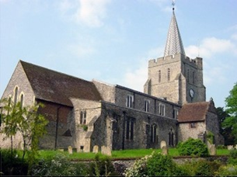
Please visit our website for information about our churches, services & events www.elhamvalleygroupofchurches.co.uk

Every Tuesday at St. Mary’s…

Traditional Morning Prayer at 8.30am in the Jesus Chapel. Download the free Church of England app or use the red book. A good way to begin the day. https://play.google.
com/store/apps/details?id=com.aimermedia.dailyprayer&pli=1


Every Monday at the Methodist Hall …
Coffee and cake, a warm welcome and friendship, 10.30am –
12pm

Churches Together in Elham Valley May
Please contact -: Ruth Collie (01303 840773) for information

7th June – 1st Sunday after Trinity
0800 Said Holy Communion; 0930 – Morning Service
Lectionary readings:
Genesis 12.1-9; Psalm 33.1-12 ; Romans 4.13-25; Matthew 9.9-13,18-26

14th June – 2nd Sunday after Trinity
0845 Morning Prayer to begin walk to Denton
Lectionary readings:
Genesis 18.1-15 [21.1-7]; Psalm 116.1,10-17; Romans 5.1-8; Matthew 9.35 - 10.8 [9-23]

21st June – 3rd Sunday after Trinity
09.30 Eucharist
Lectionary readings:
Genesis 21.8-21; Psalm 86.1-10,16-17*; Romans 6.1b-11; Matthew 10.24-39

28th June – 4th Sunday after Trinity
09:30 Morning Service
Lectionary readings:
Genesis 22.1-14; Psalm 13; Romans 6.12-23; Matthew 10.40-42

Events for the July Notice sheet Please send to Margaret Keeble by 5th of each preceding month. m.keeble@outlook.com

Elham Methodist Church
(all at 9.30am unless otherwise stated)
Services for June
7th Video Service
14th Rev Gill Songer – Holy Communion, United Service (10.15am)
21st Tom Lewis
28th United service at Rhodes Minnis

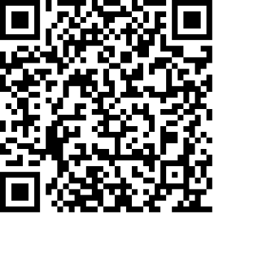
Donations
We would greatly appreciate your help to continue our work for God in the village of Elham and surrounding areas. If you can, please consider making a donation. This is our QR code for St Mary’s Elham. To donate using this code, open up the camera on a mobile phone - point the camera at the QR code – follow the instructions.
The offertory plate will go round in the service, during one of the hymns. There is also the opportunity to donate by card using the PAYAZ machine by the North door.

Safeguarding / ‘A Safe Church’:
If you ever have any concerns, contact our Parish Safeguarding Officer:
Susannah Pallot : susannahpallot@gmail.com

Paper Copies of Notices
Some copies are available on back table in church. Please take a copy to give to those unable to access the internet.

