The Winterbournes and Compton Valence

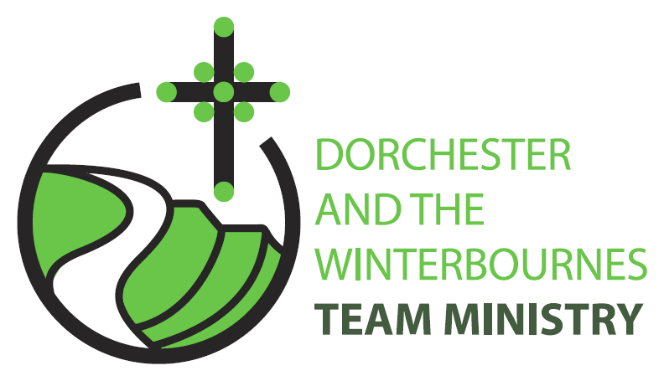

Easter 5
3rd May 2026

Welcome to this service for the Easter season especially if you're here for the first time or are a visitor to the Winterbourne Valley. Our theme this Sunday is our common purpose as Easter people to make a difference to the lives of our neighbours through our actions of love and service. We hear the joy and the cost of this calling in the story of the stoning of Stephen. So, we continue to pray for communities afflicted by war and for the continued peace processes in Iran and Israel . In this Easter season, we remember especially the Christian communities of Palestine and Israel, Russia and Ukraine.

Collect
Risen Christ,
your wounds declare your love for the world
and the wonder of your risen life:
give us compassion and courage
to risk ourselves for those we serve,
to the glory of God the Father.
All: Amen

Reading: Acts 7: 55-60

55 But filled with the Holy Spirit, he gazed into heaven and saw the glory of God and Jesus standing at the right hand of God.
56 Look, he said, I see the heavens opened and the Son of Man standing at the right hand of God!
57 But they covered their ears, and with a loud shout all rushed together against him.
58 Then they dragged him out of the city and began to stone him; and the witnesses laid their coats at the feet of a young man named Saul.
59 While they were stoning Stephen, he prayed, Lord Jesus, receive my spirit.
60 Then he knelt down and cried out in a loud voice, Lord, do not hold this sin against them. When he had said this, he died.

This is the word of the Lord.
All: Thanks be to God.

Gospel Reading: John 14:1-14

Hear the Gospel of our Lord Jesus Christ according to John.
All: Glory to you, O Lord.

14 Do not let your hearts be troubled. Believe in God, believe also in me.
2 In my Fathers house there are many dwelling-places. If it were not so, would I have told you that I go to prepare a place for you?
3 And if I go and prepare a place for you, I will come again and will take you to myself, so that where I am, there you may be also.
4 And you know the way to the place where I am going.
5 Thomas said to him, Lord, we do not know where you are going. How can we know the way?
6 Jesus said to him, I am the way, and the truth, and the life. No one comes to the Father except through me.
7 If you know me, you will know my Father also. From now on you do know him and have seen him.
8 Philip said to him, Lord, show us the Father, and we will be satisfied.
9 Jesus said to him, Have I been with you all this time, Philip, and you still do not know me? Whoever has seen me has seen the Father. How can you say, Show us the Father?
10 Do you not believe that I am in the Father and the Father is in me? The words that I say to you I do not speak on my own; but the Father who dwells in me does his works.
11 Believe me that I am in the Father and the Father is in me; but if you do not, then believe me because of the works themselves.
12 Very truly, I tell you, the one who believes in me will also do the works that I do and, in fact, will do greater works than these, because I am going to the Father.
13 I will do whatever you ask in my name, so that the Father may be glorified in the Son.
14 If in my name you ask me for anything, I will do it.
This is the Gospel of the Lord.
All: Praise to you, O Christ.

Post Communion Prayer
Eternal God,
whose Son Jesus Christ is the way, the truth, and the life:
grant us to walk in his way, to rejoice in his truth,
and to share his risen life;
who is alive and reigns, now and for ever.
All: Amen
NOTICES:
Compton Valence APCM 5th May 6pm @ Village Hall
Everyone is welcome to come along
Ascension Day Thursday 14th May: 9am Holy Communion @ St Martin

Fundraising event for The Winterbourne Valley Churches: 14th June
A Message from Tom Webb “This is a "save the date" notice for the 14th June.
Phil and Roelie Newman are opening their garden in Martinstown as part of the National Garden Scheme. The scheme itself raises money for a cancer charity but they have expressed a willingness that we provide, tea, coffee, cake, sausage rolls and other refreshments of our choosing to raise money for the valley churches.
Closer to the time I will be seeking 🙂....
- Cake and sausage roll donations for delivery on the 13th June. We will need a lot, as people travel a long way to come to these open gardens, especially new ones. You may claim for ingredients if you wish.
- Volunteers to man/woman the stand on the day. Bits of the day would be welcome. 09.30 to 16.30
I`ll be asking again closer to the time but if you could put these dates in your diary and let me know if you`re going to be able to help,
Best wishes, Tom Webb

PRAYERS FOR THE WEEK

Creator God
We pray for the world asking that those with power and authority choose to serve the good of all people and show commitment to justice, compassion and most of all peace.
We pray especially for those in power in Palestine, Isreal, Iran, Lebanon the Gulf States, America, Ukraine, and Russia

Saviour God,
We pray for all your people across the world asking that each of us might show commitment to serving and caring for one another, especially in our care for the sick, those who are sad or anxious, those who are hungry or homeless and those who are alone.
We pray especially for all migrants and those adversely affected by Climate Change

Spirit of God,
We pray for your Church asking that the family of Christ might show commitment to you and your way.
We pray especially for the ‘What Next for The Winterbournes’ Working Party as they meet to formulate a mission plan for our parishes. From our community we pray for Bruce Robertson and Maggie, Andreas, Clare Rootham, John Reed, Di Honeybun. And for those whose year’s mind occurs this month we pray for: John Dyer, Phyllis Lacy-Smith, Marion Hanger, Doreen Pritchard, Richard Hyde

