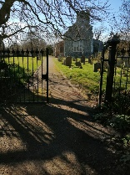

June 26 Mendham Message

All Saints Church Open 9am-dusk daily. Food & household essentials for anyone to take if needed! Weds 10am prayers for village in pub; hot drink/chat 10.30am –

NB service times change to 9.30am


Sun 7th June 9.30am MU takeover of village service to celebrate their 150 years! Come & find out more! Refreshments after.

Sun 21st June 9.30am Holy Communion. 3rd Sunday after Trinity. Refreshments after.


Church Plant Fair Sat 30th May 10am-3pm
Thank you to all those who have helped in any way including school for pictures and for donating to All Saints Church Mendham.

Coming soon Sun 5th July Village service 9.30am. Tell Diane your favourite hymn!

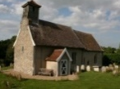
St Mary Magdalene, Withersdale
Wed 3rd June 2.30pm Short prayers for new Rector.
Sun 14th June 9am BCP Holy Communion
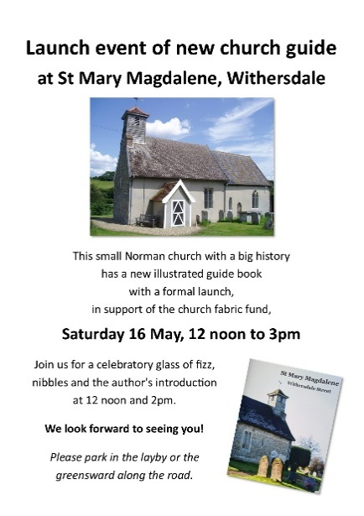
Copies of new guidebook still on sale in church or contact Diane 01986 788750.

Coming soon: Evensong for St Mary Magdalene Sun 19th July 3.30pm.

Sir Alfred Munnings Hotel 01379 854861
Sun 21st June Father’s Day menu 12-8pm
Book 2 course £25.95 or 3 course 31.95.

Mendham and Withersdale Village Hall.

Thurs 18th June 2-4pm 1st Good Afternoon Club for all ages. Thank you to those who have set this club up and who look after the grounds BUT we still need more committed volunteers to help run hall for community.

In June the Church Times is running an advert for a new Rector for our churches.
June 26 Mendham Message
All Saints Church Open 9am-dusk daily. Food & household essentials for anyone to take if needed! Weds 10am prayers for village in pub; hot drink/chat 10.30am –

NB service times change to 9.30am

Sun 7th June 9.30am MU takeover of village service to celebrate their 150 years! Come & find out more! Refreshments after.

Sun 21st June 9.30am Holy Communion. 3rd Sunday after Trinity. Refreshments after.
Church Plant Fair Sat 30th May 10am-3pm
Thank you to all those who have helped in any way including school for pictures and for donating to All Saints Church Mendham.
Coming soon Sun 5th July Village service 9.30am. Tell Diane your favourite hymn!

St Mary Magdalene, Withersdale
Wed 3rd June 2.30pm Short prayers for new Rector.
Sun 14th June 9am BCP Holy Communion
Copies of new guidebook still on sale in church or contact Diane 01986 788750.
Coming soon: Evensong for St Mary Magdalene Sun 19th July 3.30pm.

Sir Alfred Munnings Hotel 01379 854861
Sun 21st June Father’s Day menu 12-8pm
Book 2 course £25.95 or 3 course 31.95.
Mendham and Withersdale Village Hall.
Thurs 18th June 2-4pm 1st Good Afternoon Club for all ages. Thank you to those who have set this club up and who look after the grounds BUT we still need more committed volunteers to help run hall for community.

In June the Church Times is running an advert for a new Rector for our churches.

