SUNDAY MORNING READING SHEET 26th April 2026 4th Sunday of Easter

A reading from the Acts of the Apostles
Filled with the Holy Spirit, Stephen gazed into heaven and saw the glory of God and Jesus standing at the right hand of God. ‘Look,’ he said, ‘I see the heavens opened and the Son of Man standing at the right hand of God!’ But they covered their ears, and with a loud shout all rushed together against him. Then they dragged him out of the city and began to stone him; and the witnesses laid their coats at the feet of a young man named Saul. While they were stoning Stephen, he prayed, ‘Lord Jesus, receive my spirit.’ Then he knelt down and cried out in a loud voice, ‘Lord, do not hold this sin against them.’ When he had said this, he died. Acts 7:55-60

GOSPEL

‘Do not let your hearts be troubled. Believe in God, believe also in me. In my Father’s house there are many dwelling-places. If it were not so, would I have told you that I go to prepare a place for you? And if I go and prepare a place for you, I will come again and will take you to myself, so that where I am, there you may be also. And you know the way to the place where I am going.’ Thomas said to him, ‘Lord, we do not know where you are going. How can we know the way?’ Jesus said to him, ‘I am the way, and the truth, and the life. No one comes to the Father except through me. If you know me, you will know my Father also. From now on you do know him and have seen him.’ Philip said to him, ‘Lord, show us the Father, and we will be satisfied.’ Jesus said to him, ‘Have I been with you all this time, Philip, and you still do not know me? Whoever has seen me has seen the Father. How can you say, “Show us the Father”? Do you not believe that I am in the Father and the Father is in me? The words that I say to you I do not speak on my own; but the Father who dwells in me does his works. Believe me that I am in the Father and the Father is in me; but if you do not, then believe me because of the works themselves. Very truly, I tell you, the one who believes in me will also do the works that I do and, in fact, will do greater works than these, because I am going to the Father. I will do whatever you ask in my name, so that the Father may be glorified in the Son. If in my name you ask me for anything, I will do it. John 14:1-14

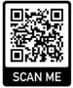
If you wish to make a donation to the church, then please hold Your phone’s camera over this image then touch the link that appears:

Royston Parish Church
Where all are welcome and God’s love is shared
Sunday 3rd May - 5th Sunday of Easter

If you would like regular copies of the Notice Sheet emailed to you please email the
Parish Office at admin@roystonparishchurch.org.uk

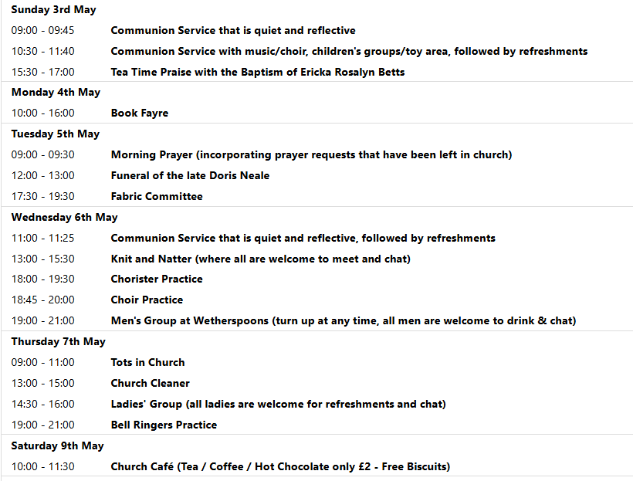
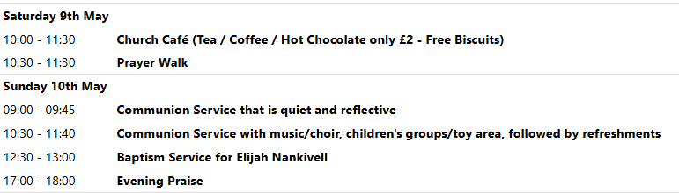

We pray for all Christians worldwide:
For all Christians in Armenia, Azerbaijan, Georgia
For all who worship at Trinity Life Church: Peter Chapman
For the work of our mission partners: GenR8

Pray for the community of Royston:
For our local health centres
For all our local Market Stall Holders
For all our young people revising for exams at this present time

We pray for our world and ECO projects:
In International Compost Awareness Week (3-9th May 2026) we pray that we may care better for our precious resources.

We pray for the sick and suffering:
3rd May | 10th May | 17th May | 24/31 May
Emma Thompso | Ted Rayment | Val Brown | Peter Coates
Jackson Herbert | Pat Tidey | Angie & Ken Rushall | Margaret Green
Marion | Mike Brown | Paula Walker | Peter Foster
Peggy Dawes | Cobi Smith | Laura O’nyamul  (On-Ya-Mul) | Keith & Elaine Edwards
George N | Max Elliott | William, Ruth & baby | Susan Bowles
Katie

We pray for those who have died in the faith of Christ:
Deceased Bereaved
Doris Neale Family and friends
Wendy Smith Sue Canon, family and friends

We pray for those whose anniversaries fall at this time:
No anniversaries this week

NOTICES

CHRISTIAN AID WEEK: 10th – 16th May 2026. Envelopes are now ready at the back of church for your donations. Please either return envelope to the black safe on the wall, or bring to church and hand in on Sunday. Thank you

WE HAVE A NEW BATCH OF CHURCH MUGS FOR SALE, at £10 each, sales go towards church funds. Available at Saturday coffee, or after church services.

PRAYER WALK ON THERFIELD HEATH, 9TH MAY A morning's walk on the Heath and its surroundings, stopping for short prayers for the local community. Meets at 10.30am at St John the Baptist Parish Church, finishes at about noon at the Old Bull for optional lunch. Just turn up at the church.

TOMATO PLANTS: I am growing tomato plants again this year. Currently they are looking quite healthy and barring any unforeseen setbacks they should be available from the first weekend in May. I plan to have a stall outside of the church to coincide with the Bookfair on May 2nd and May 4th. They will be competitively priced, and proceeds will be donated, as usual, to the church funds. It would be extremely helpful if you would bring bags/boxes if you intend to purchase any. They will then be available throughout May every Saturday morning. Thank you for your support.
Chris Wallis

BOOK FAYRE- We have our annual 2nd hand book fayre on Saturday 2nd and Monday 4th May. We are seeking donations of good quality 2nd hand fiction books. Book donations can be left at the back of church from 11th April. We're also seeking donations of cakes for refreshments on both days, and for the cake stall on 4th May. There will be a chocolate tombola, and any donations of chocolate for this will be gratefully received. HELP WANTED to set up the book stall on Friday 1st May, and to man stalls and / or serve refreshments on both days of the book fayre, and to tidy up afterwards. If you're able to help, even for just an hour, please can you sign up on the sheet at the back of church, on the day / time slot or slots that you're able to offer your time. Thanks in advance from the Events committee.

Events coming up:

2nd & 4th May - Book Fayre
14th May 8 pm - Ascension Day Evensong
Julian Prayer meeting Thursday 21st May at 7pm at 11 Middle Drift.
19th June - Hymns and PIMM’ s
20th June - Songs from the Musicals Concert

