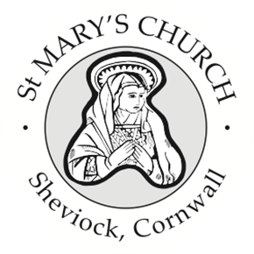

St Mary’s Church, Sheviock
Notices for Sunday 3 May 2026

- Our Annual Parish Meeting and Annual Parochial Church council Meeting will be held after this service. Please collect a coffee and return to your pew so we do not delay the start. Everyone is most welcome to stay and learn a little bit more about our church, but a reminder that you need to be on the Church Electoral Roll to vote – and contain your excitement, but there will be a vote! There are agendas at the front and the meeting pack has been available on the lectern and our website. If you would like to receive this via email – now after the meeting – I will be happy to oblige.
- Thank to the faithful team who attended Church Care morning yesterday. Our next will be on Saturday 6 June when we will be commencing our Summer clean in preparation for the wedding in July.
- The funeral of Michael Cox will be held here this coming Friday at 11 am.
- Our Book Club will be meeting again on Wednesday 20 May at 3pm in the Dawney Aisle when we will be discussing the Cof E booklet “God with Us” produced for the period of prayer, Thy Kingdom Come, between 14th – 24th May. Please do take a booklet or access via the Everyday Faith App on your phone. As always, the invitation is to come and join in the discussion or just come and enjoy a cup of tea while listening to others.
- Please also note that we will be holding our very popular May Market on Saturday 23 May- posters are up on the noticeboards and please do encourage friends and family to attend.

Weekly Services
A full list of weekly services and events for Rame & Rivers churches is published in the weekly Benefice Newsletter and Sunday services for St Mary’s and the Benefice are on our noticeboards.

Next Sunday 10 May at 10 am
Holy Communion at St Germans Priory and Maryfield, Morning Worship at Millbrook

Next Service at St Mary’s - Sunday 17 May Morning Worship at 10 am

