St Thomas’ Church and Community Project
“A Place for You”
June Newsletter

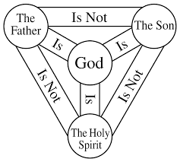

The above diagram is called the Shield of the Trinity (or Scutum Fidei) and is a traditional Christian visual diagram that summarizes the complex doctrine of the Trinity. It maps out the relationship between the Father, the Son, and the Holy Spirit, illustrating that while they are three distinct persons, they are all one God
At the end of May we celebrated Pentecost which always falls 50 days after Easter. You might recognise this festival more easily as Whitsun as it used to be called.
Pentecost and Trinity Sunday (the following Sunday) mark a major transition in the Christian calendar. Together, they celebrate the full revelation of God—the Holy Spirit coming to empower the Church, and the mystery of one God in three Persons: Father, Son, and Holy Spirit.
We try our human best to understand the Trinity, but it may well be one of those relationships we will not fully understand until we meet God in his glory at the end of our days on earth.
For me there is a Connection: Pentecost is often viewed as the moment the Holy Trinity was fully revealed to humanity and given as a gift. We experience God the Father's love, through the sacrifice of Jesus the Son, by the living power of the Holy Spirit inside us.
It’s the day the Holy Spirit was poured out, transforming a fearful group of followers into a bold, unified community. It’s a powerful reminder that God's mission is about connection and empowerment. That Holy Spirit lives in us if we know Jesus and enables us with the same power and authority to preach the gospel, as the early followers.
The Trinity reveals that God has never been solitary; God is an eternal relationship of love—Father, Son, and Holy Spirit.
At Pentecost, we see the Holy Spirit at work. One week later on Trinity Sunday, we celebrate who that Spirit is: the very life and love of the Father and the Son dwelling within us.
The desire of us to understand the relationship of the Trinity is part of our faith as Christians. We believe in a God of love and relationships.
It may seem strange writing about events in May for the June Newsletter – this year there are 22 Sundays after Trinity in the church’s year so it’s not too late!


According to centuries-old legend, Saint Patrick, the patron saint of Ireland, used the three distinct leaves of the shamrock to explain the Christian concept of the Holy Trinity (the Father, the Son, and the Holy Spirit) to the pagans.
Rev Sue Round

Confirmation
It is wonderful that we have a number of people wanting to confirm their faith in the Church of England before the Bishop. But what is Confirmation? Confirmation does not stand alone; it builds on something that must already be in place. That foundation is baptism. Baptism is the entry into the Body of Christ. It is where we are received into the Church, united with Christ and where we become part of the Christian family. Before anything else baptism comes first. Confirmation is the strengthening and affirmation of that baptismal faith.
It is a public declaration of faith, a personal ownership of what has begun in Baptism and a moment where the bishop lays hands on us and prays for the grace of the Holy Spirit.
If you are interested in being baptised or confirmed please contact Rev Sue Round sue.round@st-toms.com
It is not too late to join us. Each session takes the form of a short introductory video and discussion in a safe space. Having begun on Sunday 26th April after morning worship at 11.45am each session will last between just over an hour.

Sessions continue on 14th June 28th June 12th July. There will be some catch-up sessions for those who have been unable to join us.

The Confirmation Service will be held at St Thomas on Sunday 13th September 4pm.

June church services
If you want to discover more, come and join us any Sunday morning or at any of our community activities throughout the week.
Sunday 7th June 10am service with Holy Communion.
Sunday 14th June 10am morning prayer followed by our 4th Confirmation Session
Sunday 21st June 10am service with Holy Communion
Sunday 28th 10am – service with Holy Communion

Children are always welcome and there is the opportunity for them to leave the main service for their own age-appropriate activities in Connect Group. And don’t worry if you arrive a bit late or need to leave before the end.

If you are on the rota to read during June please assume that you will be reading the gospel. These may be subject to change. Now the excitement and celebrations of Easter are over and Christ is glorified, we return to the set gospel for the year. The readings are listed here in case you want to practice:

Sunday 7th | Matt 9 vv 9-13,18-26
Sunday 14th | Matt 9 v 35 – 10 v 8
Sunday 21st | Matt 10 vv 24-39
Sunday 28th | Matt 10 vv 40-end

Blakenhale Oasis School celebrate 75 years!
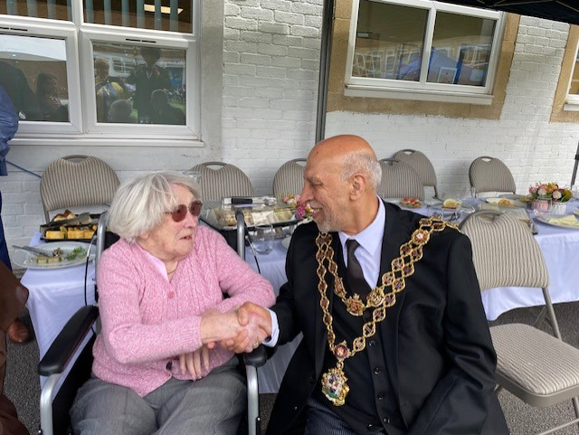
On Thursday 21st May I had the privilege and pleasure to join Blakenhale Oasis School as they celebrated their 75th anniversary. The whole school sat outside eating their picnic lunch and the sun shone down on us. Along with Doreen Cheshire, one of our first church members I was invited as a VIP guest. Doreen was invited because she started her teaching career at Blakenhale in the 1960s, starting as a classroom assistant, attending night school and eventually qualifying as a teacher. I was invited as a representative of the local church; we have a good longstanding working relationship with the school; I spend time with year 3 and 4 classes every other week delivering Godly Play sessions, our Open the Book team delivers monthly infant assemblies and of course Y2 children have enjoyed Journey to the Stable for many years.
My family came to live in Garretts Green Lane in 1961and I joined Blakenhale for just one year (top juniors) and that’s where I met my long-time friend Linda. I know many of you will have happy memories of school days at Blakenhale and I hope this might initiate some memory sharing among you.
Doreen and I mingled with staff and children who were all seated outside enjoying a picnic lunch prepared by the school catering team, the children were so pleasant courteous and polite showing respect for Doreen and helping to look after her. Together with other guests, including the Lord Mayor and Lady Mayoress and the son of Mr Hardingham the first headmaster, we had lunch whilst enjoying the children’s song and dance performances. Each year group highlighted music through the decades from the 1950s to the present day; from Splish Splash by Bobby Darin, the Twist, Thriller, the Macarena, Casper Slide and many more. Even Doreen couldn’t stop her feet tapping, hand jive and applause. It all kicked off with the cheer leaders and acrobats and when we left the whole school, including teachers were all dancing together.
What a splendid day with such a wonderful happy atmosphere. Well done and thank you to all the staff and children for your hard work and cheerful engagement.
Revd Susan Larkin

Christian Outreach

Worship, prayer, teaching and Christian fellowship doesn’t just happen in church on Sunday mornings, the church is active out in the community throughout the week.

- Stay and Play group for babies and toddlers on Monday

- Children’s club with fun and games, crafts, cooking, activities, challenges and bible stories on Mondays from 4.00 till 5.30 and youth club 5.45 till 7.15

- Young Adults discipleship group – Monday evenings from 7.30 till 8.30

- A church service Heartlands Care home happens twice monthly

- Pastoral visits at West Hall Court every other Thursday morning and at Heartlands Care Home on Friday afternoons.

- Godly Play at Oasis Blakenhale Juniors on alternate Tuesdays – Christian teaching with classes from years 3 and 4

- The Open the Book team make monthly visits to the school assembly at Oasis Blakenhale Infants School.

- Activities for those over 50 on Thursday and Friday

Foodbank Update
The foodbank is open on Wednesday mornings from 10.00 till 11.00 p.m. and we have a wonderful team of volunteers from the church and community. We are very busy serving on average 25 people a week with food to feed around 60 people. With high demand all donations are very welcome; if you can provide occasional tins of beans, spaghetti, soup, vegetables etc please leave them in the collection tray at the back of the church or in the hall entrance. We now also provide fresh fruit and vegetables and there are usually some left after our Foodbank session so please help yourselves rather than letting them go waste. A small donation is welcome.
If you have any spare shopping bags, we will be very grateful for them and we are happy to re-use plastic carrier bags you may have. Please leave them in the donation boxes.
Thank you to everyone.


An afternoon of tea and a buffet will be held to raise money for Breast Cancer research.
Admission will be £5 to include hot drinks and food from the buffet. There will also be a raffle!
There will be opportunity to buy any cakes to take home. Please let Carol Malone or Sue Round know if you intend to come.
Tickets will be available in advance on Thursdays afternoons / Sunday mornings or you can pay on the door.
Friday 10th July 2pm-4pm at St Thomas Church

Website update
Our website is being updated to reflect everything that happens in church on Sundays, including other acts of worship and study groups, as well as what happens during the week, all in the name of St Thomas. Please have a look if you are able. If you have any comments, observations of additional thoughts, please contact Rev Sue. In future all our newsletters will also be available on the website so don’t worry if you lose it. If you would like your own copy emailed to you, again, please contact Rev Sue.

Our web address is www.st-toms.com

Rochelle Dance Academy
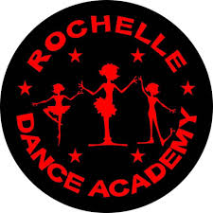
Rochelle Dance Academy are competing in a dance festival over 3 Sundays against lots of other dance schools and are working hard and are very excited!

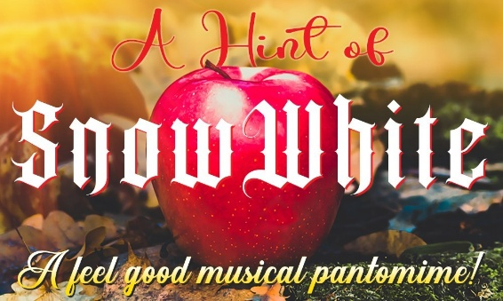
MASQUERADE MUSICAL THEATRE present “A Hint of Snow White” at the Midlands Arts Centre Sunday 21st June 2.30pm in celebration of their 20th anniversary! Masquerade meets every Wednesday night during the school term at St Thomas Church. Tickets are £20 and available from the MAC box office www.macbirmingham.co.uk or 0121 446 3232.
For more information about Masquerade their website is: www.masquerademusicaltheatre.com

Prayer Requests and Prayer Pointers

Prayer means putting ourselves into a communicating relationship with the divine God. Prayer is often used to build a relationship with God, offering thanksgiving, asking for help, and seeking forgiveness. It is described as a means to express gratitude and find comfort and strength. It is a gift for our own sense of identity as children of God, and for our own sense of purpose. It is often helpful to end or begin our prayer time with the prayer Jesus taught us:
Our Father in heaven,
hallowed be your name,
your kingdom come,
your will be done,
on earth as in heaven.
Give us today our daily bread.
Forgive us our sins
as we forgive those who sin against us.
Lead us not into temptation
but deliver us from evil.
For the kingdom, the power, and the glory are yours
now and for ever.
Amen.
In your prayers this month please consider including these pointers:
- Pray for all those who are currently unwell, receiving treatment, recovering from illness or surgery and those in residential care. Please include Ray receiving treatment for an eye condition, for Margaret recovering from hip surgery and Ann Barnes in Heartland’s Care Home, Joyce Greaves, Lijino from Church of South India recovering from emergency open heart surgery, for Tom one of the Oasis holiday club play workers who collapsed playing football.
- For Amber, a young teenager facing surgery and gruelling treatment for cancer.
- For Caroline, David and Pauline
- For those who work in nursing and caring roles in hospitals, residential homes and at home. For social workers and those who work in prisons.
- For those who are recently bereaved, continuing to remember the Twelftree family.
- For those with families affected by the troubles in the Middle East.
- For world leaders striving to negotiate peace.
- For our congregation to continue to grow in faith and numbers.
- For our work in local care homes and at Oasis Blakenhale School.
- For those preparing to be confirmed in September, especially those from our own fellowship.
- For the family of Ivy Cheshire as they mourn her passing. Ivy was much-loved and longstanding member of St Richard’s church.
- For yourself, and your own family and friends.



Sunday 7th June at 10.00

Volunteers’ Week is an annual UK-wide campaign held from the first Monday in June to celebrate and recognise the contributions of volunteers. Volunteering is a vital component of everything that happens at St Thomas both in the church and in the activities that take place here mid-week as well as in the wider community. We wouldn’t achieve as much as we do without the generosity of our volunteers giving of their precious time and skill.
Whatever your involvement you’re welcome to join us for worship to give thanks for all those who give their time and talents freely or be thanked for your contribution.

Why no balloons?



The humble balloon has a surprisingly rich history, beginning not as a toy but as a tool for scientific experiments. From early models made of animal bladders to the first rubber balloon invented by Michael Faraday.
From the invention of latex to the introduction of helium, and the development of foil balloons this simple object became the ultimate symbol of celebration and promotion. We will all remember balloons at our own children’s birthday parties, to announce the arrival of a new baby or to celebrate an anniversary. And we’ve been entertained by clowns and magicians who twist and tie balloons into various shapes without them popping. The role of balloons has expanded far beyond simple, colourful bunches tied with a string. Today, they are used to create sophisticated and impressive decorations, to symbolise farewell to a loved one, to announce the opening of a new business or to promote a charity fundraiser.
The simple colourful balloon has been a symbol of happiness BUT they have a darker side. They are single use plastic made from non-biodegradable materials like latex or plastic and can take years to decompose, breaking down into microplastics that contaminate soil and waterways. Marine animals, in particular, mistake balloon fragments for food, leading to ingestion, choking, or entanglement, which can be fatal. While balloons may seem harmless, their environmental consequences highlight the need for sustainable alternatives and responsible disposal practices to mitigate their harmful effects on the planet.
Yet they do not seem to have been earmarked in the same way as, for example, plastic straws and cotton buds. The church council have taken the decision not to allow the use of balloons at St. Thomas, and this has been written into our new rental agreement. We’re not party poopers; we appreciate our planet with all its beauty and diversity of wildlife. So, get creative and consider a range of balloon alternatives …. bubbles, colourful streamers, flags and banners, which also have the added advantage of being reusable.

Deanery Synod (Coleshill and Polesworth)

Wednesday 10th June 2026, 7:30pm

An environmental focus with speaker Caroline Egan

The next synod meeting is here at St Thomas’ church. It’s for clergy and Deanery Lay Reps and as this will be an open meeting all church members across the deanery are invited.

Church Wardens Admissions

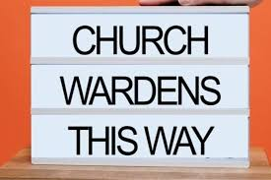
Church wardens are elected by the church congregation at the Annual Parochial Church Meeting and have key responsibilities with regard to the fabric of the building, maintenance, collections and record keeping and they play an important role in supporting the clergy; for example, ensuring the building is open and prepared for worship and people are welcomed.
Our church wardens Mark Dixon and Carol Malone will be admitted to this position by the Archdeacon at a special service on Thursday 11th June at Colehill Parish Church. Please come along to support them; lifts can be arranged.

You are invited to attend a screening of
The People's Eco-Emergency Briefing

Showing at St Thomas Church
Wednesday 10th July Doors open 5.30pm (6pm start)
Light refreshments are provided after the film.
Admission is free! Bring a friend..


An eye-opening film featuring nine leading UK scientists and experts updating us on the latest in the climate and nature crisis and its impacts on everyday national life.

Including: extreme weather, food security, health, cost of living. We’ve all felt the effect of global warming this week with the hottest day in May on record!

Based on the National Emergency Briefing in Westminster, as covered by ITV, C4, and the Times.

Followed by a short open discussion about what we can do and what it means locally.

Featuring Chris Packham, Deborah Meaden, surprise guests, and a wide range of Brits.

This event is open to the whole deanery, our ecumenical parters and the local community including elected officials. St Thomas Church needs your support in this. Please come and see how you can make a difference and understand what is being done nationally.

If you want to know more about this event or to confirm your attendance, please speak to Linda Nugent (Parish Environmental Champion) or Rev Sue Round.

Hosting this event is a big step forward towards our silver eco-church award.


I expect you will have seen in the media that the naturalist Sir David Attenborough reached the grand old age of 100 on the 8th May.
He has been popular as presenter/narrator of numerous TV series about the natural world for over 70 years since 1954 and is still going strong. His first series was Zoo Quest, a program showing him on safari with staff from London Zoo, capturing animals from the wild for the zoo’s collection, a practice that was common then but is frowned upon today.
As time has gone on, Sir David’s TV series’ have gradually shifted to acknowledge that the natural world is struggling under the strain of man’s population surge and the consequent increase in demand for food and consumer goods, which have encroached on the world’s natural resources, pushing wild animals and plants to the point of extinction.
In his 100 years Sir David has seen many major changes:
- The global human population has increased from 2 billion people to 8.3 billion, almost a four-fold increase.
- At least 500 vertebrates have become extinct (some of these are considered extinct in the wild others are declared extinct), including the Tasmanian Tiger, the Northern White Rhino, the Pinta Giant Tortoise (remember Lonesome George?), Darwin’s Galapagos Mouse, the Bali Tiger, the Javan Tiger, the Pyrenean Ibex, the Golden Toad.
- In the last 100 years the world has lost as many trees as in the last 9000 years combined – an area larger than the entire South American continent.
- Depletion of the ozone layer caused by the release of CFC’s and bromine used in industrial solvents and aerosols.
- Severe air pollution caused by burning fossil fuels, agricultural pesticides, global warming and acid rain.
- Severe pollution of the sea, by plastics contamination, land-based runoff of chemicals and untreated sewage.
- Stocks of some fish heavily depleted due to overfishing.
These can make depressing reading but, on the plus side:
- Many zoos now do valuable work in conservation.
- Conservation efforts are being made to protect endangered species in the wild.
- Deforestation has slowed in the last 10 years.
- The ozone layer has begun to recover since an agreement to ban the substances causing the problem about 40 years ago.
- There is international co-operation on climate change – COP31 (Conference of Parties) will take place in Turkey in November this year and brings together 197 countries, plus the EU to negotiate international climate commitments.
Sir David believes that we need to see a reduction in the human population. Although not everyone agrees with this view, a reduction in numbers should lead to a lowering of demand. Meanwhile, there needs to be a change in attitude to consumerism – recycling, re-using, upcycling, mending and making do, buying things that last, eating more locally produced food and less meat, reducing energy consumption. We have looked at these and more over some time now and all of them would help to lower our carbon footprint.
Sir David still absolutely believes we can ‘turn the ship’. As Christians who believe that God gave us the responsibility to look after His Creation, we should set the example and lead the way as much as we can.
Linda Nugent (Parish Environmental Champion)

Our little courtyard garden is starting to look quite summery and flourishing well thanks to the help from our willing volunteers under the guidance of Sam Ellgood our 50+ leader and a generous donation of bedding plants. Come and have a look and enjoy a cuppa out there.

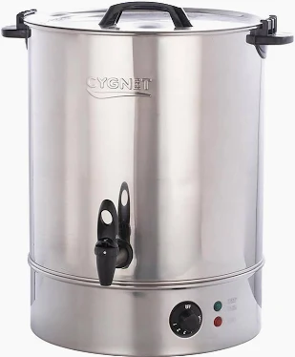
NEW HOMES WANTED

We currently have three water urns similar to the picture, looking for new homes. If anybody would like to adopt one, please speak to Susan or Sue.

There are also eight wooden chairs in need of a new home!

For a quiet moment

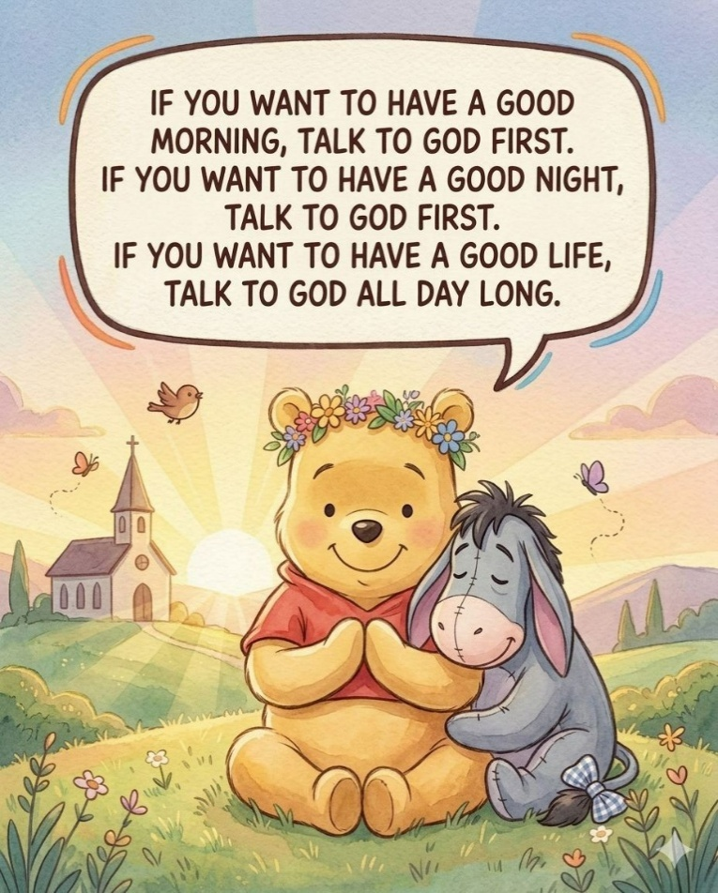
The older I get, said Pooh Bear, the more I realize that talking to God isn’t something reserved only for difficult days.
It’s not just for emergencies.
Not just for heartbreak.
Not just for the nights when life feels too heavy to carry alone.
Sometimes the most beautiful prayers are the quiet little conversations that happen throughout ordinary days.
A whispered:
“Thank You.”
“Help me today.”
“Please give me peace.”
“Protect the people I love.”
Because life moves fast.
Every day pulls us in a hundred different directions.
Responsibilities pile up.
Stress grows quietly.
And sometimes we don’t even realize how tired our hearts have become.
That’s why moments with God matter so much.
Not because He needs constant reminders that we exist…
but because we need constant reminders that we are not alone.
There’s peace in starting the morning with prayer before the noise of the world gets too loud.
Before the bad news.
Before the pressure.
Before the worries try to take over your thoughts.
And there’s comfort in ending the night the same way.
Laying your burdens down.
Releasing the fear you carried all day.
Trusting that while you sleep, God is still working on things you cannot yet see.
Honestly?
Some of the strongest people you know are the ones who quietly keep praying even when life doesn’t make sense.
Even when answers are delayed.
Even when the waiting hurts.
Even when they feel tired emotionally, mentally, and spiritually.
Because faith isn’t pretending life is easy.
Faith is believing God is still good even during the hard seasons.
And maybe that’s what prayer really does.
It softens the heart.
It calms the mind.
It reminds us that peace doesn’t come from controlling everything…
it comes from trusting the One who already sees tomorrow.
The older I get, the more I understand why people who stay close to God often carry a different kind of peace.
Not a perfect life.
Just a peaceful spirit.
They still face struggles.
They still cry sometimes.
They still have unanswered questions.
But deep down, they know they don’t walk through any season alone.
So yes…
If you want a peaceful morning, talk to God first.
If you want rest at night, talk to God first.
And if you want a life filled with strength, grace, wisdom, and peace…
keep talking to Him through every ordinary moment in between.

Bible One-Liners
Q: Who was the smartest man in the Bible?
A: Abraham—he knew a Lot!
Q: Why couldn't they play cards on the Ark?
A: Because Noah was always standing on the deck.
The Flood
A very religious man was caught in rising floodwaters and climbed onto his roof. A rescue boat came by and told him to get in, but the man said, "No, the Lord will save me!" Later, a helicopter dropped a ladder, but he refused it again. [1]
When the man eventually passed away and arrived at the Pearly Gates, he asked God, "I prayed so hard! Why didn't you rescue me?"
God looked at him and said, "What are you talking about? I sent you two boats and a helicopter!"

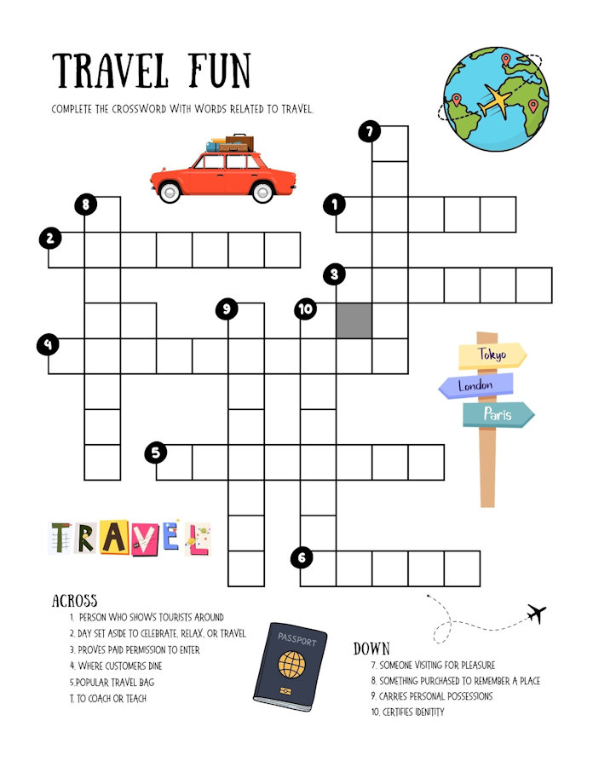

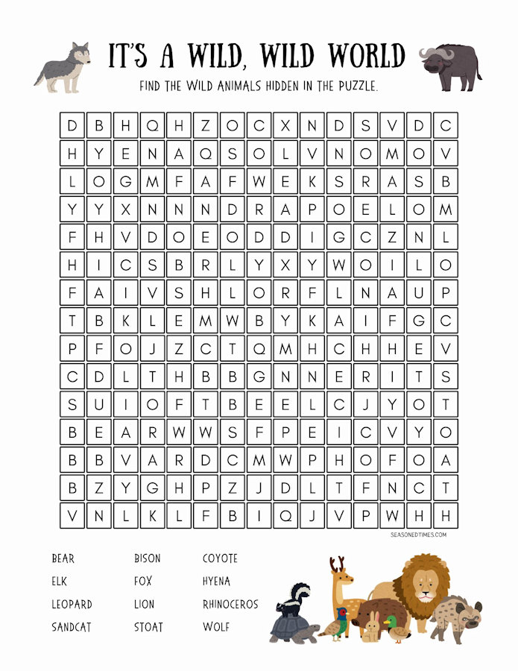

Items and articles for this newsletter are always welcome.

For the July Newsletter please send your articles and items of interest to
Revd Sue Round
Sue.Round@st-toms.com

