Palm 8
Please stand, if able, and join in with the verses in bold italics

O Lord, our Sovereign, how majestic is your
name in all the earth!
You have set your glory above the heavens.
Out of the mouths of babes and infants
you have founded a bulwark because of your foes,
to silence the enemy and the avenger.

When I look at your heavens, the work of your fingers,
the moon and the stars that you have established;

what are human beings that you are mindful of them,
mortals that you care for them?

Yet you have made them a little lower than God,
and crowned them with glory and honour.
You have given them dominion over the works of your hands;
you have put all things under their feet,
all sheep and oxen,
and also the beasts of the field,
the birds of the air, and the fish of the sea,
whatever passes along the paths of the seas.
Rev’d Ailsa will be on her Curates Placement at Melbourne Church for May, June and July, but popping back for Building Faith and weddings. Please hold her in your prayers at this exciting time.
O Lord, our Sovereign,
how majestic is your name in all the earth!

Glory be to the Father and to the Son and to the Holy Spirit,
as it was in the beginning, is now and ever shall be,
world without end. Amen

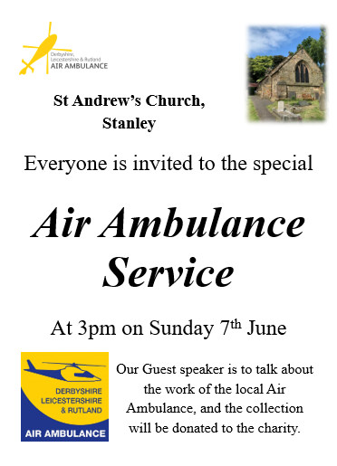
Mothers’ Union 150th Anniversary Tea Party – 1st July
Tickets are now available at £10 per person from Janet and Jane. Our branch is hosting the ‘Bring & Buy’ stall, donations to go on the stall welcomed.

In our weekly prayers for our parish
This week we pray for God’s blessing on Tudor Place, Valley Road and Valley View.
Distribution of Communion –currently the Priest will dip the communion wafer in the wine while we discern a safe way to bring the common cup back into worship, as we want everyone to feel included and safe. We also have gluten free wafers available.
Refreshments After the Morning Service
Please stay seated after the service and a hot drink will be brought to you in the pews. Do not get up and head to the back of church, it is becoming a hazard, and a risk as trays of hot drinks could be knocked over.

All Saints Church
“You are the light of the world. A city set on a hill cannot be hidden” Matthew 5:14
Church contact information
Contact: Rev’d Christine - revchristine@outlook.com
The Rectory, The Village, West Hallam, DE7 6GR
Landline 0115 646 1497
Rev’d Ailsa -revailsahunt@gmail.com
Tel - 07356064856

Churchwardens – Mrs Janet Wheeldon, -Tel: 0115 8771593
Mrs Linda Gregory – linda.gregory3@icloud.com
https://www.achurchnearyou.com/church/13402/
https://www.facebook.com/allsaintskirkhallam
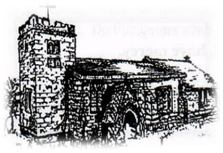
Kirk Hallam
Disabled Toilet in Friendship House.
Disabled Toilet in Friendship House.

Working with God to transform lives & communities.
Please can you ensure your mobile is on silence, or off during the service, it is affecting people with hearing aids and the loop system.

31st May – Trinity Sunday
10.00am Iona Communion Service with Rev’d Jan & Julie
6.00pm Iona Evening Prayer with Rev’d Christine

Forthcoming Events
Mon 1st 7.00pm Wedding rehearsal in church
Tues 2nd 6.30pm Home Group in Friendship House
Weds 3rd 9.30am Morning Prayer at UCAS
Thurs 4th 10.30am Funeral for Marion Hunter & burial at
Park Cemetery
Thurs 4th 7.00pm PCC meeting in church
Fri 5th 6.00pm Choir in Friendship House
Sat 6th 10.00am Prayer Meeting in Friendship House
Sat 6th 4.00pm Wedding of Paul Driver & Wendy Riley
Thurs 11th 11.00am Funeral for Angela Webster & burial at
Park Cemetery

7th June – First Sunday After Trinity
10.00am CW Communion Service with Rev’d Alan
1.00pm Baptism of Carter James Bailey
3.00pm At St Andrews – service for Air Ambulance
6.00pm BCP Evening Prayer with Julie
It’s Good to Talk! If you spot that someone is missing, please pop a news sheet through their door, & if you’ve time, call for a chat - just to check they’re OK & to let them know that they are not forgotten!

