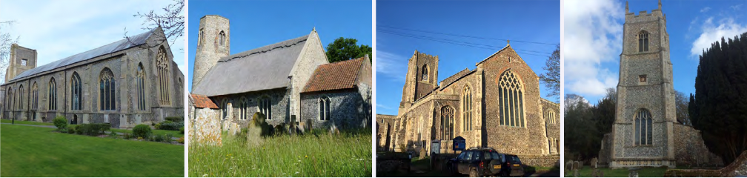
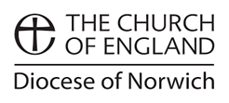
N.E.W.
North Walsham
Edingthorpe
Worstead and Westwick
NEWS
The Magazine for the North Walsham Benefice June 2026 40p
Transformed by Christ: Prayerful, Pastoral, Prophetic

Editor’s Bit

Contents in this issue:
- Vicar’s Page
- From the assistant curate
- Dates from the Diary
- May 2026 service Dates
- Upcoming Events

We hope to see you at our services; you are all welcome.

Please note the date for items to go in the July and August edition of NEWS needs to be at the Parish office by 20th June 2026 latest.

This magazine is published by the North Walsham Benefice. We reserve the right to edit or decline any material submitted for publication. While reasonable efforts are made to ensure that the contents of the magazine are accurate, no responsibility can be taken for errors and omissions or changes after publication. The material printed does not necessarily represent the views of the Benefice. In accepting advertisements for publication, no recommendation of products or services is implied and we cannot accept responsibility for any unsatisfactory transactions.

Financial Information

Please may we remind you, that if you are giving us a cheque for any of the Churches, they need to be made payable to the following:
St Nicholas’ Church – North Walsham PCC
All Saints’ – Edingthorpe PCC
St Mary’s – Worstead PCC
St Botolph’s – Diocesan Churches Trust
Please may we ask if you are sending any payments to us via an online service that you put a meaningful reference on the payment to ensure we know where the payment should go to.

Live-streamed services are available on YouTube - please search St Nicholas North Walsham. Do you participate in our live-streamed services - we would love to hear your feedback: contact David on 07506 723946 or davidnorthwalsham@gmail.com

If you are considering a change to your Committed Giving for St. Nicholas, please inform Chris Sherman (Committed Giving Officer)
Please support St. Nicholas Church, North Walsham on #easyfundraising, you can raise FREE donations when you shop online with over 5,000 retailers. It is simple and only takes 2 minutes to sign up! Plus, once you have raised your first £15, easy fundraising will match it!
Sign up now: https://www.easyfundraising.org.uk/causes/stnicholaschurchnw/

The Vicar’s page:
After a year with us, at the end of this month Dan will be ordained priest. He has been a blessing to us these past 12 months, and his kindness, energy and faithfulness have become a splendid part of our Benefice furniture - he has coped with everything that ministry has thrown at him this year, not least the accident and subsequent recovery at Christmas.
Dan has been amongst us as a Deacon, as the servant at the table, and as a priest will be one charged with being a steward of the mysteries of God. He will be the host at the meal, inviting God's people to share as Jesus commanded - he will be the host, but it is not his table, or mine, or anyone else's, but God's. Dan's commitment, and our commitment, to the inclusion of all people in God's eternal love, is lived out in the invitation to all to feast with the Lord and all his saints.
Through the laying on of hands and prayer, Dan becomes a priest - this has been God's plan for his life from the beginning, and long before he knew it - God has called, Dan has sought to follow, and God will be faithful to him, as he is to all who follow in faith.
Please join me in prayer for Dan and all preparing for ordination at this time, and do join us in person to celebrate with Dan, and for Dan - every act of Christian worship is a celebration, because here God comes to us, as he promised he always will, when we ask him in faith.
God our Father, Lord of all the world, through your Son you have called us into the fellowship of your universal Church: hear our prayer for your faithful people that in their vocation and ministry each may be an instrument of your love, and give to your servants to be ordained the needful gifts of grace; through our Lord and Saviour Jesus Christ, who is alive and reigns with you, in the unity of the Holy Spirit, one God, now and for ever. Amen.

David



The Curate’s Page
There is just one month left until my Ordination to the Sacred Priesthood, so I thought it would be good to reflect on the past year and all the amazing things I was involved in!
As I mentioned in my previous magazine article, the highlight of my time in North Walsham has to be Holy Week and the Paschal Triduum.
The emotions present in my heart on each day of the Triduum, the honour to sing for the first time in my life the Exultet and to rejoice with you all in saying a joyful ‘Alleluia’ are things that will forever stay in my mind.
It has been a privilege to be with people on their final journey during many Funerals, and to support those in mourning, as well as a great joy to welcome people into the Loving embrace of God in Baptism.
Conversations with various people during each Thursday Coffee Morning, as well as our Holy Communion, are things that I look forward to each week; these are the moments when I feel closer to God in the Sacrament, but also where I can see and experience first-hand our great community here in North Walsham!
Children’s Day was great fun, Worstead Festival was something magnificent and unforgettable, and, most importantly, your prayers and support during my time of recovery from my accident were beyond imaginable!
It’s been a long year, and yet in so many ways it’s been the shortest year of my life. There is still plenty to do and learn, and I really look forward to continuing on this journey with you all.
All I ask of you now is your prayers as the ordination approaches, and your supporting presence, especially at my First Mass at St Nick’s on the 28th June at 3pm.
Blessings and thanks,

Dan

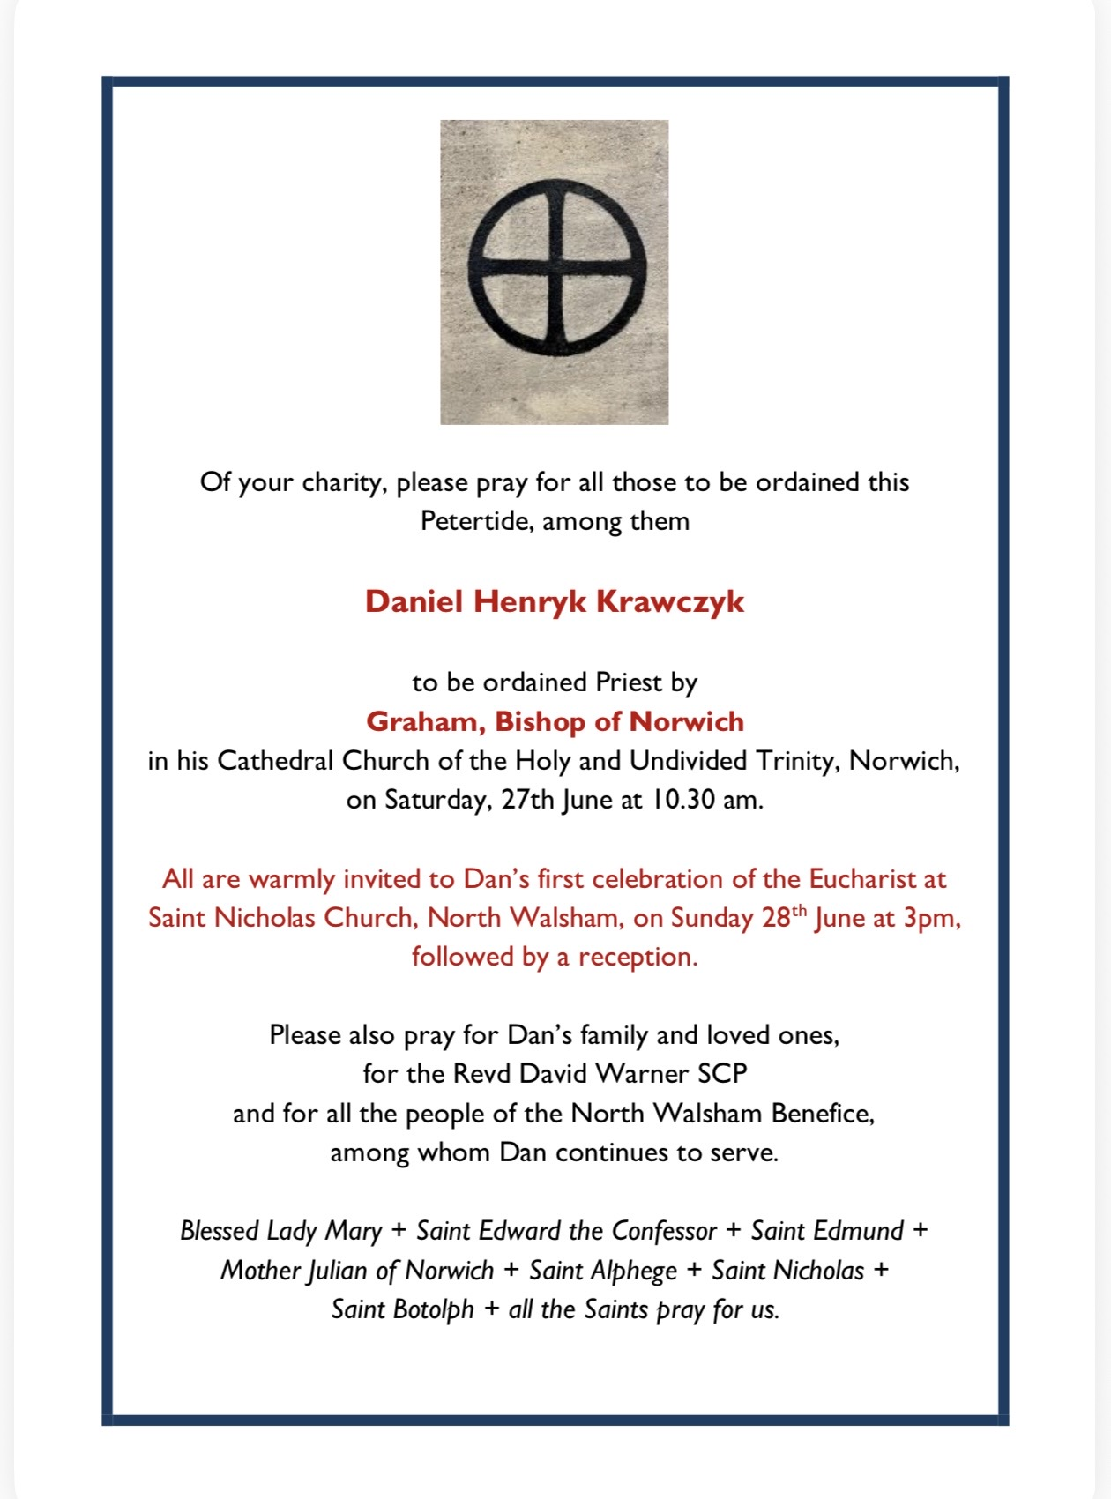

Edingthorpe Village news for May
All Saints Church, Edingthorpe

Services
14th June. Holy Communion 9.15am.
28th June. No Service at Edingthorpe
28th June North Walsham, Dan’s first service as Priest at 3 pm

On 28th June there is no service at All Saints.
There will be a service at 3pm at St Nicholas, North Walsham to celebrate the priestly ordination of Revd. Dan Krawczyk SCP with Holy Communion followed by reception.

All Saints is a SILVER EcoChurch award winner.
All Saints has been shortlisted with 3 other churches for the Norfolk Churches Trust/NWT 2026 Conservation Award. Thanks to David and Gillian for all they do towards Conservation.
18th July at 5.30pm is our Summer Concert with Jane Everard and Joseph Ballard who will be singing songs from the shows and also inviting some audience participation. Tickets are £12.50. with Buffet available from June Hannant 01692 402337 or Chris Martin 07787561850 – wardenallsaints@gmail.com .
19th July at the Church from10.30am to 3pm David and Gillian are organizing a Bug Hunt. Among the several activities are the releasing of night-flying moths , making a bug house and painting a ladybird pebble. Do come along with your family to participate in what will be a very enjoyable day.
Looking ahead there will be a Blessing of the graves on 2nd August at 4pm and a Pet Service on 6th September at 4pm .
Other dates to follow in the next issue of the Village News.
Once again we must thank Chris, Karen and their helpers for holding the Coffee Morning on the 2nd Thursday of each month at St.Benets Hall.
All events and information about the Church are available on the website
www.achurchnearyou.com/church/10076/ or the village website: www.edingthorpe.village.org.uk

June Hannant 01692 402337
ST MARY’S, WORSTEAD - June 2026
SAINT MARY’S
Without doubt, the coolest place on a hot Summer’s day is St Mary’s Church. Why? Because the walls are three feet thick! It’s a different story in the middle of Winter, but, let’s not go there.
The Wedding season is with us again. Two so far this year, with sunshine, beautiful flowers, Brides who looked as if they had just stepped down from the front cover of “Vogue “ magazine and large congregations, all dressed in their finest.
Sadly, we also had a funeral. A very large turnout for local resident, Robert Wilkinson, and a service to remember, for its pride and dignity.
We were also fortunate to host a Baptism. The granddaughter of our very own Jenni Gubbins. The sun shone, the family assembled around the Font and it all went perfectly. To witness such a service is both a joy and a pleasure for us all.
This month (Saturday, June 27th) sees the Ordination of our hard-working Curate, Dan, at Norwich Cathedral. This will be celebrated on Sunday (28th June at 3.00 pm) with a Service at St Nicholas in North Walsham, to which everyone is welcome.
Looking ahead, we have another wedding scheduled for July 11th. Let’s hope the sun comes out for the happy couple’s special day.
Then, of course, we’ll have the much-anticipated Worstead Festival at the end of July (25th and 26th). Our Church Flower Festival will reflect the 60th Anniversary of the Festival. Worstead Weavers and The Clothing and Textile Association will, once again, be displaying their wares and talents. You can, as ever, try your luck on the Tombola Stall. When you’ve done all of that, and more no doubt, we’ll have the usual array of mouthwatering refreshments to keep you going.
Dates for your Diaries:
7th June – Morning Prayer at 9.15 am
21st June – Holy Communion at 9.15 am
28th June – North Walsham, Dan’s first service as Priest at 3 pm
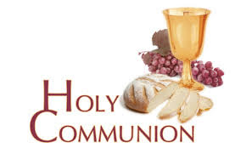
You may have read items in the press relating to the use of 'gluten free' wafers at Holy Communion - for those who require them, we use wafers which are approved and recommended for use by Coeliac UK - more information here. If you need a gluten free wafer, please advise the churchwardens/welcomers when you arrive for the service, and please indicate to the clergy distributing Holy Communion.
The Church teaches that receiving Holy Communion in both kinds (wafer and wine), or in one kind (the wafer or the wine) are acceptable and contain the fulness of the Sacrament. There are many reasons why this will be the case at different times in our lives, and there will be times when we cannot physically receive but join in an Act of Spiritual Communion (as those who watch online do - see below).

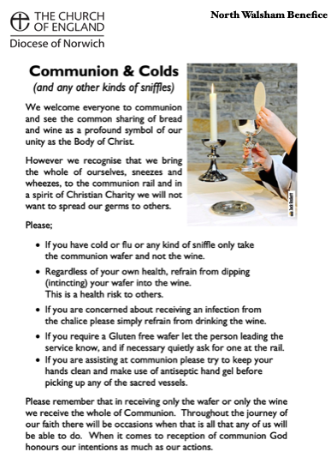
​Intinction (that is, dipping your wafer into the wine) is not permitted, both for hygiene reasons and because it might introduce gluten to the wine, which could be consumed by someone who is allergic to it.
If you wish to discuss any of this, please speak to David.

An Act of Spiritual Communion
In union, O Lord, with the faithful at every altar of your Church, where the Holy Eucharist is celebrated, I desire to offer you praise and thanksgiving. I present to you my soul and body with the earnest wish that I may always be united to you. And since I cannot now receive you sacramentally, I ask you to come spiritually into my heart.
I unite myself to you and embrace you with all the affections of my soul. Let nothing ever separate you from me. May I live and die in your love. Amen.



Why not come along to Sunday Kids and find out how to learn about what we do? We meet on the 1st and 3rd Sunday of the month at St Nicholas Church during the 10.30am service. You are most welcome.

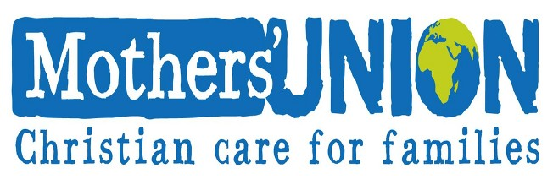

North Walsham Mothers’ Union. We meet in St Nicholas Room on the second Tuesday of the month at 2.00 p.m. Following a short act of worship and a few notices our speaker then takes the floor, after which, over tea and biscuits, there is an opportunity to ask questions and socialise. We usually finish about 3.30 pm.
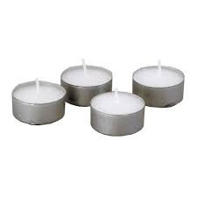
Thanks to all who’ve provided tealights for prayer stations at St Nicholas!
All donations of white, unscented tealights gratefully received!

Services for June 2026

Monday 1st June
9am Morning Prayer at North Walsham

Tuesday 2nd June
9am Morning Prayer at North Walsham
Wednesday 3rd June
9am Morning Prayer at North Walsham
Thursday 4th June – Corpus Christi
9am Morning Prayer at North Walsham
9.30am Market Day coffee morning in the St Nicholas Room
10.30am Holy Communion at North Walsham
7.00pm Holy Communion at Westwick

Friday 5th June
9am Morning Prayer at North Walsham
9.30 – 11.30 am Cuddles and Catch Up in the St Benet Hall
Sunday 7th June – Trinity 2
8am Holy Communion (1662) at North Walsham
9.15am Morning Prayer at Worstead
10.30am Holy Communion at North Walsham
5pm Choral Evensong at North Walsham

Monday 8th June
9am Morning Prayer at North Walsham
Tuesday 9th June
9am Morning Prayer at North Walsham
2pm Mothers’ Union at North Walsham
Wednesday 10th June
9am Morning Prayer at North Walsham
10am Knitting group in St Nicholas
Thursday 11th June
9am Morning Prayer at North Walsham
9.30am Market Day coffee morning in the St Nicholas Room
10.30am Holy Communion at North Walsham
Friday 12th June
9am Morning Prayer at North Walsham
9.30am Quiet Prayer at North Walsham
9.30 – 1130 am Cuddles and Catch Up in the St Benet Hall
Sunday 14th June – Trinity 3
8am Holy Communion (1662) at North Walsham
9.15am Holy Communion at Edingthorpe
10.30am Holy Communion at North Walsham
5pm Choral Evensong at North Walsham
Monday 15th June
9am Morning Prayer at North Walsham
Tuesday 16th June
9am Morning Prayer at North Walsham
Wednesday 17th June
9am Morning Prayer at North Walsham
Thursday 18th June
9am Morning Prayer at North Walsham
9.30am Market Day coffee morning in the St Nicholas Room
10.30am Holy Communion at North Walsham
7pm Holy Communion at Westwick

Friday 19th June
9am Morning Prayer at North Walsham
9.30am Quiet Prayer at North Walsham
9.30 – 1130 am Cuddles and Catch Up in the St Benet Hall
Sunday 21st June – Trinity 4
8am Holy Communion (1662) at North Walsham
9.15am Holy Communion at Worstead
10.30am Holy Communion at North Walsham
5pm Evening Prayer at North Walsham
Monday 22nd June
9am Morning Prayer at North Walsham
Tuesday 23rd June
9am Morning Prayer at North Walsham
Wednesday 24th June
9am Morning Prayer at North Walsham
10am Knitting group in St Nicholas
Thursday 25th June
9am Morning Prayer at North Walsham
9.30am Market Day coffee morning in the St Nicholas Room
10.30am Holy Communion at North Walsham
Friday 26th June
9am Morning Prayer at North Walsham
9.30am Quiet Prayer at North Walsham
9.30 – 1130 am Cuddles and Catch Up in the St Benet Hall

Sunday 28th June – Peter & Paul
8am Holy Communion (1662) at North Walsham
3pm Holy Communion at North Walsham
Monday 29th June
9am Morning Prayer at North Walsham

Tuesday 30th June
9am Morning Prayer at North Walsham
Wednesday 1st July
9am Morning Prayer at North Walsham
10am Knitting group in St Nicholas
Thursday 2nd July
9am Morning Prayer at North Walsham
9.30am Market Day coffee morning in the St Nicholas Room
10.30am Holy Communion at North Walsham

Friday 3rd July
9am Morning Prayer at North Walsham
9.30 – 11.30 am Cuddles and Catch Up in the St Benet Hall
Sunday 5th July – Trinity 6
8am Holy Communion (1662) at North Walsham
9.15am Morning Prayer at Worstead
10.30am Holy Communion at North Walsham
5pm Choral Evensong at North Walsham

Monday 6th July
9am Morning Prayer at North Walsham

Tuesday 7th July
9am Morning Prayer at North Walsham
Wednesday 8th July
9am Morning Prayer at North Walsham
10am Knitting group in St Nicholas
Thursday 9th July
9am Morning Prayer at North Walsham
9.30am Market Day coffee morning in the St Nicholas Room
10.30am Holy Communion at North Walsham
7.00pm Holy Communion at Westwick

Friday 10th July
9am Morning Prayer at North Walsham
9.30 – 11.30 am Cuddles and Catch Up in the St Benet Hall

Sunday 11th July – Trinity 7
8am Holy Communion (1662) at North Walsham
9.15am Holy Communion at Edingthorpe
10.30am Holy Communion at North Walsham
5pm Choral Evensong at North Walsham

Each week, the 10.30am service on Sundays, and 9am Morning Prayer Mon-Fri are live-streamed to YouTube - click link below or search 'St Nicholas North Walsham’
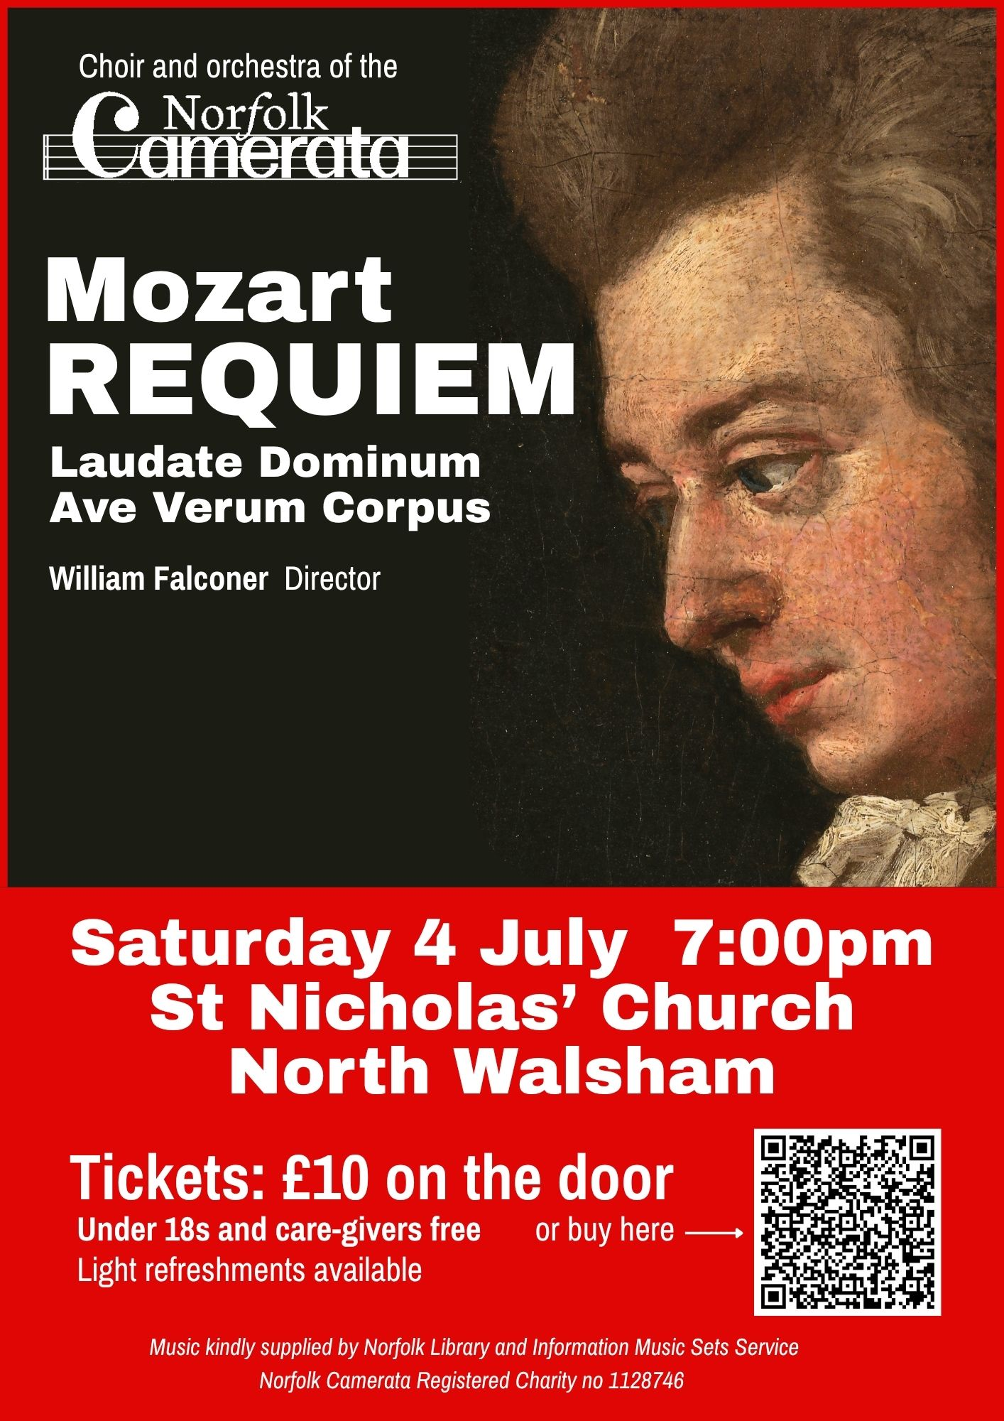

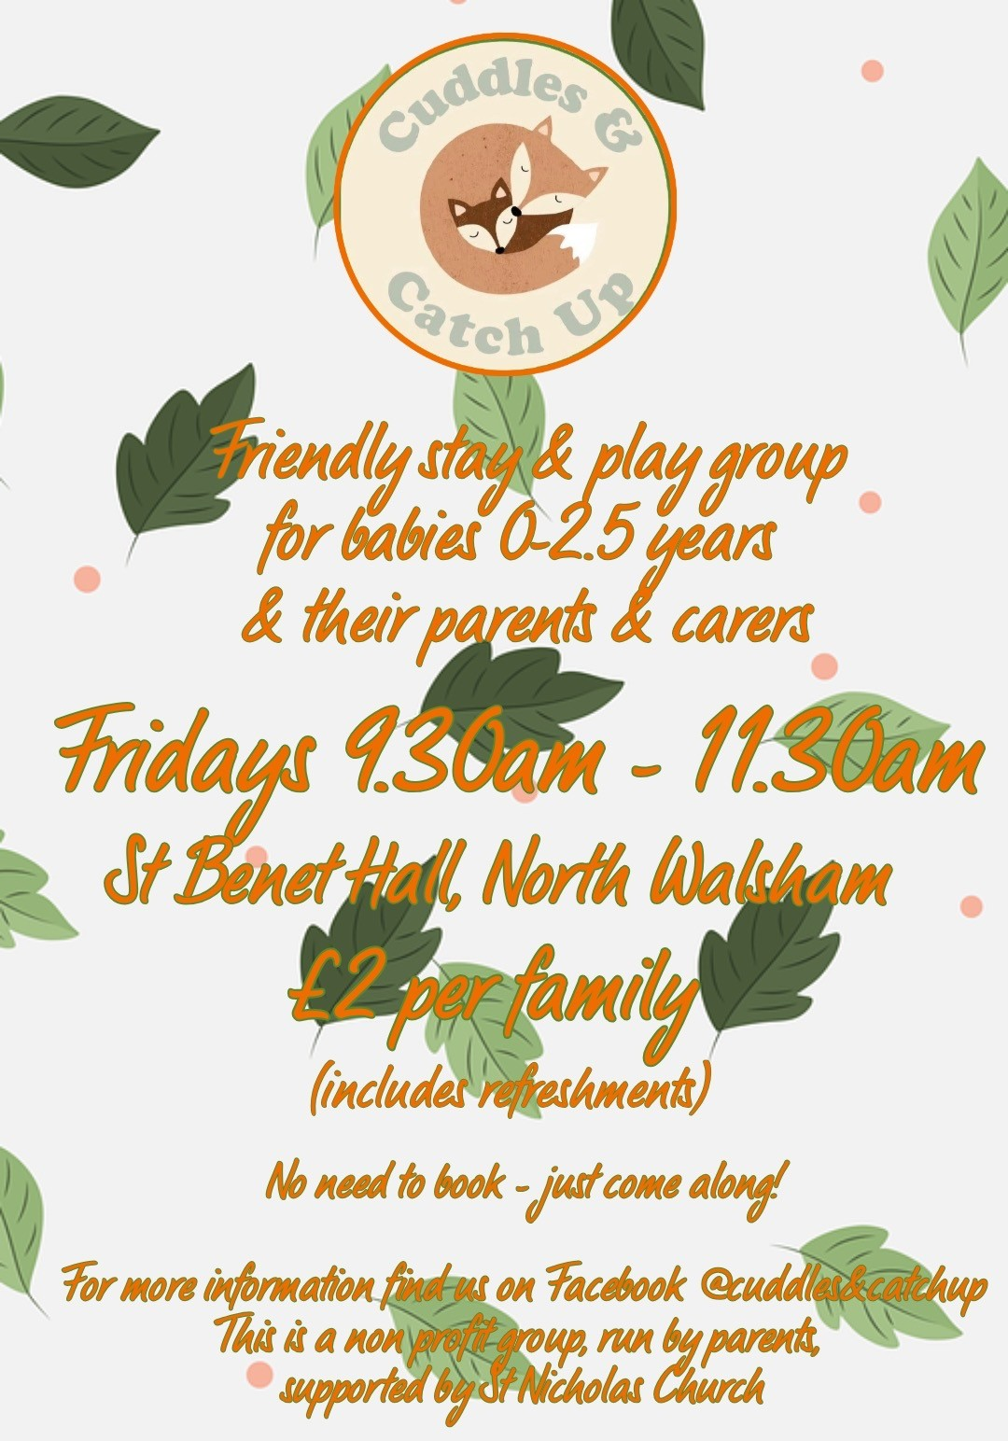
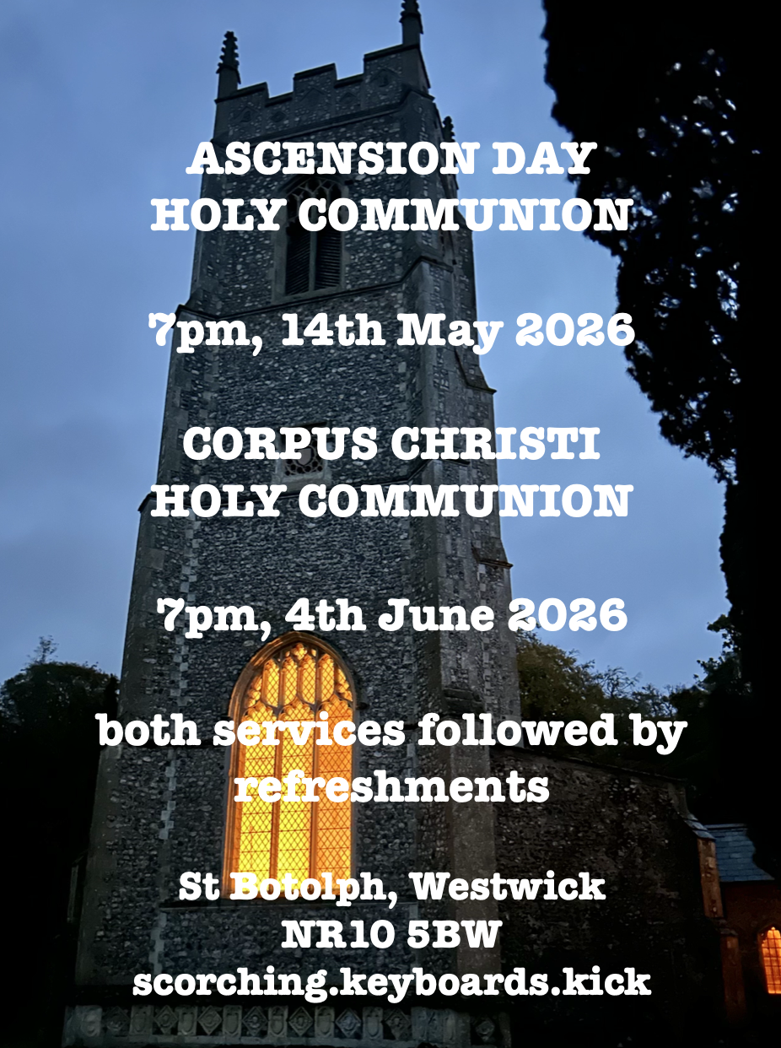

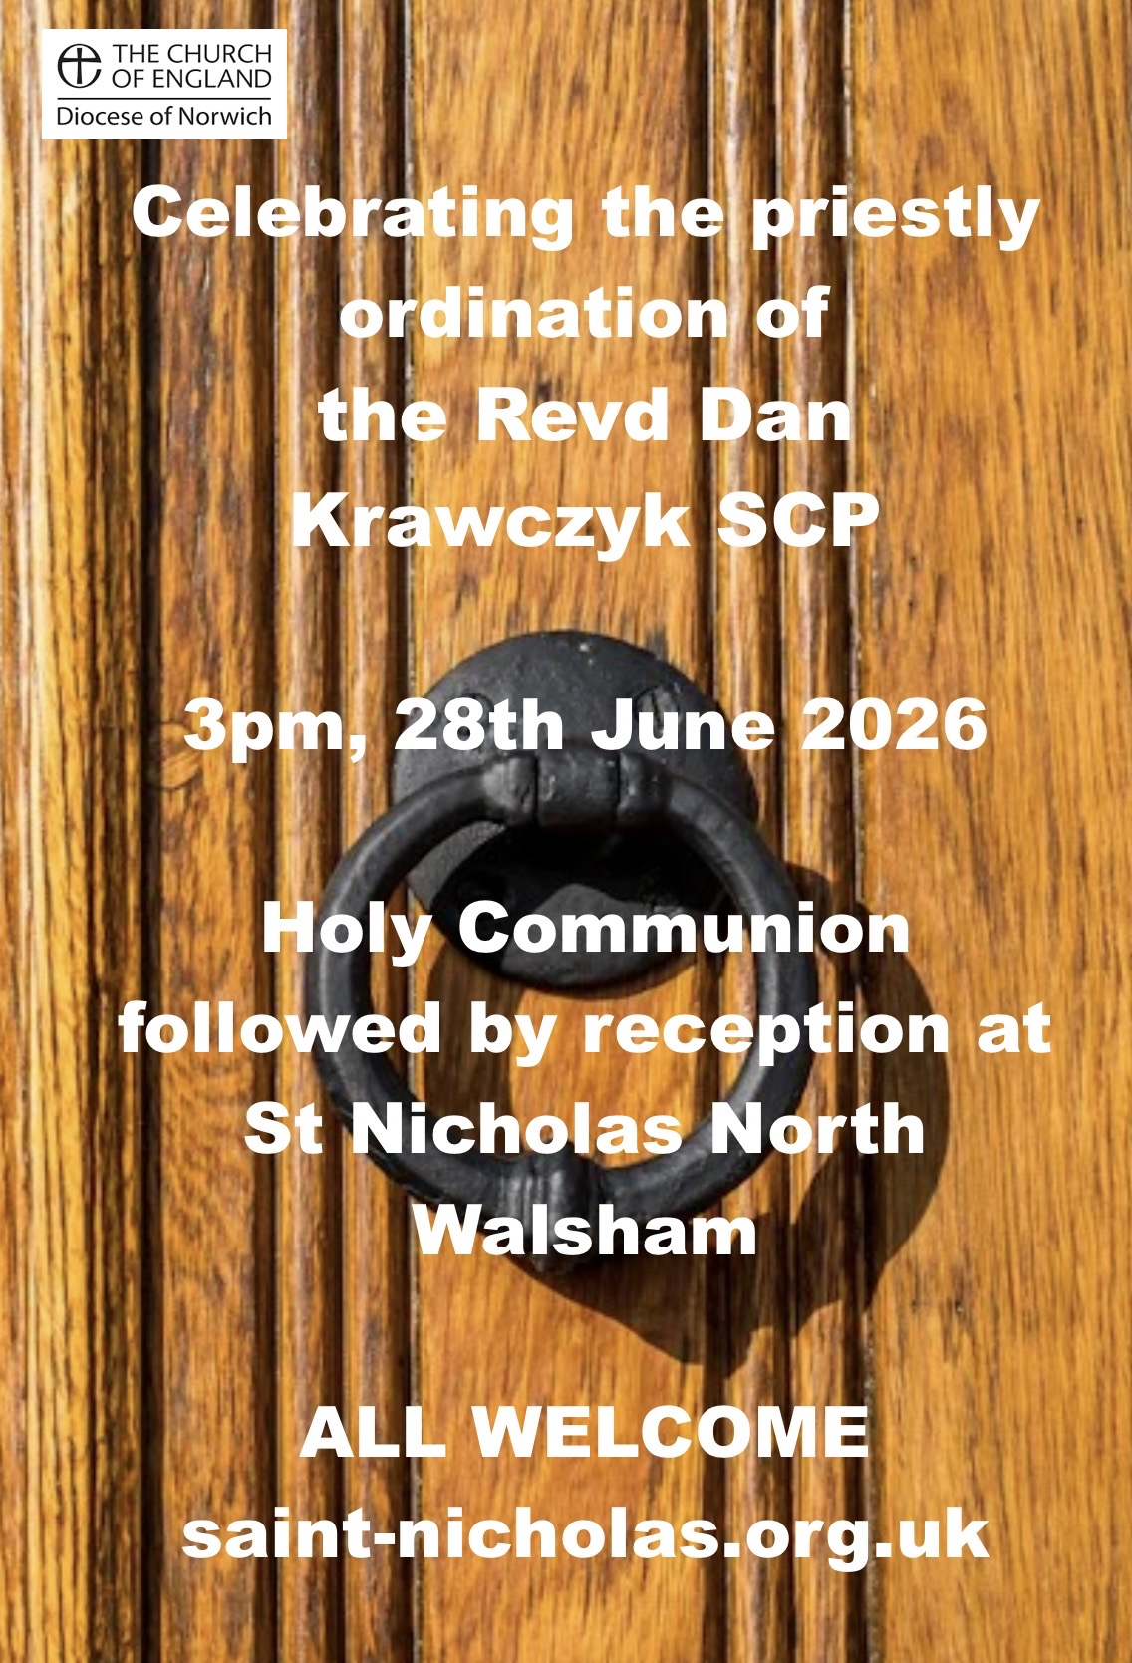
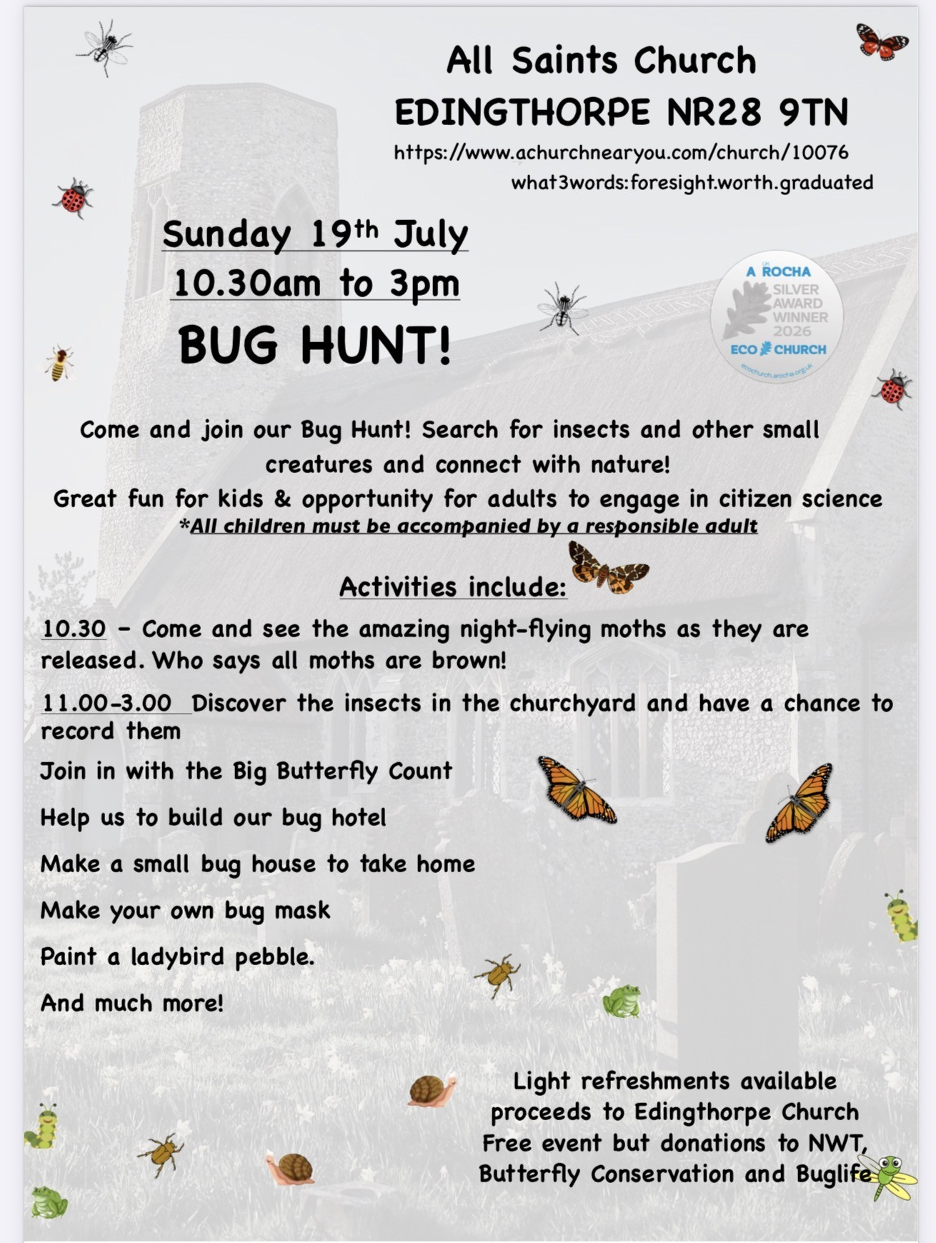

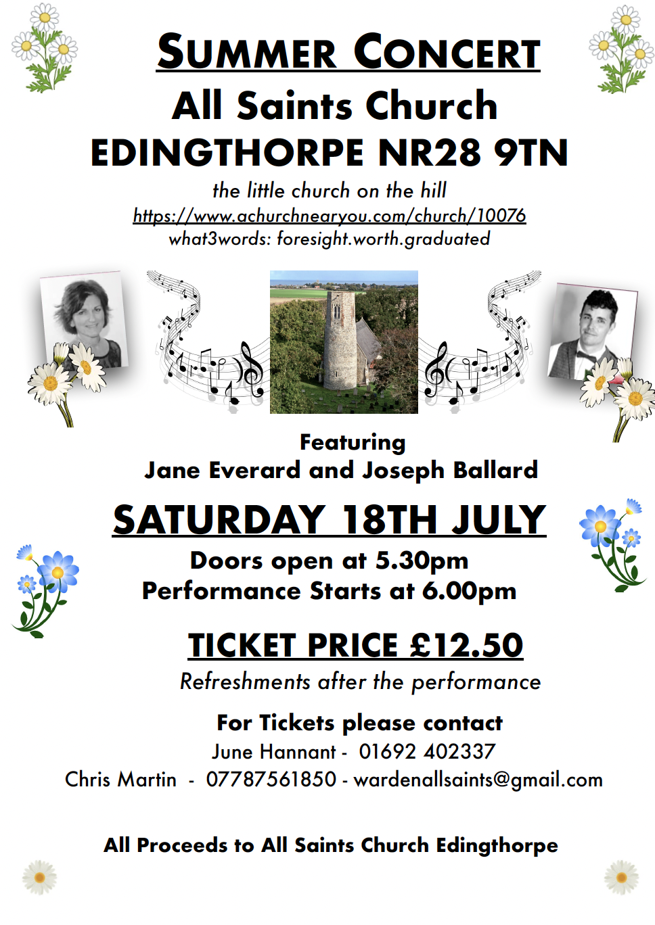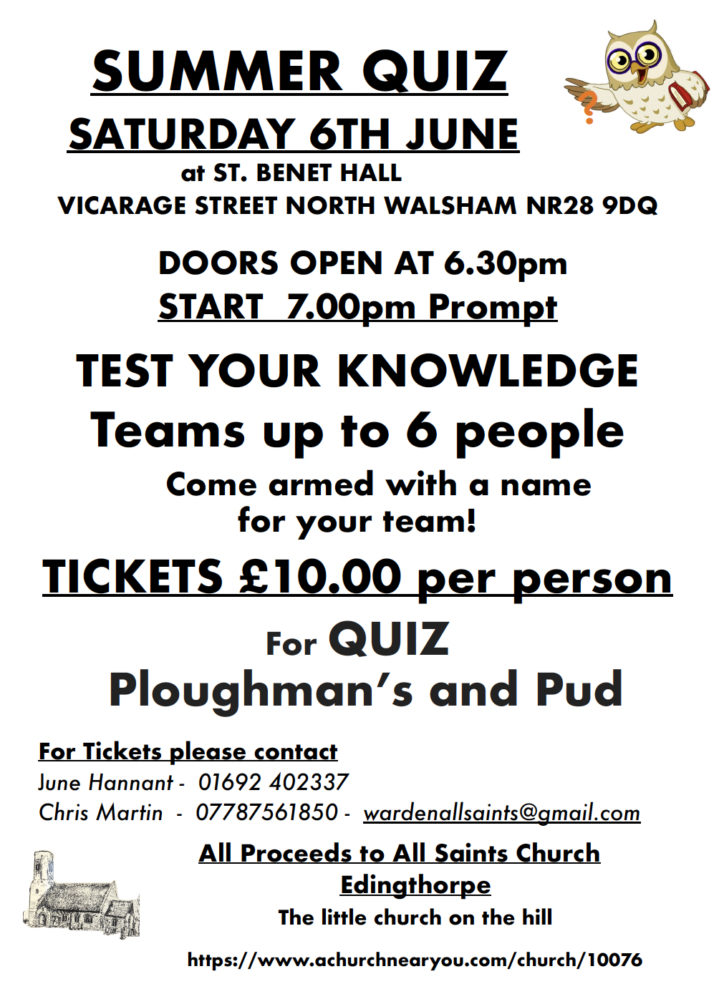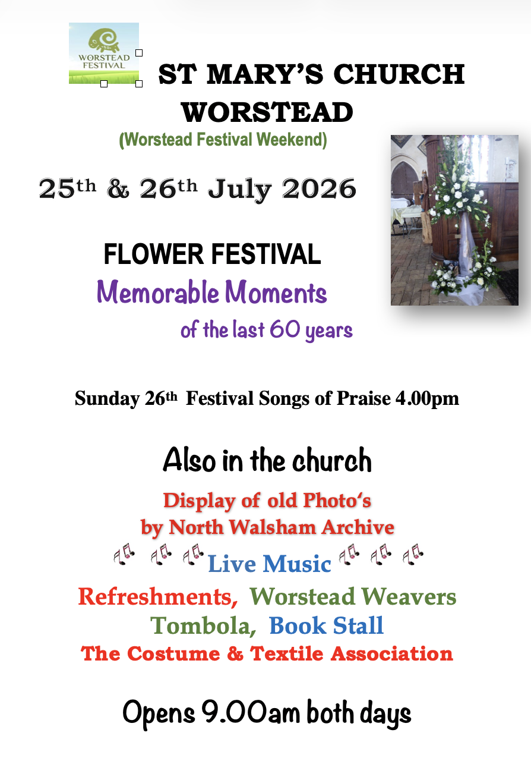


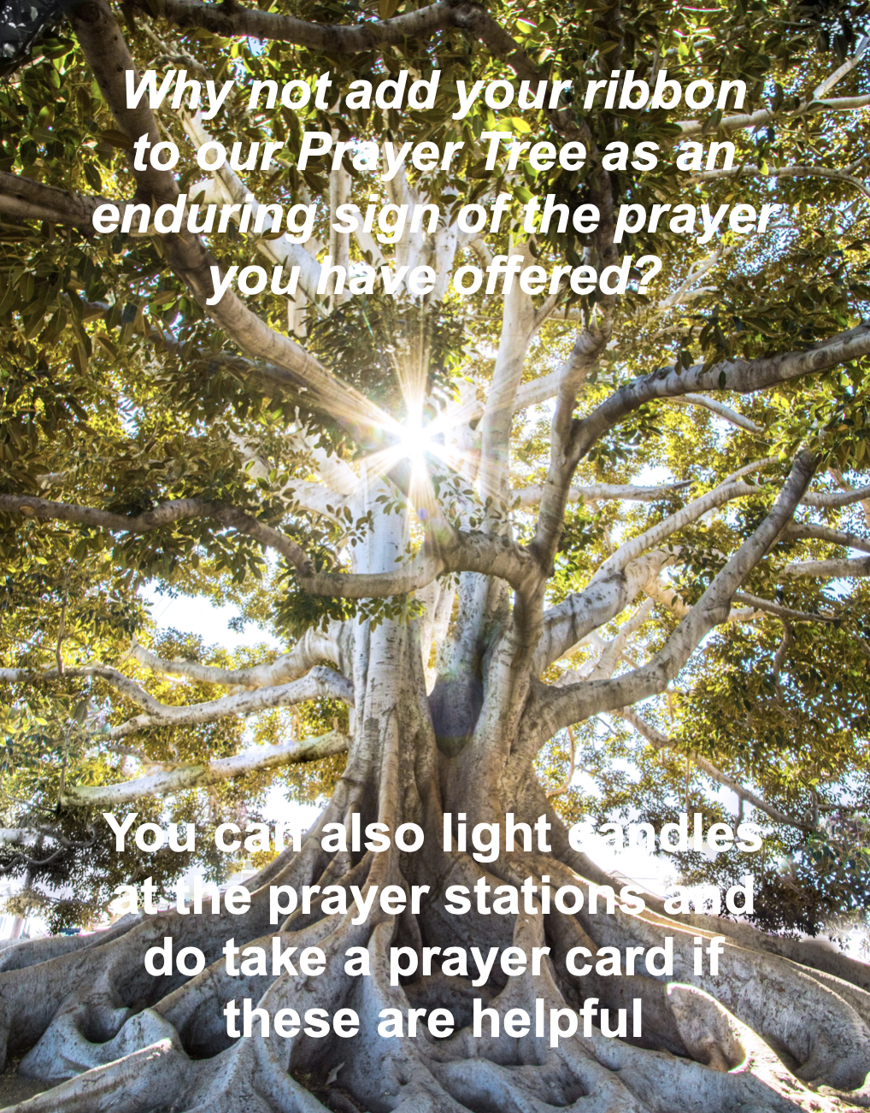

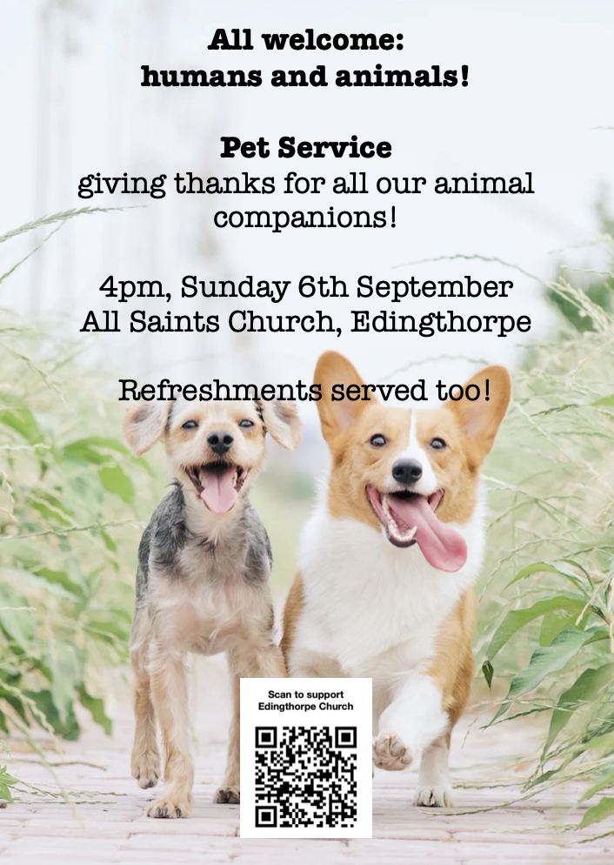

We are privileged to hold special
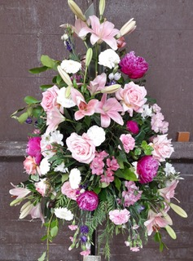
Services at any of our churches
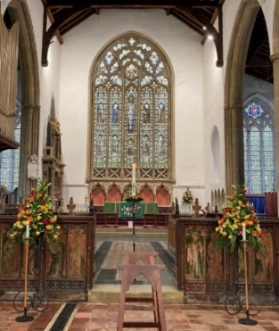
All who live in the benefice are entitled to a baptism, wedding or funeral service in church, and our clergy can officiate at the crematorium and cemeteries too. The church is here for you, through every moment of life.
************************************************************************************


Dates from the Diary

Baptisms
Rumi Pasha-Gubbins
Wedding
Bethany Lane and Jim Rijks
Sabrina Gaff and Lee Norton
Funerals
Carol Tomlin
Barry Oldham
Robert Wilkinson
Freda Stedman

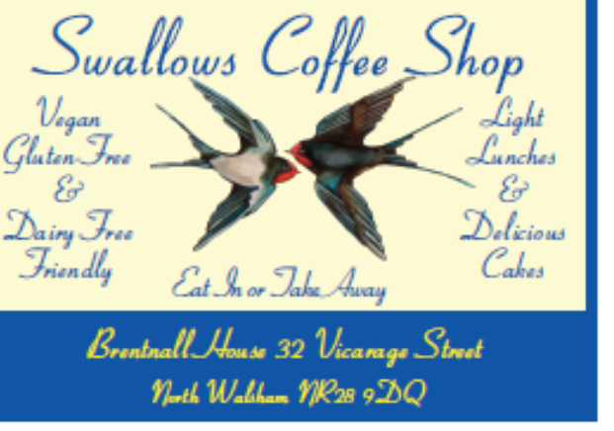
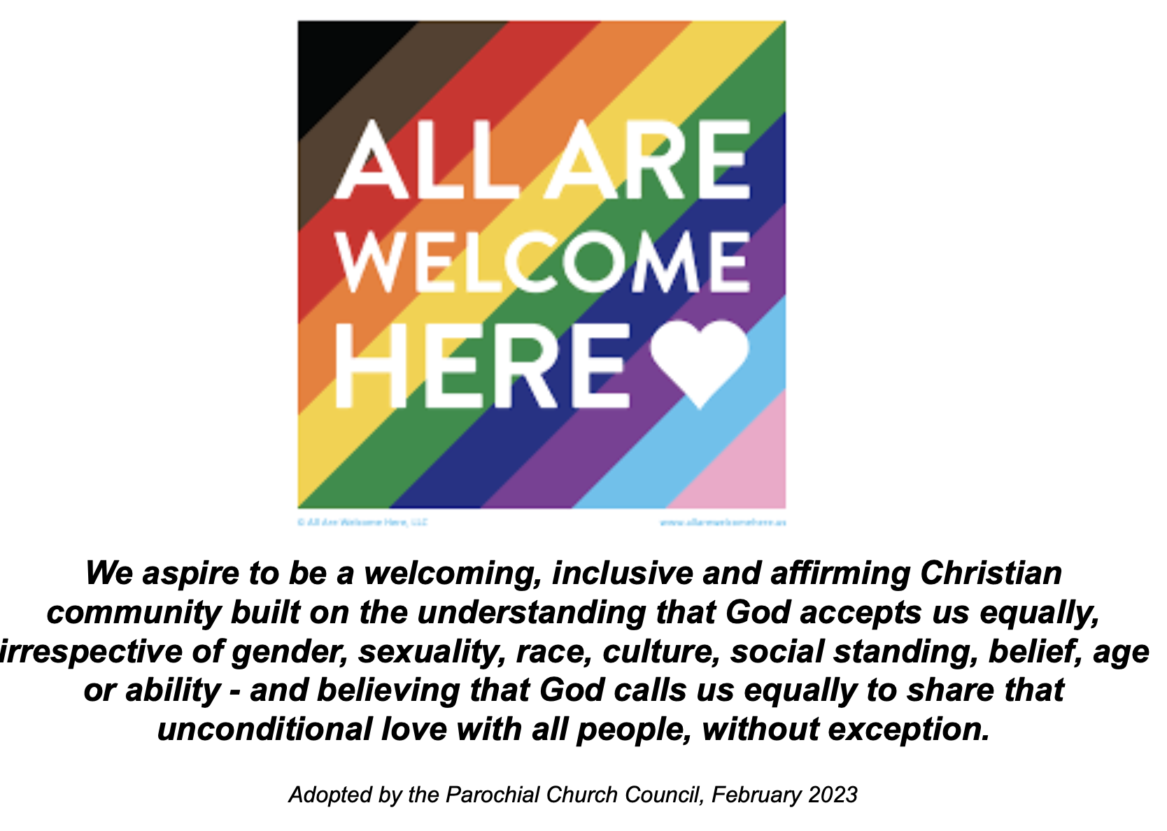

Thank you to everyone for raising donations for St. Nicholas Church, North Walsham with #easyfundraising! If you have not signed up yet, it is easy and completely FREE. 8,100 brands will donate to us when you use easy fundraising to do your everyday online shopping - at no extra cost to you! Every donation you raise makes a difference to us so please sign up & share today. https://join.easyfundraising.org.uk/stnicholaschurchnw/XT7MPH/at/TSX8RX7z/RTND2/facebook/
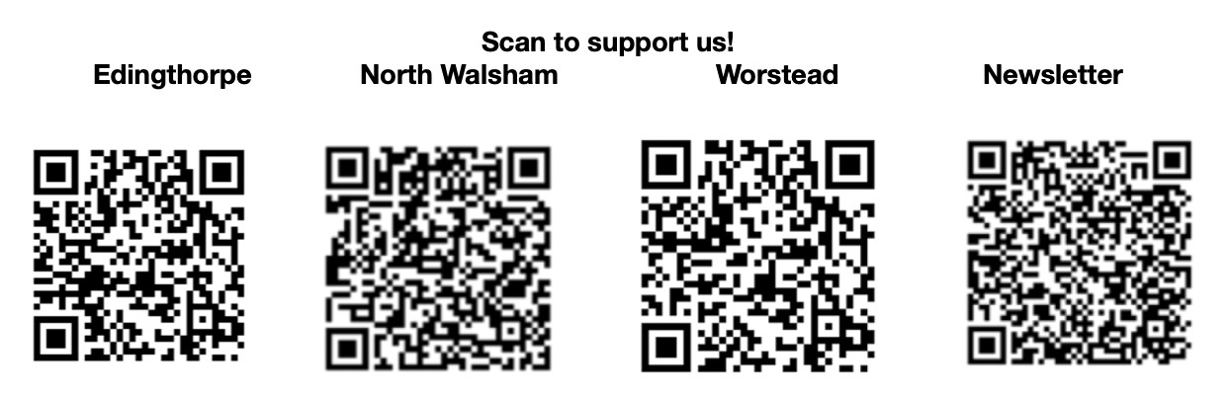


Please support the work of our Churches, by using the contactless giving point at St Nicholas or St Mary’s, leaving your gift on the offering plates or in the wall safes, or through these QR codes. Thank you.

Do you have a Business you would like to advertise in this magazine?
Whole, half or quarter page space is available.
Full Page £ 150.00
Half Page £ 75.00
Quarter Page £ 50.00
Please contact the Benefice office on 01692 408971
or email saintnicholasnw@gmail.com
for details and prices

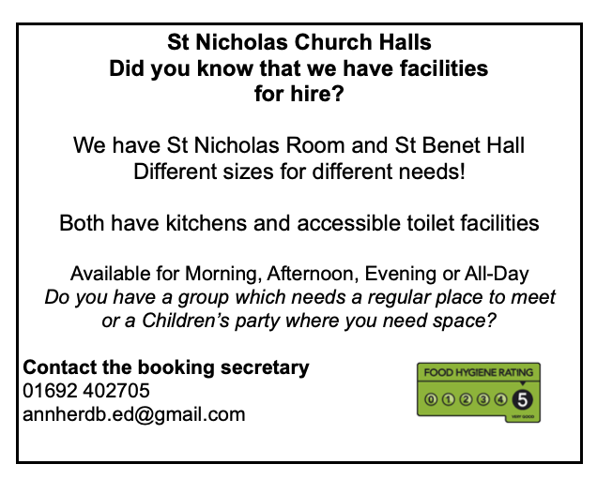
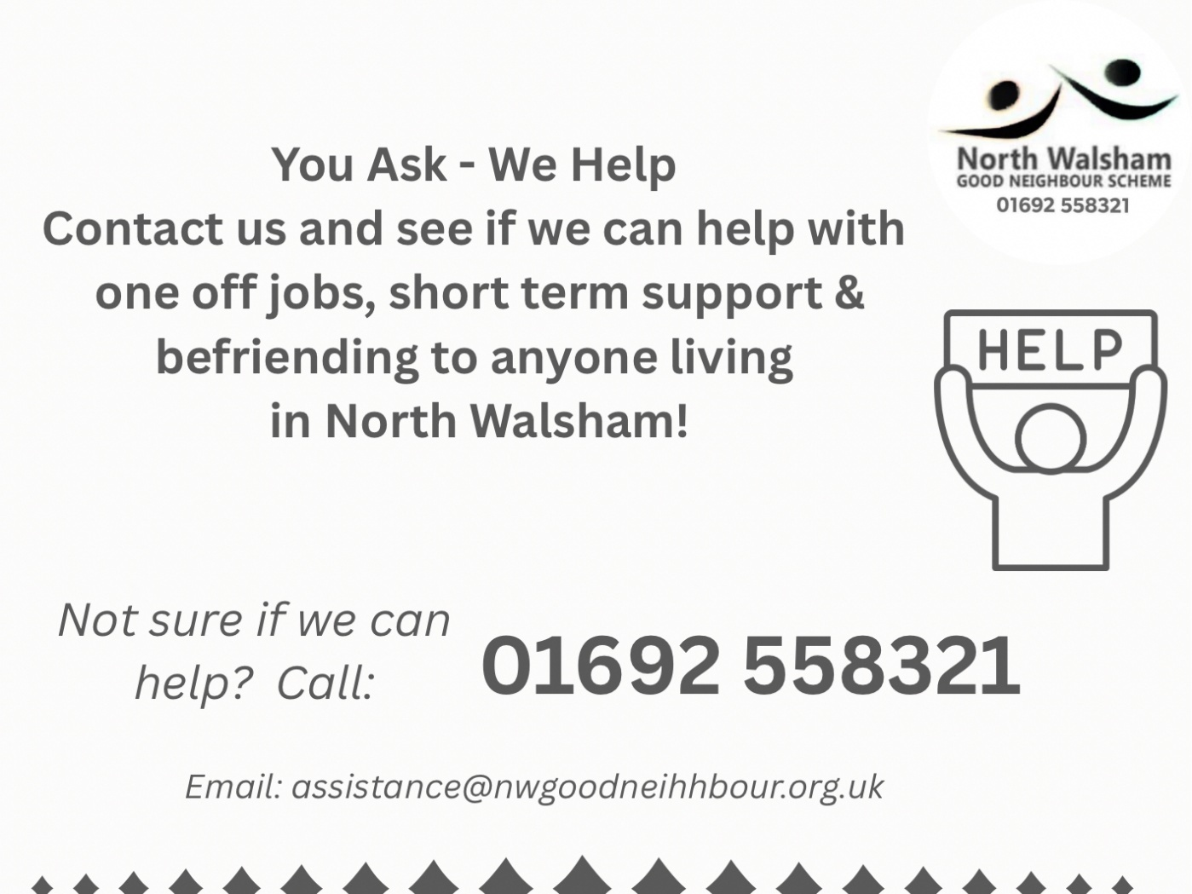

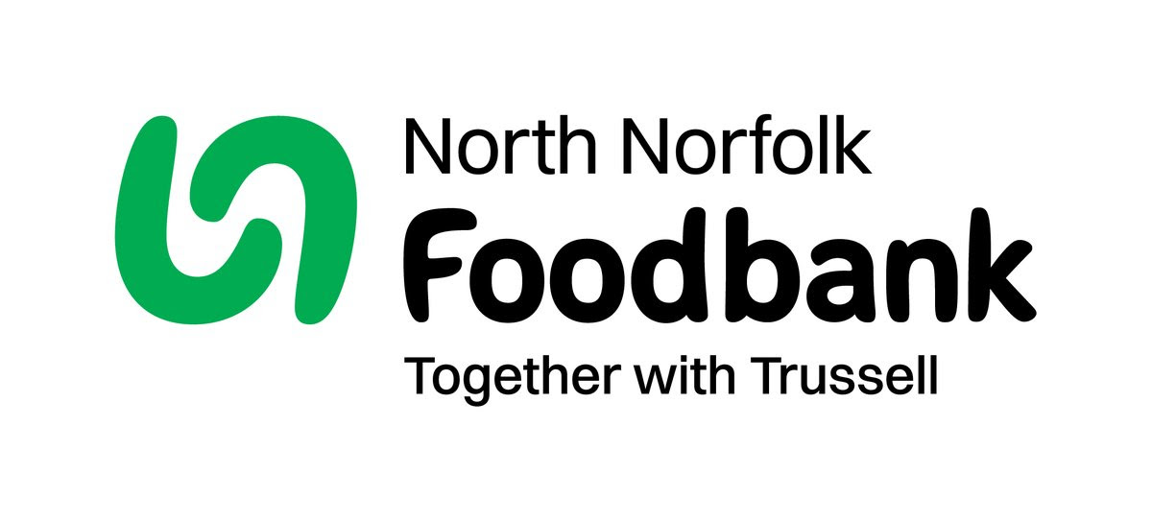
Dear Foodbank supporter,
Thank you for your donation
Receipt and thank you.
Dear Foodbank supporter,
Thank you for your donation from St Nicholas Church
last month of 44.10 kg.
As a small charity we rely on food and financial donations to operate, and we are extremely grateful when people choose to support us.
During the 24/25 year we gave out 2012 food parcels, providing food for 4,520 people; 2,843 adults and 1,677 children.
Whilst Trussell campaigns to end the need for foodbanks, we will be here helping those who need us right now. But that can only be done with kind donations from our supporters.
To see what we need most right now, our wish list is published on our website and social media, and the list gets updated throughout the month on our donation page https://northnorfolk.foodbank.org.uk/give-help/donate-food/
Thank you for thinking of us and enabling us to serve the people facing hardship across our district.
Kind regards
Julie and the Foodbank team
North Norfolk Foodbank
Cromer Methodist Church Hall, West Street, Cromer, NR27 9DT
07826 376343
Ready to tick off your list – Will Made?

"The Church of England have teamed up with Farewills to provide a free will writing service: Online Will Writing Service | Legal Will In 15 Minutes . Anyone can use this service and it is not compulsory to leave something to your church, but it would be nice if you did. It is important for each one of us to leave our earthly matters in good order so why not take advantage of this opportunity now? It is good to remember a gift in your will to a charity is tax free. If you already have a will, you could consider leaving a legacy to the church by adding a codicil. https://farewill.com/norwich-diocese

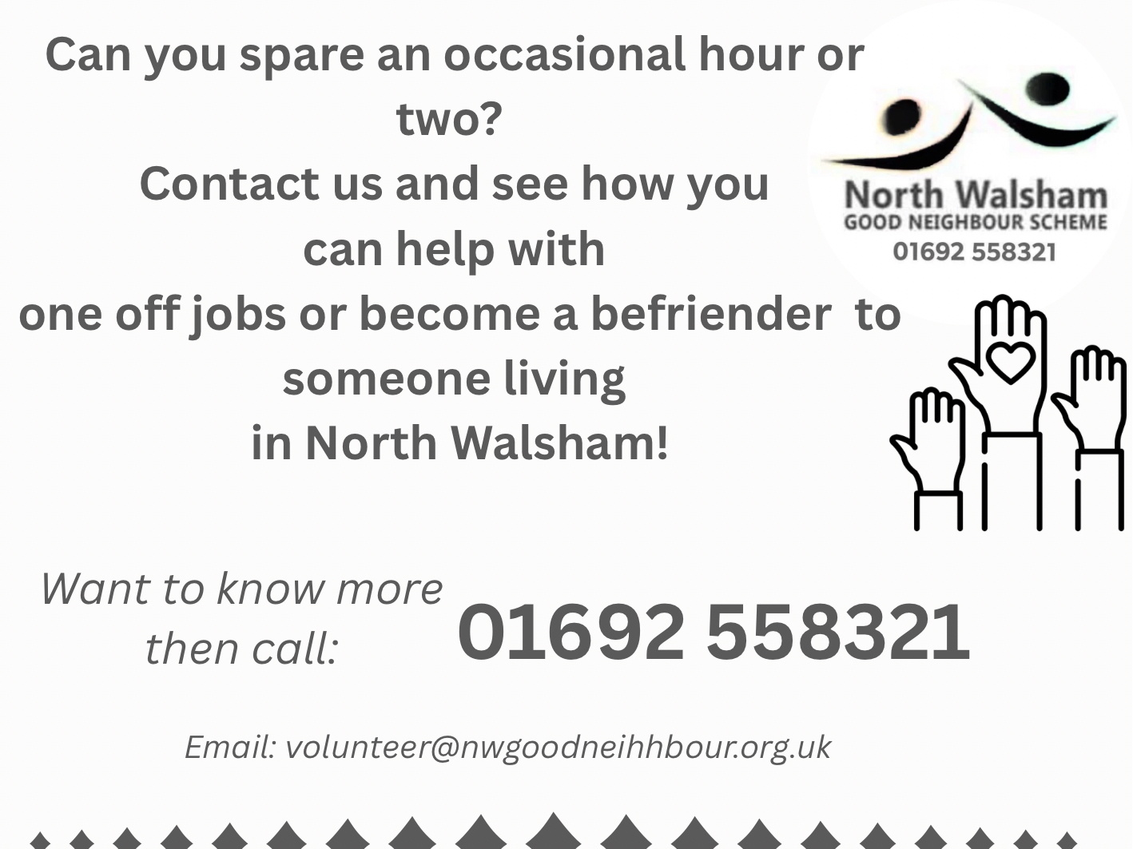

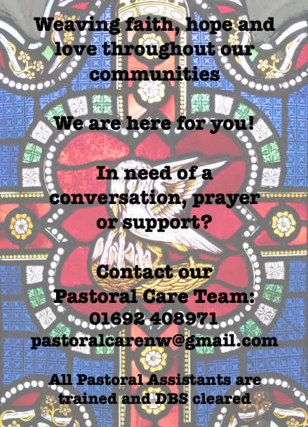

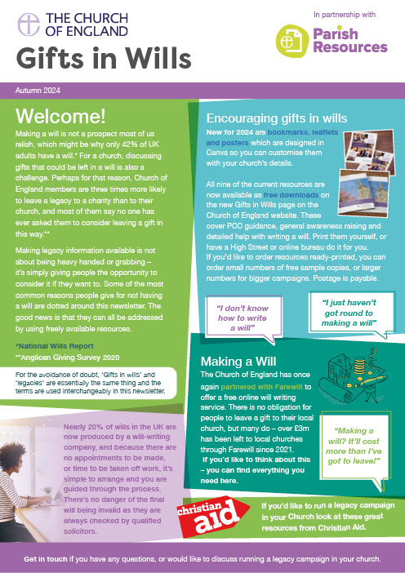
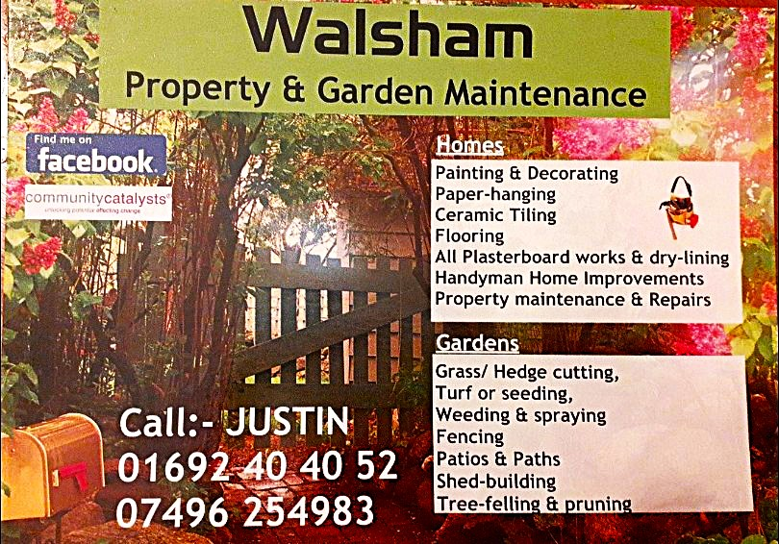

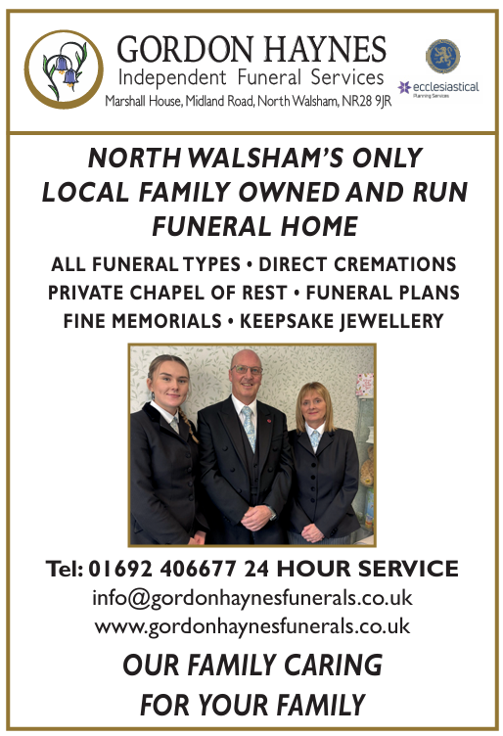
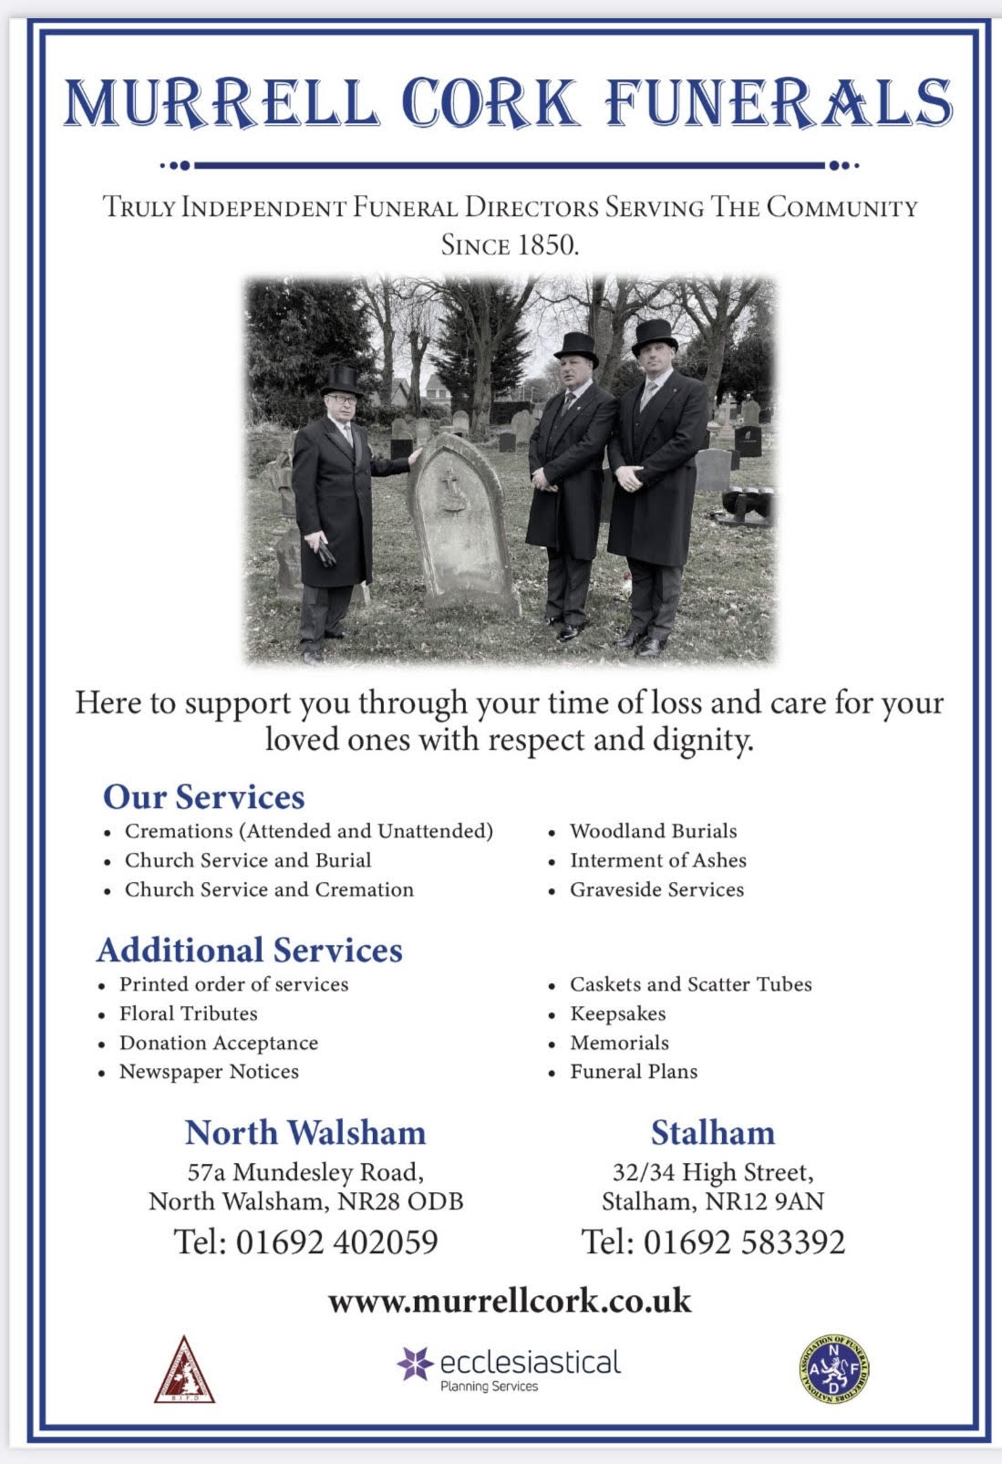
r Sale and Wants Page

Money Matters …
A regular report for our readers written by James Reginald Drake at ClearView Financial Consultants
Burgh Road, Aylsham - 01263 734859, Station Road, Hoveton - 01603 273590 and North Walsham 07773 626662

Lasting Powers of Attorney – Why are they so Important?
Lasting Powers of Attorney (LPA’s) are documents that give an individual you trust (your attorney) the legal authority to make decisions on your behalf should you either lose the mental capacity to make them, or you no longer wish to make these decisions yourself. Lasting Powers of Attorney come in 2 forms, these coming under the heading of ‘Property & Financial Affairs’ and ‘Health & Welfare’
So, how can they help?
The Property & Financial Affairs LPA covers things such as running your bank and savings accounts, making or selling investments, paying bills, buying or selling property and applying for benefits.
The Health & Welfare LPA covers things such as the type of health care and medical treatment you receive (including decisions on life sustaining treatment), where you live, as well as the type of care that you receive in areas such as diet and daily routine.
Given the wide range of areas that these documents cover, it becomes quite obvious as to why they are so important. However, according to ‘The Office of the Public Guardian’ via an article produced in 2022, less than 1% of the UK population have a Lasting Powers of Attorney in place.
So, why do so few people have them in place? One of the most commonly mentioned reasons is that people assume that their spouse will automatically have the right to make decisions for them should they ever reach the stage where they are unable to. This however is a common misconception and it is very often discovered far too late that they actually have no legal authority at all. Cost is another reason people put it off, I can assure you are costs for this type of work are minimal, in the hope this is not a reason to delay.
What should you do?
Well, the answer to this one is quite simple……. get on and set up both types of LPA as soon as you can. It is never too soon to set one up, but it certainly can be too late. By law, once your mental capacity has gone, so has your opportunity to appoint attorneys to act on your behalf. At this point your loved ones will be required to go down a different route and apply to the Court of Protection for a Deputyship order. This requires more forms, more cost and more time, which can all be easily avoided with a bit of forward planning.
So, if setting up Lasting Powers of Attorney(s) is something that you think would benefit you and your loved ones, please feel free to contact me and we can discuss how they can be put in place in a way that is best suited to your own personal requirements.
This short article in no way should be taken by readers as advice.
James can be contacted on either of the above landline numbers or via email at support@smithifa.co.uk
ClearView Financial Consultants is a trading name of Martin Smith Independent Financial Adviser Ltd, a company registered in England
under number 11439150 and authorised and regulated by the Financial Conduct Authority under number 944677.



