WORSHIP
SERVICES IN CHURCH
Christ Church is open for Sunday worship at 10.00 am
ONLINE SERVICES
twitch.tv/revdgill
LIVE from Christ Church Healey
and to view on twitch.tv/revdgill after the broadcast.
Downloads are available on request.
PASTORAL
If anyone needs help or support, please contact:
the Vicar on 01706 458506
or the Pastoral team on 07813 297313.
WEBSITE INFORMATION
Our websites are regularly updated and contain lots of useful information including service sheets, readings and news.
https://www.achurchnearyou.com/church/15941/
and
www.christchurchhealey.org.uk
BENEFICE MOTTO FOR 2026
“In everything by prayer and supplication… let your requests be made known to God. And the peace of God which surpasses all understanding, will guard your hearts and your minds in Christ Jesus.”
Philippians 4:6-7 (NRSV)
Our Mission Statement – “To glorify God and serve our community in the name of Jesus Christ.”
PRAYERS
For the sick: For May 17th
Stephen Partington, Madalen Bolton, Roger Mason, Brenda Blair, Debbie Sullivan, Andrew McElroy, Elliot Nightingale.

Home members:
Jean France.
R.I.P.
Albert Ndlovu
In Memoriam:
Kristi Higgs, Annie Conway, Sheila Barber, Peter Birchall, Eric Whitehead, Martin Broughton, Mary Alice Meadowcroft, Lilian Neaven, Irene Hartley.
Prayer for the week:
Heavenly Father, thank you for the gifts of this day. Guide my every thought, word, and action and give me peace in uncertainty and strength to face whatever comes my way.

BIBLE READING:
Love is patient and kind; love does not envy or boast; it is not arrogant or rude. It does not rejoice at wrongdoing, but rejoices with the truth. Love bears all things, believes all things, hopes all things and endures all things
Corinthians 13: 4/7

DATES FOR YOUR DIARY
NOTICES

Sunflower seeds
Maureen’s Clegg’s family gave out packets of sunflower seeds at her funeral. We are encouraged to plant them any time now as a joyful reminder of Maureen.
DATES FOR YOUR DIARY
Lviv Children's Art Project, 11th May-20th June, Riverside
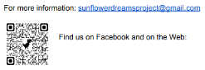

Ukraine’s children tell their stories through art.
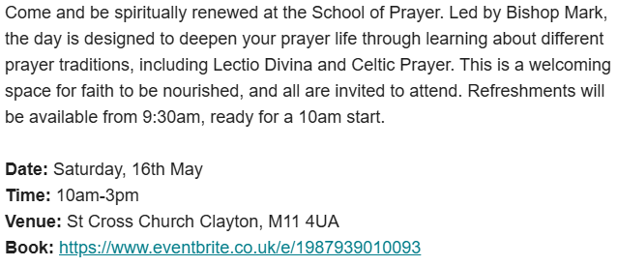
School of Prayer

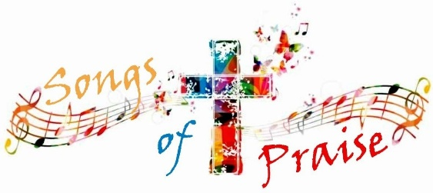
Come along on Friday 15 May at 7.00 pm for a wonderful, joyful evening singing favourite hymns. A retiring collection will be made for Cancer Research. Streamed on Twitch & Facebook

THY KINGDOM COME 2026


This year’s Thy Kingdom Come is all about the presence of God through His spirit. Over the 11 days from Ascension Day to Pentecost, we will explore a different Bible story each day, which demonstrates God’s transformative presence. Use this to pray for 5 people you know that they will also experience the life-changing love of God and choose to follow Him.

Icons on Ammo Boxes
A powerful and deeply moving collection features Ukrainian icons painted on repurposed ammunition boxes from the frontlines of the war in Ukraine. St Edmund’s Church, Wed 13th May, 7pm.
The exhibition will be showing from May 11th to May 25th, 11am – 6pm.
Upcoming Baptisms
St. Ann’s, 17th May: Romey Gartside
Christ Church, 24th May: Eleaner and Jamall Ndlovu
Easy Fundraising: Thank you to all Easy Fundraisers for the £38.26 that will be coming in to Christ Church this week

