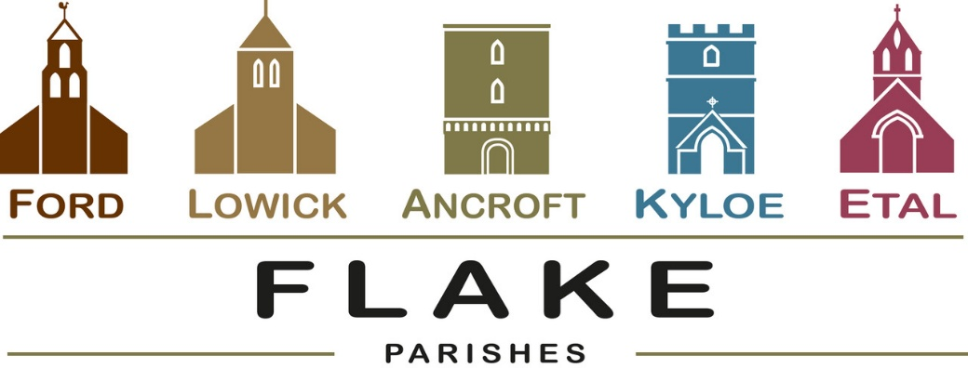
A very warm welcome to you, especially if you are visiting.
Please take this sheet home with you and use it as a basis for prayer.
Sunday 24th May 2026
Pentecost
Lowick 9.15 Holy Communion
Ford 11am Holy Communion
Ancroft 11am Holy Communion

Sunday May 31st 2026
Trinity Sunday
10 am Ancroft Flake Service of Holy Communion
with Baptism of Leo Firman
followed by buffet FOR ALL in Ancroft Memorial Hall

Sunday June 7th 2026
Lowick 9.15 Holy Communion
Ford 11am Holy Communion

Sunday June 14th 2026
Lowick 9.15 Holy Communion
Ford 11am Holy Communion

Revd Charlotte Osborn (Vicar) 01289 388591 ceosborn@mail.com 07957 367457
Revd Alex Firman (Assistant Curate) 07935 732811
alex_firman@hotmail.co.uk

Pentecost (50 days after Easter)

Do we see ourselves and one another like this?
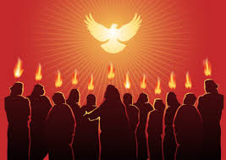
..with God’s spirit present with each of us and burning within us, guiding our daily lives?
Do we imagine that God’s spirit hovers over us as church as we gather for worship, and if we do, how might that be manifest in our worship and fellowship as we encourage one another?

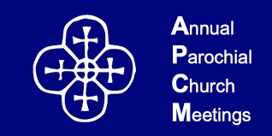
All are now completed and we welcome newly elected members to the PCC’s
At Lowick: Penny Bailey
At Ford : Annabel Milne
James Thompson
At Etal as Churchwarden: Barbara Harwood
Electoral Roll numbers : Ancroft 27, Lowick 55, Ford and Etal 60


Beating Lowick Bounds Tomorrow!
Fantastic Walks of 3 and 12 miles
Bank Holiday Monday 25th May at 10am
Lowick Village Hall
Adults £7, Children £3, Family £12
Includes breakfast and delicious in walk refreshments

Friday 5th June 2026 7pm
Ancroft Memorial Hall
Saturday 6th June 2026 7.30pm
Chirnside Community Centre
Sunday 7th June
Wooler URC 3.30pm
Tickets £10 from Dee Colam
07801 822851
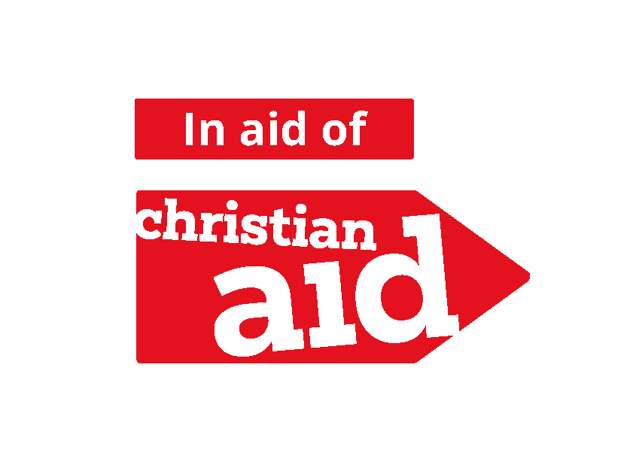
A total of £725 was raised for Christian Aid Week, with £262.00 from the pew collection and £463.00 from the Supper & Quiz. Gift aid adds even more to this total.

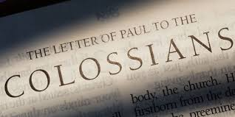
Sundays & Mondays in June
An in-depth study of Paul’s letter
Sunday Sermons
Monday Discussion

A chapter-by-chapter study, introduced at the vicarage on Monday 1st June at 7pm by Revd Alex Firman, who has prepared the paper available at the back of church.

On Sunday 7th June we are delighted to welcome Canon Nick Sagovsky to preach on Chapter 1 at both services.
For our prayers


Congratulations to the new Mr and Mrs Williams, who married at Ford yesterday

Annabel and John, to marry
at Ancroft 20th June

Ian and Yvonne to marry at Ford 18th July

We joyfully pray for them as they prepare not just for their wedding day, but for their married life together

Please continue to pray for all who suffer in body, mind or spirit, especially Heather Piper, George Hall, Gail Calder, Don and Sam Quilty, David and Judith Dobson, Alison Murray, Sue Pattinson.

We remember all who have recently died, including Margaret Grieve. We pray for those who mourn, and for all who mark anniversaries of death at this time of year: Vonda Wailes-Fairbairn.

Parish Contacts
Ancroft Leigh Yorke 07716 116739
Etal Andrew Joicey 01890 820540
Ford Kathleen Holmes 07951 099668
Lowick Niall Cartlidge 07850 876246

Websites: www.achurchnearyou.com
Instagram: https://www.instagram.com/the_flake_churches/
Facebook: the_flake_churches

Our other licensed clergy
Revd Margaret Sentamu 077871 204745, Canon Nick Sagovsky,
Revd Marion Penfold 01289 305664

