



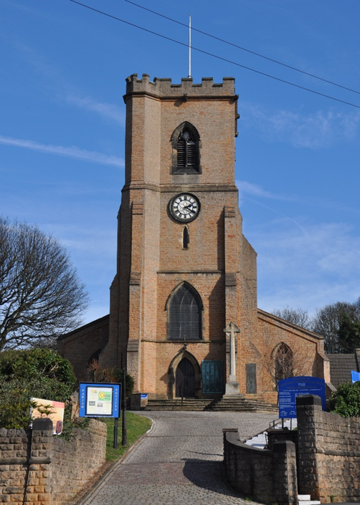

Annual Vestry Meeting &
Annual Parochial Church Meeting

Sunday 31 May 2026

Vestry Meeting Agenda

- Opening Prayers

- Apologies for Absence

- Minutes of the Vestry Meeting 2025

- Matters Arising

- Appointment of Church Wardens

Annual Parochial Church Meeting Agenda

- Apologies for Absence

- Minutes of the Annual Parochial Church Meeting 2025

- Matters Arising

- To receive the Electoral Roll

- Report on the proceedings of the Parochial Church Council (PCC) and Statement of Accounts

- Election of 3 candidates to the Parochial Church Council for a term of 3 years and one for two years

- Appointment of 2 Deanery Synod Representatives

- Appointment of Sides Persons

- Appointment of Independent Examiner

- Questions taken under Article M7 (Part 9) formally 9.7 of the Church Representative Rules

- Date of the next APCM 2027

- Closing Prayers
A short PCC meeting will be held following the APCM with the only agenda item being to appoint officers of the PCC will be held immediately after the APCM for this purpose.

Minutes of the Vestry Meeting held on Sunday 11 May 2025 after the morning service.

In attendance:
Robert Barton, Susan Barton, Robyn Bellemore, Brian Butler, Carole Butler, Helen-Lily Dutton, Zoe Elliott, Carol Ezard, Eileen Gimson, Christopher Guy, Phillip Hague, Gwen Hart, Pataricia Hotson, Ray Hotson, Alan Jackson, Carole Jackson, Doug Lang, Eleanor Lang, Robert Naylor, Cassandra Nelson, Maureen Pates, Jackie Pichowicz, Sheila Riddell, Richard Shaw, Grace Stanley, Peter Stanley, Martin Walton Les Ward and Elaine Wyatt.

1 | Opening Prayers  Fr Andrew Fisher opened the meeting by welcoming all present.  Carol Ezard read from Mark 5 Verses 21-43. Fr Andrew took a moment to reflect on the reading. He thanked Church Wardens, Ministers, PCC members, volunteers and grateful supporters and benefactors past and present.
2 | Apologies  Apologies for absence were received from Eleanor Lang, Jackie Bramford and Rosie Cheer.
3  4 | Minutes of the Vestry Meeting 2024  A proposal to accept the minutes of the Vestry meeting, 2024 was raised by Phillip Hague, seconded by Maureen Pates and accepted.  There were no matters arising from the minutes.
5 | Election of Church Wardens  Fr Andrew thanked Eleanor Lang and Martin Walton for all their work during the last 12 months.  Fr Andrew advised of the ruling of three years in post for Church Wardens and asked for confirmation from those present that the agreement to waver the general ruling was still the case. All agreed.  Eleanor Lang and Martin Walton both nominated and seconded, as there were no further nominations, Eleanor and Martin were elected to position of Church Warden for the coming year.
 | This concluded the business of the Vestry Meeting.
___________________________________________________________________

Minutes of the Annual Parochial Church Meeting 11 May 2025 after the Vestry Meeting.

In attendance:
Robert Barton, Susan Barton, Robyn Bellemore, Brian Butler, Carole Butler, Helen-Lily Dutton, Zoe Elliott, Carol Ezard, Eileen Gimson, Christopher Guy, Phillip Hague, Gwen Hart, Pataricia Hotson, Ray Hotson, Alan Jackson, Carole Jackson, Doug Lang, Eleanor Lang, Robert Naylor, Cassandra Nelson, Maureen Pates, Jackie Pichowicz, Sheila Riddell, Richard Shaw, Grace Stanley, Peter Stanley, Martin Walton Les Ward and Elaine Wyatt.

1 | Apologies for absence: Eleanor Lang, Jackie Bramford and Rosie Cheer.
2 | Minutes of the meeting held 2024.  Acceptance of the minutes of the APCM held in 2024 was proposed by Robert Naylor, seconded by Christopher Guy and carried.  There were no matters arising from the Minutes.
3 | To Receive the Electoral Roll  Sam Reynolds as Electoral Roll Officer, told the meeting that at the APCM 2024 there were 84 people on the Roll, in September 2024, 1 was removed, 2 added and 1 name change giving 82 people on the Roll. A full revision has now taken place with 86 people now on the Electoral Roll.  Thanks were extended to Sam by Fr Andrew on behalf of those present for her work in maintaining the Roll.
4 | Report on the dealings of the PCC  There were no comments or questions.
5 | Election of PCC Members  The meeting was advised that there were vacancies for 3 members for three years, one space for two years and one space for one year and two Co-opted members.  Fr Andrew offered thanks to the outgoing PCC members, Sam Reynolds, Jackie Pichowicz, Les Ward and Daniel Newton  As there were no further nominations, the following having been nominated and seconded were appointed to the PCC for three years:  Alan Jackson, Jackie Pichowicz and Les Ward.  Appointed for two Years: Sam Reynolds
6 | Deanery Synod  Fr Andrew thanked Christopher Guy for representing St Marys at Deanery Synod for the last year. Chris Guy had been nominated and was duly appointed. Fr Andrew advised that this vacancy was for two people and if anyone else was interested to please speak with him.
7 | Sides People  Martine Walton told the meeting that volunteers for sides people are needed. Fr Andrew extended many thanks to the Snr Sides People: Martin Walton, Doug Lang, Jackie Pichowicz and Richard Shaw and Eleanor Lang for their service over the last year.
8 | Appointment of Independent Examiner to Audit the Accounts  Fr Andrew told the meeting that a new Auditor was to be appointed as Michael was retiring. Andrew Howeth had agreed to take over. As there were no objections, Andrew was appointed as Auditor to our accounts.  Fr Andrew extended thanks to Peter for all the hard work with the Finances of St Marys.
10 | Questions taken under Article 9.7 of the Church Representative Rules  None
11 | The Date of the next APCM was agreed for 10 May 2026. The meeting closed with the Grace at 12.25.

________________________________________________________________

Minutes of the meeting held after the APCM to appoint officers of the PCC.

The following were proposed, seconded and after agreement to stand were appointed:

 |  | Proposed by: | Seconded
Vice Chair of PCC | Eleanor Lang | Carole Jackson | All
Secretary to PCC | Carole Jackson | Sam Reynolds | Lee Duffield
Treasurer | Peter Stanley | Jackie Bramford | All
Electoral Roll Officer | Sam Reynold | Philip Hague | Jackie Bramford
Safeguarding | Maureen Pates | Zoe Jackson | Andrea Shearing
Co-opted | Rev Bob Stephens | Helen Dutton

Standing Committee | Fr Andrew Fisher  Rev Bob Stephens  Church Wardens  Secretary  Zoe Elliott | Martin Walton
Co-opted to the PCC Rev Bob Stephens and Helen Dutton.

The next meeting of the PCC was agreed to be held on Monday 17 July at 7.30 in the West Room.
This concluded the meeting.

The Trustees’ Annual Report
Fr Andrew Fisher, written 09/03/2026

As Trustees, St Mary the Virgin & All Souls’ Parochial Church Council (PCC) is jointly responsible for writing this report, although the PCC has delegated the drafting of it to St Mary’s incumbent, Fr Andrew Fisher, as Chair of Trustees, and the PCC Secretary, Carole Jackson. This report gives the PCC the opportunity to tell you the aims of the church and what we are doing to help make them happen. We want to share our ‘‘good news’ stories and how your giving of time, energy and resources have made them possible.



2025 Report and Accounts

for the Parochial Church Council of

St Mary the Virgin & All Souls Church, Bulwell

Aim and Purposes

St. Mary’s PCC has the responsibility of cooperating with the incumbent, Fr. Andrew Fisher, in promoting in the ecclesiastical parish, the whole mission of the Church, pastoral, evangelistic, social and ecumenical. As well as the church building, the PCC is also specifically responsible for the maintenance of the former curate’s house 123 Squire’s Avenue.

Objectives and Activities

St Mary’s objectives and activities are guided and informed by our Vision and Mission Statements:

ST MARY’S IS A DOWN-TO-EARTH CHRISTIAN COMMUNITY SEEKING, SERVING AND WORSHIPPING GOD BY SHARING THE LOVE OF JESUS WITH ALL:

WE STRIVE TO BE CREATIVE IN OUR WORSHIP, OFFERING A VARIETY OF SERVICES BY TRAINING AND EQUIPPING, RESOURCING AND ENCOURAGING THE WHOLE PEOPLE OF GOD.

WE AIM TO BE A CHURCH WITHOUT WALLS - OUTWARD LOOKING, A VISIBLE PRESENCE IN OUR COMMUNITIES. WE AIM TO BE INCLUSIVE OF ALL PEOPLE AND ALL AGES.

WE ARE REACHING OUT TO CHILDREN, YOUNG PEOPLE AND FAMILIES BY BULDING LINKS WITH SCHOOLS AND ENCOURAGING FAMILY FRIENDLY WORSHIP.

OUR MISSION AND MINISTRY IS BASED ON THE TEACHING OF THE BIBLE AND THE GOOD NEWS OF JESUS CHRIST. THIS INSPIRES AND INFORMS ALL OUR ACTIVITIES.

Our Vision and Mission Statements tie in with the Southwell & Nottingham Diocesan Vision 2030 and Seven Areas of Focus:

Southwell & Nottingham Diocesan Vision 2030 -
Growing Disciples of Christ with Compassion, Confidence and Courage

COMPASSION (Our motivation)
To meet the world’s deepest needs with Jesus’ love Jesus’ first response to people, no matter what their situation or background, was one of compassion. As disciples we will be orientated towards those who are struggling, to the poor, to those in need, to those who are suffering. Our desire is that people encounter Christ and experience healing, hope and salvation.

CONFIDENCE (Our foundation)
To root our life and faith in Jesus. As disciples we can be confident in our relationship with Christ through the presence and power of the Holy Spirit. We are to have deep roots, to be well watered, confident in the gospel, despite the challenges we face in the world. Confidence is the willingness to live out our primary identity in Christ.

COURAGE (Our action)
To share Jesus with all our hearts. As disciples we will have the courage to tell our story with all our heart. Followers of Jesus are to share their faith, inviting others to discover and step into this relationship with Christ themselves.

SEVEN AREAS OF FOCUS
The Diocese has identified 7 areas of focus for mission and ministry in parishes and across the diocese. We hope these will act as reference and review points and drive investment and prioritisation of time, energy and resources:

- INSPIRING WORSHIP
Because coming together to meet with God should be the most captivating hour of anyone’s week

- REACHING YOUNGER
Because Jesus is the surest foundation for life

- ENHANCING DIVERSITY
Because each person matters to Jesus and is precious in his sight

- GROWING LEADERS
Because the harvest is plentiful

- ENABLING COMMITMENT
Because there is nothing better anyone can do with their life than become a follower of Jesus

- ENCOURAGING GENEROSITY
Because we serve a God of abundance, and every good gift comes from him

- NURTURING PRAYER
Because prayer changes everything

St Mary’s PCC is committed to enabling as many people as possible to worship at our church and around the parish, and for those people to become part of our parish community at St. Mary’s. The incumbent and PCC maintain an overview of worship, mission and ministry throughout the parish, and makes suggestions on how our services and outreach can involve the many groups, communities and people that live within our parish. Our services and worship put faith into practice through prayer and scripture, song and sacrament.

When planning our activities for the year, we have considered the Commission’s guidance on public benefits and, in particular, the supplementary guidance on charities for the advancement of religion. We have also taken into account advice from the government, the Church of England, the Diocese and our insurers, Ecclesiastical Insurance.

In particular, we try to enable ordinary people to live out their faith as part of our parish community through:
- Worship, Bible study and prayer; learning about the Gospel; and developing people’s knowledge and trust in Jesus.
- Provision of spiritual and pastoral care for people living in the parish.
- Missionary and outreach work.

To help facilitate all this, it is important that we adequately resource our mission and ministry, and continue to maintain, develop and best utilise the church building as a resource for the spiritual and pastoral needs of the parish.

Fr Andrew Fisher, Incumbent (Chair, PCC).

Achievements and Performance

St Mary’s PCC is keen to offer a range of services and events during the week and over the course of the year that our parish finds both beneficial and spiritually fulfilling. For example: our midweek services, Benediction, and monthly Prayer Mornings provide a quiet, intimate, and reflective environment for worship and prayer, whilst opportunities are provided for people to engage in more informal worship such as that provided by our special Family Masses on the first and third Sundays of each month. Our Thursday afternoon Faith Group and Lent Courses provide opportunities for study and learning.

St Mary’s is registered as an Inclusive Church. All are welcome to attend our services and events. St Mary’s is a church which celebrates and affirms every person and does not discriminate against people on grounds of disability, economic power, ethnicity, gender, gender identity, learning disability, mental health, neurodiversity, or sexuality. We believe in a Church which welcomes and serves all people in the name of Jesus Christ; which is scripturally faithful; which seeks to proclaim the Gospel afresh for each generation; and which, in the power of the Holy Spirit, allows all people to grasp how wide and long and high and deep is the love of Jesus Christ.
As can be seen from our attached 2025 Statistics for Mission, this year we have welcomed more people into our worshipping community. The figures for 2025 were generated via the online, electronic Service Register on our Church Near You website: https://www.achurchnearyou.com/church/17960/ . This makes entering our statistics somewhat easier and takes out much of the previous guesswork. As ever, some of the graphs require a little bit of interpretation:

- Most of the statistics given are generated via the Church of England’s online Service Register. I enter the attendance figures online each week from the numbers given to me by the Churchwardens and sidespeople at each Thursday and Sunday Service in church, and ministers and members of the PCC and congregation who lead services out and about in the parish and church at other times.

- Attendance figures include online views of livestreamed services. Following the Church of England guidance, I enter the number of views via the Online Service Register from St Mary’s YouTube channel on the Sunday following each livestreamed service. I assume people watching online are aged between 18-69.

- Our online views for 2022 were via the church Facebook page. The figures for online views
in 2022 were skewed slightly as figures were entered for the year end, before the guidance
changed.

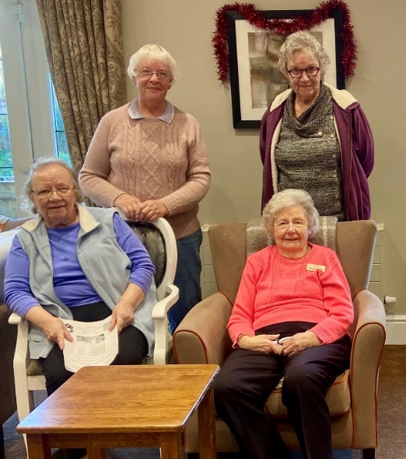
- Worshipping figures include services taken outside of the church building (eg. home communions, care home services, Highbury Hospital and St Andrew’s Winslow). I also enter onto the Online Register attendance figures for the Collective Worship led each week at Bulwell St Mary’s Church of England Primary School. These are not itemised as part of our weekly attendance figures. I do not include assemblies taken at other schools in the parish as, technically, these are not acts of worship.

- Christmas Eve in 2023 fell on a Sunday. Therefore, the figures for Christmas Eve 2023 included additional attendance from the 10am Parish Mass.

- October average week figures vary depending on which schools come into church for Harvest Festival Services and when or whether I am asked to take Harvest Assemblies and acts of Collective Worship on school premises. *

In summary, attendance at St Mary’s are back to pre-pandemic levels and is above pre-pandemic levels in some areas. However, the makeup and demographics of the congregation have changed - we now more closely reflect the demographics the parish.

At present there are 76 parishioners on the Church Electoral Roll, 36 of whom are not resident within the parish. 10 names were added during 2024 and 5 were removed either through death or because they had moved away from the parish.

The average weekly attendance, counted during October 2025 (*see bullet point above), was recorded as 232 adults and 35 children, and 35 adults and 167 children worshipped in a school context in a School Service.

As well as our regular services, we enable parishioners to celebrate, draw close, and thank God at the milestones of their journeys through life. Through baptism we thank God for the gift of life, in marriage public vows are exchanged with God’s blessing, and through funeral services friends and family members express their grief and give thanks for a life which is now complete in this world and to commend the person into God's keeping.

Statistics for Mission

Baptisms

Our 2025 Statistics for Mission report that we celebrated 20 baptisms, including the baptisms of Harrison and Layla-Mae, Cassie and Lexie, Jamelia and Abigail, Kieran and John Singh-Ryan. More recently, in 2026 we also celebrated the baptisms of Ailey and Lisa Askham, and Malcolm, amongst others.

Baptisms are a sign of the Holy Spirit at work. What is God doing amongst us? Where is God at work, and how can we join in?

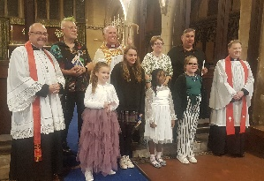
Confirmations

In 2025 we have celebrated the Confirmations of Emmanuel, Abigail, Jamelia and Chuks who were Confirmed by Bishop Paul at the Diocesan Service 7th June 2025 at Southwell Minster, and
Adaeze, Scarlett, Lexi, Cassie, Charlene, Eagle and David who were confirmed by Bishop Paul at St. Peter’s Church, Ruddington Sunday 5th October 2025. Thanks to Zoe and Rev Bob for preparing our Whiz Kids children, and to the members of St Mary’s congregation who were able to attend the services and support our Confirmation candidates. Following are some of their testimonies, presented to Bishop Paul:

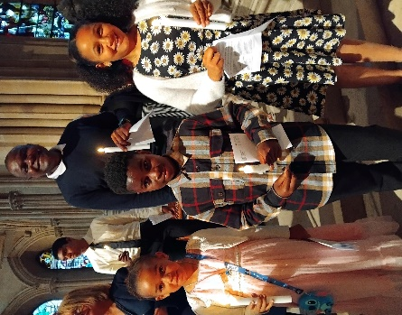
Emmanuel Changamire, Abigail Changamire, Jamelia Sherwood:
I moved to the UK in late 2005 and my attendance has been really poor until I started attending St Mary the Virgin and All Souls at the end of 2023. I take my daughter and my niece with me, and they are loving Church, and I am rediscovering myself spiritually which is something I am enjoying again. I hadn't attended Church for a long time before I came back to realise that my kids need Church just as religion and faith has done wonders for me, I want them to know what is wrong and right, for that reason I found Church as my only way to a better life.

Chuks Kalonga:
I want to be confirmed because I want to be part of the Church.

Cassandra Nelson:
I’ve always felt a connection with God and my faith. When my mum passed, it was a difficult time, and I lost my way, coming to Church, as it’s what I did with my Mum, and coming without her, I felt lost, as she and I always came to Church together. So Church was hard for me to come to, but I still had my faith. I’ve sent my three children to a C of E school, for my belief in God, and when they have their Church services with school, I attend, and when they have craft days at Church, I also attend, and with this, I started to find my spirit to come back to Church, I felt this is where I needed to be, especially with St Mary’s Church, they’ve bought me into their fold, made me feel so welcomed, loved, safe, and they understood how I felt, when I told them about my Mum. I feel I have peace when I attend, St Mary’s has bought me back to where I belong, and where I can be with my faith and Lord.

David:
When I go to my Mam Mar’s grave I sit and chat to her and I feel that she is near. Through the Church I feel at peace with myself since I have been to St Mary’s.

Charlene:
My journey into faith was to let God guide me through the rough times and show me to love others no matter what. To follow him to worship him and to teach me how to forgive myself and others.

Eagle:
I got baptised in the Church of England as a baby. I have believed in God ever since, as a small child, my sister told me that He was our Father, and we would meet Him along the road. I pictured a man who my family would pick up hitch-hiking one day. Hopefully, my theology has developed since then… …I moved to Nottingham in 2012 and finished my training as a Methodist local preacher. Two years ago, I walked into St Mary the Virgin and All Souls Church, Bulwell, Nottingham when they had a healing service on. I was in need of emotional healing at the time. I have been there ever since. So, in a mere 60 years I have come full circle.

Scarlett:
I have been going to church since before I was born. I was baptised at our church and attended my older sister Orla’s Confirmation. I enjoy learning about my faith and being a Christian. Although Mum says I am an introvert (like her) I enjoy Whiz Kids if it's not too busy, and I love Zoe and Father Andrew. I believe in God and Jesus and Jesus always get things right.

Adaeze:
I was born a Christian. I believe that God is my Saviour. I want to have a strong relationship with God and grow as a member of church. I always want to receive Holy Communion.

Lexi:
I attend St Mary’s school. My Mum applied me to this school because it’s a C of E school. She never had me baptised when I was a baby as she wanted me to make that choice when I was old enough and wanted me to see how I felt about my own beliefs. And with her sending me to St Mary’s school, and going to Church, with services, and Father Andrew and Rev Bob coming to school on Wednesdays, I feel I have found my faith in God. I feel Church is where I belong, and I learn about my faith and the Church. I feel love and peace with my faith.

Confirmations are a sign of the Holy Spirit at work. What is God doing amongst us? Where is God at work, and how can we join in?

Weddings
St Mary’s celebrated 2 weddings in 2025, including that of Mr and Mrs Philip Hague!

Weddings are a sign of the Holy Spirit at work. What is God doing amongst us? Where is God at work, and how can we join in?

Funerals
In 2025, St Mary’s held 18 funerals in church, cemetery chapels and crematoria: including those of Mick White, Marshall Bowley, Violet Irwin and Ray Hotson. In 2026 we had to say farewell (but not goodbye) to Michael Anthony and Robert Naylor.

We pray for the departed and ask God’s comforting, consoling Spirit to be with their families and friends. Ministry to the dead, dying and bereaved are a sign of the Holy Spirit at work. What is God doing amongst us? Where is God at work, and how can we join in?

A nice bit of correspondence re: my 2025 initiative shared with our local funeral directors about Church services following direct cremation:

From: Ann Lipscombe <annlipscombe@btinternet.com>
Sent: 20 February 2026 14:47
To: a.j.fisher@outlook.com
Subject: Direct Cremation information

Dear Father Andrew

I am a curate at St Edmund's Church in Bearpark, Co. Durham, and I am currently writing a dissertation about Direct Cremation. Whilst conducting some research, I came across your rather wonderful leaflet.

Having shared it with my training incumbent, we wondered if we might have your permission to reproduce a version for our own church use? We are seeing an increase in direct cremations and have intended for some months to produce an information sheet of some kind. We found your wording so balanced and non-judgmental that we decided we couldn't produce anything to match it and so wondered if we might use your version?

Obviously, we'll understand if that is just too cheeky!

Every blessing, Ann Lipscombe
Curate at St Edmund's, Bearpark

And also, the following emails from local funeral directors re: funeral ministry at St Mary’s:

Good morning, Father Andrew, I hope you had a lovely easter!

I just wanted to thank you for all your hard work as usual. The family of Baby A popped into the office Saturday while I was off and let Charis (From Hucknall) who was covering the branch know what a wonderful job you did on Friday 27th, they also emailed me stating - "The service led by Father Andrew was exceptional!"

Thank you for always looking after the families I send your way, it is always appreciated.

Kind regards,

Paige Gleedwood
Funeral Arranger



0115 9794944: paige.gleedwood@lymn.co.uk

I and my colleague Emily who work for Co-op Funeralcare Bulwell have enjoyed a very pleasant community-based working relationship with Father Andrew, and particularly Eleanor Lang over the past year, bringing the community together to enjoy pleasant events and spread a little happiness. They are both very professional and clearly committed to St Marys.

Cherie Froggatt, Funeral Director, Co-op Funeralcare, Bulwell

We have worked alongside St Marys Church for many years and have found Father Andrew and his team to be very helpful and supportive towards us and the families who require their funeral services at the Church.

St Marys is a well-run Church and a credit to its local community with Father Andrew keeping us regularly updated on events happening at the Church and is always quick to return our calls and emails to ensure his families get the best attention he can provide.

Kind Regards

Kim Terry
C Terry Funeral Services
0115 977 0866 : mail@cterryfuneralservices.co.uk



In my spare time (!) I continue to Chair the Diocesan Healing & Deliverance Ministry Team, and have been commissioned by the Diocese to undertake this ministry for a further three years. Thank you to St Mary’s PCC for allowing me the time to perform this extra-parochial ministry.

Other notable events since our APCM last year that St Mary’s has been a part of, in addition to our usual events and services, include:

18 May 2025
Family Mass led by our Whiz Kids Sunday School. Guest speaker Alison Brown from Christian Aid

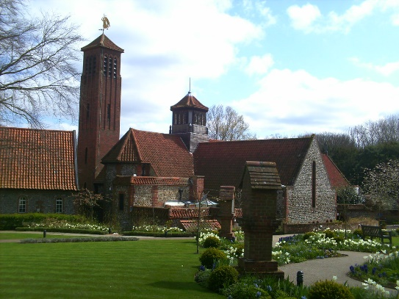
22 May
St Mary’s hosted the annual meeting of the Midlands Deliverance Forum.

4 June
Chaplaincy Stall at the Community Hub at Highbury Hospital

5 June
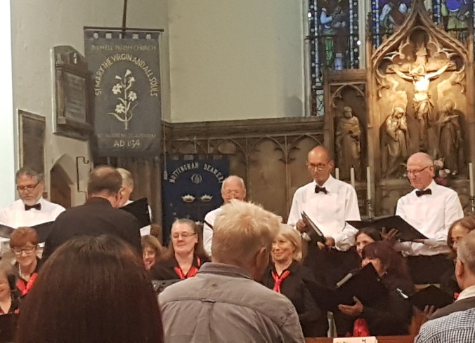
Visit and clean-up from Bulwell St Mary’s CofE Primary School, Yrs 1 and 2.

7 June
Pye Hill Male Voice Choir Concert.

13 – 15 June
Parish Pilgrimage to Walsingham ‘England’s Nazareth’.

17 June
Cantrell School Yr 3 visit to church.
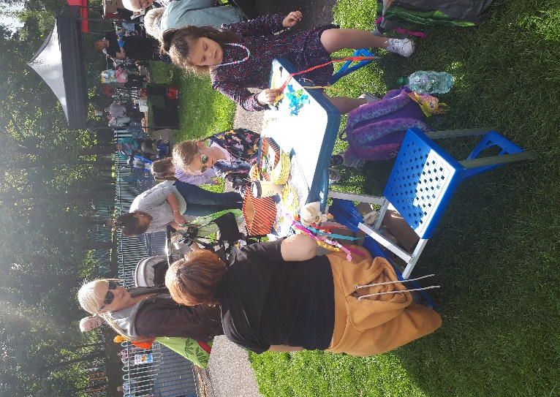
W/c 5th July – Bulwell Arts Festival Week
5th July 10am Peal to mark the start of the BAF week (Church)
5th July 2pm Church Craft Stall for the Boat Race on Bulwell Bogs (and giving out of ‘What’s on at St Mary’s’ leaflets)
5th July 7pm NHS Hospital Choir Summer Concert (Church)
7th July 11am Belly Dancing (Church)
9th July 7pm Sound of Musings (Church)

Banners by Usha Mahenthiralingam were hung in Church for the duration of the BAF week, and a static exhibition of the work of the late Emma ‘Dex’ Dexter.

7th July
Talk in church re: Autism and ADHD with the Revd. John Allister (Neurodiverse Church)
Matt Alton, a student from Bulwell Academy who occasionally worships at St Mary’s was on placement with me 7-11 July, learning about the daily life of a priest. Matt also went on a deliverance ministry visit with me and helped to bless a house!

18th July
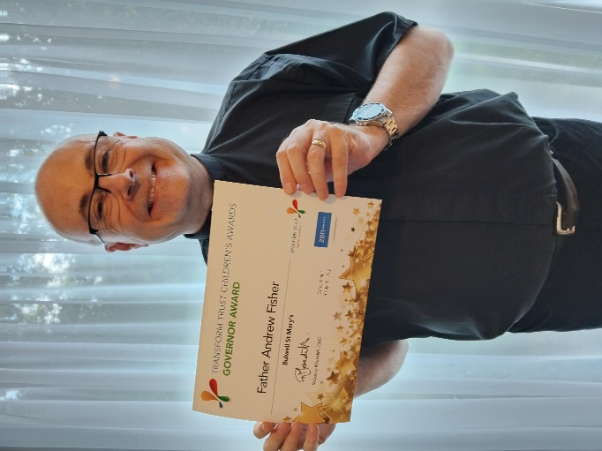
I was given a Governor’s Award from the Transform Trust at Colwick Hall in recognition of my work as a Governor at St Mary’s CofE Primary School.

23rd July
Bulwell St Mary’s Church of England Primary School Yr 6 Leavers’ Service (Church)
Archdeacon’s Visitation (Southwell Minster).

15th August
VJ 80th Anniversary Service in Church

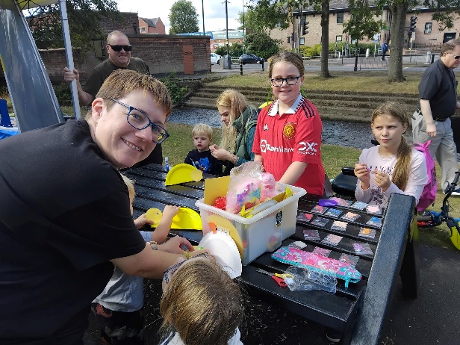
17th August
Patronal Festival Mass and Bring & Share Lunch (Church)
Farnaby & Co Choir Concert (Church)

29th August
Quarter Peal (Church)

30th August
Church Craft Stall for the Duck Race on Bulwell Bogs (and giving out of ‘What’s on at St Mary’s’ leaflets)

1st – 3rd September
I attended the National Training Conference for Deliverance Advisors, in my capacity as the Chair of the Diocesan Healing & Deliverance Ministry Team.

1st October
Opening of Bulwell Academy Community Hub. St. Mary’s has been involved with the Academy for just over two years with Rev Bob becoming a member of the Academy Council and Improvement Board, building bridges between the Church, the Academy and the community.

2nd November
‘Remembering Saints and Angels’ A Service for the Bereaved (with prayers for our departed loved ones, lighting of candles, Holy Communion)
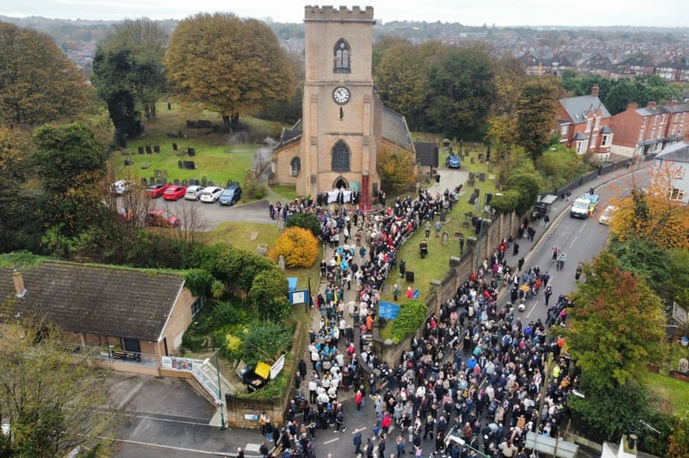
9th November
Requiem Mass for the Fallen
Remembrance Sunday Service by the Parish War Memorial

11th November
Armistice Day Service at Highbury Hospital and Dedication of Memorial Bench
Armistice Day Service by the Parish War Memorial
Armistice day Service at Fairway View Care Home

12th November
Remembrance Assembly at Bulwell St Mary’s CofE Primary School
Remembrance Assembly at Cantrell Primary School
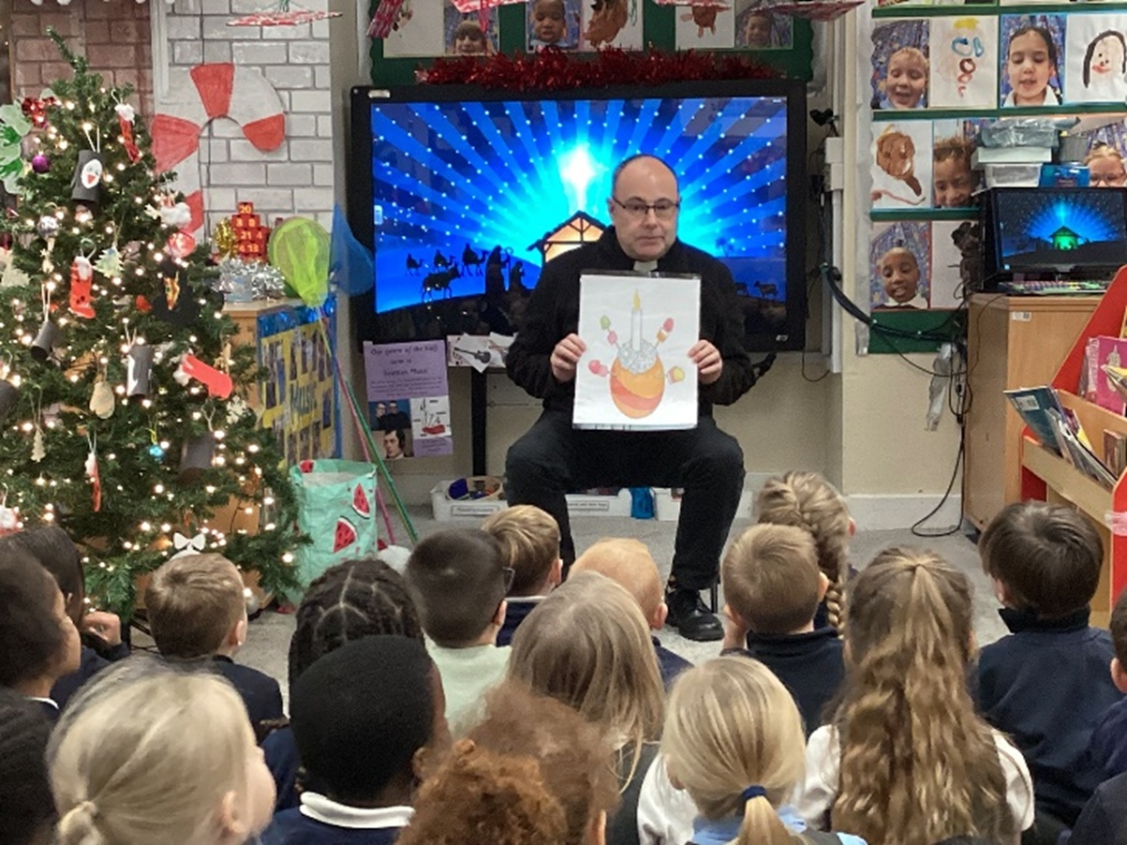
29th November
Christmas Fayre

1st December
Bulwell Christmas Lights Switch On

2nd December
Reception Years Christingle at Cantrell School

3rd December
Crabtree School Christmas Celebration in Church

4th December
Cantrell School Christingle in Church
5th December
Lully Lula Concert (Farnaby Choir)

7th December
Christingle Service

9th December
Stall at Bulwell St Mary’s CofE Primary School Christmas Fayre.

10th December
Bulwell St Mary’s CofE Primary School Christmas Service in Church

11th December
Christmas Carols & Gospel Magic at St Andrew’s, Winslow (Mental Health Unit)

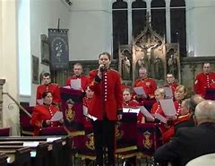
12th December
Royal Engineers’ Band Concert

14th December
Nottingham Hospitals Choir Christmas Concert
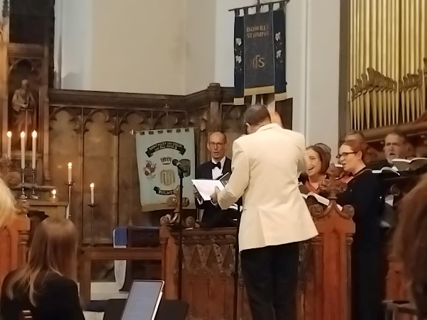
18th December
Christmas Carol Service at Highbury Hospital
Stall at Bulwell Academy Christmas Fayre

21st December
Nine Lessons & Carols

24th December (Christmas Eve)
Crib Service
Midnight Mass

25th December (Christmas Day)
Christmas Day Family Mass & Blessing of Presents

4th January (Epiphany) 2026
Family Mass and Blessing/Chalking of the Church Doors

19th January
‘Life Lounge’ at Bulwell St Mary’s CofE Primary School
Post Christmas PCC Fuddle

25th January
Service of Healing and Benediction

31st January
Quiz Night

1st February (Candlemas)
Family Mass and Blessing of Candles

8th February
Service for Healing & Wholeness remembering St Blaise, with Blessing of Throats & Holy Communion

18th February
Liturgy of Ash Wednesday (with Holy Communion and the Imposition of Ashes)

21st February
Muddy Church Pancake Party

23rd February
Inset Day Staff Meditation (Fr Andrew, St Mary's CofE Primary School)

25th February
Ash Wednesday Services (x2) at Bulwell St Mary’s CofE Primary School

14th March 2026
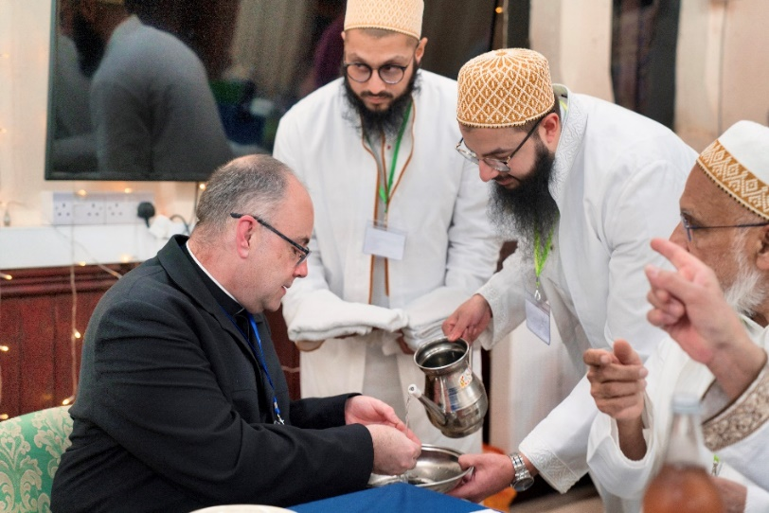
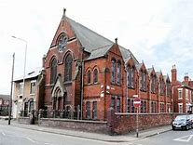
Nigel Webster (Bulwell & Bestwood Foodbank Project Manager) and Fr Andrew were invited to join the Muslim community at their mosque in Hucknall for their Ramadan Iftar (the evening meal that breaks the daily fast during Ramadan). The mosque is very generous in its giving to the Foodbank. Unfortunately, Nigel was unable to make the event. It was a special time for reflection, community building, and sharing a meal together. The community will be moving from its current premises in Hucknall (the old URC chapel on Portland Road) to Bulwell, once planning permission has been granted and their new mosque built, near the Double Tree Hotel on the edge of St Mary’s parish. The priest wrote the following letter to Fr Andrew:

Dear Fr Andrew,

I write to express my sincere thanks for your gracious presence at our Iftar gathering during the blessed month of Ramazan. It was a genuine pleasure to welcome you to our community and to share the breaking of the fast together.

I was especially pleased to have the opportunity to sit beside you and learn more about your life and your ministry in Bulwell. Our conversation about the pastoral responsibilities we carry, particularly in a time when the place of faith in society is shifting, was both thoughtful and encouraging. Your reflections on serving families while our families deal with relocation and change resonated with me.

As we spoke that evening, I was reminded that unity does not come from sameness, but from shared purpose. In our different settings, we are both striving to build trust, support families, and offer steady guidance. I found it encouraging to recognise that common ground.

The Iftar itself felt meaningful for that reason. Simply taking the time to sit together and talk strengthens the community we both serve.

Thank you once again for honouring us with your presence. I hope we may continue our dialogue and fellowship for the benefit of our communities.

With warm regards and every good wish,

Yours sincerely,
Amil Saheb, Medyan Hamiduddin
Anjuman e Ezzi Trust
Husami Markaz, 1 Henry Street
Hucknall
Nottingham

A BIG THANK YOU to everybody who helped, and helps, organise and support all our special services and events.

Vocations and Ministries

Schools and Community Outreach

Some testimonials from around St Mary’s parish:

Over the past year, our partnership between Bulwell St Mary’s CofE Primary & Nursery School and St Mary’s Church has continued to flourish and remain at the heart of our school community. The church has graciously hosted key moments in our school year, including our Harvest Festival and Easter Service, as well as our EYFS Welcome Service and our Year 6 Leavers’ Service—each providing meaningful opportunities for reflection, celebration and spiritual growth.

Father Andrew, in his role as a committed Foundation Governor, has provided invaluable support and challenge, regularly contributing to the strategic leadership of the school. Alongside Rev Bob, he has faithfully led weekly Collective Worship, helping to shape our children’s understanding of Christian values and enabling them to engage thoughtfully with faith and spirituality. Their consistent presence in school life, along with their attendance at key events, strengthens our shared vision and sense of community.

Both Father Andrew and Rev Bob offer compassionate pastoral support to pupils, families and staff, reflecting the deeply caring and inclusive ethos that underpins our work. This strong, mutually supportive relationship was recognised as a significant strength during our recent SIAMS inspection, highlighting the impact of our collective commitment to living out our Christian vision in meaningful and practical ways.

We are deeply grateful for the continued support of St Mary’s Church and look forward to building on this strong partnership in the years ahead.

Julia Burge, Headteacher, Bulwell St Mary’s CofE Primary School
Reverend Fisher visits our school, Hempshill Hall Primary School, on a termly basis to deliver themed assemblies to pupils across the age range. The messages shared are thought provoking and in line with the promotion of key Christian values that we encourage as a school. The children enjoy engaging with the content of the assemblies which are delivered in an interactive and age-appropriate way. Many thanks.
Jon Wright, Deputy Headteacher, Hempshill Hall Primary School
This year at Springfield Academy, we have enjoyed trips to the church to enrich our RE curriculum. Our Year 1 and 2 children visited the church to learn about the features of a church and what happens in certain celebrations, such as Christenings. Our Year 4 children visited the church to take part in the Easter celebration activities, developing their understanding of the Easter story. Our children have loved their experiences of visiting Bulwell St Mary’s church; it has really helped bring their curriculum to life.

Thank you,

Louise Ogle, Deputy Headteacher, Springfield Academy

Jackie Bramford, Fr Peter Sellick (St Andrews Healthcare) and Fr Andrew have been providing monthly spiritual and pastoral support St Andrews Healthcare Service Users in Bestwood. There are six residential units for people with learning difficulties: Jackie has been building rapport with them and offering them gentle connections to the Christian calendar and church events. The Service Users eagerly await Fr Andrew’s magic tricks – which be brings to the Christmas celebration.

Jackie also connects with the staff; it is a demanding and varied role. Affirming the role that faith and spirituality plays in wellbeing and care, helps everyone at St Andrews Unit to be reminded of their passion and commitment.

The connection of St Marys with the unit is valued . St Andrews Healthcare is a national charity that helps people with complex mental health needs to transform their lives: we also have units, Birmingham, Essex and Northampton.

Report by Revd Peter Sellick, Head of Chaplaincy, St Andrews Healthcare

Worship and Ministry
Alan Jackson is exploring his vocation with myself and the Diocese, and is gaining experience in leading worship, preaching and ministering at St Mary’s and around the parish.

Juliet Twumasi and her children have been worshipping with us over the last year or so. Juliet was a Licensed Lay Minister (Reader) at St John the Baptist in Bilborough (part of the Woven group of churches). Some of you will remember Juliet from when she was on placement at St Mary’s in 2024. She wrote the following article in St Mary’s parish magazine:

My name is Juliet Twumasi, a mother of four children. I enjoy socializing with family and friends; I like listening to music all the time. Serving others is something that gives me joy. I love to share my faith with others in every situation I find myself.

I worship with St John’s the Baptism which is part of Woven churches. I am privileged to do LLM with Nottinghamshire diocese and as part of my placement I had the opportunity to come to Bulwell St Mary’s the virgin and all souls Church to worship together with you.

As I embarked on my placement at the local church, I felt a mix of excitement and anticipation coursing through me. Stepping into the hallowed halls of the sanctuary, I was enveloped by a sense of peace and purpose that I had long yearned for. From the very beginning, I was welcomed with open arms by the members of the congregation, each eager to share their stories and faith with me. Under the guidance of the clergy, I embraced every opportunity to immerse myself in the diverse tapestry of church life – from giving me opportunities to do things, serving and being part of community events. With each passing day, I discovered new depths of spirituality and compassion within myself, finding fulfilment in the sacred act of serving others. My placement at the church has not only deepened my understanding of ministry but has also reaffirmed my calling to walk the path of faith with unwavering conviction and humility.

Furthermore, St. Mary the Virgin & All Souls Parish Church stands as a timeless testament to the enduring power of faith, community, and heritage. Its rich history, architectural splendour, and spiritual significance make it a beloved landmark in the heart of Bulwell, inviting all who enter to pause, reflect, and find peace amidst the hustle and bustle of modern life.

The Revd. Peter Jones came to St Mary’s from St Margaret’s, Aspley, and the benefice of Kimberley (Holy Trinity) & Nuthall. When St John’s Bulwell became vacant, Rev Peter was asked in the Deanery to offer priestly ministry at St John’s when needed. Rev Peter became an Associate Minister at St Mary’s after his wife came here from Aspley as a Licensed Lay Minister. Rev Peter has always offered to step down from ministering at St Mary’s when this was not needed and was asked to step down from ministering at St Mary’s in 2025.

Director of Music
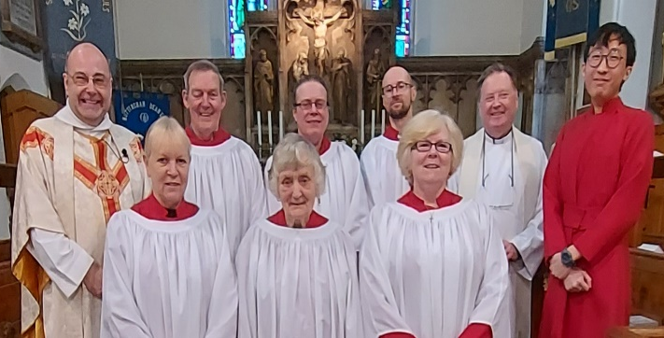
Our previous Organist, Howard, left Bulwell in 2025 to take up employment in London. In the meantime, Choir member John Hall did a sterling job playing the organ for us before he went abroad for his winter holiday. Alan and Maureen Pates have worked hard keeping the choir practices going and looking for locum organists, and Shaun Hooper from St John’s, Carrington, has played for us when available on the second Sunday of the month.

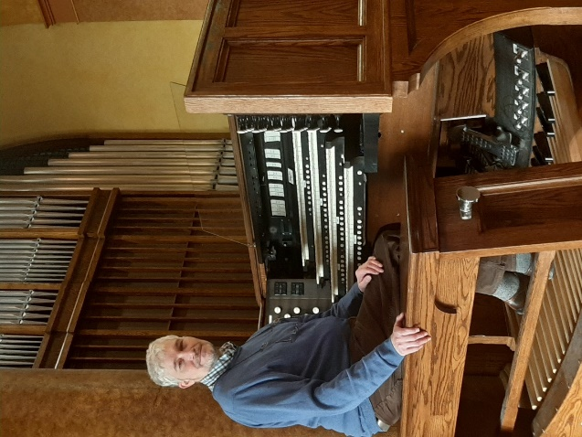
With the support of the Churchwardens and PCC, in February 2026 I was pleased to offer Ian Bevell the post of Director of Music, and Ian kindly accepted! Born in the UK in 1970, Ian William Bevell GRSM (Hons) LRAM (Organ Teacher) is an alumnus and prize winner of the Royal Academy of Music, London, UK. Ian studied the organ with Christopher Bowers-Broadbent, and Church Music studies including choral conducting with Patrick Russell. He was awarded the Lady Wallace Budge Prize for organ improvisation in 1989. Ian has a wide-ranging knowledge of Organ and Choral repertoire, as well as Church music of many styles.

The St Mary’s Mirror Notice Sheet - Temporary Editor
Karen Wolfe has done a brilliant job as our Temporary Editor for our weekly notice sheet, the ‘St Mary’s Mirror’ – helping to keep us all informed about what is happening in and church and parish each week. We are looking for a volunteer to take on the post of Editor for the weekly newsletter “The Mirror”. You will need a computer with internet and be able to use word processing software and send and receive emails and attachments. Please speak with Karen for more information.


‘The Church on the Hill’ - New Magazine Editor: Jacqueline Pichowicz
Following Ray Hotson and Fr Andrew’s recent work putting together our parish magazine, ‘The Church on the Hill’, in 2026 Jackie Pichowicz has taken on the mantle as Editor. Jackie first started coming to St Mary’s when she and her husband moved to Bulwell in 2018, and discovered the St Mary’s, ‘the Church on the hill’. While out walking, Jackie decided to have a look and has been a member of the congregation ever since. It has also been Jackie’s great pleasure to serve as a member of the PCC since 2020. As the role of Editor for the ‘The Church on the Hill’ needed filling and Jackie rather enjoyed playing around with layouts, Jackie kindly offered to give it a go, and will take over the magazine from Fr Andrew for the May 2026 edition.

Faith Study Sessions and Tea & Toast
The thriving Thursday Faith Study Group wished to continue during Lent as St Mary’s Lent Course, attracting up to 25 participants each week. Martin and Eagle led some stand-alone sessions using Café resources (thank you, both). The Group has studied the Book of Revelation amongst other things. Thursdays are a wonderfully busy day at St Mary’s, with over new 2026 venture ‘Tea & Toast’ being open to the Church and parish following our 9.30am Mass.

Children & Family Worker – Strategic Development Fund (SDF)4 Funding
Having secured funding through the Diocese and the national Church of England Strategic Development Fund for a part-time Children & Family Worker, we have advertised for the post twice in 2025, both locally and through the Diocesan website. There was some interest in the post, but some applications were deemed to be unsuitable, and one applicant would have had childcare issues carrying out the role. A copy of the Job Description is attached, should anyone know of anybody suitable who would be interested in the role. I have spoken with the Diocese who have recommended that St Mary’s shifts the current proposal into a new funding stream and re-advertises it as a full-time post.

Fr Andrew Fisher, Incumbent (Chair, PCC).

St Mary’s Church is looking to appoint a Children & Families Worker. Could this be you?!

Children & Families Worker, St Mary the Virgin & All Souls Church, Bulwell Nottingham
15 hours per week / £15 per hour. Contributory pension scheme (3%) / 20 days holiday per annum plus 8 bank holidays (pro rata for part time) and two discretionary days / 2.5 years fixed term

We are looking for a passionate and gifted Children & Families Worker to join the team here at St Mary the Virgin & All Souls church, Bulwell, Nottingham. This is a vital role in helping our children continue to deepen their faith and grow in discipleship, as well as connecting with their families and families in our communities.

We are looking for someone who is able to demonstrate a clear passion for working with children and their families, and can demonstrate creativity in communicating in interactive, engaging and relevant ways. This person will also have a clear understanding of safeguarding practices and, while not essential, it would be ideal for this person to have previous experience in leading children’s ministry.

Job Description & Person Specification: (see following/attached)

Deadline: 11th May 2025

How to apply: Submit a CV and covering letter to andrew.fisher@southwell.anglican.org

For more information or an informal conversation, please contact Fr Andrew Fisher 0115 975 5358 andrew.fisher@southwell.anglican.org

We hope to interview 20th May 2025

CHILDREN & FAMILIES WORKER
LOCATION – ST MARY THE VIRGIN & ALL SOULS, BULWELL, NOTTINGHAM

JOB PROFILE
Title: | Children & Families Worker
Contract: | Part Time, 2.5 years
Reports to: | Vicar
Location: | St Mary the Virgin & All Souls Church, Bulwell, and Bulwell St Mary’s Church of England Primary School.
Basis of employment: | Part Time - 15 hours per week
DBS check required? (Yes/No) | Yes
Special conditions of employment | There is a genuine occupational requirement for the post holder to be a communicant member of the Church of England or a member of the Churches Together in Britain & Ireland.
Date written/updated | 7th January 2025

PURPOSE OF ROLE
To develop St Mary’s Children (3-11 yrs.) and Families Ministry within the Parish, reaching and discipling children in the church, and subsequently extending outreach into the surrounding parish by working in partnership with our local primary schools (in particular Bulwell St Mary’s Church of England Primary School).

MAIN RESPONSIBILITIES
- Provide strategic leadership of the children & families ministry under the authority/guidance of the vicar with the aim of creating new children & families missional initiatives to reach and disciple families. Work closely with the vicar to develop and implement a clear children and families strategy, and effective Growing Disciples Plan.
- Work closely with the vicar to establish the children and families vision at the heart of the church.
- Establish a thriving children and families ministry with an average of 25 ‘new’ children engaged in weekly worship & discipleship groups.
- Establish a New Worshipping Community (NWC) focused on reaching children & families in fresh ways (likely to be in the church or Bulwell St Mary’s Church of England Primary School).
- Monitor and report quarterly on progress using the Growing Disciples Plan, identifying priorities, risks, learning and next steps.
- Build, run and train an effective volunteer team.
- Oversee the children’s and families budget working with the Vicar/Treasurer/Churchwardens to run it effectively.
- Work with the Vicar/Treasurer/Churchwardens to explore possible funding opportunities to further the development of the ministry.
- Ensure all Safeguarding policies and procedures are adhered to in all working practices.
- Work alongside the Leadership Team (Vicar, Associate Ministers and Churchwardens)/Children & Young People’s Committee/Parochial Church Council (PCC) on key objectives to serve the wider parish.

ROLE DIMENSIONS
Budget management (where relevant) | Monitoring children/families budget
People management | Line management of other volunteers and, where applicable, employed families workers, including recruitment, performance management and development
Key relationships – internal | Vicar and Leadership Team, Children & Young People’s Committee, PCC
Key relationships – external | Primary schools in the parish (in particular Bulwell St Mary’s Church of England Primary School)  Other children’s organisations e.g. uniformed organisations.  Diocesan Lead for Growing Younger Disciples (Children & Youth Lead), Children & Youth work Trainer & Enabler, Operations Administrator – Children & Youth & Project Support Officer.

PERSON SPECIFICATION
 | Essential | Desirable
Personal Characteristics | Passionate and vibrant personal Christian faith which inspires children and families in their walk with God.  Passionate about reaching children and families not currently in church.  Comfortable in operating their own spiritual giftings and the ability to develop spiritual gifts in others.  Prepared to take risks and in mission, make mistakes and learn from them.
Competencies and Skills | Ability to help children and families connect with Jesus and develop in their faith.  Ability to inspire people to volunteer in the children and families ministry.  Excellent communicator particularly with children and families.  Ability to work as part of a team, able to support and bring out the best in colleagues.  Competent user of Microsoft office products (word, excel etc).
Qualification and Experience | Educated to A level standard or equivalent level of work experience.  Experience of working with children and families.  Experience of leading/developing others including volunteers. | Experience of children and family work in a church setting.  Relevant qualification.  Valid first aid certificate.  Food hygiene certificate.
Knowledge and Understanding | Knowledge of the strategies to be employed to encourage Children and Families into becoming members of the worshipping community.  Good understanding of the principles of Safeguarding of Children and Vulnerable Adults, and willingness to develop a thorough working knowledge of safeguarding.
Special Requirements | Willing and able to work flexibly, recognising that Church life does not fit normal office hours. You can expect to work some evenings and weekends and to attend and participate in meetings/events.

TERMS OF EMPLOYMENT
Work pattern | Standard working hours are 15 hours per week. It is expected that staff members will be active members of Church including Sunday services. Flexible working essential according to the needs of the role and responsibilities.
Salary | £15 per hour. Contributory pension scheme (3%).
Holiday | 20 days holiday per annum plus 8 bank holidays (pro rata for part time) and two discretionary days.
Probation | 6 months (followed by review)

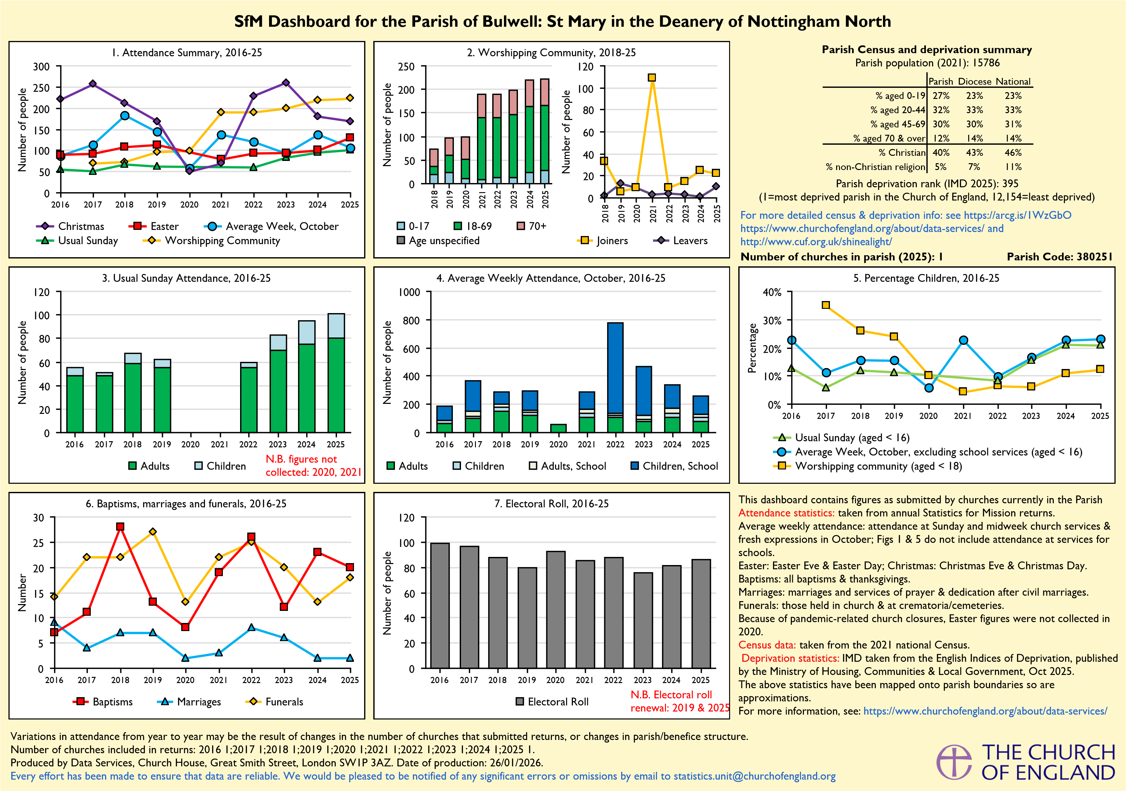
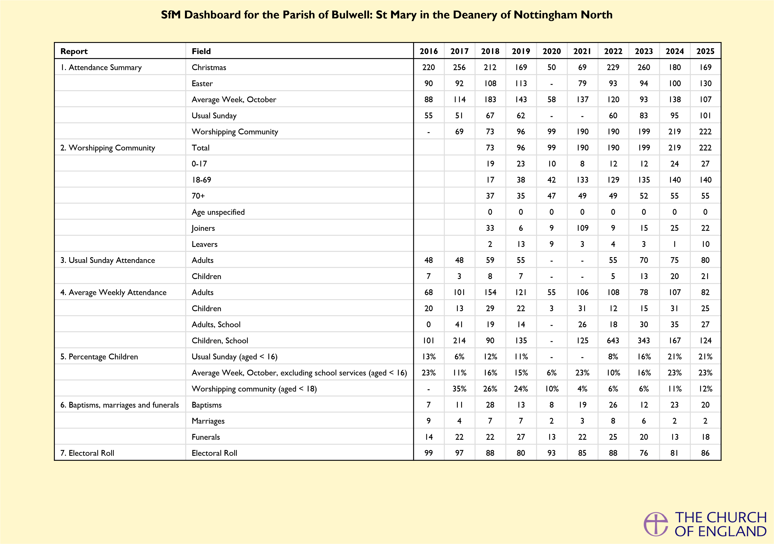

St Mary the Virgin & All Souls Parochial Church Council
STATEMENT OF ACCOUNTS
FOR THE YEAR ENDED
31st DECEMBER 2025

REPORT OF THE PCC FOR THE YEAR ENDING 31 DECEMBER 2025

Administrative information

St. Mary the Virgin and All Souls Church is on Highbury Road, Bulwell, Nottingham NG6 9AD. It is part of the Diocese of Southwell & Nottingham. The correspondence address is The Rectory, Station Road, Bulwell, Nottingham, NG6 9AA.

The Parochial Church Council (PCC) is a charity excepted from registration with the Charity Commission.
PCC members who have served since the 2025 Annual Parochial Church Meeting until the date this report was approved are:

Incumbent: Fr Andrew Fisher
Church Wardens: Eleanor Lang
Martin Walton
Associate Priests: Revd Robert Stephens

Licensed Lay Minister Juliette Twumasi

Representatives on the Deanery Synod:
Christopher Guy

Elected Members:
Retiring 2026: Zoe Elliott
Jackie Bramford

Retiring 2027: Phillip Hague
Sam Reynolds
Carole Jackson

Retiring 2028: Alan Jackson
Jackie Pichowicz
Les Ward

Retiring Co-opted
Members: Helen Lily

Structure, governance and management

The method of appointment of PCC members is set out in the Church Representation Rules. All Church attendees are encouraged to register on the Electoral Roll and stand for election to the PCC.

Objectives and activities

The PCC has the responsibility of co-operating with the Vicar, in promoting in the ecclesiastical parish, the whole mission of the church, pastoral, evangelistic, social and ecumenical. It also has financial and maintenance responsibilities for St Mary’s Church.

The number of parishioners on the Church Electoral Roll was 76 at the end of 2025. The previous year, at the end of 2024 it was 81.

Parish Returns:
All details are available in the Parish Returns Online document
(includes Sunday and midweek church services & fresh expressions in October but excludes attendance at services for schools).

Review of the year

This is in the annual reports which are in a separate document distributed with these accounts prior to the Annual Parochial Church Meeting.

Reserves Policy

At present, it is the PCC’s policy in its bank current accounts at the end of each month, to ensure that its bank balances remain in surplus, and that it can meet all routine expenditure in the following month, and any unexpected situations that may arise from time to time.

Financial Review

Parish Share is paid to the Church of England (Diocese of Southwell & Nottingham) and is mainly to pay for the cost of vicars across the deanery and diocese. In 2025 we paid £27,404 in Parish Share, which was £116 more than the amount due. That £116 has been credited to the Deanery Shortfall fund 2025.

Approved by the PCC on May 2026 and signed on its behalf by:

Fr Andrew Fisher, Vicar and PCC Chairman. _____________________________

INDEPENDENT EXAMINER’S REPORT TO THE MEMBERS OF THE PAROCHIAL CHURCH COUNCIL
I have examined the financial statements on Pages 4 to 10 and the accounting policies set out on Page 6.
RESPECTIVE RESPONSIBILITIES OF THE PAROCHIAL CHURCH COUNCIL & EXAMINER
The Charity’s trustees consider that an audit is not required for this year (under Section 144(2) of the Charities Act 2011 (the Act)) and that an independent examination is needed.
It is my responsibility to:-
- Examine the accounts (under Section 145 of the Act)
- To follow the Directions given by the Charity Commission (under Section 145(5)(b) of the Act) and:-
- To state whether particular matters have come to my attention.

BASIS OF INDEPENDENT EXAMINER’S STATEMENT
My examination was carried out in accordance with General Directions given by the Charity Commissioners. An examination includes a review of the accounting records kept by the Charity and a comparison of the accounts presented with those records. It also includes consideration of any unusual items or disclosures in the accounts and seeking explanations from the trustees concerning any such matters. The procedures undertaken do not provide all the evidence that would be required in an audit and consequently I do not express an audit opinion on the accounts.

INDEPENDENT EXAMINER’S STATEMENT
In the course of my examination no matter has come to my attention:
i) Which gives me reasonable cause to believe that in any material respect the trustees have not met the requirements to ensure that:-
- Proper accounting records are kept (in accordance with Section 130 of the Act) and
- Accounts are prepared which agree with the accounting records and comply with the accounting requirements of the Act or

ii) To which, in my opinion, attention should be drawn in order to enable a proper understanding of the accounts to be reached.

Receipts and payments
 | From | 01 January 2025 | 01 January 2024
Note | To | 30 December 2025 | 30 December 2024
FF - Flowers Fund (Designated) Fund
Income and endowments from:
Donations and legacies
Individual Donations |  | 25.00 | 125.00
Total Donations and legacies |  | 25.00 | 125.00
Total Income and endowments from: |  | 25.00 | 125.00
Expenditure on:
Expenditure on charitable activities
Upkeep of services |  | 29.20 | 44.20
Total Expenditure on charitable activities |  | 29.20 | 44.20
Total Expenditure on: |  | 29.20 | 44.20
Excess of Income and endowments over Expenditure |  | (4.20) | 80.80
Brought forward balance |  | 48.87 | (31.93)
Total carried forward balance |  | 44.67 | (31.93)
CC - Collections For Charity (Designated) Fund
Income and endowments from:
Donations and legacies
Donations appeals etc |  | - | 120.80
Total Donations and legacies |  | - | 120.80
Total Income and endowments from: |  | - | 120.80
Excess of Income and endowments over Expenditure |  | - | 120.80
Brought forward balance |  | 120.80 | -
Total carried forward balance |  | 120.80 | -
MF - Mission Fund (Designated) Fund
Expenditure on:
Raising funds
Costs of fetes & other events |  | - | 150.00
Total Raising funds |  | - | 150.00
Expenditure on charitable activities
Parish training and mission |  | - | 138.35
Total Expenditure on charitable activities |  | - | 138.35
Total Expenditure on: |  | - | 288.35
Excess of Income and endowments over Expenditure |  | - | (288.35)
Brought forward balance |  | 622.93 | 911.28
Total carried forward balance |  | 622.93 | 911.28
STF - Social Team Fund (Designated) Fund
 |  | - | -
Brought forward balance |  | 1,000.00 | 1,000.00
Total carried forward balance |  | 1,000.00 | 1,000.00
BC - Baptism Certificate (Designated) Fund
Income and endowments from:
Other income
Baptism Certificate |  | 77.00 | 158.00
Total Other income |  | 77.00 | 158.00
Total Income and endowments from: |  | 77.00 | 158.00
Excess of Income and endowments over Expenditure |  | 77.00 | 158.00
Brought forward balance |  | 259.00 | 101.00
Total carried forward balance |  | 336.00 | 101.00
WPF - Walsingham Pilgrimage Fund (Designated) Fund
Income and endowments from:
Other income
Walsingham Pilgrimage Money |  | 3,879.00 | -
Total Other income |  | 3,879.00 | -
Total Income and endowments from: |  | 3,879.00 | -
Expenditure on:
Expenditure on charitable activities
Home mission |  | 1,200.00 | -
Total Expenditure on charitable activities |  | 1,200.00 | -
Total Expenditure on: |  | 1,200.00 | -
Excess of Income and endowments over Expenditure |  | 2,679.00 | -
Brought forward balance |  | - | -
Total carried forward balance |  | 2,679.00 | -
VDF - Vicar's Discretionary Fund (Designated) Fund
Expenditure on:
Expenditure on charitable activities
Home mission |  | - | 3.99
Total Expenditure on charitable activities |  | - | 3.99
Total Expenditure on: |  | - | 3.99
Excess of Income and endowments over Expenditure |  | - | (3.99)
Brought forward balance |  | (3.99) | -
Total carried forward balance |  | (3.99) | -
T & C - Tea And Coffee Income (Designated) Fund
Income and endowments from:
Donations and legacies
Other funds generated |  | 468.99 | 415.65
Total Donations and legacies |  | 468.99 | 415.65
Total Income and endowments from: |  | 468.99 | 415.65
Excess of Income and endowments over Expenditure |  | 468.99 | 415.65
Brought forward balance |  | 485.73 | 57.93
Total carried forward balance |  | 954.72 | 57.93
GDF - Growing Disciples Fund (Designated) Fund
Expenditure on:
Raising funds
Costs of fetes & other events |  | - | 70.98
Total Raising funds |  | - | 70.98
Expenditure on charitable activities
Home mission |  | - | 354.03
Total Expenditure on charitable activities |  | - | 354.03
Total Expenditure on: |  | - | 425.01
Excess of Income and endowments over Expenditure |  | - | (425.01)
Brought forward balance |  | 277.06 | 702.07
Total carried forward balance |  | 277.06 | 702.07
EE - Easter Experience (Designated) Fund
 |  | - | -
Brought forward balance |  | 1,300.00 | 1,300.00
Total carried forward balance |  | 1,300.00 | 1,300.00
RFH - Restricted Fund HSBC (Restricted) Fund
Expenditure on:
Expenditure on charitable activities
Organ / piano tuning |  | 204.00 | 288.00
Church maintenance |  | 1,333.04 | 1,051.53
Administration |  | - | 7,425.13
Church major repairs - structure |  | 3,270.00 | -
Total Expenditure on charitable activities |  | 4,807.04 | 8,764.66
Total Expenditure on: |  | 4,807.04 | 8,764.66
Excess of Income and endowments over Expenditure |  | (4,807.04) | (8,764.66)
Brought forward balance |  | (16,845.25) | (8,080.59)
Total carried forward balance |  | (21,652.29) | (8,080.59)
RFL - Restricted Fund Leeds BS (Restricted) Fund
Income and endowments from:
Investments
Bank and building society interest |  | 2,191.34 | -
Total Investments |  | 2,191.34 | -
Total Income and endowments from: |  | 2,191.34 | -
Excess of Income and endowments over Expenditure |  | 2,191.34 | -
Brought forward balance |  | - | -
Total carried forward balance |  | 2,191.34 | -
RFM - Restricted Fund Mansfield BS (Restricted) Fund
Income and endowments from:
Investments
Bank and building society interest |  | 2,755.65 | -
Total Investments |  | 2,755.65 | -
Total Income and endowments from: |  | 2,755.65 | -
Excess of Income and endowments over Expenditure |  | 2,755.65 | -
Brought forward balance |  | - | -
Total carried forward balance |  | 2,755.65 | -
General - General Fund (Unrestricted) Fund
Income and endowments from:
Donations and legacies
Gift Aid - Envelopes |  | 1,115.97 | 2,547.10
Other planned giving |  | 7,153.35 | 6,047.00
Loose plate collections |  | 7,531.69 | 7,274.62
Electronic Donations |  | 2,363.26 | 1,542.95
Giving through church boxes |  | 71.29 | 330.10
One-off Gift Aid gifts |  | 5.00 | -
Individual Donations |  | 2,647.11 | 4,244.67
Donations appeals etc |  | 45.00 | 87.70
Legacies |  | 3,000.00 | 120,000.00
Non-recurring one-off grants |  | - | 350.00
Other funds generated |  | 4,370.78 | 6,016.29
Total Donations and legacies |  | 28,303.45 | 148,440.43
Income from charitable activities
Fees for weddings and funerals |  | 8,294.25 | 7,127.80
Bookstall sales to promote objectives |  | - | 10.07
Church hall lettings - objectives |  | - | 105.00
Total Income from charitable activities |  | 8,294.25 | 7,242.87
Investments
Bank and building society interest |  | 10.58 | 165.17
Rent from lands or buildings |  | 5,273.50 | 7,004.00
Total Investments |  | 5,284.08 | 7,169.17
Other income
Group/Organisation Donations |  | 1,350.00 | 870.00
Walsingham Pilgrimage Money |  | 80.00 | 2,432.00
Insurance claims |  | - | 130.00
Total Other income |  | 1,430.00 | 3,432.00
Total Income and endowments from: |  | 43,311.78 | 166,284.47
Expenditure on:
Raising funds
Fees paid to fund raisers |  | 50.00 | -
Costs of stewardship campaign |  | 198.56 | 1,449.00
Costs of fetes & other events |  | 380.55 | 460.43
Total Raising funds |  | 629.11 | 1,909.43
Expenditure on charitable activities
Giving to missionary societies |  | - | 87.70
Giving - relief and development agencies |  | 121.30 | -
Home mission |  | 4,440.52 | 2,421.46
Secular charities |  | 233.73 | -
Ministry parish share etc |  | 31,579.00 | 25,530.00
Assistant staff costs |  | - | 42.79
Working expenses of incumbent |  | 2,563.70 | 2,815.82
Parish training and mission |  | 20.00 | 78.05
Church running - insurance |  | 5,644.80 | 5,454.42
Organ / piano tuning |  | 180.00 | -
Church maintenance |  | 1,324.86 | 3,418.49
Upkeep of services |  | 2,583.60 | 1,348.14
Administration |  | 35.67 | -
Church running - electric |  | 4,106.97 | 3,649.47
Church running - gas |  | 4,158.90 | 3,377.47
Church running - water |  | 215.57 | 190.64
Hall running - electricity |  | 87.82 | -
Other PCC property upkeep |  | 2,827.12 | 339.20
Total Expenditure on charitable activities |  | 60,123.56 | 48,753.65
Other expenditure
Bellringer's Fees |  | 445.00 | 405.00
Organist Fees |  | 3,498.50 | 3,080.00
Expenses of Associate Ministers |  | 628.34 | 889.54
Vicar's Funeral Travel expenses |  | 287.00 | 160.00
Treasurer's Expenses |  | 150.00 | 94.60
PCC Expenses |  | 1,230.67 | 2,049.04
Church Network/Internet |  | 911.75 | 1,166.10
Church Printer Costs |  | 1,693.97 | 1,037.77
Catering and Cleaning |  | 470.47 | 92.82
Printer Paper |  | 80.38 | -
Bank Charges |  | 55.64 | 170.37
Total Other expenditure |  | 9,451.72 | 9,145.24
Total Expenditure on: |  | 70,204.39 | 59,808.32
Excess of Income and endowments over Expenditure |  | (26,892.61) | 106,476.15
Brought forward balance |  | 340,087.91 | 232,833.78
Total carried forward balance |  | 313,195.30 | 232,833.78
None - Agency collection (Restricted) Fund
 |  | - | -
Brought forward balance |  | 169,857.78 | 169,857.78
Total carried forward balance |  | 169,857.78 | 169,857.78

Statement of Assets and Liabilities (by code)
Class and nominal code |  | General | Designated | Restricted | Endowment | Total | Last year
Fixed Asset - Investments
 | 6430: Property | 175,000.00 | - | - | - | 175,000.00 | 175,000.00
Total |  | 175,000.00 | - | - | - | 175,000.00 | 175,000.00
Current Asset - Cash At Bank And In Hand
 | 6501: Bank current account | 97,734.40 | 4,570.78 | 3,149.34 | - | 105,454.52 | 120,962.87
 | 6502: Choir Account | 716.78 | - | - | - | 716.78 | 707.99
 | 6503: Bequests Account | 239.79 | - | - | - | 239.79 | 238.00
 | 6504: Lloyds Treasurer's Account | 38,519.37 | 3,137.14 | (2,287.04) | - | 39,369.47 | 52,540.60
 | 6505: Cater Allen Account | - | - | 5,977.29 | - | 5,977.29 | 5,977.29
 | 6506: Virgin Money Account | - | - | 467.51 | - | 467.51 | 467.51
 | 6507: Leeds Building Society | 150.32 | - | 94,194.82 | - | 94,345.14 | 89,398.15
 | 6508: Mansfield Building Society | - | - | 51,650.56 | - | 51,650.56 | 51,650.56
 | 6590: Cash Box Account | 766.62 | (376.73) | - | - | 389.89 | 267.87
Total |  | 138,127.28 | 7,331.19 | 153,152.48 | - | 298,610.95 | 322,210.84
Net total assets |  | 313,127.28 | 7,331.19 | 153,152.48 | - | 473,610.95 | 497,210.84
Represented by
 | General (Unrestricted) | 313,127.28 | - | - | - | 313,127.28 | 340,087.91
 | Designated - BC | - | 336.00 | - | - | 336.00 | 259.00
 | Designated - CC | - | 120.80 | - | - | 120.80 | 120.80
 | Designated - EE | - | 1,300.00 | - | - | 1,300.00 | 1,300.00
 | Designated - FF | - | 44.67 | - | - | 44.67 | 48.87
 | Designated - GDF | - | 277.06 | - | - | 277.06 | 277.06
 | Designated - MF | - | 622.93 | - | - | 622.93 | 622.93
 | Designated - STF | - | 1,000.00 | - | - | 1,000.00 | 1,000.00
 | Designated - T & C | - | 954.72 | - | - | 954.72 | 485.73
 | Designated - VDF | - | (3.99) | - | - | (3.99) | (3.99)
 | Designated - WPF | - | 2,679.00 | - | - | 2,679.00 | -
 | Restricted - None | - | - | 169,857.78 | - | 169,857.78 | 169,857.78
 | Restricted - RFH | - | - | (21,652.29) | - | (21,652.29) | (16,845.25)
 | Restricted - RFL | - | - | 2,191.34 | - | 2,191.34 | -
 | Restricted - RFM | - | - | 2,755.65 | - | 2,755.65 | -
Total |  | 313,127.28 | 7,331.19 | 153,152.48 | - | 473,610.95 | 497,210.84

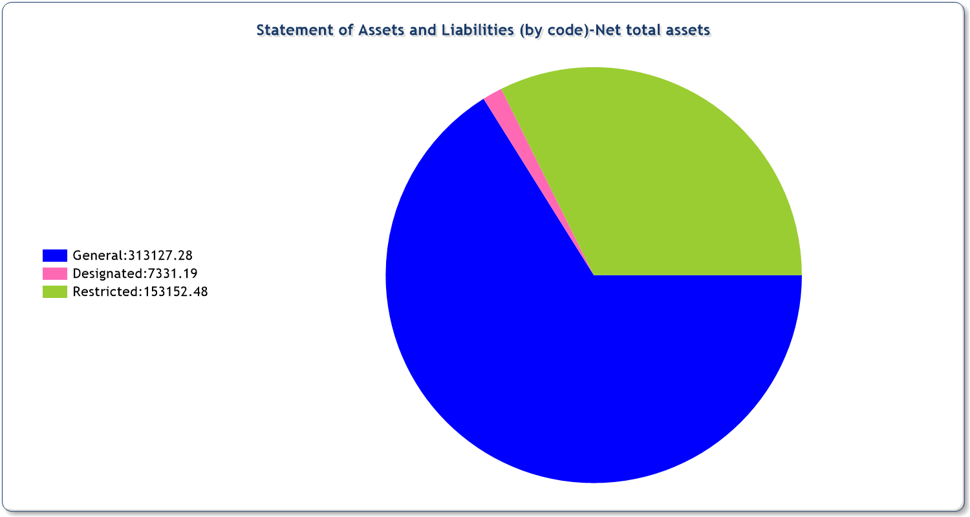
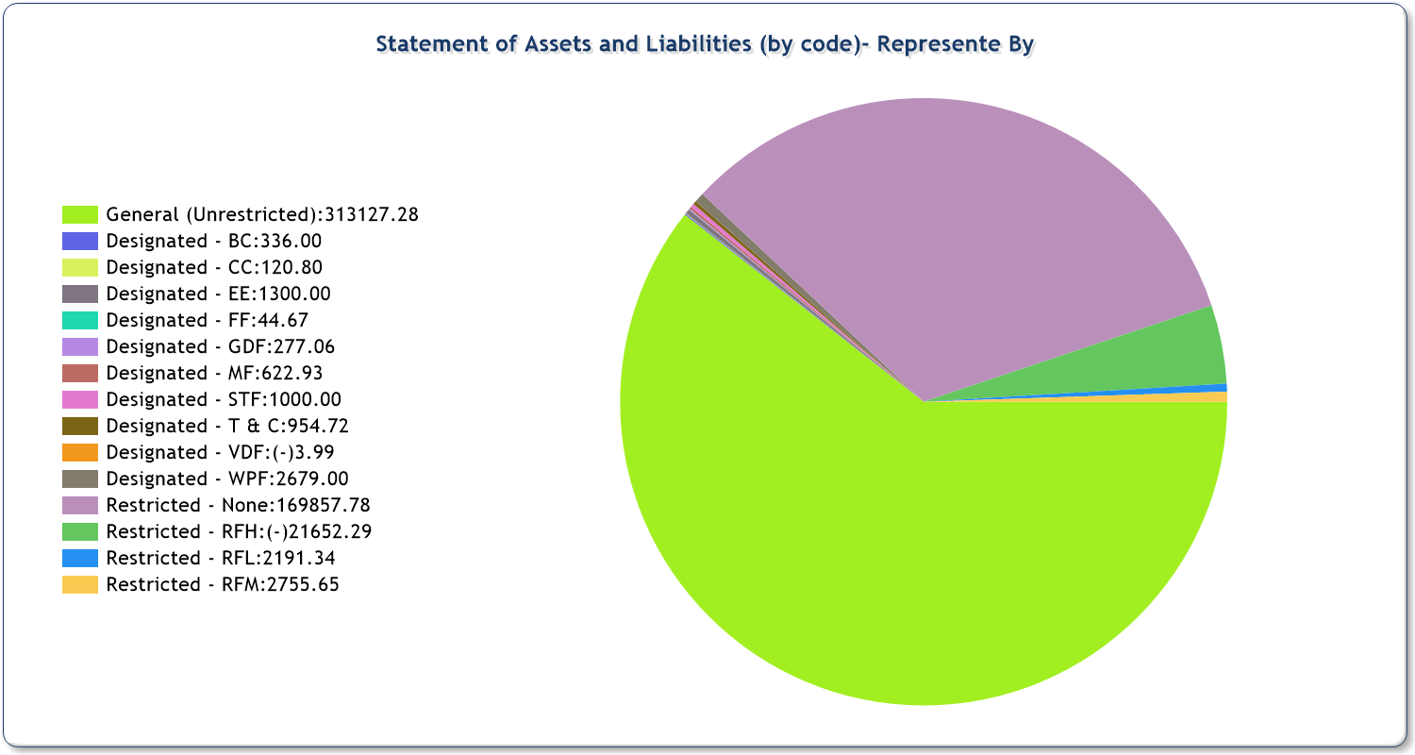
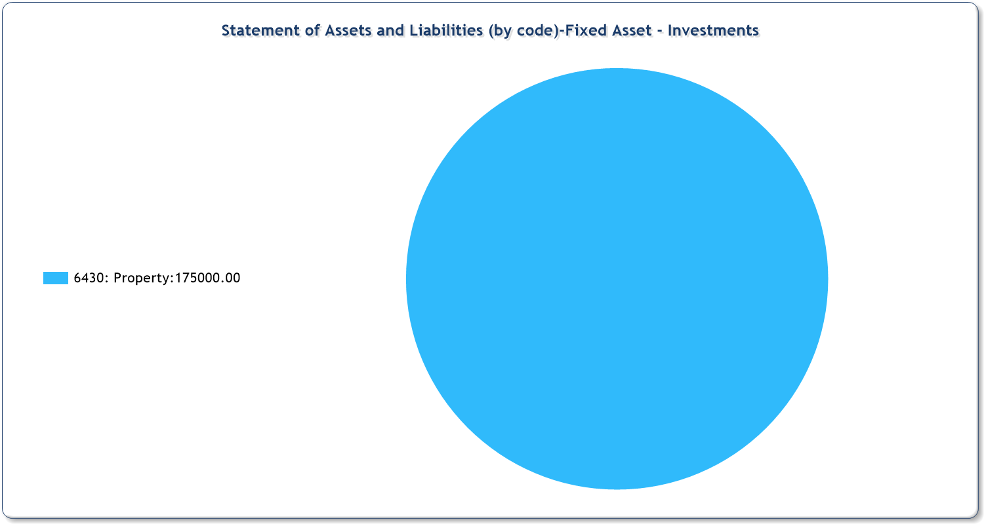
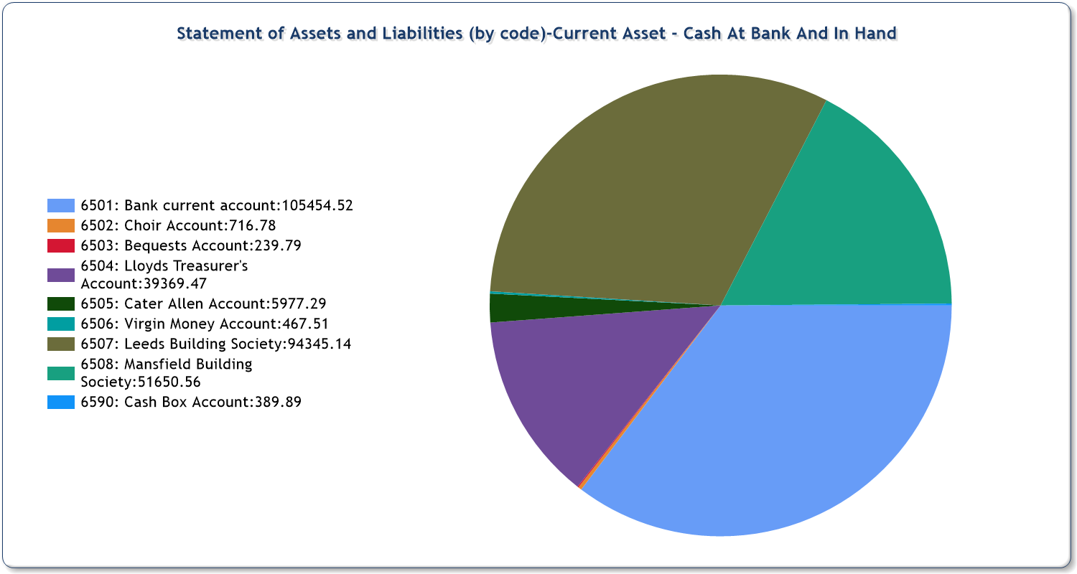
Fund movement summary
Fund | Opening | Incoming | Outgoing | Transfers | Gains/Losses | Journals | Closing
BC
Designated | 259.00 | 77.00 | - | - | - | - | 336.00
Sub-totals | 259.00 | 77.00 | - | - | - | - | 336.00
CC
Designated | 120.80 | - | - | - | - | - | 120.80
Sub-totals | 120.80 | - | - | - | - | - | 120.80
EE
Designated | 1,300.00 | - | - | - | - | - | 1,300.00
Sub-totals | 1,300.00 | - | - | - | - | - | 1,300.00
FF
Designated | 48.87 | 25.00 | 29.20 | - | - | - | 44.67
Sub-totals | 48.87 | 25.00 | 29.20 | - | - | - | 44.67
GDF
Designated | 277.06 | - | - | - | - | - | 277.06
Sub-totals | 277.06 | - | - | - | - | - | 277.06
MF
Designated | 622.93 | - | - | - | - | - | 622.93
Sub-totals | 622.93 | - | - | - | - | - | 622.93
RFH
Restricted | (16,845.25) | - | 4,807.04 | - | - | - | (21,652.29)
Sub-totals | (16,845.25) | - | 4,807.04 | - | - | - | (21,652.29)
RFL
Restricted | - | 2,191.34 | - | - | - | - | 2,191.34
Sub-totals | - | 2,191.34 | - | - | - | - | 2,191.34
RFM
Restricted | - | 2,755.65 | - | - | - | - | 2,755.65
Sub-totals | - | 2,755.65 | - | - | - | - | 2,755.65
STF
Designated | 1,000.00 | - | - | - | - | - | 1,000.00
Sub-totals | 1,000.00 | - | - | - | - | - | 1,000.00
T & C
Designated | 485.73 | 468.99 | - | - | - | - | 954.72
Sub-totals | 485.73 | 468.99 | - | - | - | - | 954.72
VDF
Designated | (3.99) | - | - | - | - | - | (3.99)
Sub-totals | (3.99) | - | - | - | - | - | (3.99)
WPF
Designated | - | 3,879.00 | 1,200.00 | - | - | - | 2,679.00
Sub-totals | - | 3,879.00 | 1,200.00 | - | - | - | 2,679.00
General
Unrestricted | 340,087.91 | 43,331.78 | 70,292.41 | - | - | - | 313,127.28
Sub-totals | 340,087.91 | 43,331.78 | 70,292.41 | - | - | - | 313,127.28
None
Restricted | 169,857.78 | - | - | - | - | - | 169,857.78
Sub-totals | 169,857.78 | - | - | - | - | - | 169,857.78
Totals | 497,210.84 | 52,728.76 | 76,328.65 | - | - | - | 473,610.95

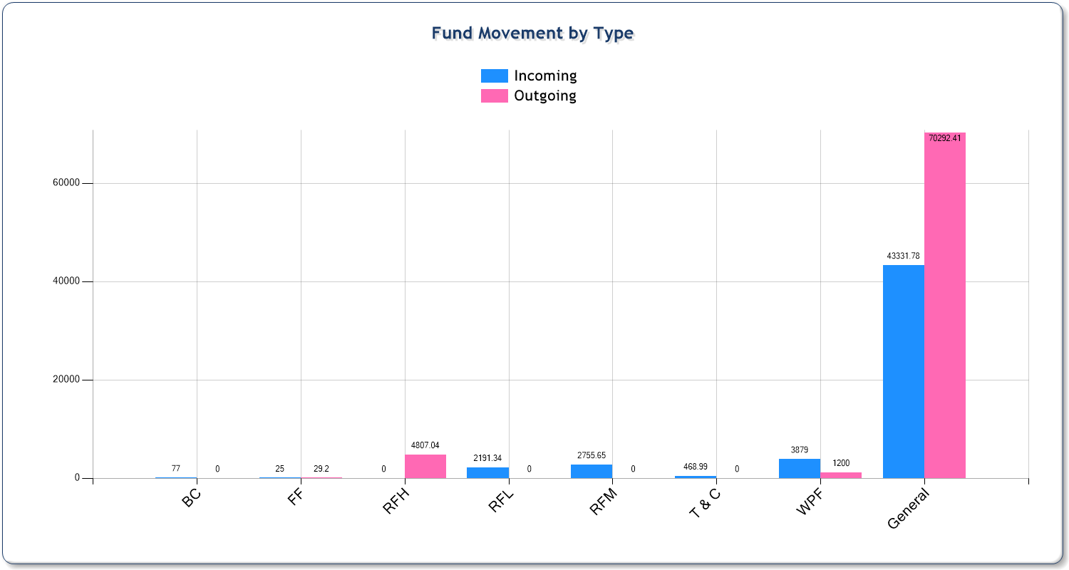
Analysis of income and expenditure
 |  |  |  |  |  | Total
 |  | Unrestricted | Designated | Restricted | Endowment | This year | Last year
Income and endowments from:
Donations and legacies
0101 - Gift Aid - Bank |  | - | - | - | - | - | -
0110 - Gift Aid - Envelopes |  | 1,115.97 | - | - | - | 1,115.97 | 2,547.10
0201 - Other planned giving |  | 7,153.35 | - | - | - | 7,153.35 | 6,067.00
0301 - Loose plate collections |  | 7,531.69 | - | - | - | 7,531.69 | 7,367.87
0302 - Electronic Donations |  | 2,363.26 | - | - | - | 2,363.26 | 1,542.95
0401 - Regular gift days |  | - | - | - | - | - | -
0410 - Giving through church boxes |  | 71.29 | - | - | - | 71.29 | 330.10
0501 - One-off Gift Aid gifts |  | 5.00 | - | - | - | 5.00 | -
0502 - Individual Donations |  | 2,647.11 | 25.00 | - | - | 2,672.11 | 4,369.67
0550 - Donations appeals etc |  | 45.00 | - | - | - | 45.00 | 208.50
0601 - Tax recoverable on Gift Aid |  | - | - | - | - | - | -
0701 - Legacies |  | 3,000.00 | - | - | - | 3,000.00 | 120,000.00
0801 - Recurring grants |  | - | - | - | - | - | -
08A1 - Non-recurring one-off grants |  | - | - | - | - | - | 350.00
0901 - Other funds generated |  | 4,370.78 | 468.99 | - | - | 4,839.77 | 7,138.82
Donations and legacies Totals |  | 28,303.45 | 493.99 | - | - | 28,797.44 | 149,922.01
Income from charitable activities
1101 - Fees for weddings and funerals |  | 8,294.25 | - | - | - | 8,294.25 | 7,127.80
1210 - Bookstall sales to promote objectives |  | - | - | - | - | - | 10.07
1230 - Church hall lettings - objectives |  | - | - | - | - | - | 105.00
Income from charitable activities Totals |  | 8,294.25 | - | - | - | 8,294.25 | 7,242.87
Other trading activities
0910 - Rummage sales etc |  | - | - | - | - | - | -
1220 - Bookstall sales - fund raising |  | - | - | - | - | - | -
1240 - Church hall lettings - fund raising |  | - | - | - | - | - | -
1250 - Magazine income - advertising |  | - | - | - | - | - | -
1260 - Parish magazine sales |  | - | - | - | - | - | -
Other trading activities Totals |  | - | - | - | - | - | -
Investments
1001 - Dividends |  | - | - | - | - | - | -
1020 - Bank and building society interest |  | 10.58 | - | 4,946.99 | - | 4,957.57 | 165.17
1030 - Rent from lands or buildings |  | 5,273.50 | - | - | - | 5,273.50 | 7,004.00
Investments Totals |  | 5,284.08 | - | 4,946.99 | - | 10,231.07 | 7,169.17
Other income
0503 - Group/Organisation Donations |  | 1,370.00 | - | - | - | 1,370.00 | 870.00
0902 - Walsingham Pilgrimage Money |  | 80.00 | 3,879.00 | - | - | 3,959.00 | 2,432.00
1102 - Baptism Certificate |  | - | 77.00 | - | - | 77.00 | 158.00
1103 - Burial of Ashes |  | - | - | - | - | - | -
1310 - Insurance claims |  | - | - | - | - | - | 130.00
1320 - Surplus - sales of fixed assets |  | - | - | - | - | - | -
1330 - Return of Overpayment |  | - | - | - | - | - | -
Other income Totals |  | 1,450.00 | 3,956.00 | - | - | 5,406.00 | 3,590.00
Income and endowments Grand totals |  | 43,331.78 | 4,449.99 | 4,946.99 | - | 52,728.76 | 167,924.05
Expenditure on:
Raising funds
1701 - Fees paid to fund raisers |  | 50.00 | - | - | - | 50.00 | -
1710 - Costs of applying for grants |  | - | - | - | - | - | -
1720 - Costs of stewardship campaign |  | 198.56 | - | - | - | 198.56 | 1,449.00
1730 - Costs of fetes & other events |  | 380.55 | - | - | - | 380.55 | 681.41
1740 - Investment management costs |  | - | - | - | - | - | -
Raising funds Totals |  | 629.11 | - | - | - | 629.11 | 2,130.41
Expenditure on charitable activities
1801 - Giving to missionary societies |  | - | - | - | - | - | 87.70
1830 - Giving - relief and development agencies |  | 121.30 | - | - | - | 121.30 | -
1850 - Home mission |  | 4,440.52 | 1,200.00 | - | - | 5,640.52 | 2,779.48
1870 - Secular charities |  | 233.73 | - | - | - | 233.73 | -
1901 - Stipends quota |  | - | - | - | - | - | -
1910 - Ministry parish share etc |  | 31,579.00 | - | - | - | 31,579.00 | 25,530.00
2001 - Assistant staff costs |  | - | - | - | - | - | 42.79
2050 - Salary of parish administrator |  | - | - | - | - | - | -
2101 - Working expenses of incumbent |  | 2,563.70 | - | - | - | 2,563.70 | 2,815.82
2120 - Council tax |  | - | - | - | - | - | -
2130 - Parsonage house expenses |  | - | - | - | - | - | -
2140 - Water rates - vicarage |  | - | - | - | - | - | -
2145 - Parsonage - water |  | - | - | - | - | - | -
2150 - Vicar's telephone |  | - | - | - | - | - | -
2170 - Education |  | - | - | - | - | - | -
2201 - Parish training and mission |  | 20.00 | - | - | - | 20.00 | 216.40
2301 - Church running - insurance |  | 5,644.80 | - | - | - | 5,644.80 | 5,454.42
2310 - Church office - telephone |  | - | - | - | - | - | -
2320 - Organ / piano tuning |  | 180.00 | - | 204.00 | - | 384.00 | 288.00
2330 - Church maintenance |  | 1,324.86 | - | 1,333.04 | - | 2,657.90 | 4,470.02
2331 - Cleaning |  | - | - | - | - | - | -
2340 - Upkeep of services |  | 2,583.60 | 29.20 | - | - | 2,612.80 | 1,392.34
2350 - Upkeep of churchyard |  | - | - | - | - | - | -
2360 - Administration |  | 35.67 | - | - | - | 35.67 | 7,425.13
2370 - Visiting speakers / locums |  | - | - | - | - | - | -
2401 - Church running - electric |  | 4,106.97 | - | - | - | 4,106.97 | 3,649.47
2410 - Church running - gas |  | 4,158.90 | - | - | - | 4,158.90 | 3,377.47
2420 - Church running - water |  | 215.57 | - | - | - | 215.57 | 190.64
2430 - Church running - oil |  | - | - | - | - | - | -
2440 - Church running - heating and lighting |  | - | - | - | - | - | -
2501 - Magazine expenses |  | - | - | - | - | - | -
2510 - Bookstall costs |  | - | - | - | - | - | -
2520 - Hall running - oil |  | - | - | - | - | - | -
2530 - Hall running - electricity |  | 87.82 | - | - | - | 87.82 | -
2540 - Hall running - gas |  | - | - | - | - | - | -
2550 - Hall running - insurance |  | - | - | - | - | - | -
2560 - Hall running - maintenance |  | - | - | - | - | - | -
2570 - Hall running - telephone |  | - | - | - | - | - | -
2580 - Hall running - water |  | - | - | - | - | - | -
2590 - Hall running - heating and lighting |  | - | - | - | - | - | -
2601 - Governance costs examination/audit fee |  | - | - | - | - | - | -
2701 - Church major repairs - structure |  | - | - | 3,270.00 | - | 3,270.00 | -
2710 - Church major repairs - installation |  | - | - | - | - | - | -
2720 - Church interior and exterior decorating |  | - | - | - | - | - | -
2801 - Hall + major repairs - structure |  | - | - | - | - | - | -
2820 - Hall + major repairs - installation |  | - | - | - | - | - | -
2830 - Hall + interior and exterior decorating |  | - | - | - | - | - | -
2840 - Other PCC property upkeep |  | 2,827.12 | - | - | - | 2,827.12 | 339.20
2901 - New building parsonage house |  | - | - | - | - | - | -
2910 - New building house for curate |  | - | - | - | - | - | -
2920 - New building Church |  | - | - | - | - | - | -
2930 - New building Hall |  | - | - | - | - | - | -
Expenditure on charitable activities Totals |  | 60,123.56 | 1,229.20 | 4,807.04 | - | 66,159.80 | 58,058.88
Other expenditure
1702 - Bellringer's Fees |  | 445.00 | - | - | - | 445.00 | 405.00
1703 - Organist Fees |  | 3,498.50 | - | - | - | 3,498.50 | 3,080.00
2102 - Expenses of Associate Ministers |  | 628.34 | - | - | - | 628.34 | 889.54
2103 - Vicar's Funeral Travel expenses |  | 287.00 | - | - | - | 287.00 | 160.00
2104 - Treasurer's Expenses |  | 150.00 | - | - | - | 150.00 | 94.60
2105 - PCC Expenses |  | 1,230.67 | - | - | - | 1,230.67 | 2,049.04
2302 - Church Network/Internet |  | 911.75 | - | - | - | 911.75 | 1,166.10
2303 - Church Printer Costs |  | 1,781.99 | - | - | - | 1,781.99 | 1,067.77
2332 - Catering and Cleaning |  | 470.47 | - | - | - | 470.47 | 92.82
2361 - Printer Paper |  | 80.38 | - | - | - | 80.38 | -
2402 - Bank Charges |  | 55.64 | - | - | - | 55.64 | 170.37
Other expenditure Totals |  | 9,539.74 | - | - | - | 9,539.74 | 9,175.24
Expenditure Grand totals |  | 70,292.41 | 1,229.20 | 4,807.04 | - | 76,328.65 | 69,364.53

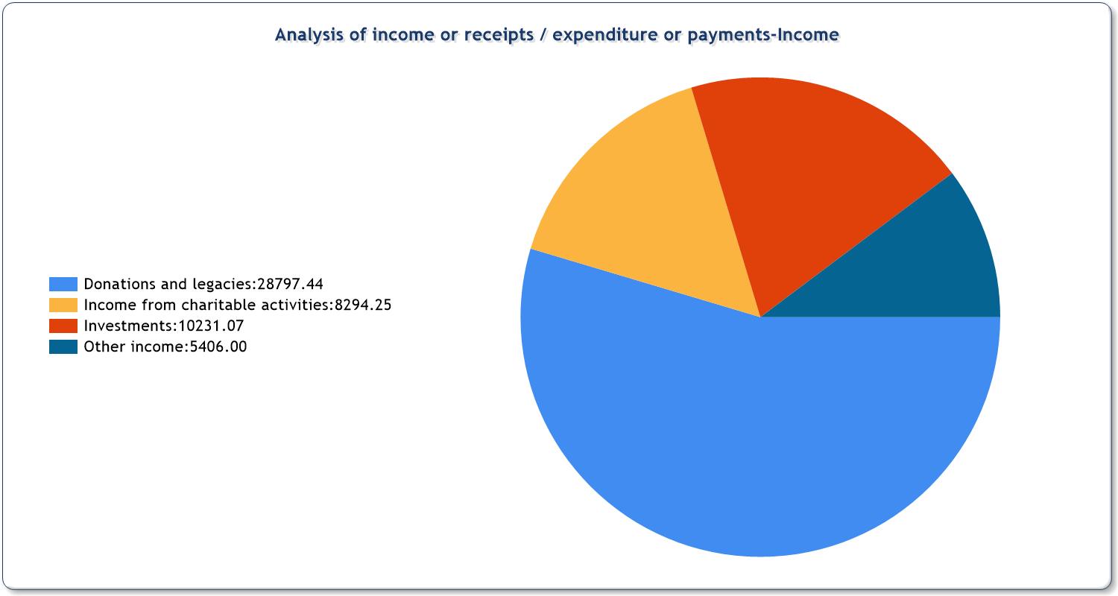
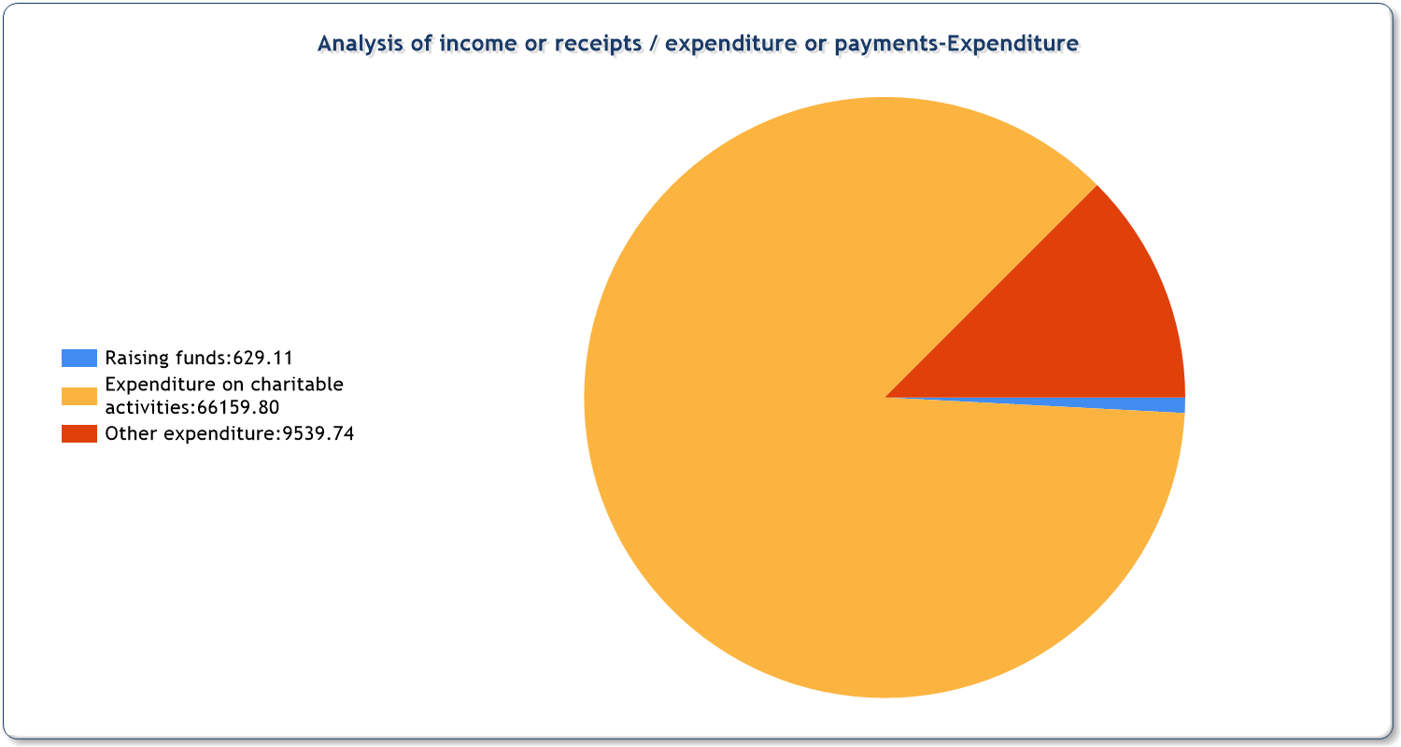
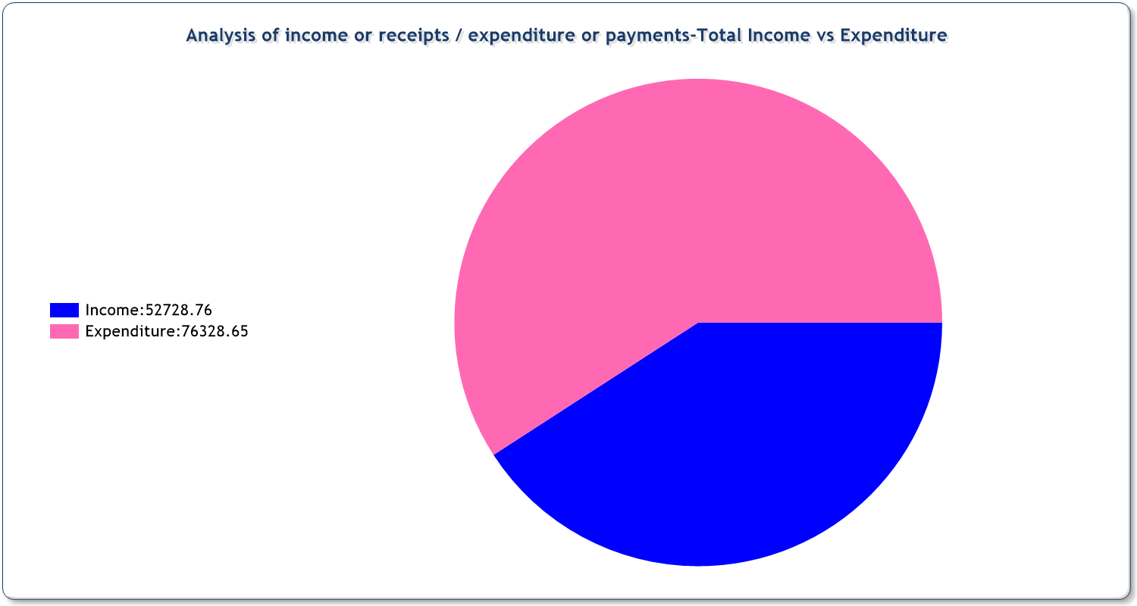
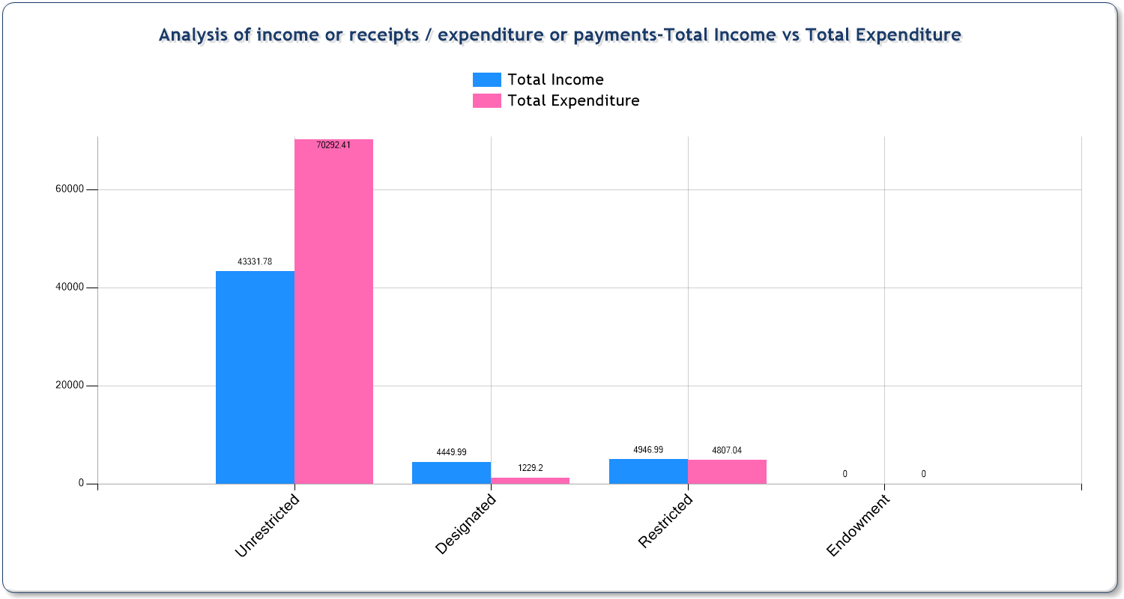

NOTES TO AND FORMING PART OF THE FINANCIAL STATEMENTS FOR THE YEAR ENDED 31 DECEMBER 2025
1. BASIS OF PREPARATION
Basis of Accounting
These accounts have been prepared in accordance with section 133 of the Charities Act 2011 using the Receipts & Payments basis. This basis is allowed because our income is below £250,000. It is considered easier to understand and has been recommended by the Association of Church Accountants & Treasurers (ACAT).
There has been no change in the basis of accounting since last year. The accounts are prepared using The Fund Accounting software as approved by the C of E.
Funds
General funds represent the funds of the PCC that are not subject to any restrictions regarding their use and are available for application on the general purposes of the PCC. Funds designated for a particular purpose by the PCC are also unrestricted.
The accounts include all transactions, assets and liabilities for which the PCC is responsible in law. They do not include the accounts of church groups that owe their main affiliation to another body or those that are informal gatherings of church members.

2. ACCOUNTING POLICIES
Income and Expenditure
Income is only accounted for when received. Expenditure is only accounted for when incurred. In particular:
Parish share is accounted for when paid to the Diocese. Any parish share to be paid by 31 December, but not yet paid, is not included in expenditure. It is included as a creditor, an amount owing, in the Assets & Liabilities statement.

Income tax recoverable on Gift Aid donations is received directly by the Diocese and does not go through our accounts, as shown in note 10.
Income and expenditure are accounted for gross, which means for example that the income from fundraising events is included in income, and the costs incurred are included in expenditure.

Fixed Assets
Consecrated and beneficed property is excluded from the accounts by Section 10(2)(a) and (c) of the Charities Act 2011. The only item currently in fixed assets is a house on Squires Avenue, which is included at the trustees estimated market value. There has been no other spending, such as on furniture or equipment, which is considered significant enough to include as a fixed asset in the accounts.





NOTTINGHAM NORTH DEANERY 2025 ANNUAL REPORT

During 2025 we held three Synods:

- 18 February 2025: Compassion
Our first Synod was held at St Martin’s, Sherwood. We watched James’ Halstead’s talk from Diocesan conference and discussed in groups what it means to grow disciples with compassion. We said goodbye to both Tim Pullen, Area Dean, and Kirsty Cowley, Deanery Administrator and thanked them for all they have done for the deanery.

- 10 July 2025: Confidence
Our July Synod was held at St Martha’s, Broxtowe. Our Interim Area Dean, Peter Huxtable welcomed all of the parishes and explored how the deanery function has changed. Greg Cowley, Treasurer gave an update as to what parts of his role are being looked after the diocese and answered questions around finance. We explored our Calling and Mission, and groups had an opportunity to share their personal and parish experiences concerning confidence.

- 12 November 2025: Courage
Our November Synod was held at St Helen’s, Trowell. We explored the theme of growing disciples with Courage. We were guided through the evening by listening to different videos from the diocesan Living Hope series. We had a finance update from Greg Cowley, Treasurer. We also celebrated our joint lay chair, John Cartwright who stepped down after serving the deanery faithfully. We thanked him for all he has contributed.

Our Deanery Prayer meetings have continued and are now on the first Tuesday of every other month at Christ Church, Cinderhill.

Rev’d Canon Tim Pullen retired from his posts of Area Dean and Rector of Wollaton St Leonard’s. St Leonard’s have been in vacancy and are soon to welcome their new Rector, Rev’d Mark Fraser.

We would like to thank you all for your generous and faithful giving during 2025. We managed to pay 94% of our share allocation!

Rev’d Canon Peter Huxtable Joanna Smith
Area Dean Lay Chair
January 2026

Fabric and Buildings Report

In the past year we have fitted lever taps to the wash basins in the ladies and gents toilets. The gutters and rain water pipes have been cleaned. We have installed a hose union lock shield bib tap in preparation for full immersion baptisms. The electrical PAT testing has been done, thanks to Phillip Hague. Leaking and faulty valve to our church boiler has been replaced. Gas servicing completed. Internet issues hopefully have been resolved. The emergency lighting to the stairs has been replaced, thanks to Les Ward. At the moment, we are in the process of replacing the hot water heaters to the toilets.

The PCC have a number of projects it wishes to pursue. The first among these is to replace the lift. Three surveys have been carried out and the specifications and quotes are in. It will cost us approximately £30,000. The PCC Fabric Sub-Committee is at present studying the three quotes and will make its recommendations to the PCC. Thanks to Phillip, Les and Richard Shaw. If it is decided to proceed, a Faculty will be sought.

Other work we need to proceed with is the repairs to the plaster work in the Lady Chapel. The PCC is also looking at refurbishing the toilets and kitchen as well as improving access to the church. We will require church architectural advise before any decision to proceed can be taken.

Martin Walton, PCC Fabric Sub Committee

Pastoral Care report

Report for APCM to be held 10th May 2026 from the Pastoral Care Team of St. Mary the Virgin & All Souls, Bulwell, Nottingham.

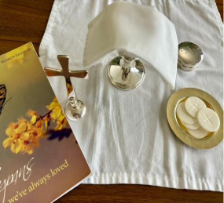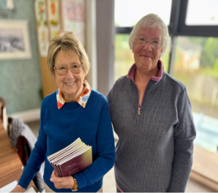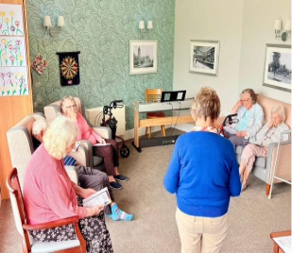

The Pastoral Care team uses our church’s vision and mission statements to help us reach out to those in our community who cannot attend church or in supporting our congregation members who can no longer come to church either due to illness or increasing frailty due to age.
“St. Mary’s is a down-to-earth Christian community serving and worshipping God by sharing the love of Jesus with all.” (Our Vision)
“We aim to be a church without walls - outward looking: a visible presence in our communities. We aim to be inclusive of all people and all ages. (Part of our Mission Statement).

Before commencing Pastoral Care visits, the team undergo Pastoral Care training, are DBS checked etc, attend Safeguarding Training, Raising Awareness of Domestic Abuse Training and are authorised by the Bishop in Distribution of Holy Communion (if Lay Member of the Church). Other training can be accessed e.g. Dementia Awareness.

The Pastoral Care team (Fr. Andrew Fisher, Revd. Bob Stephens & Jackie Bramford) use a monthly visiting rota which is drawn up by one of the team for visits to parishioners. These visits enable the team to keep in contact with parishioners and congregation members unable to get to church. During these visits (mainly in the home, sometimes hospital) there is the opportunity to share Holy Communion and to pray together. The Pastoral Care visitor will be accompanied by another member of the team or congregation if the person being visited is considered vulnerable. These visits are planned to be either monthly, fortnightly or weekly depending on the parishioner’s needs. We are flexible with our visits as numbers and needs change.

The Pastoral Care team have continued to visit three care homes for the elderly in Bulwell, Park House Care Home, Fairway View Care Home and Hall Park Care Home. These visits are monthly. Maureen Pates and Carole Jackson help at these visits. During these visits we have a short service of Holy Communion which includes hymn singing and the distribution of Holy Communion to those residents, who wish to receive it. During 2025 attendance usually has been 18-21 residents at Park House, 4-6 at Fairway View and 12-15 at Hall Park. Sometimes we are asked to visit residents in their rooms, if they are unable to attend the service. If any of the care homes request extra visits or services, the team try to accommodate this. Recent feedback from the homes has been positive. (Visits to Park House are on alternate months with United Reformed Church visiting the remainder. There is close liaison between the two churches following visits)

The Pastoral Care Team have continued to visit St. Andrew’s Winslow since beginning late 2025. It is a non-hospital residential building with six individual flats occupied by single residents, who have learning disabilities or complex mental health needs and are younger adults. These visits are monthly, and each service user is visited individually and time spent with them. One or two staff members are always present. These visits are about building trust with the service users and gradually introducing some aspect of God’s love to them, and we may only say the Lord’s Prayer or sing a hymn. During December 2025 Fr. Andrew & Jackie Bramford attended a Christmas party and shared Carol Singing, prayer & food with service users and staff.

The Pastoral team also have links with Highbury Hospital (Adult Mental Health Services). Fr. Andrew Fisher attends every Tuesday in his role as Chaplain and on the first Sunday of the month, a service of Holy Communion is led by Fr. Andrew for patients and supported by congregation members. At the time of writing this report visits are temporarily suspended. At the service of Holy Communion during January there was one patient who caused some difficulty and there was no staff member present. Fr. Andrew has had breakaway training. Discussions are being held regard the way forward and training has been offered by the Spiritual & Pastoral Care Team at Highbury for the other volunteers from St. Mary’s. It is hoped to resume services in April.

At the beginning of 2026 Bulwell Academy came under the umbrella of Pastoral Care. On the last Wednesday of the month Revd. Bob Stephens has started to go into the Academy in the morning and work with staff and support them. Pupils have a chance to voice how they feel about anything called Pupil Voice. It is proving to be interesting and challenging. The role is one of Pastoral support and not Chaplaincy.

Jackie Bramford and Daniel Newton have continued through the past year to receive requests for the prayer which are the passed on to the Prayer Chain.
In conclusion the Pastoral Care team continues to ---- “Strive to be creative in our worship, offering a variety of services by training and equipping, resourcing and encouraging the whole people of God” (Part of our Mission Statement)

Jackie Bramford,
Pastoral Care Team March 2026

Mission and Evangelism APCM Report

The mission and evangelism committee has been meeting to discuss the readability of setting up outreach projects to help the people of Bulwell and aid in giving fellowship to church members. We have met several times over the last few months. It consists of Rev Bob Cassandra Nelson Gwen Heart and Alan Jackson.

We have discussed many topics. A desire of having a shop in Bulwell for multiple purposes, however the rent and other expenses are prohibitive. Fr Andrew had previously made enquiries about this to see if any schemes or community initiatives were available, but sadly as we are a religious group we were not eligible. So we have had to think of other ideas. A wellness cafe has been discussed at length.

I have received my food hygiene certificate and as to date Cassie is in the process of taking hers. I am hoping that the wellness cafe will be starting in the next few weeks. I have attended two meetings of "Crunchy issues". This is about social issues affecting Bulwell. I told them that St Marys was starting a wellness cafe and they seemed delighted. After the meeting the Bulwell and Top Valley social prescribing team wanted to promote the cafe with their clients. We exchanged details so I can inform them of the start date. Another lady took my details saying that a small grant aid may be available. We are serving two kinds of homemade soups and cakes. This will take place from 11.30 until 1.30 on a Friday. Tea and toast after midweek mass started on Thursday the 19th of March.

We are also aiming to open a men's club in due course. This will be on a Saturday morning once a month. All details of the men's group are yet to be finalised. The Bulwell arts festival has asked the wellness cafe to have a refreshment stall at the festival on Saturday 11th July from 1pm until 5pm.

Alan Jackson.

Spirituality Report

The planning for this year’s Walsingham pilgrimage continues with a take up very similar to last years.

There will be a "quiet day" at Mount St. Bernards Abbey near Coleville, but a final date has yet to be confirmed.

The monthly Prayer Mornings continue and are much appreciated by those who attend.

We seek to encourage members of the congregation to deepen their spirituality.

Les Ward

Further Information

Volunteers
Fr Andrew and the PCC members would like to thank all the volunteers, both lay and ordained, who work so hard to make our church the lively and vibrant community it is. In particular we want to mention our churchwardens Eleanor Lang and Martin Walton who worked so tirelessly on our behalf and Peter Stanley our Treasurer who has helped us all to understand the church’s accounts and its finances. Special thoughts are to Robert Naylor who passed away in January, Robert served St Marys for 60 years. He held the role of Church Warden Emiratis, Tower Captain and representative with Churches Together. Grateful thanks.

Structure, Governance and Management

The method of appointment of PCC members is set out in the Church Representation Rules. At St Marys the membership of the PCC consists of Reverend Andrew Fisher, Vicar and Chair, Churchwardens, Associate Priests, Deanery Synod representative, and 12 members elected by members of the congregation who are on the electoral roll at the Annual Parochial Church Meeting, Co-opted members at a maximum of 2 whenever possible. Members of the congregation are encouraged to register on the Electoral Roll and to stand for election to the PCC.

The PCC is responsible for making decisions regarding the financial affairs of the church and upkeep of the church building and assets, assisting clergy in management of church affairs and promoting the mission of the church.

The PCC have met four times during the past year, May 2025 to May 2026 with an average of 70% attendance over the four meetings. As necessary, between planned meetings, the PCC are notified via email, together with relevant papers attached, by Reverend Andrew Fisher or PCC Secretary; Items that necessitate PCC input/decision via proposal and voting. All of which are noted by the PCC Secretary, and signed by the Incumbent, Reverend Andrew Fisher. If necessary, an Extraordinary Meeting will be planned. The Standing Committee consists of the Vicar, Churchwardens, Treasurer, PCC Secretary and a member of the PCC agreed by the PCC after the APCM.

The PCC has several Sub Committees that cover various aspects of the church and parish. At every scheduled meeting, the agenda includes reports from the Sub Committees - Worship, Spirituality, Pastoral Care, Children and Young People, Social, Fabric, Deanery Synod, Electoral Roll, Safeguarding, Church Wardens Report, Treasurers Report and the Vicars report. These reports and other papers pertaining to the coming meeting are circulated prior to the meeting by the PCC secretary to enable PCC members to take time to read them. Any points for discussion are raised at the PCC meeting.

Administrative Information

St Mary the Virgin and All Souls Church is situated on Highbury Road, Bulwell, Nottingham and is part of the Diocese of Southwell and Nottingham Correspondence address is usually The Rectory, Station Road, Bulwell, Nottingham NG6 9AA. The PCC is a body corporate (PCC Powers Measure 1956, Church Representation Rules 2020) and a charity currently excepted from registration with the Charity Commission.

The PCC membership from May 202 to April 2026 see Financial Review

Signed by: Fr Andrew Fisher Incumbent, the Revd. Andrew Fisher

Appendix

Consists of reports to the Annual Parochial Meeting of the Church Wardens Report, and from Uniform Organizations, Church Volunteers, Lay Eucharistic Ministers, Social Committee, Bells, Choir, Children and Families, Safeguarding, Church Wardens Report.
.

Church Warden PCC Report – 2025-2026

The life of your church wardens is never quiet. We still have an ongoing project looking at improving access via the hill and our property on Squires Avenue has been undergoing some major repairs after the last tenant left. Martin is in discussion with the diocese regarding the hill and the toilets. Our lift will need replacing soon and quotes are being reviewed by the PCC and we are also looking at re-fitting the kitchen.

We also keep the St Marys Facebook updated with information and share information of the church website. Please like and share the page – St Mary the Virgin and All Souls Church.
All of the church events are posted here.

Mick, a member of our congregation, has continued to carry out a great deal of work and
ongoing maintenance around the churchyard to keep it looking fantastic.

We would like to say a big thank you to the regular team of sides persons, refreshment helpers and the extra members who help with the larger events such as the Summer and Christmas Fayres.

Eleanor & Martin - Churchwardens

AGM Safeguarding Report

At the time of writing this report our Parish Dash Board is at 100%, this means we are up to date with all our policies and procedures. As the year proceeds there will be members of the congregation who will need to renew their DBS and training, I will contact these
people when the time comes.

Recently we had a briefing from the Diocese Safeguarding team, they would like to thank members of each parish that completed the questionnaire for the audit in January. The outcome of the audit will be released in the future, but they did say, when they reviewed the
feedback, it was what they expected.
However, they did mention the case load is increasing each year. In 2025 they had 305 referrals, which does not include cases for advice, 48 case managed groups (Church Officers), 81 open cases and 18 active cases in church communities. In January 2026 the case load is increasing.

As you can see so much is going on behind the scenes which the average member of the congregation does not know about. Remember, everybody is responsible for keeping St.Mary’s church a safe environment for us all.

Maureen Pates,
Safeguarding Officer

Lay Eucharistic Ministers at St. Mary’s Church
Lay Eucharist ministers (altar servers) volunteer for the role. They undertake training in the role, are required to undergo Safeguarding training and have a DBS check. They have a certificate of permission to assist at Holy Communion and to give Communion to the housebound. Issued by the Bishop at the Diocese of Southwell and Nottingham, this is renewable every three years.
The lay eucharist ministers (servers) namely Maureen Pates, Chris Guy, Jackie Bramford, Sophia Fisher, Chrissie Barton and Daniel Newton have supported our clergy assisting in giving the sacraments at Mass at the mid-week Mass on Thursdays and at the Sunday services. We have also served at extra services including Midnight Mass on Christmas Eve, Maundy Thursday (stripping the altar) and at funerals that include Requiem Mass.
Our roles interlink at times and as well as serving, we act as crucifer and thurifer.
Jackie Bramford, Maureen Pates and Carole Jackson visit Fairway View, Hall Park and Park House care homes monthly where Holy Communion is distributed to those residents, who wish to receive it. This is part of a short service of worship.
Jackie Bramford is also part of the Pastoral Care team and visits parishioners and members of the congregation at home who are unable to attend church and shares Holy Communion with them.

Social Committee Report

We organised our two main fundraising events – Summer and Christmas fayres which were both very successful. At the Band Concert in December, we helped with refreshments and the raffle.

Over the year there have been numerous events held at church and members of the social team have supported these events with refreshments.

Our Annual Quiz night was a great success with many of our regulars and newcomers enjoying a good evening out.

We have lots of events coming up over the Summer months. If you feel that you could help with refreshments, please see me.

Thank You
Eleanor, Social Committee Chair

Flower Team

The Ministry of Flowers in Church
Why do we have flowers in church? Flowers in church are much more than decoration. They service as a silent form of worship to remind us of the beauty of God’s creation and of an act of praise. Fresh flowers can symbolize the cycle of life and different flowers represent the seasons. The very act of arranging flowers is a form of worship. I would like to extend heartfelt thanks you all those who have given a donation towards flowers, this is very much appreciated.

During the past year, small displays were also provided for reception of Ashes for services of thanksgiving and blessing for families after cremation of loved ones; take care of funeral flowers brought back into church and posies for Mothering Sunday. Thank you to the Co-op Funeral Services for their kind donation of daffodils.

At Synod, Church of England supported moving towards more sustainable, seasonable and locally sourced flowers which was something we tried to do at Christmas, using greenery and berries, my tree in the garden provided the majority of this and foraging with George my dog at Bulwell Hall Park woods or the churchyard.

If you have an abundance of flowers or lovely greenery in your garden and would like to donate them for display in church, please do speak with me.

Finally, a vote of thanks for their contribution to the lovely displays to Zoe, Pam and Paula Palmer at Christmas. If needed the aisle carpet gets a hoovering as well as the West Room after we have finished. If you feel you would like to help, make an arrangement or simply help in any way, please do come forward, many hands lighten the load.

Carole Jackson

Choir Report

As you know we lost our organist Howard in September 2025. Until Howard left the choir was growing steadily. The choir sang an anthem once a month until he left. John Hall kindly played the organ until he left for Shri Lanka in November. Shaun kindly played for nine lessons and carols allowing the choir to sing some pieces not in the digital hymnal. We now have the ability to sing descants, this is thanks to Ursula and Seamus.

Choir practice has been rather limited by having to use the digital hymnal. The digital hymnal contains an archive of hymn melodies as well as the mass setting. Sadly, it cannot provide accompaniment for anthems and seasonal music not in the digital hymnal. Phil Miles was able to play for Mass on the 1st Sunday of the month and for Benediction. Shaun has kindly played for funerals as well.

We have appointed a new Director of Music, Ian Bevel who has played for one service in February but officially started on Sunday the 15th of March. He has plans to expand the choir and reintroduce part singing.

He plans to form a separate children's choir with hopes of musical ministry to children and encourage them to become involved members of the church. He is also planning to approach music students to join the choir to create a 4-part choir. We are all looking forward to this challenge and musical development under him.

Alan Jackson

Organist Report

Regarding the choir, I would like to do a slight rebuild, filling the parts that are missing or non-existent on a regular basis. This might involve contacting one of the private schools to establish a choral scholarship. For instance, Worksop Priory has a good relationship with Worksop College, allowing them to have a student bass during term time.

I’d also like to explore the possibility of doing joint choir events as well.

As we know, the life blood of any church is its children. St Mary’s has quite a few. Establishing a separate children’s choir, aside from the main choir, is one of my priorities. It would allow them to have fun, and grow in confidence. Some may gravitate to the church choir, some may not, we will have to see. Obviously, this will involve the church school.

Ian Bevel, Director of music.

The Mirror

The Mirror has been published fortnightly or weekly during the past year.
It has been distributed widely via the internet and has been available in church to for folk to pick up. Its contents have given information regarding the events for the coming week. Occasionally information is given to encourage parishioners to attend special events

The Mirror is edited by Fr Andrew.

Children and Families work reports

Little Acorn Toddler group
This continues to be a free group, much needed in Bulwell, however, parents do make donations when able. This goes towards the cost of snacks given to the children, and the extras we try to provide, such as gifts on birthdays, Easter and Christmas. We offer hot and cold drinks for parents plus a biscuit, and all children are offered a cold drink, plus a snack of fruit and a biscuit. We have a hour and a half of free play followed by a story and singing, with musical instruments for the children to use. The children particularly love parachute games.

We have been recommended many times now on the Bulwell Community social media site, with some lovely positive words from parents current and past. Due to having more children who are neurodiverse, it has been lovely seeing them play in the same room as other children and interact. I hope in the future to be able to look at play ideas/ resources that target neurodiverse children, but that will also stimulate the needs of all our children who attend.

Whiz Kids
Whiz Kids continues in its usual format on the 2nd and 4th Sundays of a month (and the 5th Sunday when this occurs, usually every 3 months). We have a story, linked to the service or discuss a theme, such as The Lord’s prayer, the Apostle’s Creed, what is the Eucharist? Easter, Christmas Baptism the Trinity and many more, followed by a linked craft or activity. The children and young people love to show and discuss what they have done at the end of the service.
Currently there are 3 leaders available with Sophia also filling in where she can.

Currently we have a lot of Children who have underlying needs, who have really settled in to coming upstairs and working alongside other children. We have one of our young people being confirmed in May and she is very excited! Whiz kids’ mass, on the 3rd Sunday of each month continues to be popular with our children.

I am conscious of children in this service who have not been up to Whiz kids and I have spoken to some children and parents about letting me know if they would like to be included in the service, to let me or any leaders know.

Any children who would like to read or participate in another way, parents can let me know on zoejackson000@gmail.com

Muddy Church
Muddy Church continues on the 3rd Saturday of a month. If anyone on the PCC fancies helping, it’s always appreciated, helping with crafts, food or just chatting to parents and of course tidying up. To continue we need help!

Children's corner.
Can we remind parents that this is primarily for children under 5 and school age to come up to Whiz kids. Perhaps we could announce at the beginning if a service for all children of school age being welcome upstairs.

Good Friday activities for children
This took place 11 to 3pm and was very well attended with over 50 children as well as some parents/carers. As well as activities, we had an egg hunt, unfortunately, we had to cancel the activity outside due to the high winds causing health and safety concerns.

Zoe Elliott
Children and Families Leader/PCC Children and Families Chair.

87th Nottingham Guides report 2025 - 2026

Our guide unit currently has 18 guide members aged between 10 and 14. We do have a few spaces. There are 6 leaders running the unit – Eleanor Lang, Jo Redmile, Donna Ginger,
Elizabeth Lang, Zoe Illingsworth and Keia Fusiara.

We make a monthly contribution to church and have helped at both the Summer and
Christmas fayres. We pay our yearly subscription to Girlguiding UK. For 2026, including leaders we paid £1,512.00

Through the year the guides enjoyed a varied programme of activities. We have completed many of our unit meeting activities, skills builders and interest badges with guides gaining their Theme awards, Bronze awards and Silver awards. We had a visit from the RNLI. We also had Cleon for Salsa dancing. In the summer we enjoyed being outside with campfires, outdoor games, cooking,
pitching tents and eating lots of ice creams. In the school summer holidays we held three camp days at church. Activities included making bird feeders, tent pitching, campfire, glass decorating,
crafts, scone making, popcorn making and champion “Dobble” players.

Leaders and one of the guides took to the stage at the Theatre Royal for Gang Show
2025. We also had leaders helping backstage and front of house, supporting the show.

We held an Easter Tombola at Tesco in Bulwell. This was a great fundraising event.

We also attended a regional event called Magical Midlands which was held at
Uttoxeter racecourse on the hottest day of 2025. The guides enjoyed many activities and drank plenty of water.

We went to PGL adventure at Caythorpe where the Guides, Rangers and the 88 th
Brownies had a great weekend. Whilst there we took part in lots of activities including Zip Wire, Archery, Rifle Shooting, Problem Solving and Aero ball which is the leaders favourite.

We had a joint Race Night event together with our other units. We raised £2,674.00 towards the subscription to Girlguiding for all of our units. The event was supported by parents, friends, families and the local community. We also had a donation of £1,500 from Fire Consultancy Specialists towards the annual subscription to Girlguiding for all the units at St Marys.

We had a great attendance at this year’s Remembrance Sunday parade. The event
was well supported by the local community.

We had also had a great evening at the Nottingham Playhouse in December when we all went to see the pantomime, Sleeping Beauty. We were very lucky to have been offered tickets for the Press Night.

We have lots of great events to look forward to in the coming year.

Thank you to all the leaders for their work with the units.

Eleanor Lang
Guide Leader

87th Nottingham Rangers

We attend church every week on Thursday evenings 7pm-9pm with a group of 13 rangers who are very inclusive. We enjoy activities which include arts and crafts, badges work, team building exercises and going out on trips to the cinema. This year we gained a grant and decided to take the girls for dinner and we have also booked a visit to the space centre in Mansfield for October! Some of our rangers will be attending camp this summer and we are also looking forward to that! We have been very creative this term with our Mother’s Day crafts and painted our own plant pots and planted flowers for our mothers. We also attended our first sleepover as a ranger unit this year where one of our leaders successfully achieved her 1 night away license! We look forward to creating more memories with our rangers this year at church.

Ranger Leaders

Annual Report 88 th Nottingham Brownies 2026
We are the 88 th Nottingham Brownies and we meet in the West Room on Thursdays
between 6:00pm – 7.30pm.
We have 21 girls in the unit, their ages range between 7 and 10.

July – Magical Midlands
October – PGL
December – Panto Nottingham Art Theatre
March – Cinema with Guides
May – Drayton Manor….

We have had 2 Brownies achieve their Brownie Gold award and 1 who has been
awarded with Silver. We are extremely proud of the girl’s commitment and are thrilled
that they have decided to remain in Girlguiding.

The whole unit were very proud to represent the young people of the Bulwell and
Girlguiding community at the Remembrance Parade and were excited to be on TV
following the campaigning that took place to ensure the parade went ahead.
We have had a fun filled year of activities including trips to the cinema, Black Country
Museum and a pack holiday at Hanson House in Linby, which for some girls was the
first overnight stay away from home.

The unit are looking forwards to VE Day celebrations, we will be remembering the
roles that Girlguiding played during the war and a Girlguiding Midlands event that we
are attending with other units from the Division.

We have done several fundraising activities to help raise funds for our annual census
including Clip N Climb – where we ran the activity for free and asked parents for
donations to the unit. We have run a couple of tombola stalls with 87 th Guides and
helped with the Race Night event, which was a great success, which will be held
again later this year.

We have 5 leaders and 1 unit helper who is currently at University in Dundee, she
loved and missed Brownies so much that she is now volunteering with a local
Brownie unit in her university town. 1 of the leaders is now a mentor and has been
supporting a leader in training from the 87 th Nottingham Brownie unit.

Sarah Anthony – Unit Leader

