St Peter and the Holy Apostles, Plymouth
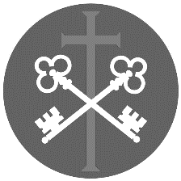
Sunday 24th May 2026- Pentecost Sunday
Welcome to the Parish Mass
Welcome to St Peters Church. This sheet provides all that you will need for today’s Mass. If you need any assistance before, during or after the service or need a large print copy of this order of service please speak to one of our welcome team. (identifiable by a lanyard)
Please respond to the words in non-italic Bold, The Hymns are sung by all. Please inform the people on the door when you enter if you require a Gluten Free Host
………………………………………………………………………………
We Stand for The Entrance Hymn

1. Come down, O Love divine,
Seek thou this soul of mine,
And visit it with thine own ardour glowing;
O Comforter, draw near,
Within my heart appear,
And kindle it,
thy holy flame bestowing.
2. O let it freely burn,
Till earthly passions turn
To dust and ashes in its heat consuming;
And let thy glorious light
Shine ever on my sight,
And clothe me round,
the while my path illuming.
3. Let holy charity
Mine outward vesture be,
And lowliness become mine inner clothing;
True lowliness of heart,
Which takes the humbler part,
And o'er its own shortcomings
weeps with loathing.
4. And so the yearning strong,
With which the soul will long,
Shall far outpass the power of human telling;
For none can guess its grace,
Till it become the place
Wherein the Holy Spirit
makes his dwelling.

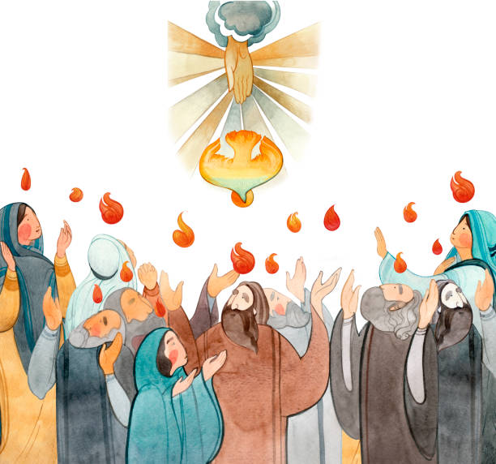
The Introductory Rite
In the name of the Father and of the Son and of the Holy Spirit. Amen.
Following the greeting we respond.
And with your spirit.
The Priest introduces the Mass
The Penitential Rite
Dear brethren (brothers and sisters), let us humbly beseech the Lord our God to bless this water he has created, which will be sprinkled on us as a memorial of our Baptism. May he help us by his grace to remain faithful to the Spirit we have received.
And after a brief pause for silence, he continues with hands joined:
Lord our God, in your mercy be present to your people’s prayers, and, for us who recall the wondrous work of our creation and the still greater work of our redemption, graciously + bless this water. For you created water to make the fields fruitful and to refresh and cleanse our bodies. You also made water the instrument of your mercy: for through water you freed your people from slavery and quenched their thirst in the desert; through water the Prophets proclaimed the new covenant you were to enter upon with the human race; and last of all, through water, which Christ made holy in the Jordan, you have renewed our corrupted nature in the bath of regeneration. Therefore, may this water be for us a memorial of the Baptism we have received, and grant that we may share in the gladness of our brothers and sisters who at Easter have received their Baptism. Through Christ our Lord.
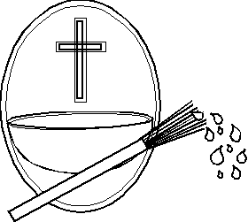
Amen.

Taking the aspergillum, the Priest sprinkles himself and the ministers, then the clergy and people, moving through the church, Meanwhile, the following is sung.

Water of life, cleanse and refresh us;
Raise us to life in Christ Jesus

1. All you who thirst, come to the waters, And you will never be thirsty again.
Water of life, cleanse and refresh us; Raise us to life in Christ Jesus
2. As rain from heaven, so is God’s word, it Waters the earth and brings forth life.
Water of life, cleanse and refresh us; Raise us to life in Christ Jesus
3. Dying with Christ, so we shall rise with him. Death shall no longer have power over us.
Water of life, cleanse and refresh us; Raise us to life in Christ Jesus
4. Turn to the Lord, cast off your wickedness, You will find peace in his infinite love.
Water of life, cleanse and refresh us; Raise us to life in Christ Jesus

When he returns to his chair and the singing is over, the Priest stands facing the people and, with hands joined, says:

May almighty God cleanse us of our sins, and through the celebration of this Eucharist make us worthy to share at the table of his Kingdom. Amen.

The Gloria
Glory to God in the highest, and on earth peace to people of good will. We praise you, we bless you, we adore you, we glorify you, we give you thanks for your great glory, Lord God, heavenly King, O God, almighty Father.
Lord Jesus Christ, Only Begotten Son, Lord God, Lamb of God, Son of the Father, you take away the sins of the world, have mercy on us; you take away the sins of the world, receive our prayer; you are seated at the right hand of the Father, have mercy on us.
For you alone are the Holy One, you alone are the Lord, you alone are the Most High, Jesus Christ, with the Holy Spirit, in the glory of God the Father. Amen.

The Collect- The Priest leads the prayer of the day.

Let us pray. O God, who by the mystery of today’s great feast sanctify your whole Church in every people and nation, pour out, we pray, the gifts of the Holy Spirit across the face of the earth and, with the divine grace that was at work when the Gospel was first proclaimed, fill now once more the hearts of believers. Through our Lord Jesus Christ, your Son, who lives and reigns with you in the unity of the Holy Spirit, God, for ever and ever. Amen.

We sit for The First Reading- Acts 2:1-11

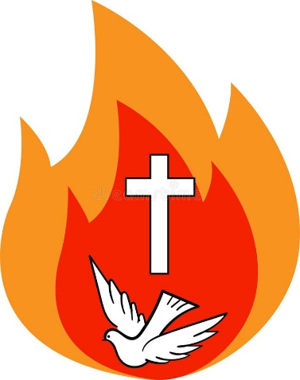
When the day of Pentecost arrived, the Apostles were all together in one place. And suddenly there came from heaven a sound like a mighty rushing wind, and it filled the entire house where they were sitting. And divided tongues as of fire appeared to them and rested on each one of them. And they were all filled with the Holy Spirit and began to speak in other tongues as the Spirit gave them utterance.
Now there were dwelling in Jerusalem Jews, devout men from every nation under heaven. And at this sound the multitude came together, and they were bewildered, because each one was hearing them speak in his own language. And they were amazed and astonished, saying, ‘Are not all these who are speaking Galileans? And how is it that we hear, each of us in his own native language? Parthians and Medes and Elamites and residents of Mesopotamia, Judea and Cappadocia, Pontus and Asia, Phrygia and Pamphylia, Egypt and the parts of Libya belonging to Cyrene, and visitors from Rome, both Jews and proselytes, Cretans and Arabians — we hear them telling in our own tongues the mighty works of God.’

The word of the Lord. Thanks be to God.
The Responsorial Psalm- Ps 104(103):1ab, 24ac. 29b-30. 31, 34. ℟ cf. 30

Response- Send forth your spirit, O Lord, and renew the face of the earth.

Bless the Lord, O my soul! O Lord my God, how great you are!
How many are your works, O Lord! The earth is full of your creatures. R

You take away their breath, they die, returning to the dust from which they came.
You send forth your spirit, and they are created, and you renew the face of the earth. R

May the glory of the Lord last for ever! May the Lord rejoice in his works!
May my thoughts be pleasing to him. I will rejoice in the Lord. R

The Second reading- 1 Corinthians 12:3b-7, 12-13

Brothers and Sisters: No one can say ‘Jesus is Lord’ except in the Holy Spirit. Now there are varieties of gifts, but the same Spirit; and there are varieties of service, but the same Lord; and there are varieties of activities, but it is the same God who empowers them all in everyone. To each is given the manifestation of the Spirit for the common good. For just as the body is one and has many members, and all the members of the body, though many, are one body, so it is with Christ. For in one Spirit we were all baptised into one body — Jews or Greeks, slaves or free — and all were made to drink of one Spirit.

The word of the Lord. Thanks be to God

We stand for - The Sequence- Veni, sancte Spiritus

SUNG BY THE CANTOR

Holy Spirit, Lord of Light,
From the clear celestial height
Thy pure beaming radiance give.

Come, thou Father of the poor,
Come with treasures which endure
Come, thou light of all that live!

Thou, of all consolers best,
Thou, the soul’s delightful guest,
Dost refreshing peace bestow

Thou in toil art comfort sweet
Pleasant coolness in the heat
Solace in the midst of woe.

Light immortal, light divine,
Visit thou these hearts of thine,
And our inmost being fill:

If thou take thy grace away,
Nothing pure in man will stay
All his good is turned to ill.

Heal our wounds, our strength renew
On our dryness pour thy dew
Wash the stains of guilt away:

Bend the stubborn heart and will
Melt the frozen, warm the chill
Guide the steps that go astray.
Thou, on us who evermore
Thee confess and thee adore,
With thy sevenfold gifts descend:

Give us comfort when we die
Give us life with thee on high
Give us joys that never end.

We remain standing for The Gospel Procession and Acclamation-

Alleluia, alleluia. Come, Holy Spirit, fill the hearts of your faithful and kindle in them the fire of your love. Alleluia.

The Gospel- John 20:19-23

The Lord be with you. And with your spirit.
A reading from the holy Gospel according to N. Glory to you, O Lord.
On the evening of that day, the first day of the week, the doors being locked where the disciples were for fear of the Jews, Jesus came and stood among them and said to them, ‘Peace be with you.’ When he had said this, he showed them his hands and his side. Then the disciples were glad when they saw the Lord. Jesus said to them again, ‘Peace be with you. As the Father has sent me, even so I am sending you.’ And when he had said this, he breathed on them and said to them, ‘Receive the Holy Spirit. If you forgive the sins of any, they are forgiven them; if you withhold forgiveness from any, it is withheld.’

The Gospel of the Lord. Praise to you, Lord Jesus Christ.

We sit for The Homily

We stand for The Creed

I believe in one God, the Father almighty, maker of heaven and earth, of all things visible and invisible.

I believe in one Lord Jesus Christ, the Only Begotten Son of God, born of the Father before all ages. God from God, Light from Light, true God from true God, begotten, not made, consubstantial with the Father; through him all things were made. For us men and for our salvation he came down from heaven,

At the words that follow, up to and including ‘and became man’, all bow.
and by the Holy Spirit was incarnate of the Virgin Mary, and became man.

For our sake he was crucified under Pontius Pilate, he suffered death and was buried, and rose again on the third day in accordance with the Scriptures.

He ascended into heaven and is seated at the right hand of the Father. He will come again in glory to judge the living and the dead and his kingdom will have no end.
I believe in the Holy Spirit, the Lord, the giver of life, who proceeds from the Father and the Son, who with the Father and the Son is adored and glorified, who has spoken through the prophets.

I believe in one, holy, catholic and apostolic Church. I confess one Baptism for the forgiveness of sins and I look forward to the resurrection of the dead and the life of the world to come. Amen.
…………………………………………………………………………..

We stand for The Prayers of the Faithful

Each biding concludes with the following said or sung-
We pray to the Lord- Lord in your Mercy hear our prayer.

The Priest Concludes the Prayers of the Faithful
…………………………………………………………………………..
No collection is taken during the Mass, but there is a collection box at the back of church for you to give your financial contribution. All money collected helps towards the mission and ministry of our churches. If you would prefer, a card reading machine is available at the back of the church for your contribution

The Offertory Hymn

1. All together in one place
friends of Jesus met to pray;
waiting as the Lord had said
for the Pentecostal day.
2. All together with one power
poured out when the Spirit came;
touching each and filling all,
rushing wind and burning flame.
3. All together with one voice,
praising God in every tongue;
languages they never learned,
telling what the Lord had done.
4. All together with one aim:
bearing witness to their Lord;
sharing faith by word and deed,
preaching Christ, the living Word.
5. All together still today,
though two thousand years have gone.
Still the Spirit's power is given,
still God's people meet as one;
6. One in mission, one in faith,
still responding to God's call:
one in telling all the world
Jesus Christ is Lord of all!



The Liturgy of the Eucharist
Pray, brethren (brothers and sisters), that my sacrifice and yours may be acceptable to God, the almighty Father.
May the Lord accept the sacrifice at your hands for the praise and glory of his
name, for our good and the good of all his holy Church.

The Lord be with you. And with your spirit.
Lift up your hearts. We lift them up to the Lord.
Let us give thanks to the Lord our God. It is right and just.
The Priest continues with the Preface. The Sanctus is said or sung:
Holy, Holy, Holy Lord God of hosts.
Heaven and earth are full of your glory. Hosanna in the highest.
Blessed is he who comes in the name of the Lord. Hosanna in the highest.

The Priest continues the Eucharistic prayer. The following is said or sung
The mystery of faith. We proclaim your Death, O Lord, and profess your Resurrection until you come again.

The Priest concludes the Eucharistic prayer.
Through him, and with him, and in him, O God, almighty Father, in the unity of the Holy Spirit, all glory and honour is yours, for ever and ever. Amen.

The Lord’s Prayer
At the Saviour’s command and formed by divine teaching, we dare to say:
Our Father, who art in heaven, hallowed be thy name; thy kingdom come, thy will be done on earth as it is in heaven. Give us this day our daily bread, and forgive us our trespasses, as we forgive those who trespass against us; and lead us not into temptation, but deliver us from evil.
Deliver us, Lord, we pray… and the coming of our Saviour, Jesus Christ.
For the kingdom, the power and the glory are yours now and for ever.

The Peace
Lord Jesus Christ, who said to your Apostles: Peace I leave you, my peace I give you,
look not on our sins, but on the faith of your Church, and graciously grant her peace and unity in accordance with your will. Who live and reign for ever and ever. Amen.
The peace of the Lord be with you always: And with your spirit.
Let us offer each other the sign of peace.
All are invited to make a acknowledgement to each other to mark the sign of the peace.
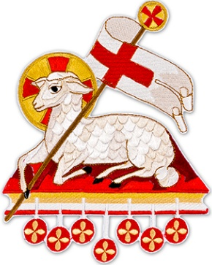
The Agnus Dei
All say or sing:
Lamb of God, you take away the sins of the world, have mercy on us.
Lamb of God, you take away the sins of the world, have mercy on us.
Lamb of God, you take away the sins of the world, grant us peace.

The Invitation to Communion
Behold the Lamb of God, behold him who takes away the sins of the world. Blessed are those called to the supper of the Lamb.
Lord, I am not worthy that you should enter under my roof, but only say the word and my soul shall be healed.
All who are regular communicants in their own tradition are welcome to receive the sacrament if you are not a communicant you are welcome to come forward at this point in the service to receive a blessing To indicate that it is just a blessing you require, please take this service sheet up with you. We have returned to offering the chalice at the time of communion but please do not feel any pressure to receive from the common cup as the church teaches that the sacrament is received fully in one kind. We request that you do not intinct (dip) your host in the Chalice but either take a sip from the cup or return directly to your seat. This is for reasons of good hygiene.
The Communion Hymn

1. O Thou who camest from above
The pure celestial ﬁre to impart,
Kindle a ﬂame of sacred love
On the mean altar of my heart!
2. There let it for Thy glory burn
With inextinguishable blaze;
And trembling to its source return,
In humble prayer and fervent praise.
3. Jesus, conﬁrm my heart’s desire
To work, and speak, and think for Thee;
Still let me guard the holy ﬁre,
And still stir up Thy gift in me.
4. Ready for all Thy perfect will,
My acts of faith and love repeat,
Till death Thy endless mercies seal,
And make the sacriﬁce complete.

We stand for The Prayer After Communion
Let us pray. O God, who bestow heavenly gifts upon your Church, safeguard, we pray, the grace you have given, that the gift of the Holy Spirit poured out upon her may retain all its force and that this spiritual food may gain her abundance of eternal redemption. Through Christ our Lord. Amen.
The priest may give some brief notices

The Concluding Rites- Blessing and Dismissal
The Lord be with you. And with your spirit.

Bow down for the blessing

May God, the Father of lights, who was pleased to enlighten the disciples’ minds by the outpouring of the Spirit, the Paraclete, grant you gladness by his blessing and make you always abound with the gifts of the same Spirit. Amen.

May the wondrous flame that appeared above the disciples, powerfully cleanse your hearts from every evil and pervade them with its purifying light. Amen.

And may God, who has been pleased to unite many tongues in the profession of one faith, give you perseverance in that same faith and, by believing, may you journey from hope to clear vision. Amen.

And may the blessing of almighty God, the Father, and the Son, ✠ and the Holy Spirit,
come down on you and remain with you for ever. Amen.

Go forth, the Mass is ended. Thanks be to God.

The Final Hymn

1. Filled with the Spirit's power, with one accord
the infant church confessed its risen Lord.
O Holy Spirit, in the church today
no less your power of fellowship display.
2. Now with the mind of Christ set us on fire,
that unity may be our great desire.
Give joy and peace; give faith to hear your call,
and readiness in each to work for all.
3. Widen our love, good Spirit, to embrace
in your strong care all those of every race.
Like wind and fire with life among us move,
till we are known as Christ's, and Christians prove.

The Regina Cœli

Joy to thee O Queen of heaven, alleluia.
He whom thou wast meet to bear, alleluia.
As he promised, hath arisen, alleluia.
Pour for us to God thy prayer, alleluia.
Rejoice and be glad, O Virgin Mary, alleluia.
For the Lord is risen indeed, alleluia.
Let us pray. O God, who, by the Resurrection of thy Son, our Lord Jesus Christ, hast brought joy to the whole world; grant, that through His Mother, the Virgin Mary, we may obtain the joys of life everlasting. Through Jesus Christ our Lord. Amen
…………………………………………………………………………….
The Notices:
Jenny Harvey RIP Jenney’s Requiem Mass and Funeral Rite will take place on Tuesday at 2.30pm.
Walsingham 2026 14th-18th September, There are still spaces available, if you would like to join us please fill in a form as soon as possible and arrange for the deposit to be paid. If you have paid some of the cost and want to know the balance please email walsinghaminexeter@gmail.com
Catechesis on Zoom- we will be holding an online catechesis group on zoom on Monday evenings- 25th May at 7.30pm- all are welcome- for further information please speak to Alfie or Ben
Confirmations- 26th June- At St Peter’s at 7.30pm Please come and support our Candidates who will be getting confirmed on that day
Ben’s ordination- God willing Ben will be ordained on 27th June at Exeter Cathedral- information will be available soon about attending the event, however for now please keep Ben in your prayers, ember cards are available in church.
The Solemnity of St Peter and St Paul 28th June- As well as being our Patronal Festival, This will be the first Mass at which Ben will Deacon and certainly a Mass that which should be well attended

For prayer
Those who have asked for our prayers…. Denise, Janice Allin, Leslie Porch,
Sheila Tucker, Tina Smart, Bobby Lilicrap, June Brock, Emma Addison, Georgie Maher, Ian Craggs, Brenda Alderson, Lois Tobin, Brenda Steed, Anne Lewis, Jackie Morrison, Anna, Gwen Lamb, Anna Lynch, Helen Lewis, Val Bradden, Cynthia Way, Pauleen Stewart, Amelia Coughlan, Roger Lewis, Shaun Carrie, Fr Jon Bielawski, Catherine Samuel, Julian Davies, Shaun Whittam.

Recently Departed-

Anniversaries of Death-
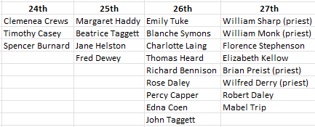
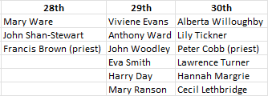

The Mission Community of St Peter and the Holy Apostles
St Peter, Wyndham Square + St Thomas, Royal Navy Avenue + St James-the-Less, Ham Drive

A Church of England Parish in the care of the Bishop of Oswestry

Parish Priest Fr. David Way SSC: 01752 240119 fr.david@stpeterplymouth.org

Mission Development Minister/ LLM/ Parish Ordinand: Ben Otley 07939800544 benotley.mission.plym@gmail.com

Parish Website: plymouthstpeter.co.uk ~ FOR MUCH MORE INFORMATION ON EVENTS, ETC.

Sunday 24th-  Pentecost Sunday  Year A/ Cycle 1 (Psalter week iv) | 8.30am St Thomas Fr DCW  11.00am St Peter Fr DCW | Mass  Sung Mass
Monday 25th-  Mary Mother of the Church | St Peter 10.00am Fr PL | Mass
Tuesday 26th-  St Philip Neri, Priest | St Peter 2.30pm Fr DCW | Requiem Mass  Margaret Jennifer Harvey
Wednesday 27th- Weekday in OT/  St Augustine of Canterbury | St Peter 10.00am Fr DCW | Mass
Thursday 28th- Our Lord Jesus Christ the Eternal High Priest | St Peter 10.00am Fr DCW | Mass
Friday 29th- Weekday in OT/  St Paul VI, Pope | St Peter 10.00am Fr DCW | Mass
Saturday 30th-  Weekday in OT | St Peter 10.00am Fr DCW | Mass
Sunday 31st-  Trinity Sunday  Year A/ Cycle 1 (Psalter week i) | 8.30am St Thomas Fr DCW  11.00am St Peter Fr DCW | Mass  Sung Mass

St Peters is open daily 8.30am- 12noon- Place of Welcome, Place of Prayer.

Safeguarding: If you have any concerns regarding the safety of children and others who are vulnerable, regardless of age, you must tell the Duty Priest or our parish Lay Safeguarding Representative- Jackie Morrison- email randj49@gmail.com Tel 07848859124.

For online donations please scan the QR code

