Sunday 17th May 2026 St Paul’s, Woodhouse Eaves
WE WELCOME YOU, for we are all one in Christ Jesus

MISSION  Our Mission Statement  Our Mission is to make known the Gospel and love of Jesus Christ. We hope that you experience us as a safe, sacramental, welcoming, loving and inclusive Kingdom people who seek to make Christ present in the hearts of all.  Safeguarding  The parishes of St Paul’s, Woodhouse Eaves & St Mary’s, Woodhouse, are committed to the safeguarding of children, young people and adults. We follow the House of Bishops’ guidance and policies, and have our own Parish Safeguarding Officers. If you are concerned that a child or adult has been harmed or may be at risk of harm please contact –  ST PAUL’S - Safeguarding  Co-ordinator: Tony Lane  07977 924 677  ST MARY’S - Safeguarding  Co-ordinator: Andrea Farnsworth 07958 376 963  As a Benefice, we affirm that it is about not just a set of policies and procedures, but about all of us as the body of Christ sharing the responsibility for making God’s Church as safe as we can  Please take this pew sheet  home and recycle it when you’ve read it. Thank you |  | PRAYER  Let us use our time  before the service  to talk to God,  during the service  may God talk to us, and  after the service  let us talk to one another  If you would like someone to listen or to pray with you, please contact your Parish Priest:  Rev’d Lisa Temperley-Barnes - 01509 890 972  If you would like us to pray for someone by name in our Sunday services and through the week, please email Rev’d Lisa or Stephen  Save the date!  LOROS Fundraiser  St Mary’s, Woodhouse  - Do join us for an  Afternoon of Tea and Cake  in aid of LOROS hospice -  Saturday 13th June, 2-4pm  Website  St Paul’s has a new website!  https://stpaulschurch-we.uk  This will be a wonderful tool for mission and outreach. We hope that you will find it informative and inspiring.  Our heartfelt thanks to Bob Young for all his hard work creating and setting up the website |  | We pray for all who are ill  for June Taylor,  Sue and John Thorne  We remember before God the faithful departed  Anne Jukes, June Shilton,  Kenneth Wilson  and from St Mary’s Book of Remembrance  Lucy Bryan, Alan Kirkham,  Margaret ‘Peggy’ Sarah Smith  and from St Paul’s Book of Remembrance  Ellen Marshall, Muriel Turner, Martin Christopher Turner,  Ian Fraser Cameron,  Eric John Dryden,  Doris McFetrich  Rest eternal grant unto them, O Lord, and let light perpetual shine upon them. May the souls of the faithful departed through the mercy of God, rest in peace and rise in glory. Amen  An Easter Collect  Risen Christ, faithful shepherd of your Father’s sheep: teach us to hear your voice and to follow your command, that all your people may be gathered into one flock,  to the glory of God the Father.  A Collect for Peace  Almighty God, from whom all thoughts of truth and peace proceed: kindle, we pray, in the hearts of all, the true love of peace  and guide with your pure and peaceable wisdom those who take counsel for the nations of the earth  that in tranquillity your kingdom may go forward, till the earth is filled with the knowledge of your love; through Jesus Christ our Lord. Amen  
Easter 7 Sung Holy Eucharist
COLLECT  O God the King of glory, you have exalted your only Son Jesus Christ  with great triumph to your kingdom in heaven: we beseech you, leave us not comfortless, but send your Holy Spirit to strengthen us and exalt us to the place where our Saviour Christ is gone before, who is alive and reigns with you, in the unity of the Holy Spirit, one God, now and for ever. Amen  FIRST READING  A reading from the  Acts of the Apostles  When the apostles met together with Jesus, they asked him, “Lord, will you at this time give the Kingdom back to Israel?” Jesus said to them, “The times and occasions are set by my Father's own authority, and it is not for you to know when they will be. But when the Holy Spirit comes upon you, you will be filled with power, and you will be witnesses for me in Jerusalem, in all of Judea and Samaria, and to the ends of the earth.” After saying this, he was taken up to heaven as they watched him, and a cloud hid him from their sight. They still had their eyes fixed on the sky as he went away, when two men dressed in white suddenly stood beside them and said, “Galileans, why are you standing there looking up at the sky? This Jesus, who was taken from you into heaven, will come back in the same way that you saw him go to heaven.” Then the apostles went back to Jerusalem from the Mount of Olives, which is about half a mile away from the city. They entered the city and went up to the room where they were staying: Peter, John, James and Andrew, Philip and Thomas, Bartholomew and Matthew, James son of Alphaeus, Simon the Patriot, and Judas son of James. They gathered frequently to pray as a group, together with the women and with |  | Mary the mother of Jesus and with his brothers.  Acts 6:1-14  This is the word of the Lord  Thanks be to God  GOSPEL  Alleluia, alleluia  “Speak, Lord, your servant is listening. You have the words to eternal life.” Alleluia  Hear the holy Gospel of our Lord Jesus Christ according to St John  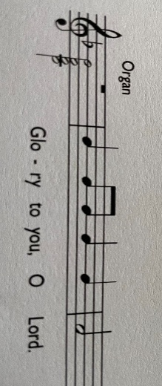  After Jesus had spoken these words, he looked up to heaven and said, ‘Father, the hour has come; glorify your Son so that the Son may glorify you, since you have given him authority over all people, to give eternal life to all whom you have given him.  And this is eternal life, that they may know you, the only true God, and Jesus Christ whom you have sent.  I glorified you on earth by finishing the work that you gave me to do.  So now, Father, glorify me in your own presence with the glory that I had in your presence before the world existed.  ‘I have made your name known to those whom you gave me from the world. They were yours, and you gave them to me, and they have kept your word. Now they know that everything you have given me is from you; for the words that you gave to me I have given to them, and they have received them and know in truth that I came from you; and they have believed that you sent me. I am asking on their behalf; I am not asking on behalf of the world, but on behalf of those whom you gave me, because they are yours. All mine are yours, and |  | yours are mine; and I have been glorified in them.  And now I am no longer in the world, but they are in the world, and I am coming to you.  Holy Father, protect them in your name that you have given me, so that they may be one, as we are one.  John 17:1-11  This is the Gospel of the Lord  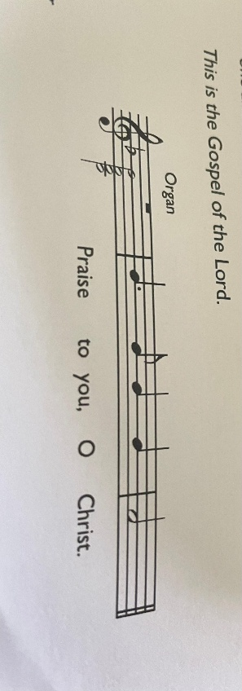  POST COMMUNION  Eternal God, giver of love and power,  your Son Jesus Christ has sent us into all the world  to preach the gospel of his kingdom:  confirm us in this mission,  and help us to live the good news we proclaim;  through Jesus Christ our Lord. Amen

