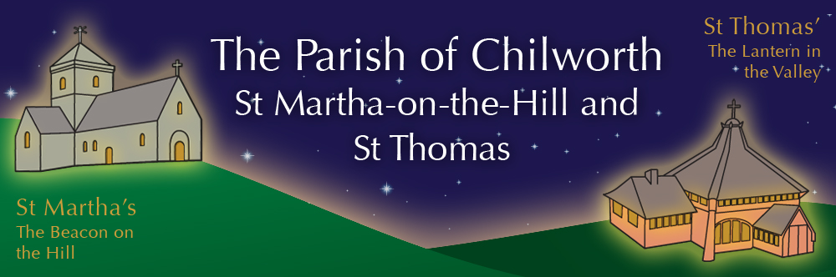

NOTICES: - 3rd MAY 2026
Priest David Oakden – Revdavid@parishofchilworth.org.uk - 01483 534293 (day off Friday)
Do let me know of anybody or anything that you would like to be prayed for.
www.parishofchilworth.org.uk and find us on https://www.achurchnearyou.com

***********:John 14:6 (NRSVA)***********
Jesus said to him, ‘I am the way, and the truth, and the life. No one comes to the Father except through me.
***********************************

Opportunities to pray together: -
Ecumenical Prayer Breakfast 1st Saturday of the month at the Vicarage, from 9am, prayer, coffee and croissant. Next is the 2nd May – Thursday evening at St Thomas at 6:00 pm for an hour every other week. 7th & 21st May 2026.

This Sunday Services: – 5th of EASTER
9:30 St Thomas Holy Communion.
11:15 St Martha’s Mattins.

Next Sunday Services: - 10th of May
9:30 St Peter & St Paul Albury Holy Communion.
11:15 St Martha’s Holy Communion.

Looking further ahead: -
Tots and Toddlers: St T’s Monday 9:15am
Social Committee Meeting: 5th May
PCC via Zoom: 7th May to agree accounts 7:30pm
Albury APCM: 10th May after the service
TRIENNIAL CLERGY CONFERENCE: 12th to 14th May
Plant Sale: St T’s 16th May
APCM: St T’s 21st May at 7:30pm
Infant School Pilgrimage: 22nd May St M’s
Chilworth Manor NGS Open Day: 24th May
Summer Music on the Hilltop: 25th May 12-5pm
Broad Horizons: 26th May St M’s @ 7pm

Food & Hygiene Bank: -
The Foodbank Larder box is located in the porch of St Thomas Church.

Chilworth Tinies and Toddler Group: -
Mondays from 9:15 -10:45 meet in St Thomas, play chat, pray and support.

Broad Horizons Book Group: -
Our informal book discussion group, meet once a month on Tuesday evenings (7-8:30pm) throughout the summer. All welcome to any or all of the sessions. Dress warmly, as we meet on the benches outside St Martha’s, to enjoy the view, a hot drink and the setting sun. May 26th Voices of Silence: Meditations on T S Eliot’s Four Quartets (J C Woods).

APCM/ Electoral Roll 21st May: -
The APCM will be held at 7:30 in St Thomas Church. Please put this in your diaries as it is an important annual meeting. If you would like to vote at the forthcoming APCM and are not already on the Church Electoral Roll, please complete an application form and return it by the 6th May. Forms are obtainable from the Parish Office or the Electoral Roll Officer at jenniferannelove@aol.com.
The APCM for Albury will be 10th May after the 9:30 service.

PLANT SALE 16th May: -
Saturday 16th May - Plant Sale at St Thomas' - donations of plants and cakes welcome, more details to follow.

Chilworth Manor NGS Open day Teas:
May 24th, once again we have been invited, along with the Infant school, to provide and serve the refreshments. Cakes and offers of help on the day welcome, more details to follow.

Triennial Clergy Conference 12th to 14th May:
No Clergy will be available for a few days as we are all away on a conference which only happens every three years. Please remember us in your prayers as we journey together, worship, study and maybe renew friendships.

