The Winterbournes and Compton Valence

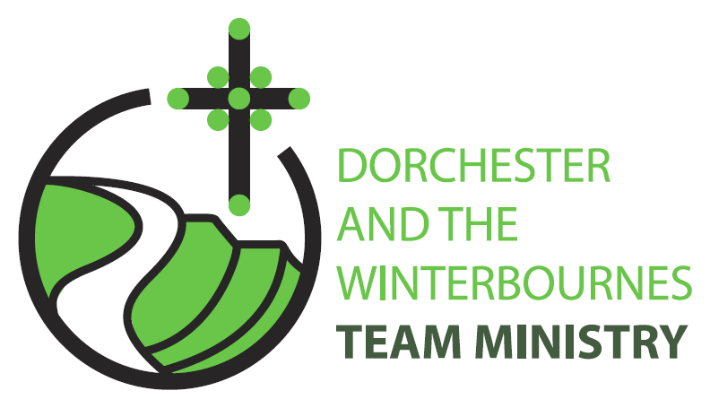

Easter 6
10th May 2026

Welcome to this service for the Easter season especially if you're here for the first time or are a visitor to the Winterbourne Valley. Today we hear the promise of Jesus, ‘I will not leave you orphaned’. We rejoice in God’s saving presence in our lives and we pray that we might bring others to find solace in God’s love. So, we continue to pray for communities afflicted by war and for the continued peace processes in Iran and Israel and Ukraine. In this Easter season, we remember especially the Christian communities of Palestine and Israel, Russia and Ukraine.

Collect
Risen Christ,
by the lakeside you renewed your call to your disciples:
help your Church to obey your command
and draw the nations to the fire of your love,
to the glory of God the Father.
All: Amen

Reading: Acts 17: 22-31

22 Then Paul stood in front of the Areopagus and said, Athenians, I see how extremely religious you are in every way.
23 For as I went through the city and looked carefully at the objects of your worship, I found among them an altar with the inscription, To an unknown god. What therefore you worship as unknown, this I proclaim to you.
24 The God who made the world and everything in it, he who is Lord of heaven and earth, does not live in shrines made by human hands,
25 nor is he served by human hands, as though he needed anything, since he himself gives to all mortals life and breath and all things.
26 From one ancestor he made all nations to inhabit the whole earth, and he allotted the times of their existence and the boundaries of the places where they would live,
27 so that they would search for God and perhaps grope for him and find him-though indeed he is not far from each one of us.
28 For In him we live and move and have our being; as even some of your own poets have said, For we too are his offspring.
29 Since we are Gods offspring, we ought not to think that the deity is like gold, or silver, or stone, an image formed by the art and imagination of mortals.
30 While God has overlooked the times of human ignorance, now he commands all people everywhere to repent,
31 because he has fixed a day on which he will have the world judged in righteousness by a man whom he has appointed, and of this he has given assurance to all by raising him from the dead.
This is the word of the Lord.
All: Thanks be to God.

Gospel Reading: John 14:15-21

Hear the Gospel of our Lord Jesus Christ according to John.
All: Glory to you, O Lord.

15 If you love me, you will keep my commandments.
16 And I will ask the Father, and he will give you another Advocate, to be with you for ever.
17 This is the Spirit of truth, whom the world cannot receive, because it neither sees him nor knows him. You know him, because he abides with you, and he will be in you.
18 I will not leave you orphaned; I am coming to you.
19 In a little while the world will no longer see me, but you will see me; because I live, you also will live.
20 On that day you will know that I am in my Father, and you in me, and I in you.
21 They who have my commandments and keep them are those who love me; and those who love me will be loved by my Father, and I will love them and reveal myself to them.

This is the Gospel of the Lord.
All: Praise to you, O Christ.

Post Communion Prayer
God our Father,
whose Son Jesus Christ gives the water of eternal life:
may we thirst for you,
the spring of life and source of goodness,
through him who is alive and reigns, now and for ever.
All: Amen
NOTICES:
Ascension Day Thursday 14th May: 9am Holy Communion @ St Martin
7pm Holy Communion @ St Mary, Edward Road, Dorchester

Fundraising event for The Winterbourne Valley Churches: 14th June
A Message from Tom Webb “This is a "save the date" notice for the 14th June.
Phil and Roelie Newman are opening their garden in Martinstown as part of the National Garden Scheme. The scheme itself raises money for a cancer charity but they have expressed a willingness that we provide, tea, coffee, cake, sausage rolls and other refreshments of our choosing to raise money for the valley churches.
Closer to the time I will be seeking 🙂....
- Cake and sausage roll donations for delivery on the 13th June. We will need a lot, as people travel a long way to come to these open gardens, especially new ones. You may claim for ingredients if you wish.
- Volunteers to man/woman the stand on the day. Bits of the day would be welcome. 09.30 to 16.30
I`ll be asking again closer to the time but if you could put these dates in your diary and let me know if you`re going to be able to help,
Best wishes, Tom Webb

PRAYERS FOR THE WEEK

Lord Jesus we listen to your words today which call for us to live in a radically different way. By your Holy Spirit cleanse the thoughts of our hearts and lead us to loving actions. We pray that the way in which we live would reflect our Christian calling. May our fellowship with one another on Sundays be an occasion in which we are encouraged and equipped to make a difference in our world.

Lord Jesus as you have welcomed us, may we seek out others that more may be blessed with the knowledge of your unfailing love. We pray for those troubled or in need. We think of those who are facing or undergoing medical treatment, those who are fearful of test results, those who are sick and long to be well. Be their constant companions, guard and protect them, set your angels charge over them and may they know the power of your healing touch. We pray especially for Bruce Robertson and Maggie, Andreas, Clare Rootham, Mandy Reed, John Reed, Di Honeybun.

Lord God we are mindful that you have promised to us that beyond the trials of this world you have prepared good things which no eye can see. So set our hearts beyond the temporary things of this world, that we might live in an awareness of your heavenly country to which we all belong. We remember those who have died, and we pray that we with them might be united in that place beyond the time and tears of this world and know the joy of living in your presence. We pray especially for Malcolm Mitchell who has died recently and for those whose year’s mind occurs this month we pray for: David Lacy-Smith, Anne Armstrong, Elizabeth Penfold, Lorna Power, Eileen Hobday

