St James the Great  Wrightington with Heskin  www.stjamesthegreat.net |  | 92 Church Lane  Wrightington  WN6 9SP  Phone: 07769 462502  vicar@stjamesthegreat.net

3rd May – 5th Sunday after Easter
09.00am Holy Communion - David Long
10.30am Family Service
5.00pm 30@5

The Electoral Roll for 2026 is at the back of church, please have a look to check if your name is listed. If you wish to apply to be included, please complete the necessary form and hand to Sue Crawford.

Parents – please ensure that you complete an Attendance Form each time you come to a service (slips are in the box on the back table). This will inform me and is essential information when the time comes for Faith References.

We have a vacancy on the Deanery Synod – if you wish to apply fill in the form and hand to Sue Crawford.

Summer Fair -June 13th – we are hoping to make this bigger and better this year but need your help with ideas for stalls and activities, plus help on the day. If you have some ideas, please come along to a meeting at St James Church Hall on 6th May at 12.00 noon, or pass on your ideas to a member of the Fund Raising Team. If anyone would like a table-top stall on the day – cost £5.00 – please see Cathy Pass.

Advance notice of our Christian Aid Brunch on the 17th May in the church hall following the 10.30 service. Everyone is welcome and Kids eat for a £1.00 donation. Please come and support us.
*+*+*+*+*+*+*+*+*
Mon 4th May Heskin School closed for Mayday holiday
Wed 6th May 10.30am Play & Praise Toddler Group
*+*+*+*+*+*+*+*+*
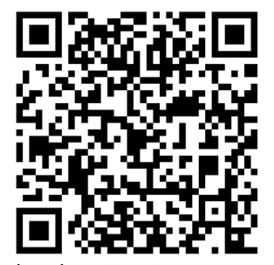
May 10th 6th Sunday after Easter (Rogation Sunday)
09.00am Holy Communion - David Gaskell
10.30am Holy Communion - David Ward
12.00 noon APCM in the Church Hall – all welcome
5.00pm 30@5

