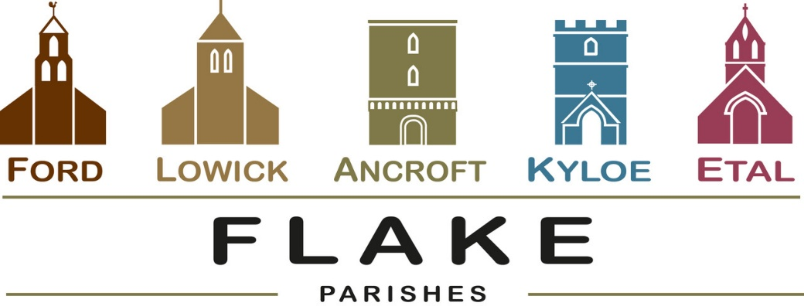
A very warm welcome to you, especially if you are visiting.
Please take this sheet home with you and use it as a basis for prayer.
Children may be at all our services.
Sunday May 10th 2026
Lowick 9.15 Holy Communion
Ford 11am Holy Communion

Sunday 17th May 2026
Lowick 9.15 Holy Communion
Ford 11am Holy Communion

Sunday 24th May 2026
Pentecost
Lowick 9.15 Holy Communion
Ford 11am Holy Communion
Ancroft 11am Holy Communion

Sunday May 31st 2026
Trinity Sunday
10 am Ancroft Flake Service of Holy Communion
with Baptism of Leo Firman

Revd Charlotte Osborn (Vicar) 01289 388591 ceosborn@mail.com 07957 367457
Revd Alex Firman (Assistant Curate) 07935 732811
alex_firman@hotmail.co.uk
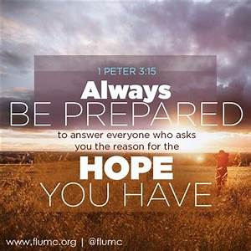
Sixth Sunday of Easter
Peter in his letter urges us to always be ready to give an answer to anyone who asks us about the faith we hold. We can only do this trusting that God will give us the words when asked- so let’s be available to Him as modern day witnesses, and enjoy the opportunities he gives, rather than be consumed by worry that we might say the ‘wrong’ thing.

Parish Business
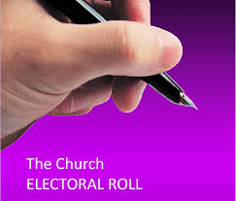
Electoral Rolls are being revised ahead of the Annual Parochial Church Meetings in all our parishes. Please check the published roll at the back of church for correctness. If you would like to join, speak to Nici Gibb at Ford or Margaret Urwin at Lowick, or Charlotte for Ancroft.

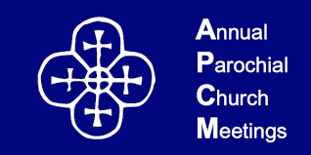
Annual Parochial Church Meetings 2026
Annual Reports are received and elections for Churchwardens and PCC members take place.

Ford – in the Estate Office on Tuesday 19th May 5.30pm
Lowick – Lowick Village Hall on Wednesday 20th May at 7pm



- Tuesday 12th May Lowick Standing Committee Vicarage 3pm

- Thursday 14th May is Ascension Day Prayers from the Top of the Tower at Ancroft at 10am followed by coffee.

- Clergy team meeting Lowick Vicarage 8.30am Monday 18th May

- Beating Lowick Bounds Monday 25th May Start LVH 10am

- Lowick/HI School service for Pentecost Holy Island 10.30am

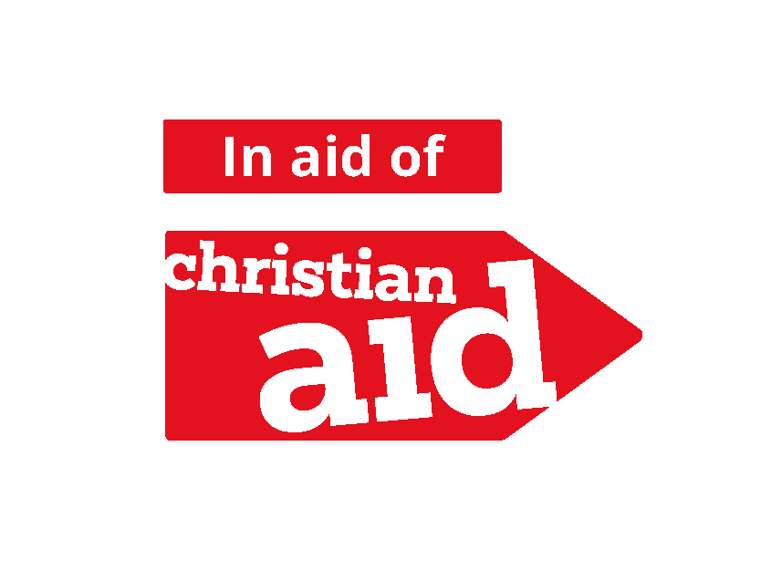
Christian Aid Week is May 10th – 16th

As benefices we support the work of Christian Aid with these 2 events:

- Concert in Berwick Baptist Church on Wednesday 13th May at 7pm given by the Golden Square Singers, donations to Christian Aid.

- Quiz and Supper in Bowsden Village Hall on Saturday 16th May at 7pm. £10 per person. Come as a team of 4 or join with others on the night. Bar and Raffle. Book with Diane
rumplecottage@yahoo.com

For our prayers


Over the next few weeks, we shall be reading the banns of marriage for

Katkin and Alex to marry at Ford 23rd May
Annabel and John, to marry
at Ancroft 20th June
Ian and Yvonne to marry at Ford 18th July

We joyfully pray for them as they prepare not just for their wedding day, but for their married life together

Please continue to pray for all who suffer in body, mind or spirit, especially Heather Piper, George Hall, Gail Calder, Don and Sam Quilty, David and Judith Dobson, Alison Murray, Rachel Inglis.

We remember all who have recently died especially Edward Younger, (Ancroft) Sandra Hall (Etal) Ian Hay (Lowick) and Chloe French. We pray for those who mourn, and for all who mark anniversaries of death at this time of year.
Parish Contacts

Ancroft Leigh Yorke 07716 116739
Etal Andrew Joicey 01890 820540
Ford Kathleen Holmes 07951 099668
Lowick Niall Cartlidge 07850 876246

Websites: www.achurchnearyou.com
Instagram: https://www.instagram.com/the_flake_churches/
Facebook: the_flake_churches

Other licensed clergy
Revd Margaret Sentamu 077871 204745, Canon Nick Sagovsky,
Revd Marion Penfold 01289 305664

