
Next collection will be June 24th please leave donations in narthex.


Small Pilgrim Places are: Small places, simple, quiet & unpretentious, with the
presence of the Divine. St Laurence’s Church.www.smallpilgrimplaces.org Thur10-11am & Sat 2-4pm

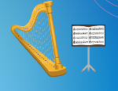
Belmont Hall: Songs & Poems of the North. Thursday, 4th June celebrate the music and poetry of Scotland, Ireland, and the North of England. Time: 2:30pm – 4pm. Featuring Pauline Vallance, a singer-songwriter and Celtic harp player and Clive Wright a prize-winning poet born in Northern Ireland sharing reflections from his time in Scotland and Durham. £10.

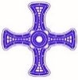
Bishop Rick will be installed as Bishop of Durham at Durham Cathedral on Sunday, 7 June. To attend, go to Durham Cathedral’s website from 12 noon on Wed 13 May. Go to ‘Visits’ page -
‘Concerts and evening events’, - 7 June.
Use the code RICK2026 for a max. of 2 tickets.

Thur 28th May: Money, Race & Climate: Christian perspectives. 7-8.30pm at Cranmer hall. A panel of experts chaired by Sarah Edwards from Just Money Movement. Register for the event here; Money, Race and Climate Tickets, Thursday, May 28 • 7 PM - 8:30 PM | Eventbrite

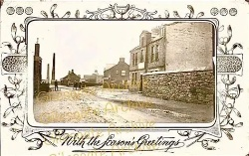
Pittington Parish Remembered: Recollections of people and places: Sat 6th and Sun 7th June 10.30-4.30 at SL. Admission £2

Durham Harmonics Friday 19th June, 7.30 at St Laurence’s Church. Admission £5 inc. tea/coffee. In aid of church building fund.


For our prayers this week:
Pray for those who are unwell or asked for our prayers: Jean Dennison, Anne Johnson (P’ton), George Kitching, Trevor Uren, Geoffrey Winter. Those who have been bereaved: the family of Peter Hampson.

From our Parish weekly prayer cycle:
The church administrator; pastoral visiting team; Hallgarth Farm, Pittington; St Joseph’s Roman Catholic Church; those involved in baptism & confirmation preparation; residents of Wellington Street, Pittington; Swinside Drive, Eden Terrace, Adolphus Place, Dene Drive, Cheveley Walk, Belmont.
The Benefice of
St Mary Magdalene, Belmont &
St Laurence, Pittington

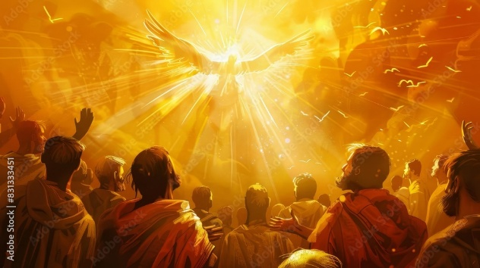
Pentecost Sunday
May 24th 2026

Collect: Holy Spirit, sent by the Father, ignite in us your holy fire; strengthen your children with the gift of faith, revive your Church with the breath of love, and renew the face of the earth, through Jesus Christ our Lord. Amen

Hymns: 102 Come down O Love divine; 595 Spirit of the living God; 76 Break thou the bread of life; 578 She sits like a bird; 77 Breathe on me; 105 Come Holy Ghost; 223 Go forth and tell.

Bible Readings: Acts 2:1-21 (BCP also)
Numbers 11:24-30
Gospel Reading: John 20:19-23

Upcoming services
w/b Sunday 24th May
9.00 am Holy Communion BCP SMM
9.30 am Holy Communion SL
11.30am Baptism of Jacob Proctor SL
10.30 am Holy Communion SMM
4-5.30pm Youth/confirmation group SMM
Mon NO Morning prayer SMM
Wed 10.00am Holy Communion SMM
Thu 10-11am Morning prayer & open church SL
Sat 12.30 Wedding of Luke Renwick and Kaitlyn
Ball SL
Sat 10-12 Orthodox Mass SMM
Sat 2-4pm Open Church SL
w/b Sunday 31st May:
9.00 am Holy Communion BCP SMM
9.30 am Holy Communion SL
10.30am Holy Communion SMM
Mon 9.00am Morning Prayer SMM
Wed 10.00am Holy Communion SMM
Thu 10-11am Morning prayer & open church SL
Fri 10.30am Spirit -led prayer group SMM
Sat 2-4pm Church Open SL
Acts 2:1-21
When the day of Pentecost came, they were all together in one place. ² Suddenly a sound like the blowing of a violent wind came from heaven and filled the whole house where they were sitting. ³ They saw what seemed to be tongues of fire that separated and came to rest on each of them. ⁴ All of them were filled with the Holy Spirit and began to speak in other tongues
as the Spirit enabled them. ⁵ Now there were staying in Jerusalem God-fearing Jews from every nation under heaven.
⁶ When they heard this sound, a crowd came together in bewilderment, because each one heard their own language being spoken. ⁷ Utterly amazed, they asked: ‘Aren’t all these who are speaking Galileans? ⁸ Then how is it that each of us hears them in our native language?
⁹ Parthians, Medes and Elamites; residents of Mesopotamia, Judea and Cappadocia, Pontus and Asia, Phrygia and Pamphylia, Egypt and the parts of Libya near Cyrene; visitors from Rome ¹¹ (both Jews and converts to Judaism); Cretans and Arabs – we hear them declaring the wonders of God in our own tongues!’ ¹² Amazed and perplexed, they asked one another, ‘What does this mean?’
¹³ Some, however, made fun of them and said, ‘They have had too much wine.’
¹⁴ Then Peter stood up with the Eleven, raised his voice and addressed the crowd: ‘Fellow Jews and all of you who live in Jerusalem, let me explain this to you; listen carefully to what I say. ¹⁵ These people are not drunk, as you suppose. It’s only nine in the morning! ¹⁶ No, this is what was spoken by the prophet Joel:
¹⁷ ‘“In the last days, God says,
I will pour out my Spirit on all people.
Your sons and daughters will prophesy,
your young men will see visions,
your old men will dream dreams.
¹⁸ Even on my servants, both men and women, I will pour out my Spirit in those days, and they will prophesy.
¹⁹ I will show wonders in the heavens above
and signs on the earth below,
blood and fire and billows of smoke.
²⁰ The sun will be turned to darkness
and the moon to blood
before the coming of the great and glorious day of the Lord.
²¹ And everyone who calls
on the name of the Lord will be saved.”
Numbers 11:24-30
So Moses went out and told the people what the Lord had said. He brought together seventy of their elders and made them stand round the tent. ²⁵ Then the Lord
came down in the cloud and spoke with him, and he took some of the power of the Spirit that was on him and put it on the seventy elders. When the Spirit rested on them, they prophesied – but did not do so again.
²⁶ However, two men, whose names were Eldad and Medad, had remained in the camp. They were listed among the elders, but did not go out to the tent. Yet the Spirit also rested on them, and they prophesied in the camp. ²⁷ A young man ran and told Moses, ‘Eldad and Medad are prophesying in the camp.’ ²⁸ Joshua son of Nun, who had been Moses’ assistant since youth, spoke up and said, ‘Moses, my lord, stop them!’ ²⁹ But Moses replied, ‘Are you jealous for my sake? I wish that all the
Lord’s people were prophets and that the
Lord would put his Spirit on them!’ ³⁰ Then Moses and the elders of Israel returned to the camp.

John 20:19-23
On the evening of that first day of the week, when the disciples were together, with the doors locked for fear of the Jewish leaders, Jesus came and stood among them and said, ‘Peace be with you!’ ²⁰ After he said this, he showed them his hands and side. The disciples were overjoyed when they saw the Lord. ²¹ Again Jesus said, ‘Peace be with you! As the Father has sent me, I am sending you.’ ²² And with that he breathed on them and said, ‘Receive the Holy Spirit. ²³ If you forgive anyone’s sins, their sins are forgiven; if you do not forgive them, they are not forgiven.’

