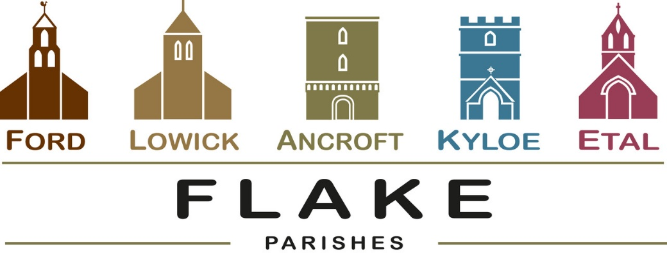
A very warm welcome to you, especially if you are visiting.
Please take this sheet home with you and use it as a basis for prayer.
Children may be at all our services.
Sunday 17th May 2026
Lowick 9.15 Holy Communion
Ford 11am Holy Communion

Sunday 24th May 2026
Pentecost
Lowick 9.15 Holy Communion
Ford 11am Holy Communion
Ancroft 11am Holy Communion

Sunday May 31st 2026
Trinity Sunday
10 am Ancroft Flake Service of Holy Communion
with Baptism of Leo Firman

Sunday June 7th 2026
Lowick 9.15 Holy Communion
Ford 11am Holy Communion

Revd Charlotte Osborn (Vicar) 01289 388591 ceosborn@mail.com 07957 367457
Revd Alex Firman (Assistant Curate) 07935 732811
alex_firman@hotmail.co.uk
Easter 7
The Sunday after Ascension Day

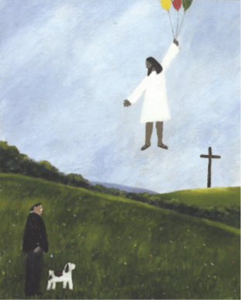

This painting by Gary Bunt, a British artist born in 1957, comes from his book ‘By the grace of God’. Bert and his dog visualise the ascension, or enthronement. In today’s gospel reading in his farewell discourse to his disciples, Jesus looks forward with confidence to returning to his Father.
Today we contemplate how absence enables presence.

Annual Parochial Church Meetings 2026
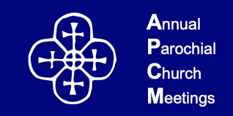
Annual Reports are received and elections for Churchwardens and PCC members take place this week. All are welcome to come and hear what God is doing in our midst, and be encouraged.

- Ford – in the Estate Office on Tuesday 19th May 5.30pm

- Lowick – Lowick Village Hall on Wednesday 20th May at 7pm


- Clergy team meeting Lowick Vicarage 8.30am Monday 18th May

- Beating Lowick Bounds Monday 25th May Start LVH 10am

- Lowick/HI School service for Pentecost Holy Island 10.30am


Friday 5th June 2026 7pm
Ancroft Memorial Hall
Saturday 6th June 2026 7.30pm
Chirnside Community Centre
Sunday 7th June
Wooler URC 3.30pm
Tickets £10 from Dee Colam
07801 822851

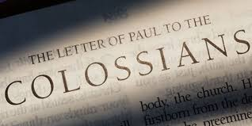
Sundays and Mondays in June

An in-depth study of Paul’s letter

Sunday Sermons, Monday Discussion

For our prayers

Over the next few weeks, we shall be reading banns of marriage for

Katkin and Alex

to marry at Ford 23rd May

Annabel and John,
to marry at Ancroft 20th June

Ian and Yvonne
to marry at Ford 18th July

We joyfully pray for them as they prepare not just for their wedding day, but for their married life together

Please continue to pray for all who suffer in body, mind or spirit, especially Heather Piper, George Hall, Gail Calder, Don and Sam Quilty, David and Judith Dobson, Alison Murray, Rachel Inglis.

We remember all who have recently died. We pray for those who mourn, and for all who mark anniversaries of death at this time of year.
Parish Contacts

Ancroft Leigh Yorke 07716 116739
Etal Andrew Joicey 01890 820540
Ford Kathleen Holmes 07951 099668
Lowick Niall Cartlidge 07850 876246

Websites: www.achurchnearyou.com
Instagram: https://www.instagram.com/the_flake_churches/
Facebook: the_flake_churches

Other licensed clergy
Revd Margaret Sentamu 077871 204745, Canon Nick Sagovsky,
Revd Marion Penfold 01289 305664

