NEWSLETTER NUMBER 321
SAD NEWS – We are sorry to tell you the very sad news that Susan Dobson died recently. She was a valued member of the choir at All Saints’ Church and a very longstanding member of the church.

OUR SERVICE ON SUNDAY 17TH MAY 2026 – EASTER 6/SUNDAY AFTER ASCENSION
The next service at All Saints’ Church will be on Sunday 17th May 2026 and it will start at 10.30 a.m. This will be a Sung Eucharist starting at 10.30 a.m. and refreshments will be served after the service. The celebrant will be Rev David Burton.

LOOKING FORWARDS – REV ANDY
Nothing received

ROTA FOR SUNDAY 17TH MAY 2026
Sidesmen:- Jacquie Hockaday and Ann Fry
Reader:- Philippa Deem
Coffee:- Jacquie Hockaday and Ann Fry
Flowers:- Philippa Deem

READINGS FOR SUNDAY 17TH MAY 2026 – EASTER 6/SUNDAY AFTER ASCENSION
Collect:- O God the King of glory, you have exalted your only Son Jesus Christ with great triumph to your kingdom in heaven: we beseech you, leave us not comfortless, but send your Holy Spirit to strengthen us and exalt us to the place where our Saviour Christ is gone before, who is alive and reigns with you, in the unity of the Holy Spirit, one God, now and for ever. Amen

Readings:-
Acts Chapter 1 vv 6 – 14
1ST Peter Chapter 4 vv 12 – 14 and Chapter 5 vv 6 – 11
John 17 Chapter 17 vv 1 – 11

PRAYER LIST
Elizabeth Miles
Eunice Durrance
Hazel Ware
Ian Sansom
John Wilkie
Mike Toogood
Pam Wilkie
Paul Tatnall
Stephen Daley
The families mourning Susan Dobson
YEARS MIND FOR MAY
19TH Alice (Mary) Taylor
19TH Elizabeth (Betty) Elwyn Perry
20TH Anthony John Aitken
21ST Eileen Margaret Hill
23RD Jack Gormley
24TH Phyllis Gwendoline Grinter

BIRTHDAY LIST FOR MAY
22ND Jonathan Kimber
You may have moved away from Rockwell Green but we still know it is your birthday! Have a good celebration and enjoy your day.

OUTREACH GROUPS
Churchyard Group
If you are willing to help, the next meeting will be at 10.00 a.m. on Tuesday 26TH May 2026 if anyone is free. We now need to get a watering can and some fill-in plants and wonder if anyone has any of the following that they would be willing to donate:- White aubretia, white mini periwinkle, white iberis, white omphaloides, tête-a- tête daffodil bulbs (if not, we will plant them in the autumn), small green/yellow or green/white hostas and small ferns.
Recycled Teenagers
The next meeting will take place on Tuesday, 26th May 2026 at 2.30 p.m. Come along and enjoy cups of tea plus sandwiches and cakes along with some conversation.
Knit, Sew and Natter
The next meeting will be on Thursday, 4TH June 2026 at 2.00 p.m. It will be the usual meeting with lots of chat and refreshments.

Shanty Singing
The next meeting of this group will be at 6.00 p.m. on Sunday 7TH June 2026. You do not have to have been to any previous meeting to join any session of shanty singing.

Soup ‘n’ a Bite
This will be on Saturday 13TH June 2026 at 12.00 noon. It will be the normal fare of soup, bread, cheese and fruit combined with lots of conversation!

OUR NEXT SERVICE
The next service at All Saints’ Church will be on Sunday 24 May 2026. This will be a Sung Eucharist starting at 10.30 a.m. and refreshments will be served after the service. The celebrant will be Rev Sarah Rowden with Rev Andy Barton preaching. Also on the same day, there will be Families@4.

FUND RAISING COMMITTEE EVENTS
Saturday 23rd May – Rogationtide walk with pasty and cider
The annual Rogationtide walk will start at 10.30 a.m. and use a circular walk to get back to the church for the wonderful Tim Potter pasties and cider. This is a leisurely ramble very roughly along the parish boundary with the odd break for some non-religious readings. IF YOU INTEND TO COME, PLEASE EMAIL ME OR SIGN THE LIST IN CHURCH SO WE BUY ENOUGH PASTIES. Start praying for good weather!
FORTHCOMING EVENTS FROM ELSEWHERE IN THE BENEFICE
Saturday 16/5/2026 Plant sale at 2.30 p.m.
This is at Hellings Farm, Bathealton and is in aid of the church – see poster sent previously.

6/6/2026 Garden Party and Fete at 2.00 p.m.
This will be held at Stawley Mill. Please see the poster attached to this newsletter.

OTHER INFORMATION
Report from the Quiz night (held on 9th May 2026)
In a hot and steamy Lang Room, teams battled through the easy quiz. It was a very close battle at the beginning but, ultimately, the team “May contain nuts” won through. Second place went to the team from our bell ringers called “The Clappers”. People enjoyed the supper and the sum of £190-00 was raised for church funds.

West Tone Benefice Walk Saturday 20th June 2026
This year the walk will start at Holy Cross Church, Sampford Arundel, with signing in from 8.30 a.m. followed by All Saints Church. We will need to supply a couple of items of food e.g. cheese scones and a cake or small cakes to cheer the walkers on their way. The rest of the route is as per last year and will end in Ashbrittle, where there will be a barbecue at Greywalls. If you could offer to help with the food request, please let me know.

Two Items from the Daily Telegraph 9/5/2026
1) Peterborough column
“New Archbishop of Canterbury Sarah Mullally had better watch out – Rachel Reeves is coming for her. The Chancellor and her team are still putting the finishing touches to the so-called ‘mansion tax’ or ‘high value council tax surcharge’ on properties worth over £2 million. Asked by Sir James Cleverley if the Church of England will be ‘liable for council tax’ on the Archbishop’s Lambeth Palace and its associated gardens, Dan Tomlinson, the Treasury minister, said “Owners, not residents, will pay the surcharge. The Government will consult on potential exemptions and reliefs in due course”.
Better put out the collection plate!!!
2) From S P McKie, Rudge, Somerset in the Letters page
It is a common misapprehension, sedulously promoted by diocesan staff, that the payment of the ‘parish share’ is compulsory. It is not. It is voluntary. Parishes should refuse to pay it so as to persuade dioceses to stop wasting resources on central initiatives that either do little good or do positive harm, and instead support properly the parishes, where the Christian life of the nation is lived.

From Rev Andrew Norris
The “Home Service” is a weekly programme which brings Christian worship into your front room which is broadcast on 105.3 FM on Wednesdays at 11.00am. This week: Dan Bedford from The Well in Rockwell Green takes us on a simple gospel journey in a time of worship and song and we remember the work of Christian Aid during their special appeal week.

FUN CORNER
From Edward Hill, Chandler Ford, in the Daily Telegraph letters page 9/5/2026
With the first robot Buddhist ordained in South Korea, when will the Church of England fashionably follow suit to address its dire shortage of vicars?

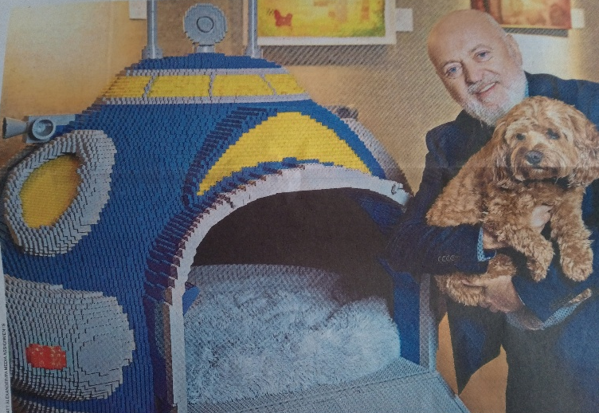
PAMPER YOUR POOCHES
I shall expect anyone with a dog or two to order one of these immediately!

