
ST. ANN’S, BELFIELD NEWS LETTER
WORSHIP

Church open
St Ann’s is open for public worship Sundays and Wednesdays at 10.30am

Streamed service
On-line via twitch.tv/revdgill and for 1 week after. Downloads on request.

Prayers for the sick
Ghislaine Glover, Cath Boon, Roger , Lilian.

Prayers for home members
Bob (in Mona Cliffe Care Home), Dorothy (in Braeside)

The anniversary of the dearly departed
Norma Sayer,


Scan this with your phone to contribute to St Ann’s mission and ministry

Benefice Motto, 2026
“In everything by prayer and supplication… let your requests be made known to God. And the peace of God which surpasses all understanding, will guard your hearts and your minds in Christ Jesus.”

New Service – Said Communion
A quiet communion service, 2nd Sunday every month over the summer, 2pm, Christ Church. For those for whom 10am is a bit too early. Next one: 14th June. Please share this invitation with those who like a bit of p&q!

School of prayer
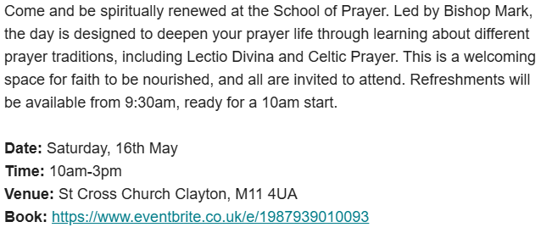

17th May 2026
Seventh Sunday of Easter
Baptism of Romey Garside
Rev. Gill

Hymns All NEH
237 Morning has broken
375 Lord of the dance
264 All things bright and beautiful
120 Thine be the glory

NOTICES
Songs of Praise
Christ Church, Healey, Friday 15th May, 7pm, Cancer Research.

Icons on Ammo Boxes
A powerful and deeply moving collection features Ukrainian icons painted on repurposed ammunition boxes from the frontlines of the war in Ukraine. The exhibition will be showing from 11th to 25th May, 11am – 6pm.

Joint service May 31st
List at the back of church for refreshment donations and help to set up on day before Sat.30th May at 3.30pm after party hire in the hall.

April 2026 Finances
Income £2992.40 Expenditure £3306.40. Thank you for generous donation and increased giving from members of the congregation.

Lviv Children's Art Project, 11th May - 28th June, Riverside
Ukraine’s children tell their stories through art.

Thy Kingdom Come 2026
This year’s Thy Kingdom Come - the presence of God through His spirit. 11 days from Ascension to Pentecost, a different Bible story which demonstrates God’s transformative presence. Use this to pray for 5 people you know.

