All Saints’ Church, Orton

Notice Sheet

Sunday 3rd May: 5th Sunday of Easter
10.30 a.m. Holy Communion with the Revd. Sandra Ward
New Testament: Acts 7:55-end (Mary Jenkin)
I Peter 2:2-10 (Margaret Longworth)
Gospel: John 14:1-14 Prayers: Angela Milburn
Organ Voluntary: "Christ is Risen" by Christopher Tambling (1964-2015).

THIS WEEK

Monday 4th: 10.30am – 12.30pm: Drop In at The Hub, St. James’, Tebay.

Wednesday 6th: 10.30 a.m. – 12 noon: Drop In at Orton Chapel Schoolroom. Free coffee, cakes and friendly conversation.

Thursday 7th: 9.30 a.m. Charlie’s Church in church

Friday 8th: 7.30 p.m. Bell-ringing practice

Saturday 9th: Farmers’ Market Coffee Morning in church

Next Sunday, 10th May: 6th Sunday of Easter
8.30 a.m. Holy Communion (BCP) with the Revd. Brendan Giblin
New Testament: Acts 17.22–31 and 1 Peter 3.13–end
Reader: Keith Capp Gospel: John 14.15–21

12.00 noon: Orton with Tebay Annual Parochial Church Meeting
at St. James’ Church, Tebay.

Thursday 14th May: ASCENSION DAY. 7.30 p.m.
Solemn Eucharist at St. Lawrence’s Church, Crosby Ravensworth.
The Revd. Andrew Burrell will preside.
Preacher: The Revd. Stephen Tudway

The Link: Copies of the May issue of The Link are now in church.

K Shoes Concert: We offer grateful thanks to everyone who helped to make this a good occasion, especially for the excellent refreshments (and those who served them) – always much appreciated by the choir members!
The parishes of Upper Eden and Upper Lune
United Benefice Holy Communion
10.30 a.m.: Sunday 17th May - Sunday after Ascension Day
Kirkby Stephen Parish Church
Singing led by “our wonderful Benefice Choir”.
Farewell Service for the Revd. Canon Brendan Giblin
NB: Farewell gift to Brendan and Suzannah:
Any contribution to their farewell gift (from all the churches in the Benefice) should be put in the basket at the back of Orton Church today, or given to Mary or Keith (preferably in an envelope) by Sunday 10th May.

Thursday 21st May, 7.30 p.m.
“Left To Their Own Devices” – Tech-savvy kids and how to raise them
The “Care for the Family” Spring Tour 2026 visits
The Halston, Carlisle, CA1 1AB
Parents are invited to join us for our live event, to be equipped with practical skills and knowledge, to stay ahead of the curve and help their children to navigate the online world safely and to their advantage. It’s never too late to establish healthy digital boundaries with our children – whatever their age.
Please mention this event to any parents of school-age children.
https://www.careforthefamily.org.uk/events/tourevents/left-to-their-own-devices
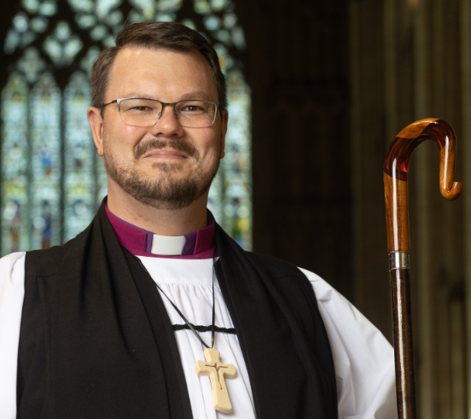
New Bishop of Penrith: Hundreds of people gathered at York Minster on 30th April as the new Suffragan Bishop of Penrith was consecrated. Bright sunshine welcomed the Rt Rev Michael Leyden as he emerged onto the Minster’s western steps following the two-hour service which began at 11am and was presided over by the Archbishop of York, the Most Reverend Stephen Cottrell. He will take up his role in the summer.

Church Exhibition Posters: (at the back of the church): Please take and display these posters wherever you can!

