ALL WELCOME
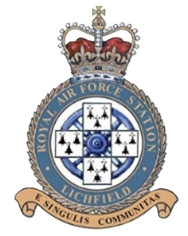

RAF Lichfield 27 OTU
RAF Lichfield 51 MU
Dedication of
RAF Lichfield Memorial Lightbox
St. Stephen’s Church, Fradley
Saturday 13th June 2026 at 11:00 a.m.






