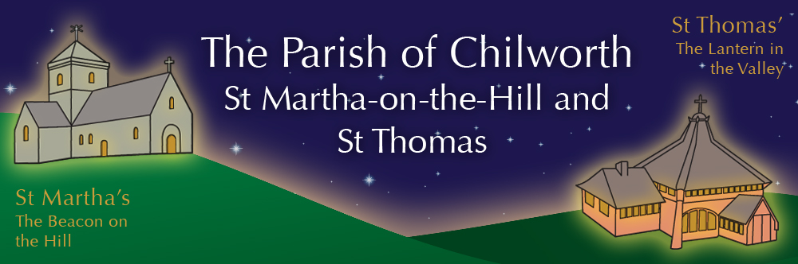

NOTICES: - 24th MAY 2026
Priest David Oakden – Revdavid@parishofchilworth.org.uk - 01483 534293 (day off Friday)
Do let me know of anybody or anything that you would like to be prayed for.
www.parishofchilworth.org.uk and find us on https://www.achurchnearyou.com

***********John 20:22 (NRSVA)***********
When he had said this, he breathed on them and said to them, ‘Receive the Holy Spirit.
***********************************

Opportunities to pray together: -
Ecumenical Prayer Breakfast 1st Saturday of the month at the Vicarage, from 9am, prayer, coffee and croissant. Next is the 6th June – Thursday evening at St Thomas at 6:00 pm for an hour every other week. 21st May & 4th June.

This Sunday Services: – PENTECOST
9:30 St Peter & St Paul’s Albury Holy Communion.
11:15 St Martha’s Holy Communion inc Baptisms.

Next Sunday Services: - 31st of May
10:00 St James Shere All Age Worship.
11:15 St Martha’s Fifth Sunday.

Looking further ahead: -
Tots and Toddlers: St T’s Monday 9:15am
APCM: St T’s 21st May at 7:30pm
Infant School Pilgrimage: 22nd May St M’s
Chilworth Manor NGS Open Day: 24th May
Summer Music on the Hilltop: 25th May 12-5pm
Broad Horizons: 26th May St M’s @ 7pm

Food & Hygiene Bank: -
The Foodbank Larder box is located in the porch of St Thomas Church. Please help!
(We are currently very low on funds and struggling to keep up with demand.)
Donations of LL milk, tinned meat, fish, veg & beans, pasta, pasta sauces, sachets rice, toiletries and cleaning products always needed. We also supply 6 families, 4 single households with monthly deliveries of fresh food at a cost £400-£500 a month.
Donations can be made at: treasurer@parishofchilworth.org.uk or scanning Foodbank QR code. Thank you.

Chilworth Tinies and Toddler Group: -
Mondays from 9:15 -10:45 meet in St Thomas, play chat, pray and support.

Broad Horizons Book Group: -
Our informal book discussion group, meet once a month on Tuesday evenings (7-8:30pm) throughout the summer. All welcome to any or all of the sessions. Dress warmly, as we meet on the benches outside St Martha’s, to enjoy the view, a hot drink and the setting sun. May 26th Voices of Silence: Meditations on T S Eliot’s Four Quartets (J C Woods).

PLANT SALE 16th May 10:30-13:00: -
This raised the fantastic total of £768.10, possibly the best ever, so a very huge thanks to all who helped, set up, grew plants and donated them, the cake bakers, those who helped on the day & all who came & bought plants & more.

Chilworth Manor NGS Open day Teas:
May 24th, We have been invited, along with the Infant school, to provide and serve the refreshments. As one of our major fundraising opportunities of the year we need 30 cakes plus the equivalent of 20 savouries. If you are donating bought cakes please can they be gluten free or otherwise 'free from' cakes. Savouries can include quiche, batches of sausage rolls etc. All donations can be left in St Thomas' church on Saturday 23rd May but please let Linda know what you are donating so we can keep a tally. If you are able to help on the day please contact Linda at Linda.Holden1@btinternet.com. Many thanks.

Summer Music on the Hilltop:
Monday 25th May starting with Jazz at Noon, followed by The Virtuoso Stage at 1:15 music from film and stage, and then 2:30 Music Miscellany with musicians from the University of Surrey ending with Celebrating Gifts, tiny musicians from 4pm.

Bishop Gathering 29th June 7:30-9pm:
Bishop Paul invites you to a special gathering at St Nicholas Church, Cranleigh on 26th June, where we will meet, pray and worship together as a deanery. Put it into your diaries now.

