TODAY’S SERVICE
11.00am: | Sung Eucharist
Presider: | Revd Melissa
Preacher: | Revd Melissa
New English Hymnal:
Processional | 139
Introit | 138
Gradual | 342 |  | Tune 178 - Carlisle
Offertory | 142 |  | Tune 265 – Regent Square
Communion | 421
Recessional | 137
At the end of the service, from Easter to Trinity, the Regina Coeli will be sung. The words may be found inside the back cover of the NEH.
THIS WEEK
Wednesday 27th |  | 10am – 12 noon – Church open
Friday 29th |  | 10.00am: Holy Communion
Sunday 31st  FIFTH SUNDAY |  | TRI-COMMUNITY EUCHARIST at ST GEORGE COLEGATE – 9.30am  NO SERVICES TODAY AT SGT  or ST-GILES-ON-THE-HILL
SERVICES & EVENTS AT ST GEORGE COLGATE
Tuesday 26th |  | 8.30am: BCP Holy Communion
Wednesday 27th |  | 9.40am: Morning Prayer  10.30am - 1.00pm: Hot Spot Coffee Morning. All welcome.
SUNDAY 31st - FIFTH SUNDAY OF THE MONTH |  | 9.30am – TRI-COMMUNITY EUCHARIST  NO SERVICES TODAY AT  ST GEORGE TOMBLAND or  ST-GILES-ON-THE-HILL

ROTAS: Please do check the rotas from time to time and, wherever possible, take a slot.
This particularly applies to the flower rota.

NOTICES
THE CHRISTIAN AID WEEK COLLECTION raised £200.00 inclusive of Gift Aid.
Thank you to all who contributed

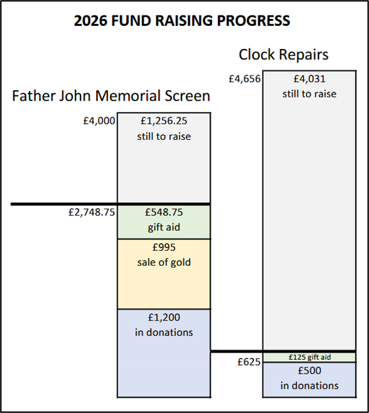

ECO CHURCH NOTE:
Enjoy the best of British seasonal vegetables and fruit during the summer, by making sure that everything you buy is from local producers and fresh. One easy way to do this is to sign up for a local organic vegetable box scheme.

OUR POWER – This is a free and genuine offer of assistance to anyone over 65 regarding their energy use or who are thinking of making changes including green technologies.
If you are interested, please see the notice on the board at the back of the church, by the tower.

