St James the Great  Wrightington with Heskin  www.stjamesthegreat.net |  | 92 Church Lane  Wrightington  WN6 9SP  Phone: 07769 462502  vicar@stjamesthegreat.net
31st May Trinity Sunday
09.00am Holy Communion -Alex Baker
10.30am Songs of Praise with Readings and Prayers
5.00pm No 30@5

Parents – please ensure that you complete an Attendance Form each time you come to a service (slips are in the box on the back table). This will inform me and is essential information when the time comes for Faith References.

Summer Fair -June 13th – we are hoping to make this bigger and better this year but need your help with ideas for stalls and activities, plus help on the day. If you have some ideas, please pass on to anyone on the Committee. If anyone would like a table-top stall on the day – cost £5.00 – please see Cathy Pass. Cathy would also welcome any empty plastic hanging baskets/tubs you may have for her stall. We also need items for Raffle and Tombola, if you have anything spare, please bring to Church and put in box at the back. Thank you.

*+*+*+*+*+*+*+*+*
Mon 1st June 2.00-4.00pm Craft & Chat in the Church Hall
Wed 3rd June 10.30am No Play & Praise Toddler Group

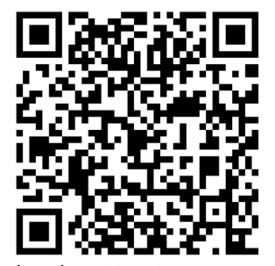
7th June The First Sunday after Trinity
09.00am Holy Communion - Alex Baker
10.30am Holy Communion - David Ward
5.00pm No 30@5

