St Peter and the Holy Apostles, Plymouth
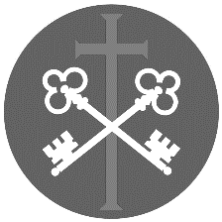
Sunday 10th May 2026- The Sixth Sunday of Eastertide (Year A)
Welcome to the Parish Mass
Welcome to St Peters Church. This sheet provides all that you will need for today’s Mass. If you need any assistance before, during or after the service or need a large print copy of this order of service please speak to one of our welcome team. (identifiable by a lanyard)
Please respond to the words in non-italic Bold, The Hymns are sung by all. Please inform the people on the door when you enter if you require a Gluten Free Host
………………………………………………………………………………
We Stand for The Entrance Hymn
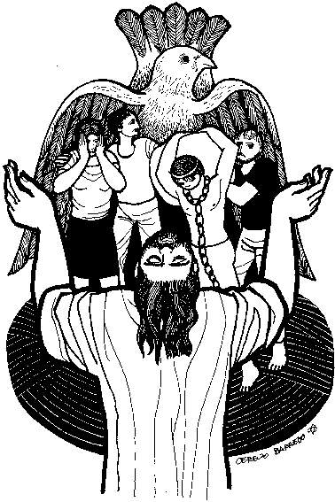
1. Ye servants of God, your Master proclaim,
and publish abroad his wonderful name;
the name all victorious of Jesus extol:
his kingdom is glorious, and rules over all.
2. God ruleth on high, almighty to save;
and still he is nigh: his presence we have:
the great congregation his triumph shall sing,
ascribing salvation to Jesus our King.
3. Salvation to God who sits on the throne!
let all cry aloud, and honour the Son.
The praises of Jesus the angels proclaim,
fall down on their faces, and worship the Lamb.
4. Then let us adore, and give him his right:
all glory and pow'r, all wisdom and might,
all honour and blessing, with angels above,
and thanks never-ceasing, and infinite love.
The Introductory Rite
In the name of the Father and of the Son and of the Holy Spirit. Amen.
Following the greeting we respond. And with your spirit.
The Priest introduces the Mass
The Penitential Rite
Dear brethren (brothers and sisters), let us humbly beseech the Lord our God to bless this water he has created, which will be sprinkled on us as a memorial of our Baptism. May he help us by his grace to remain faithful to the Spirit we have received.
And after a brief pause for silence, he continues with hands joined:
Lord our God, in your mercy be present to your people’s prayers, and, for us who recall the wondrous work of our creation and the still greater work of our redemption, graciously + bless this water. For you created water to make the fields fruitful and to refresh and cleanse our bodies. You also made water the instrument of your mercy: for through water you freed your people from slavery and quenched their thirst in the desert; through water the Prophets proclaimed the new covenant you were to enter upon with the human race; and last of all, through water, which Christ made holy in the Jordan, you have renewed our corrupted nature in the bath of regeneration. Therefore, may this water be for us a memorial of the Baptism we have received, and grant that we may share in the gladness of our brothers and sisters who at Easter have received their Baptism. Through Christ our Lord.
Amen.

Taking the aspergillum, the Priest sprinkles himself and the ministers, then the clergy and people, moving through the church, Meanwhile, the following is sung.

1. Holy holy, holy holy
Holy holy holy, Lord God Almighty
And we lift our hearts before You
As a token of our love
Holy holy holy holy
2. Gracious Father gracious Father
We're so blessed to be Your children
Gracious Father
And we lift our heads before You
As a token of our love
Gracious Father gracious Father

3. Precious Jesus precious Jesus
We're so glad that You've redeemed us
Precious Jesus
And we lift our hands before You
As a token of our love
Precious Jesus precious Jesus

4. Holy Spirit Holy Spirit
Come and fill our hearts anew Holy Spirit
And we lift our voice before You
As a token of our love
Holy Spirit Holy Spirit

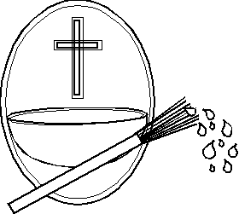
5. Alleluia, Alleluia,
Alleluia, Alleluia, Alleluia
And we lift our hearts before You
As a token of our love
Alleluia, Alleluia.

When he returns to his chair and the singing is over, the Priest stands facing the people and, with hands joined, says:
May almighty God cleanse us of our sins, and through the celebration of this Eucharist make us worthy to share at the table of his Kingdom. Amen.

The Gloria
Glory to God in the highest, and on earth peace to people of good will. We praise you, we bless you, we adore you, we glorify you, we give you thanks for your great glory, Lord God, heavenly King, O God, almighty Father.
Lord Jesus Christ, Only Begotten Son, Lord God, Lamb of God, Son of the Father, you take away the sins of the world, have mercy on us; you take away the sins of the world, receive our prayer; you are seated at the right hand of the Father, have mercy on us.
For you alone are the Holy One, you alone are the Lord, you alone are the Most High, Jesus Christ, with the Holy Spirit, in the glory of God the Father. Amen.

The Collect- The Priest leads the prayer of the day.

Grant, almighty God, that we may celebrate with heartfelt devotion these days of joy,
which we keep in honour of the risen Lord, and that what we relive in remembrance we may always hold to in what we do. Through our Lord Jesus Christ, your Son, who lives and reigns with you in the unity of the Holy Spirit, God, for ever and ever. Amen

We sit for The First Reading- Acts 8:5-8, 14-17

In those days: Philip went down to the city of Samaria and proclaimed to them the Christ. And the crowds with one accord paid attention to what was being said by Philip, when they heard him and saw the signs that he did. For unclean spirits, crying out with a loud voice, came out of many who had them, and many who were paralysed or lame were healed. So there was much joy in that city.
Now when the Apostles at Jerusalem heard that Samaria had received the word of God, they sent to them Peter and John, who came down and prayed for them that they might receive the Holy Spirit, for he had not yet fallen on any of them, but they had only been baptised in the name of the Lord Jesus. Then they laid their hands on them and they received the Holy Spirit.

The word of the Lord. Thanks be to God.

The Responsorial Psalm- Ps 66(65):1-3a. 4-5. 6-7a. 16, 20. ℟1

Response- Cry out with joy to God, all the earth.

Cry out with joy to God, all the earth; O sing to the glory of his name.
O render him glorious praise. Say to God, ‘How wondrous your deeds!’ R
‘Before you all the earth shall bow down, shall sing to you, sing to your name!’
Come and see the works of God: his wondrous deeds among the children of Adam. R

He turned the sea into dry land; they passed through the river on foot.
Let our joy, then, be in him; he rules for ever by his might. R

Come and hear, all who fear God; I will tell what he did for my soul.
Blest be God, who did not reject my prayer, nor withhold from me his merciful love. R

The Second reading- 1 Peter 3:15-18

Beloved: In your hearts honour Christ the Lord as holy, always being prepared to make a defence to anyone who asks you for a reason for the hope that is in you; yet do it with gentleness and respect, having a good conscience, so that, when you are slandered, those who revile your good behaviour in Christ may be put to shame. For it is better to suffer for doing good, if that should be God’s will, than for doing evil. For Christ also suffered once for sins, the righteous for the unrighteous, that he might bring us to God, being put to death in the flesh but made alive in the spirit.

The word of the Lord. Thanks be to God

We stand for The Gospel Procession and Acclamation- John 14:23

Alleluia, alleluia. If anyone loves me, he will keep my word, says the Lord,
and my Father will love him, and we will come to him. Alleluia.

The Gospel- John 14:15-21

The Lord be with you. And with your spirit.
A reading from the holy Gospel according to N. Glory to you, O Lord.
At that time: Jesus said to his disciples, ‘If you love me, you will keep my commandments. And I will ask the Father, and he will give you another Helper, to be with you for ever, even the Spirit of truth, whom the world cannot receive, because it neither sees him nor knows him. You know him, for he dwells with you and will be in you.
‘I will not leave you as orphans; I will come to you. Yet a little while and the world will see me no more, but you will see me. Because I live, you also will live. In that day you will know that I am in my Father, and you in me, and I in you. Whoever has my commandments and keeps them, he it is who loves me. And he who loves me will be loved by my Father, and I will love him and manifest myself to him.’

The Gospel of the Lord. Praise to you, Lord Jesus Christ.

We sit for The Homily
We stand for The Creed

I believe in one God, the Father almighty, maker of heaven and earth, of all things visible and invisible.

I believe in one Lord Jesus Christ, the Only Begotten Son of God, born of the Father before all ages. God from God, Light from Light, true God from true God, begotten, not made, consubstantial with the Father; through him all things were made. For us men and for our salvation he came down from heaven,

At the words that follow, up to and including ‘and became man’, all bow.
and by the Holy Spirit was incarnate of the Virgin Mary, and became man.

For our sake he was crucified under Pontius Pilate, he suffered death and was buried, and rose again on the third day in accordance with the Scriptures.

He ascended into heaven and is seated at the right hand of the Father. He will come again in glory to judge the living and the dead and his kingdom will have no end.

I believe in the Holy Spirit, the Lord, the giver of life, who proceeds from the Father and the Son, who with the Father and the Son is adored and glorified, who has spoken through the prophets.

I believe in one, holy, catholic and apostolic Church. I confess one Baptism for the forgiveness of sins and I look forward to the resurrection of the dead and the life of the world to come. Amen.

…………………………………………………………………………..


We stand for The Prayers of the Faithful

Each biding concludes with the following said or sung-
We pray to the Lord- Lord in your Mercy hear our prayer.

The Priest Concludes the Prayers of the Faithful
…………………………………………………………………………..

No collection is taken during the Mass, but there is a collection box at the back of church for you to give your financial contribution. All money collected helps towards the mission and ministry of our churches. If you would prefer, a card reading machine is available at the back of the church for your contribution

The Offertory Hymn

1. I danced in the morning
When the world was begun,
And I danced in the moon
And the stars and the sun,
And I came down from heaven
And I danced on the earth,
At Bethlehem I had my birth.
Dance, then, wherever you may be,
I am the Lord of the Dance, said he,
And I’ll lead you all, wherever you may be,
And I’ll lead you all in the Dance, said he.

2. I danced for the scribe
And the pharisee,
But they would not dance
And they wouldn’t follow me.
I danced for the fishermen,
For James and John –
They came with me And the Dance went on… Dance, then…
3. I danced on the Sabbath
And I cured the lame;
The holy people
Said it was a shame.
They whipped and they stripped
And they hung me on high,
And they left me there On a Cross to die… Dance, then…
4. I danced on a Friday
When the sky turned black –
It’s hard to dance
With the devil on your back.
They buried my body
And they thought I’d gone,
But I am the Dance, And I still go on.
Dance, then…
5. They cut me down
And I leapt up high;
I am the life
That’ll never, never die;
I’ll live in you
If you’ll live in me –
I am the Lord of the Dance, said he.
Dance, then…

The Liturgy of the Eucharist
Pray, brethren (brothers and sisters), that my sacrifice and yours may be acceptable to God, the almighty Father.
May the Lord accept the sacrifice at your hands for the praise and glory of his
name, for our good and the good of all his holy Church.

The Lord be with you. And with your spirit.
Lift up your hearts. We lift them up to the Lord.
Let us give thanks to the Lord our God. It is right and just.
The Priest continues with the Preface. The Sanctus is said or sung:
Holy, Holy, Holy Lord God of hosts.
Heaven and earth are full of your glory. Hosanna in the highest.
Blessed is he who comes in the name of the Lord. Hosanna in the highest.

The Priest continues the Eucharistic prayer. The following is said or sung
The mystery of faith. We proclaim your Death, O Lord, and profess your Resurrection until you come again.

The Priest concludes the Eucharistic prayer.
Through him, and with him, and in him, O God, almighty Father, in the unity of the Holy Spirit, all glory and honour is yours, for ever and ever. Amen.

The Lord’s Prayer
At the Saviour’s command and formed by divine teaching, we dare to say:
Our Father, who art in heaven, hallowed be thy name; thy kingdom come, thy will be done on earth as it is in heaven. Give us this day our daily bread, and forgive us our trespasses, as we forgive those who trespass against us; and lead us not into temptation, but deliver us from evil.
Deliver us, Lord, we pray… and the coming of our Saviour, Jesus Christ.
For the kingdom, the power and the glory are yours now and for ever.

The Peace
Lord Jesus Christ, who said to your Apostles: Peace I leave you, my peace I give you,
look not on our sins, but on the faith of your Church, and graciously grant her peace and unity in accordance with your will. Who live and reign for ever and ever. Amen.
The peace of the Lord be with you always: And with your spirit.
Let us offer each other the sign of peace.
All are invited to make a acknowledgement to each other to mark the sign of the peace.
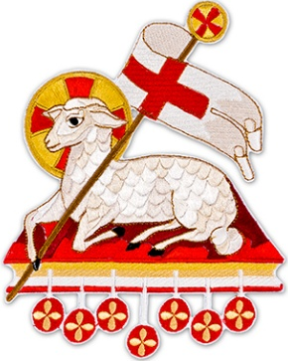
The Agnus Dei
All say or sing:
Lamb of God, you take away the sins of the world, have mercy on us.
Lamb of God, you take away the sins of the world, have mercy on us.
Lamb of God, you take away the sins of the world, grant us peace.

The Invitation to Communion
Behold the Lamb of God, behold him who takes away the sins of the world. Blessed are those called to the supper of the Lamb.
Lord, I am not worthy that you should enter under my roof, but only say the word and my soul shall be healed.
All who are regular communicants in their own tradition are welcome to receive the sacrament if you are not a communicant you are welcome to come forward at this point in the service to receive a blessing To indicate that it is just a blessing you require, please take this service sheet up with you. We have returned to offering the chalice at the time of communion but please do not feel any pressure to receive from the common cup as the church teaches that the sacrament is received fully in one kind. We request that you do not intinct (dip) your host in the Chalice but either take a sip from the cup or return directly to your seat. This is for reasons of good hygiene.
The Communion Hymn

1. This is my body broken for you
bringing you wholeness, making you free
Take it and eat it and when you do
Do it in love for me.
2. This is my blood poured out for you
bringing forgiveness, making you free
Take it and eat it and when you do
do it in love for me.
3. Back to my Father soon I sall go
Do not forget me, then you will see
I am still with you, and you will know
you're very close to me.
4. Filled with my Spirit, how you will grow
You are my branches, I am the tree
If you are faithful, others will know
you are alive in me.

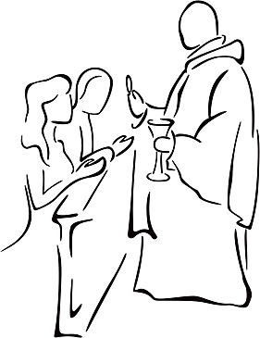
5. Love one another, I have loved you
and I have shown you how to be free
serve one another, and when you do
do it in love for me.

We stand for
The Prayer After Communion

Almighty ever-living God, who restore us to eternal life in the Resurrection of Christ,
increase in us, we pray, the fruits of this paschal Sacrament and pour into our hearts the strength of this saving food. Through Christ our Lord. Amen

The priest may give some brief notices
The Concluding Rites- Blessing and Dismissal
The Lord be with you. And with your spirit.

Bow down for the blessing

May God, who by the Resurrection of his Only Begotten Son was pleased to confer on you the gift of redemption and of adoption, give you gladness by his blessing. Amen.

May he, by whose redeeming work you have received the gift of everlasting freedom, make you heirs to an eternal inheritance. Amen.

And may you, who have already risen with Christ in Baptism through faith, by living in a right manner on this earth be united with him in the homeland of heaven. Amen.

And may the blessing of almighty God, the Father, and the Son, ✠ and the Holy Spirit, come down on you and remain with you for ever. Amen.

Go forth, the Mass is ended. Thanks be to God.

The Final Hymn

1. Holy Spirit, come, confirm us
in the truth that Christ makes known;
We have faith and understanding
through your helping gifts alone.
2. Holy Spirit, come, console us,
come as advocate to plead;
Loving Spirit stand beside us,
grant in Christ the help we need.
3. Holy Spirit, come, renew us,
come yourself to make us live;
Make us holy through your presence,
holy through the gifts you give.
4. Holy Spirit, come, fulfill us,
you the love of Three in One;
Bring our lives to full completion
through your work in us begun.

The Regina Cœli

Joy to thee O Queen of heaven, alleluia.
He whom thou wast meet to bear, alleluia.
As he promised, hath arisen, alleluia.
Pour for us to God thy prayer, alleluia.
Rejoice and be glad, O Virgin Mary, alleluia.
For the Lord is risen indeed, alleluia.
Let us pray. O God, who, by the Resurrection of thy Son, our Lord Jesus Christ, hast brought joy to the whole world; grant, that through His Mother, the Virgin Mary, we may obtain the joys of life everlasting. Through Jesus Christ our Lord. Amen
The Notices:
Baptisms – Next weekend we have the exciting occasions of some Baptisms. On Saturday 16th Baby Charles Hancock is being Baptised to which the Hancock family would like to invite you all. Then, on Sunday 17th at our 10.00am Mass Sean and Claire are being Baptised in the Baptismal Pool, praying the Water Heater is working this time!
New City Dean Visiting St Peter’s, Fr Alex will be visiting this coming Wednesday(13Th)
Extras form- form are available for those who regally donate additional items to church- we are able to claim gift aid on these donations, this significantly helps our church funds- further information is included on the form.
Catechesis on Zoom- we will be holding an online catechesis group on zoom on Monday evenings- 11th, 18th and 25th May at 7.30pm- all are welcome- for further information please speak to Alfie or Ben
May Devotion- At St Peter’s on the 17th May at 6.00pm- please see posters located around church
ATTENTION It was announced at the APCM that as of Pentecost Sunday May 24th our Sunday Mass will be at the new time of 11.00am!
Petertide 2026
Confirmations- 26th June- At St Peter’s at 7.30pm Please come and support our Candidates who will be getting confirmed on that day
Ben’s ordination- God willing Ben will be ordained on 27th June at Exeter Cathedral- information will be available soon about attending the event, however for now please keep Ben in your prayers, ember cards are available in church.
The Solemnity of St Peter and St Paul 28th June- As well as being our Patronal Festival, This will be the first Mass at which Ben will Deacon and certainly a Mass that which should be well attended

For prayer
Those who have asked for our prayers…. Denise, Janice Allin, Leslie Porch,
Sheila Tucker, Tina Smart, Bobby Lilicrap, June Brock, Emma Addison, Georgie Maher, Ian Craggs, Brenda Alderson, Lois Tobin, Brenda Steed, Anne Lewis, Jackie Morrison, Anna, Gwen Lamb, Anna Lynch, Helen Lewis, Val Bradden, Cynthia Way, Pauleen Stewart, Amelia Coughlan, Roger Lewis, Shaun Carrie, Fr Jon Bielawski, Catherine Samuel, Julian Davies.

Recently Departed- Jenny Harvey, Baby Lucas

Anniversaries of Death-
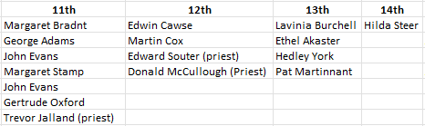
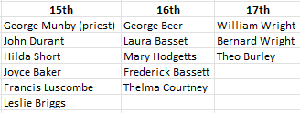

The Mission Community of St Peter and the Holy Apostles
St Peter, Wyndham Square + St Thomas, Royal Navy Avenue + St James-the-Less, Ham Drive

A Church of England Parish in the care of the Bishop of Oswestry

Parish Priest Fr. David Way SSC: 01752 240119 fr.david@stpeterplymouth.org

Mission Development Minister/ LLM/ Parish Ordinand: Ben Otley 07939800544 benotley.mission.plym@gmail.com

Parish Website: plymouthstpeter.co.uk ~ FOR MUCH MORE INFORMATION ON EVENTS, ETC.

Sunday 10th May  The Sixth Sunday of Eastertide Year A/ Cycle 1 (Psalter week ii) | 8.30am St Thomas Fr DCW  10.00am St Peter Fr PL | Mass  Sung Mass
Monday 11th-  Weekday of Eastertide | St Peter 10.00am Fr PL | Mass
Tuesday 12th-  Weekday of Eastertide | St Peter 10.00am Fr DCW | Mass
Wednesday 13th-  Weekday of Eastertide/  Our lady of Fatima | St Peter 10.00am Fr DCW | Mass
Thursday 14th-  The Solemnity of  The Ascension of the Lord | St Peter 10.00am Fr PL | Mass
Friday 15th-  Weekday of Eastertide | St Peter 10.00am Fr DCW | Mass
Saturday 16th-  Weekday of Eastertide | St Peter 10.00am Fr DCW | Mass
Sunday 17th May  The Seventh Sunday of Eastertide Year A/ Cycle 1 (Psalter week ii) | 8.30am St Thomas Fr DCW  10.00am St Peter Fr DCW  6.00pm St Peter’s | Mass  Sung Mass & Baptism  May Devotion

St Peters is open daily 8.30am- 12noon- Place of Welcome, Place of Prayer.

Safeguarding: If you have any concerns regarding the safety of children and others who are vulnerable, regardless of age, you must tell the Duty Priest or our parish Lay Safeguarding Representative- Jackie Morrison- email randj49@gmail.com Tel 07848859124.

For online donations please scan the QR code

