TODAY’S SERVICE is a ‘Fifth Sunday’
TRI-COMMUNITY EUCHARIST
at ST GEORGE COLEGATE AT 9.30AM.
THERE WILL BE NO SERVICES TODAY
AT ST GEORGE TOMBLAND or
ST GILES-ON-THE-HILL
THIS WEEK AT TOMBLAND
Wednesday 3rd |  | 10am – 12 noon – Church open
Friday 5th |  | 10.00am: Holy Communion  9:00pm: Sung Compline followed by drinks and nibbles at  St George Tombland
Sunday 7th |  | 11.00am: SUNG EUCHARIST -  TRINITY I
SERVICES & EVENTS AT ST GEORGE COLGATE
Tuesday 2nd |  | 8.30am: BCP Holy Communion
Wednesday 3rd |  | 9.40am: Morning Prayer  10.30am - 1.00pm: Hot Spot Coffee Morning. All welcome.
Thursday 4th |  | 7:30pm: Colegate Talk at St George Colegate. Dave Cole will be talking about ‘Installing oil and gas platforms in the North Sea 1970/80s’. Refreshments will be served afterwards.
SUNDAY 7th |  | 9.30am: Sung Eucharist

Also, on SUNDAY 7th JUNE at 5:00pm -
LGBTQIA+ Inclusive Church Communion Service
at St Luke’s Church followed by a shared supper.
All are welcome.

ECO CHURCH NOTE: Enjoy the best of British seasonal vegetables and fruit during the summer, by making sure that everything you buy is from local producers and fresh. One easy way to do this is to sign up for a local organic vegetable box scheme.

NOTICES
THE CHRISTIAN AID WEEK COLLECTION
raised £200.00, inclusive of Gift Aid.
Thank you to all who contributed.
THANK YOU to the person who used
Ecclesiastical for their Home insurance recently. We have received the £130 you kindly nominated should go to St George Tombland.

FR JOHN’S MEMORIAL SCREEN – update:
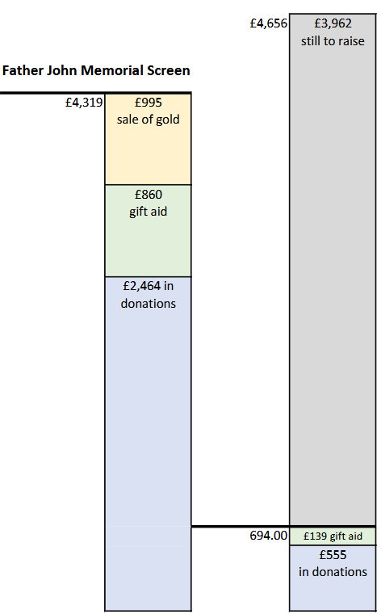

A HUGE ‘THANK YOU’ to all who have given so generously to help us reach our target for Father John’s Memorial Screen.
The total cost is £14,000 and with these donations and funds already held of £9,448.90 from The Friends and The Rotary Club we now have £13,768.
If anyone else would like to make a donation,
we are still looking for £232 to cover every penny without using church funds.

