The Winterbournes and Compton Valence

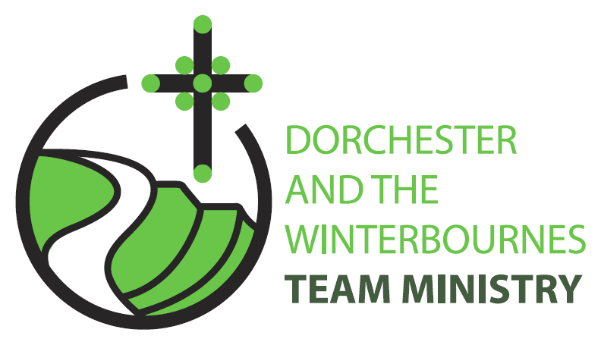

Easter 7
17th May 2026

Welcome to this service for the Sunday after Ascension. We rejoice today in God’s saving presence in our lives and we pray that we in turn might bring others to find solace in God’s love. So, we look out at our broken world and continue to pray for communities afflicted by war and for the continued peace processes in Iran and Israel and Ukraine.

Collect
Risen, ascended Lord,
as we rejoice at your triumph,
fill your Church on earth with power and compassion,
that all who are estranged by sin
may find forgiveness and know your peace,
to the glory of God the Father.
All: Amen

Reading: Acts 1: 6-14

6 So when they had come together, they asked him, Lord, is this the time when you will restore the kingdom to Israel?
7 He replied, It is not for you to know the times or periods that the Father has set by his own authority.
8 But you will receive power when the Holy Spirit has come upon you; and you will be my witnesses in Jerusalem, in all Judea and Samaria, and to the ends of the earth.
9 When he had said this, as they were watching, he was lifted up, and a cloud took him out of their sight.
10 While he was going and they were gazing up towards heaven, suddenly two men in white robes stood by them.
11 They said, Men of Galilee, why do you stand looking up towards heaven? This Jesus, who has been taken up from you into heaven, will come in the same way as you saw him go into heaven.
12 Then they returned to Jerusalem from the mount called Olivet, which is near Jerusalem, a sabbath days journey away.
13 When they had entered the city, they went to the room upstairs where they were staying, Peter, and John, and James, and Andrew, Philip and Thomas, Bartholomew and Matthew, James son of Alphaeus, and Simon the Zealot, and Judas son of James.
14 All these were constantly devoting themselves to prayer, together with certain women, including Mary the mother of Jesus, as well as his brothers.

This is the word of the Lord.
All: Thanks be to God.

Gospel Reading: John 17:1-11

Hear the Gospel of our Lord Jesus Christ according to John.
All: Glory to you, O Lord.

17 After Jesus had spoken these words, he looked up to heaven and said, Father, the hour has come; glorify your Son so that the Son may glorify you,
2 since you have given him authority over all people, to give eternal life to all whom you have given him.
3 And this is eternal life, that they may know you, the only true God, and Jesus Christ whom you have sent.
4 I glorified you on earth by finishing the work that you gave me to do.
5 So now, Father, glorify me in your own presence with the glory that I had in your presence before the world existed.
6 I have made your name known to those whom you gave me from the world. They were yours, and you gave them to me, and they have kept your word.
7 Now they know that everything you have given me is from you;
8 for the words that you gave to me I have given to them, and they have received them and know in truth that I came from you; and they have believed that you sent me.
9 I am asking on their behalf; I am not asking on behalf of the world, but on behalf of those whom you gave me, because they are yours.
10 All mine are yours, and yours are mine; and I have been glorified in them.
11 And now I am no longer in the world, but they are in the world, and I am coming to you. Holy Father, protect them in your name that you have given me, so that they may be one, as we are one.

This is the Gospel of the Lord.
All: Praise to you, O Christ.

Post Communion Prayer
Eternal God, giver of love and power,
your Son Jesus Christ has sent us into all the world
to preach the gospel of his kingdom:
confirm us in this mission,
and help us to live the good news we proclaim;
through Jesus Christ our Lord.
All: Amen

NOTICES:
Fundraising event for The Winterbourne Valley Churches: 14th June
A Message from Tom Webb “This is a "save the date" notice for the 14th June.
Phil and Roelie Newman are opening their garden in Martinstown as part of the National Garden Scheme. The scheme itself raises money for a cancer charity but they have expressed a willingness that we provide, tea, coffee, cake, sausage rolls and other refreshments of our choosing to raise money for the valley churches.
Closer to the time I will be seeking 🙂....
- Cake and sausage roll donations for delivery on the 13th June.
- Volunteers to man/woman the stand on the day.
Best wishes, Tom Webb

PRAYERS FOR THE WEEK
Creator God, we pray for our broken world, its peoples and their leaders. We pray for those caught up in war, and violence, and hatred; especially the innocent victims of these evils and those who are abused because of their faith in Christ. May peace reign in all nations, injustice be overcome and suffering ends.

Creator God, we pray for all the people that we encounter in our daily lives. Help us to recognise Christ in one another however stressed and tired they may be. We ask that you help us to recognise the risen Christ in the face of someone we meet today and give us an opportunity to brighten their day with a smile or a word.

Loving God, we pray for all those in need; for those who are filled with guilt; who are broken-hearted; who are confused and afraid; or saddened because a relationship has broken down. We pray for all suffering from illness, particularly those requesting our prayers and give joyful thanks for those on the road to recovery. We pray especially for Bruce Robertson and Maggie, Andreas, Clare Rootham, Mandy Reed, John Reed, Di Honeybun.

Loving God, we pray for all who have died; especially those who encouraged us in our faith by their example. As we pray for them, may they in turn continue to pray for us that we may stay true to our faith and give the same kind of example ourselves to others.
We pray especially for Malcolm Mitchell who has died recently and for those whose year’s mind occurs this month we pray for: David Lacy-Smith, Anne Armstrong, Elizabeth Penfold, Lorna Power, Eileen Hobday

