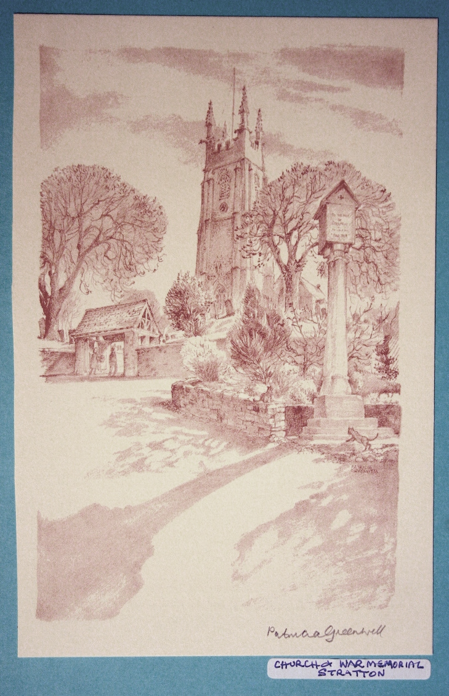 | The Parish Church  of St Andrew, Stratton  Priest in Charge  The Revd Teresa Folland  Tel: 01288 352599  e-mail: teresa.folland@gmail.com  Churchwarden  Mrs Diana Ohlson  Tel: 01288 354441  e-mail: dohlson24@gmail.com
MAY 2026

Lord of peace, be with those who guide the destinies of the
World so that an end may come to boasting and vainglory,
and the reign of arrogance dwindle in our time.
Give them the courage to speak the truth and the humility to listen.
Help us all to put the good of our fellow men above our own ambitions, and the truth which does not profit us above the lie which does.
So may we stand upright, freed from the burden of fear and the weight of suspicion, learning to trust each other.

Amen.

Services at St Andrew’s May 2026

Sun  3rd | 5th Sunday of Easter  Readings: Acts 7:55-end; Ps 31:1-5,15-16; 1 Peter 2:2-10; John 14:1-14  Morning Worship 9.30am – LWLs Val Hopper & Judy Dunne  Evensong 6pm with LWL Val Barker Cantor: Dafydd Thomas  Psalm: 147:1-12  Readings: Zechariah 4:1-10 Revelation 21:1-14 Reader: Vee Ellis
Wed  6th | Christian Meditation 9.30am  Midweek Mass Wed. 10.30am – Officiant: Rev Teresa Folland
Sun  10th | 6th Sunday of Easter  Readings: Acts 17:22-31; Ps 66:7-end; 1 Peter 3:13-end; John 14:15-21  Parish Mass 9.30am – Officiant: Rev Jeffery Terry
Wed  13th  Thur 14th | Midweek Mass Cancelled  Ascension Day  Christian Meditation 9.30am  Mass 10.30am Officiant: Rev Doug Adams
Sun  17th | 7th Sunday of Easter - 1st Sunday after Ascension Day  Readings:  Acts 1:6-14; Ps 68:1-10,32-end; 1 Peter 4:12-14, 5:6-11; John 17:1-11  Morning Worship 9.30am – LWLs Judy Dunne & Val Hopper
Wed  20th | Christian Meditation 9.30am  Midweek Mass Wed. 10.30am – Officiant: Rev Jane Bradbury
Sun  24th | Pentecost  Readings: Acts 2:1-21; Psalm 104:26-36, 37b; 1 Corinthian 12:3b-13; John 10:19-23 or John 7:37-39  Parish Mass 9.30am – Officiant: Rev Jeffery Terry
Wed  27th | Christian Meditation 9.30am  Midweek Mass Wed. 10.30am – Officiant: Rev Doug Adams
Sun  31st | Trinity Sunday  Readings: Isaiah 40:12-17, 27-end; Psalm 8; 2 Corinthians 13:11-end; Matthew 28:16-end  Benefice Service with Holy Communion 11.15am at St Swithins, Launcells Officiants: Rev Teresa Folland and Rev Jane Bradbury
Dates for your diary
Mon 4th May | M U Branch Meeting 2pm Stamford House
Tues 5th May | Sustainable Flower Arranging demonstration in the Church at 7.30pm. with Elaine Reynolds. Entry £5 to include Coffee & Cake. Everyone welcome.
Sun 10th May | Stall at Pendeen Car Boot sale pm.
Mon 11th May | Stratton School Children visiting in the morning
Tues 12th May | Funeral at 11.30am for Lyzette Bevan PCC meeting in the church at 2.30pm
Thur 14th May | Ascension Day Mass 10.30am
Fri 22nd May to Sun 24th May | Flower Festival. 10-4pm daily (Sun 11-4pm) ’For the Beauty of Flowers’. Refreshments each day.
Sun 31st May | Benefice Service of Holy Communion at Launcells
Fri 5th June | FoStA Committee meeting 3pm at Stamford House
Sat 6th June | Diocesan Training Day in Church
Mon 8th June | Stratton School Children visiting in the morning M U Branch Meeting 2pm Stamford House
Sun 14th June | Stall at Pendeen Car Boot sale pm.
Sat 20th June | Wedding in church
Tues 23rd June | Pastoral planning meeting 10.30am at 6 Drovers Way
Thur 25th June | Social Committee meeting at 6 Drovers Way 10.30am
Mon 29th June | MU Cream Tea at 6 Drovers Way from 2pm

100 Club
Lucky winners in the bonus Easter draw were number 49 1st prize £60, 38 2nd prize £40, and 3rd prize £20. Congratulations to them all. New members always welcome, application forms available in church.
St Andrew’s Festival of Music and Arts – advance notice!
Something to whet your appetite and give you something to look forward to. During July 11th - 19^{th,} there are exciting events across the week in church celebrating music and arts. As we all hear the desperate news of wars, famine and struggles for so many around the world we need to refresh our days with something positive. The programme is music in different styles played by young and old! Art and craft exhibitions, children’s competitions and of course refreshments at all events with a very special afternoon tea! All culminating in a visit from Bishop David to bless the East window and Bells after their restoration, Reserve the week in your diary with more details next month.

Mothers’ Union Kledh Kernow

At our last meeting members enjoyed a celebration of Eastertide and the ongoing anniversary of our 150 years since the founding of the organisation. We joined in worship together watching the Songs of Praise Easter service from Cornwall. Some members travelled to St. Endellion’s Church for the member’s Open Afternoon. We enjoyed hearing about ‘Ripple Effect’ the charity formerly known as ‘Send a Cow’

Thursday 14th May will be Ascension Day and MU members will join with the international call to prayer of Thy Kingdom Come which continues until Pentecost Sunday on May 24th. Prayer is an important part of the life of the MU and all we do to support families here in Cornwall, nationally and globally begins with prayer.
Future Dates
May 4th Branch Meeting 2pm Stamford House, Stamford Hill.
June 29th Fundraising Cream Tea at 6 Old Drovers Way, Stratton beginning
at 2pm. We will be joined by Kerstin Lewis our Diocesan President. All proceeds will go toward our MU projects here in Cornwall.
As always everyone is welcome to come along to any MU gathering.

Flower Festival - For the Beauty of Flowers

Friday 22nd May - Sunday 24th May

Preparations are well underway for this year’s Flower Festival. But the success of the festival does not just depend upon the flower arrangements alone. Support is needed with welcoming visitors, the catering and manning of the raffle and plants stall. This is an appeal for people to help where they can at some time during the festival. A list for volunteers to sign up will be at the back of the church. We are once again having a plant stall, any contributions to stock this would be gratefully received.

Thank You

Lent Lunches
Thank you to everyone who supported the lunches in any way this year. St Andrew’s were raising money for the South-West Hospices and we have collected £355.38. Well done everyone.

The Pastoral Committee have been busy during last month tidying the Lychgate area and the lantern, dusk to dawn light which hadn’t worked for some time, has been replaced with new fitments. A special Thank You to Alan McIntosh for refurbishing the gates and treating the wood. Later this month, before the Flower Festival, it is planned to add flower baskets on the stone surface of the Lychgate facing the road. We thought this would add, not only to the look of the area, but give a nice welcome to those passing by when entering the churchyard.
Thank you too committee for cleaning away the cobwebs in the windows of the church despite the spiders.
Thanks also go to the members of the Fabric Committee who limewashed some of the interior walls and continue on with work in the churchyard.


St Andrew’s Church Flower Festival
Friday 22nd -Sunday 24th May

For the Beauty of Flowers

Friday 22nd - 10am - 4pm
Saturday 23rd - 10am - 4pm
Sunday 24th - 11am - 4pm

Refreshments served all day

Raffle and Plant stall


For the month of May 2026
We remember in our prayers all those living in:
Week beginning:
Sunday 3rd | Those living outside of the Parish but for whom St Andrews is their spiritual home.
Sunday 10th | Diddies Lane, Diddies Road, Old Drovers Way Sanctuary Lane, Cott Hill.
Sunday 17th | Maiden Street, Market Street, Pollards, Townsend, and the parts of Bush within the Parish.
Sunday 24th | Links View, Lea Way, Melliars Way.
Sunday 31st | The parts of William Edwards Close, Flexbury Park Road, Meadow Drive and Fosters Way within the Parish.

Those who have asked for our prayers:
Allan Gouldson, Molly Hooper, Karen Hunting, Gloria Braund, Mick Carter.
We bring before God, especially at this time, all who work in our local hospitals, the inpatients and all undergoing investigations and outpatient treatment. We remember too those of our church family who are ill at home or housebound.
The recently departed: Lyzette Bevan, Margaret Blatchford. May they rest in peace and rise in glory. We pray for the recently bereaved and all who mourn their loved ones.

For the month of May 2026
Those in our Year’s Mind:
Week beginning:
Sunday 3rd | Leslie Bailey, Michael Thorp, June Baylis, Pam Stevens, Kenneth Swaker, Thomas McIntosh, Sebastian Claydon, Dorothy Stacey, Jean Jennings, Dennis Cornish.
Sunday 10th | Vicky Walton, Jill Cullimore, Timothy Blatchford, Jocelyn Nicholls, Emily Heard, William Cole, Bessie Bailey, George Gilbert, Gordan Rowe, James Blight, Patrick Davey.
Sunday 17th | Antony Vanstone, John Thompson, John Worden, Violet Leslie-Jones, Lambert Grills.
Sunday 24th | Lesley Erdjan, Vera Heard, Doreen Bamford, Sylvia Kidby, Joseph Swift, Francis Sykes, Timothy Sweet, Patricia Blight, James Phillips, Charles Harding, Christopher Blythe.
Sunday 31st | David Carswell, Joan Nash, Ted Hatfield, Susie Durston, Herbert Statton, Leslie Pearce, Pamela Statton, Richard Wickett.

News Sheet Editors:
Val Barker Tel: 353435 and Sheila Waring Tel: 714338

If you have anything for inclusion in the next news sheet for please send it to the editors by the 10th of the month.

Please submit all documents in Calibri (Body) Font, size 12. Thank you.

