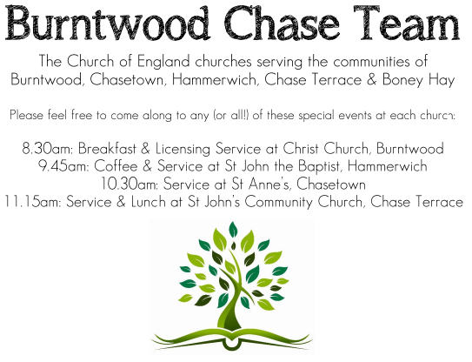
CHRIST CHURCH
Registered Charity Nos. 1217129

SERVICE ON SUNDAY 10th May 2026 at 10am

Morning Worship

6th Sunday of Easter

Readings:
Acts 17: 22-31

²² Then Paul stood in front of the Areopagus and said, ‘Athenians, I see how extremely religious you are in every way. ²³ For as I went through the city and looked carefully at the objects of your worship, I found among them an altar with the inscription, “To an unknown god.” What therefore you worship as unknown, this I proclaim to you. ²⁴ The God who made the world and everything in it, he who is Lord of heaven and earth, does not live in shrines made by human hands, ²⁵ nor is he served by human hands, as though he needed anything, since he himself gives to all mortals life and breath and all things. ²⁶ From one ancestor he made all nations to inhabit the whole earth, and he allotted the times of their existence and the boundaries of the places where they would live, ²⁷ so that they would search for God and perhaps grope for him and find him—though indeed he is not far from each one of us. ²⁸ For “In him we live and move and have our being”; as even some of your own poets have said,
“For we too are his offspring.”
²⁹ Since we are God’s offspring, we ought not to think that the deity is like gold, or silver, or stone, an image formed by the art and imagination of mortals. ³⁰ While God has overlooked the times of human ignorance, now he commands all people everywhere to repent, ³¹ because he has fixed a day on which he will have the world judged in righteousness by a man whom he has appointed, and of this he has given assurance to all by raising him from the dead.’

John 14: 15-21
¹⁵ ‘If you love me, you will keep my commandments. ¹⁶ And I will ask the Father, and he will give you another Advocate, to be with you for ever. ¹⁷ This is the Spirit of truth, whom the world cannot receive, because it neither sees him nor knows him. You know him, because he abides with you, and he will be in you.
¹⁸ ‘I will not leave you orphaned; I am coming to you. ¹⁹ In a little while the world will no longer see me, but you will see me; because I live, you also will live. ²⁰ On that day you will know that I am in my Father, and you in me, and I in you. ²¹ They who have my commandments and keep them are those who love me; and those who love me will be loved by my Father, and I will love them and reveal myself to them.’

COLLECT FOR TODAY
God our redeemer,
you have delivered us from the power of darkness
and brought us into the kingdom of your Son:
grant, that as by his death he has recalled us to life,
so by his continual presence in us he may raise us
to eternal joy;
through Jesus Christ your Son our Lord,
who is alive and reigns with you,
in the unity of the Holy Spirit,
one God, now and for ever.

WHAT’S GOING ON
Upcoming Services and Events
Sunday 17th May Holy Communion 10am
Wednesday 20th May Morning Prayer 9.30am
Sunday 24th May Morning Worship 10am
Wednesday 27th May Morning Prayer 9.30am
Sunday 31st May Holy Communion 10am

DATES FOR YOUR DIARY
Saturday 16th May Spring Fayre
Saturday 27th June Cream Tea
Saturday 11th July Shelfield Choir Concert
Saturday 14th November Christmas Fayre

APCM Meeting
Please note the APCM meeting will be held in Church on Sunday 17th May after the 10am Communion Service. Further details nearer the date.

Christian Aid
Christian Aid Week this year is Sunday 10th May to Saturday 16th May. A collection plate will be available on Sunday 10th May if you wish to make a donation to this very important charity supported by Christ Church.

FLOODLIGHTING
If you think about commemorating a special occasion by floodlighting our Church. Please contact Chris Brown on 01543 683862 for details.

PRAYER CHAIN
Christ Church is blessed with a very active prayer chain. If you, or anyone you know, feel that they would like others to pray for them, please speak to Chris Brown on 01543 683862.

HOME COMMUNION
For anyone who is unable to attend church and would like a Home Visit and Communion, please contact the Vicar and he will be able to carry this out.

VICAR CONTACT DETAILS
Rev’d Stephen Morgan Tele: 07305 852152
CHURCH WARDENS CONTACT DETAILS
Judith Rogers Tele: 01543 324718
Mike Holmes Tele: 01543 672970
Church Office Tele: 01543 642187 [leave a message and we will respond]
Church Web Site:www.christchurchburntwood.org.uk
Church Email: christchurchburntwood15@gmail.com
Facebook: www.facebook.com/group/christchurchburntwood/

Other Contacts
Rev’d Matt Wallace St. John’s, Chase Terrace— Tele: 01543 670078

NEXT SUNDAY SERVICE
Sunday 17th May at 10am
Holy Communion
Acts 1: 6-14
John 17: 1-11
Easter 7

