
SPIRE & LIGHT United Churches
United Benefice of St Keverne, St Ruan with St Grade & St.Wynwallow (The Lizard)

*If you do not wish to receive these notices, please let your Churchwarden know*

10th May 2026
EASTER 6 Rogation Sunday

Readings
Acts 17: 22-31
Psalm 66:7-end
1 Peter 3:13-end
John 14:15-21

9.30am – Morning Prayer - St.Peter’s, Coverack
9.30am – Holy Communion - St.Ruan, Ruan Minor
11am – Holy Communion – St.Keverne (with Methodists)
11.15am – Café Church – St.Wynwallow, The Lizard
6pm – Evensong – St.Grade

Next week – Sunday May 17th

9.30am Joint Holy Communion at St Peter's Coverack followed by APCM at 10.45am. No service at St Keverne.
9.30am –- Holy Communion - St.Wynwallow, The Lizard
11.15am – Family Service – St.Ruan, Ruan Minor


The Prayer Spot


Heavenly Father, as we come to pray to you today, remind us of the love you have given us to share with others, that love given to us by you. Remind us we are a Benefice of four churches brought together by you to share with each other God's love and to remember we are all brothers and sisters brought to faith by the same God and his Son Jesus Christ who gave his life on the Cross for all of us.
Help us to remember those in need within our churches and community and how we can be there for them - it may just need an act of kindness to show you really care.

It says in 1 Peter 1 ‘Therefore prepare your minds for action, be self-controlled, set your hope fully on grace to be given to you when Jesus Christ was revealed to you. As obedient children of God, do not conform to evil desires you had when you lived in ignorance but just as he who called you is Holy so be Holy in all you do, for it is written to be Holy because I am Holy.’

Remember God has given you gifts to use in the need of others, use them well because everyone needs your help in our times of trouble. Be generous and full of God’s love, pray for all those in need of hospital treatment, that God will be present with them and for those who have the job of taking them and caring for them.

We praise you for your kindness shown to us all, for your endless willingness to forgive us when we fail you. We thank you for the love shown to us all as members of your flock, for being the shepherd who guides us through each day giving us all the help we need to care for others. Thank you for those wonderful gifts given to us of forgiveness, kindness, generosity and peace and of course that great joy of knowing your presence in our lives.

As I always tell you, God will be ever present in your prayer time and will answer all your prayers in the name of his son Jesus Christ. Be blessed by all you do in his wonderful name.

O God our father, grant that whatever happens to us today we may take it to you, if we have decisions to make, help us to ask for your guidance and grant us humility and obedience to take what you give to us. If we have problems to solve, help us to ask for you to shine your light upon them so we may see our way through them. If we have difficult things to do, help us to ask for strength so that we maybe enabled to do which we could not do ourselves. If we face temptations, help us to seek thy grace and remember that Jesus was tempted and is able to help us who are tempted. Help us to decide everything by thy will and to test everything by thy presence so that we may come to the days end without mistakes and without regrets through Jesus Christ our Lord. Amen

Maker of heaven and earth, you rule over all nations. As we think 0f your unfailing, eternal, enduring love, we look forward to the day when we will worship you in eternity. Your throne will be surrounded by people of every tribe, tongue and nation, and all testifying that you remained faithful, we will see that you have kept every promise you made, we will see your goodness and grace, we will be transformed by your glory, we would ask that we glimpse that glorious future as we pray today. Through the God the Father God the Son and God the Holy Spirit. Amen
Sam Buchanan

The Diocese of Truro’s Prayer Diary for this week

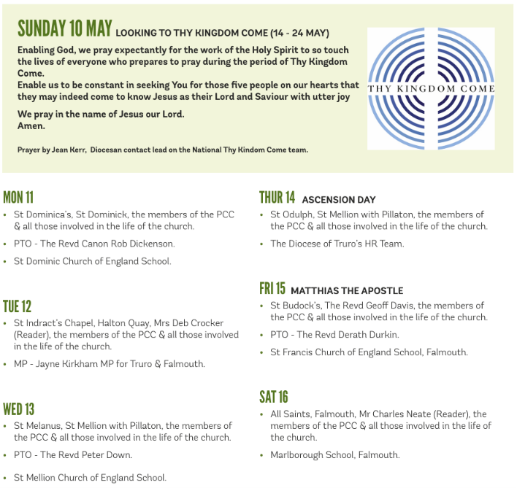

On the Way Prayers

Dear Lord, we give thanks for the ancient customs and traditions such as Flora Day which make this part of your world so special. With the beautiful green of the new leaves, with the pale hues of blossom and the call of the returning cuckoo, we thank you for the Spring and the promise of warmer days and yet more light. Shine into all our hearts, even if we are weary or just not feeling 100%, give us hope that we will see better times, that our prayers, our hopes and aspirations are not in vain, but that new life and growth are all around us.

We give thanks for all who gave their time and talents to organise Flora Day and for who danced and played. As our thoughts have been on Helston let us pray for St Michael’s Church – for all who worship there. And we pray for all our churches and particularly for the outreach to our communities, for the hospitality we can provide and for the welcome we can give as people come and admire our beautiful buildings. We pray for Lisa as she prepares to take up her new appointment in Penwith Deanery.

As the new suffragan Bishop of St Germans, James Treasure is installed, as is the new interim Dean of Truro – Ali Hogger Gadsby, let us pray for our Diocese and for a period of stability, so that we can all continue our work to become more fruitful and sustainable. And we continue to pray that you are calling priests to come and join our Deanery team so that we too can be complete. We give thanks for all who minister in Deanery, our clergy, our lay minister and all those who are putting themselves forward at this time to serve on their PCC. Lord, we ask that you show us the way to best serve you, in our churches, in our communities and in our Deanery.

We continue to pray for our troubled world. O God, we pray for all the children of Abraham in Israel and Palestine and in every country of the world. We pray for Muslims, Jews and Christians that we will draw on the best of our traditions to guide us away from words and acts of division and discrimination so that everyone may be free to live in safety. Protect the vulnerable, strengthen the fearful and comfort the grieving.

Amen

