
SPIRE & LIGHT United Churches
United Benefice of St Keverne, St Ruan with St Grade & St.Wynwallow (The Lizard)

*If you do not wish to receive these notices, please let your Churchwarden know*

31st May 2026
Trinity

Readings
Isaiah 40: 12-17,27-end
Psalm 8
2 Corinthians 13:11-end
Matthew 28:16-end

11am – United Benefice Service at St.Keverne Church
to celebrate Trinity Sunday and to say thank you to all who volunteer in our churches.

Next week – Sunday June 7th
9.30am – Holy Communion - St.Peter’s, Coverack
9.30am – Holy Communion (BCP) - St.Wynwallow, The Lizard
11am – Morning Prayer (BCP) – St.Keverne
11.15am – Morning Prayer – St.Ruan, Ruan Minor



- Click here for the Diocese of Truro Newsletter for June - you might spot somebody you know! Our-News-June-2026.pdf
The Prayer Spot


Heavenly Father, as we come to pray to you today, remind us of the love you have given us to share with others, that love given to us by you. Remind us we are a Benefice of four churches brought together by you to share with each other God's love and to remember we are all brothers and sisters brought to faith by the same God and his Son Jesus Christ who gave his life on the Cross for all of us.
Help us to remember those in need within our churches and community and how we can be there for them - it may just need an act of kindness to show you really care.

It says in 1 Peter 1 ‘Therefore prepare your minds for action, be self-controlled, set your hope fully on grace to be given to you when Jesus Christ was revealed to you. As obedient children of God, do not conform to evil desires you had when you lived in ignorance but just as he who called you is Holy so be Holy in all you do, for it is written to be Holy because I am Holy.’

Remember God has given you gifts to use in the need of others, use them well because everyone needs your help in our times of trouble. Be generous and full of God’s love, pray for all those in need of hospital treatment, that God will be present with them and for those who have the job of taking them and caring for them.

We praise you for your kindness shown to us all, for your endless willingness to forgive us when we fail you. We thank you for the love shown to us all as members of your flock, for being the shepherd who guides us through each day giving us all the help we need to care for others. Thank you for those wonderful gifts given to us of forgiveness, kindness, generosity and peace and of course that great joy of knowing your presence in our lives.

As I always tell you, God will be ever present in your prayer time and will answer all your prayers in the name of his son Jesus Christ. Be blessed by all you do in his wonderful name.

O God our father, grant that whatever happens to us today we may take it to you, if we have decisions to make, help us to ask for your guidance and grant us humility and obedience to take what you give to us. If we have problems to solve, help us to ask for you to shine your light upon them so we may see our way through them. If we have difficult things to do, help us to ask for strength so that we maybe enabled to do which we could not do ourselves. If we face temptations, help us to seek thy grace and remember that Jesus was tempted and is able to help us who are tempted. Help us to decide everything by thy will and to test everything by thy presence so that we may come to the days end without mistakes and without regrets through Jesus Christ our Lord. Amen

Maker of heaven and earth, you rule over all nations. As we think 0f your unfailing, eternal, enduring love, we look forward to the day when we will worship you in eternity. Your throne will be surrounded by people of every tribe, tongue and nation, and all testifying that you remained faithful, we will see that you have kept every promise you made, we will see your goodness and grace, we will be transformed by your glory, we would ask that we glimpse that glorious future as we pray today. Through the God the Father God the Son and God the Holy Spirit. Amen
Sam Buchanan

The Diocese of Truro’s Prayer Diary for this week

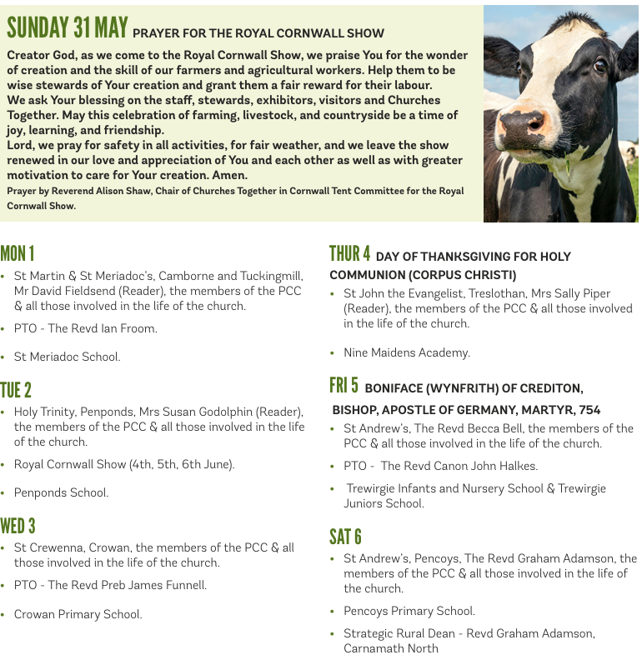

On the Way Prayers

Eternal Father, strong to save – we pray for strength to continue developing your church here in Kerrier Deanery. We pray for the work of the Deanery Implementation Team which met this week. Your arm binds us together in all this work as we seek collectively to grow our congregations, reach out to help our communities, and bring more people, particularly younger people to know of you love and support for us all. We give thanks for all who give their time and their talents in this work for us all.

O Saviour, whose almighty word is read to us each week in our churches, help us to spread your Gospel and to live it out in our daily lives. We pray for our congregations, for all the elderly who struggle to come, particularly for the smallest of our churches as they struggle with all the various tasks that need to be done. We give thanks for the flowers that have been placed in memory of loved ones in both St Antony and Manaccan churches over the bank holiday weekend. And we thank you Lord for the beauty of the flowers in our hedgerows and on our cliffs at this time. As we tend our gardens and enjoy spending time in them let us remember how Jesus spent so much time outside, teaching, healing and just enjoying this wonderful world.

O Sacred Spirit hear us when we cry to thee for anyone in peril. We pray for the souls of all those who have drowned recently in cold waters. Let us pray for our emergency services and for our lifeboat crews and surf life savers, that they may be helped through the traumas they experience in their work. And now let’s pray for anyone who needs the comfort of our collective prayers right now.

O Trinity of love and power we give thanks for the power of the Trinity; which gives us reassurance and understanding of the complexity, yet the comprehensiveness of God’s love for us all. And may we ever let there rise to thee glad hymns of praise from this beauty land in which we are blessed to live and the beautiful seas that surround our shores. We pray for our county and give thanks for the great spell of early summer weather that we have recently experienced. We give thanks for the tourists who have already started coming into our midst, for the boost they give to local economies and to the way that they can swell our congregations.

We give thanks that you bring us together, to pray for our churches, our communities and one another. We bind unto ourselves today the strong name of the Trinity. By invocation of the same, the Three in One, and One in Three. Of whom all nature has creation; Eternal Father, Spirit, Word. Praise to the Lord of our salvation; Salvation is of Christ the Lord. Amen

