
SPIRE & LIGHT United Churches
United Benefice of St Keverne, St Ruan with St Grade & St.Wynwallow (The Lizard)

*If you do not wish to receive these notices, please let your Churchwarden know*

24th May 2026
Pentecost

Readings
Acts 2: 1-21
Psalm 104:24-36,37b
1 Corinthians 12:3b-13
John 19:19-23 or John 7:37-39

9.30am – Morning Prayer - St.Peter’s, Coverack
9.30am – Holy Communion - St.Ruan, Ruan Minor
11am – Holy Communion – St.Keverne
11.15am – Baptism – St.Wynwallow, The Lizard

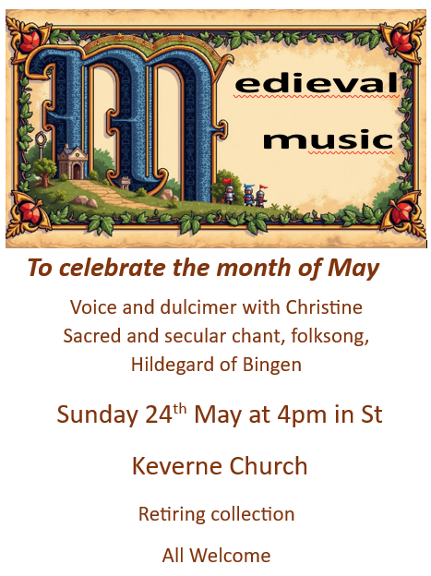

Next week – Sunday May 31st
11am – United Benefice Service at St.Keverne Church

The Prayer Spot


Heavenly Father, as we come to pray to you today, remind us of the love you have given us to share with others, that love given to us by you. Remind us we are a Benefice of four churches brought together by you to share with each other God's love and to remember we are all brothers and sisters brought to faith by the same God and his Son Jesus Christ who gave his life on the Cross for all of us.
Help us to remember those in need within our churches and community and how we can be there for them - it may just need an act of kindness to show you really care.

It says in 1 Peter 1 ‘Therefore prepare your minds for action, be self-controlled, set your hope fully on grace to be given to you when Jesus Christ was revealed to you. As obedient children of God, do not conform to evil desires you had when you lived in ignorance but just as he who called you is Holy so be Holy in all you do, for it is written to be Holy because I am Holy.’

Remember God has given you gifts to use in the need of others, use them well because everyone needs your help in our times of trouble. Be generous and full of God’s love, pray for all those in need of hospital treatment, that God will be present with them and for those who have the job of taking them and caring for them.

We praise you for your kindness shown to us all, for your endless willingness to forgive us when we fail you. We thank you for the love shown to us all as members of your flock, for being the shepherd who guides us through each day giving us all the help we need to care for others. Thank you for those wonderful gifts given to us of forgiveness, kindness, generosity and peace and of course that great joy of knowing your presence in our lives.

As I always tell you, God will be ever present in your prayer time and will answer all your prayers in the name of his son Jesus Christ. Be blessed by all you do in his wonderful name.

O God our father, grant that whatever happens to us today we may take it to you, if we have decisions to make, help us to ask for your guidance and grant us humility and obedience to take what you give to us. If we have problems to solve, help us to ask for you to shine your light upon them so we may see our way through them. If we have difficult things to do, help us to ask for strength so that we maybe enabled to do which we could not do ourselves. If we face temptations, help us to seek thy grace and remember that Jesus was tempted and is able to help us who are tempted. Help us to decide everything by thy will and to test everything by thy presence so that we may come to the days end without mistakes and without regrets through Jesus Christ our Lord. Amen

Maker of heaven and earth, you rule over all nations. As we think 0f your unfailing, eternal, enduring love, we look forward to the day when we will worship you in eternity. Your throne will be surrounded by people of every tribe, tongue and nation, and all testifying that you remained faithful, we will see that you have kept every promise you made, we will see your goodness and grace, we will be transformed by your glory, we would ask that we glimpse that glorious future as we pray today. Through the God the Father God the Son and God the Holy Spirit. Amen
Sam Buchanan

The Diocese of Truro’s Prayer Diary for this week

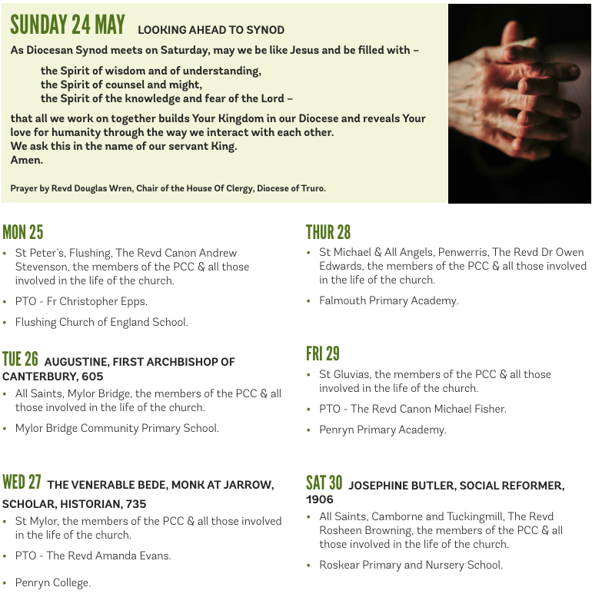

On the Way Prayers

Let’s start our prayers with a period of quiet and let’s bring to mind the 5 people that we have been praying for during this period between Ascension time and Pentecost, that they may come to know of your love. Lord we remember that you have promised to give us the words to help people come to faith, and that there is no greater sermon than a Christ-like life.

We look forward to our celebrations of Pentecost this next weekend; may the Holy Spirit guide our preparations. Spirit of God as strong as the wind, gentle as is the dove, give us your joy, give us your peace, show to us Jesus’ love.

Lord we pray for our world; for all the conflict and cruelty that seems to be dominating our TV screens. We bring before you the people of the Gulf, the Holy Land and Ukraine. We hear so much about anti Semitism, anti Islamist, and prejudices of all kinds. We pray for tolerance, that people can learn to live together regardless of race, colour, sexual orientation, or creed. We pray too for all those affected by the Ebola outbreak in the eastern part of the Democratic Republic of the Congo.

The political turmoil in our government at the moment also needs our prayers, that our leaders can put aside personal ambition, humiliation and anger to ensure that the most needy in our society are cared for, that our planet is protected and that the health and well being of the nation is paramount in their decision making.

As the holiday season begins to ramp up let us pray for our county; whilst it may have been wet on and off the last few days, let us give thanks for the rain that keeps Cornwall so lush and green. Many of our hospitality businesses are struggling with costs and staff shortages; Lord may the coming season bring them relief and positivity for their future. We give thanks that so many of our churches are magnets for holiday makers – may we do all we can to welcome them into our buildings and to our services.

We pray now for anyone or anything known to us that needs the power of special prayers right now. And let’s pray for all our clergy, and for all our lay leaders.

We give thanks for time spent in prayer, for the joy of praying together, for the chance to share our concerns, our joys and our hopes. Lord, help us to be refreshed, renewed and re-energised to do your work in this place. Amen.

