Palm 23
Please stand, if able, and join in with the verses in bold italics

The LORD is my shepherd,
I shall not be in want.

He makes me lie down in green pastures,
he leads me beside quiet waters, he restores my soul.
He guides me in paths of righteousness
for his name's sake.

Even though I walk
through the valley of the shadow of death,
I will fear no evil, for you are with me;
your rod and your staff, they comfort me.

You prepare a table before me
in the presence of my enemies.
You anoint my head with oil;
my cup overflows.

Surely goodness and love will follow me
all the days of my life,
and I will dwell in the house of the LORD
forever.

Glory be to the Father and to the Son and to the Holy Spirit,
as it was in the beginning, is now and ever shall be,
world without end. Amen



Thank you for your donations to Water Aid,
together we raised an amazing £157.75!



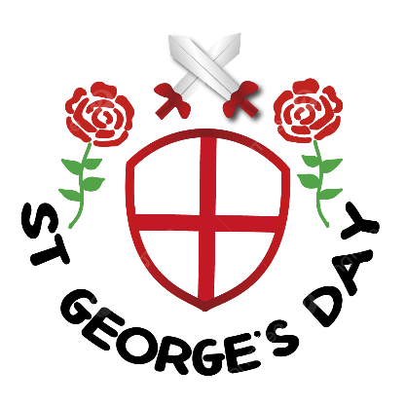
In our weekly prayers for our parish
This week we pray for God’s blessing on Quarry Hill Road, Queen Elizabeth Way and Ribblesdale.
Don’t forget our Annual Parochial Church Meeting is on Sunday 26th after the morning service. All welcome
Distribution of Communion –currently the Priest will dip the communion wafer in the wine while we discern a safe way to bring the common cup back into worship, as we want everyone to feel included and safe. We also have gluten free wafers available.
Refreshments After the Morning Service
Please stay seated after the service and a hot drink will be brought to you in the pews. Do not get up and head to the back of church, it is becoming a hazard, and a risk as trays of hot drinks could be knocked over.

All Saints Church
Church contact information
Contact: Rev’d Christine - revchristine@outlook.com
The Rectory, The Village, West Hallam, DE7 6GR
Landline 0115 646 1497
Rev’d Ailsa -revailsahunt@gmail.com
Tel - 07356064856

Churchwardens – Mrs Janet Wheeldon, -Tel: 0115 8771593
Mrs Linda Gregory – linda.gregory3@icloud.com
https://www.achurchnearyou.com/church/13402/
https://www.facebook.com/allsaintskirkhallam
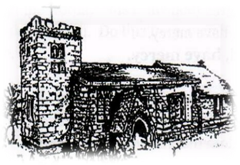
Kirk Hallam
Disabled Toilet in Friendship House.
Disabled Toilet in Friendship House.

Working with God to transform lives & communities.
Please can you ensure your mobile is on silence, or off during the service, it is affecting people with hearing aids and the loop system.
26th April – Third Sunday After Easter
10.00am CW Communion Service with Rev’d Christine
11.15am APCM Meeting
1.30pm St George Day Service with Uniformed Groups
6.00pm BCP Evening Prayer in church

Forthcoming Events
Tues 28th 6.00pm Home Group in Friendship House
Weds 29th 9.30am Morning Prayer at UCAS
Thurs 30th 1.30pm Internment of ashes for Bill Cownan
Fri 1st 6.00pm Choir in Friendship House
Sat 2nd 10am Prayer Meeting in Friendship House

3rd May – Fourth Sunday After Easter
10.00am CW Communion Service with Rev’d Jan
6.00pm BCP Evening Prayer in church with Rev’d Christine
“Love your neighbour as yourself’ Matthew 22:39
It’s Good to Talk! If you spot that someone is missing, please pop a news sheet through their door, & if you’ve time, call for a chat - just to check they’re OK & to let them know that they are not forgotten!

