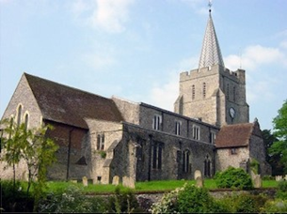
Please visit our website for information about our churches, services & events www.elhamvalleygroupofchurches.co.uk

Every Tuesday at St. Mary’s…

Traditional Morning Prayer at 8.30am in the Jesus Chapel. Download the free Church of England app or use the red book. A good way to begin the day. https://play.google.
com/store/apps/details?id=com.aimermedia.dailyprayer&pli=1


Every Monday at the Methodist Hall …
Coffee and cake, a warm welcome and friendship, 10.30am –
12pm

Churches Together in Elham Valley May
Please contact -: Ruth Collie (01303 840773) for information

3rd May – 5th Sunday of Easter
0800 Said Holy Communion; 0930 – Morning Service
Lectionary readings:
Acts 7:55-end; Psalm 31:1-5; 1 Peter 2:2-10; or Genesis 8:1-19; John 14:1-14

10th May – 6th Sunday of Easter - Rogation Sunday
0845 Morning Prayer to begin walk to Denton
Lectionary readings:
Acts 17:22-31; Psalm 66:7 – end; 1 Peter 3:13-end; or Genesis 8:20-9:17; John 14:15-21
1100 Prayers at Denton; 1300 Final Prayers at Wootton (approx. times)

17th May – 7th Sunday of Easter
09.30 Eucharist
Lectionary readings:
Acts 1:6-14; Psalm 68:1-10; 1 Peter 4:12-14,5:6-11 or Ezekiel 36:24-28; John 17:1-11

24th May – Pentecost – Whit Sunday
09:30 Morning Service
Lectionary readings:
Acts 2:1-21; Psalm 104:26-end; 1 Corinth 12:3b-13 or Numbers 11:24-30 ; John 20:19-23

31st May – Trinity Sunday
1000 All Age Benefice Service at St Peter’s, Swingfield
Lectionary readings:
Isaiah 40:12-17,27-end; Psalm 8; 2 Corinth 13:11-end; Matthew 28:16-end

Events for the June Notice sheet Please send to Margaret Keeble by 5th of each preceding month. m.keeble@outlook.com

Elham Methodist Church
(all at 9.30am unless otherwise stated)
Services for May
3rd Local arrangement
10th United Service at Rhodes Minnis
17th Local arrangement (video available)
24th United Service at St Andrew’s
31st United Service at Lyminge 10.15am

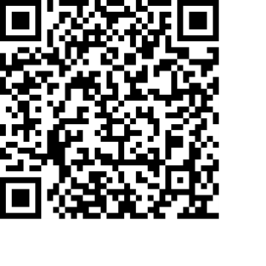
Donations
We would greatly appreciate your help to continue our work for God in the village of Elham and surrounding areas. If you can, please consider making a donation. This is our QR code for St Mary’s Elham. To donate using this code, open up the camera on a mobile phone - point the camera at the QR code – follow the instructions.
The offertory plate will go round in the service, during one of the hymns. There is also the opportunity to donate by card using the PAYAZ machine by the North door.

Safeguarding / ‘A Safe Church’:
If you ever have any concerns, contact our Parish Safeguarding Officer:
Susannah Pallot : susannahpallot@gmail.com

Paper Copies of Notices
Some copies are available on back table in church. Please take a copy to give to those unable to access the internet.

