
Next collection will be May 20th please leave donations in narthex.

Parish Hall quiz night. 9th May 7pm start 6pp per team £3 each, Bring your own refreshments.


Small Pilgrim Places are: Small places, simple, quiet & unpretentious, with the
presence of the Divine. St Laurence’s Church.www.smallpilgrimplaces.org Thur10-11am


Messy church is on Sunday 26th April 3-5 in Belmont Parish Hall –craft activities, story, songs & food! For info Tel. 3863588
Bible notes are now available in the Narthex for those who order them.

Ascension Day service at Finchale Priory on 14th May at 6.00pm. It is outdoors so please wear appropriate clothing for the weather. Everyone welcome

Please note there will be a service in Durham Cathedral at 3.30pm on Sunday 3rd May.
This will see the installation of the Reverand Jane Maycock as Canon Missioner.
But it will also celebrate the Durham Lesotho Link. Lesotho is our link Diocese. Please come and encourage others.

APCM for SMM & SL on May 10th. SMM reports & agendas will be emailed out to save our carbon footprint. If you are NOT on church email list and/or would like a hard copy please ask Charlotte Reynolds.


For our prayers this week:
Pray for those who are unwell or asked for our prayers: Jean Dennison, Anne Johnson (P’ton), George Kitching, Trevor Uren, Geoffrey Winter.
Those who have been bereaved.

From our Parish weekly prayer cycle:
Retired and lay ministers helping churches; all schools in Durham educating the young people of the United Benefice; Durham Cathedral and the Archdeacon of Durham; residents of Elemore Street, Pittington; St Mary's Road, Wilson Crescent, Dinsdale Drive, Cedar Close, Ennerdale Close, Belmont.

The Benefice of
St Mary Magdalene, Belmont &
St Laurence, Pittington
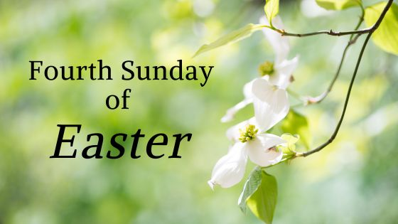

April 26th 2026

Collect: Risen Christ, faithful shepherd of your Father’s sheep: teach us to hear your voice and to follow your command, that all your people may be gathered into one flock, to the glory of God the Father. Amen

SMM Hymns: 86 Christ is made the sure foundation; 637 The Lord’s my shepherd; 300 I heard the voice of Jesus; 330 I will sing the wondrous story; 238 Great is thy faithfulness; 16 All heaven declares; 678 Thy hand O God, has guided.

Bible Readings
Readings: Acts 2:42-end (BCP also)
1 Peter 2:19-end
Gospel Reading: John 10:1-10

Upcoming services

w/b Sunday 26th April
9.00 am Holy Communion BCP SMM
9.30 am Holy Communion SL
10.30 am Holy Communion SMM
3-5pm Messy Church SMM
Mon 9.00 Morning prayer SMM
Wed 10.00am Holy Communion SMM
Thu 10-11am Morning prayer & open church SL

w/b Sunday 3rd May:
10.30 am Joint Holy Communion SMM
Mon NO Morning prayer SMM
Wed 10.00am Holy Communion SMM
Thu 10-11am Morning prayer & open church SL
Fri 10.30am Spirit-led prayer group SMM

Acts 2:42-end: The Fellowship of the believers
⁴² They devoted themselves to the apostles’ teaching and to fellowship, to the breaking of bread and to prayer. Everyone was filled with awe at the many wonders and signs performed by the apostles. ⁴⁴ All the believers were together and had everything in common. ⁴⁵ They sold property and possessions to give to anyone who had need. ⁴⁶ Every day they continued to meet together in the temple courts. They broke bread in their homes and ate together with glad and sincere hearts, ⁴⁷ praising God and enjoying the favour of all the people. And the Lord added to their number daily those who were being saved.

1 Peter 2:19-end

For it is commendable if someone bears up under the pain of unjust suffering because they are conscious of God. ²⁰ But how is it to your credit if you receive a beating for doing wrong and endure it? But if you suffer for doing good and you endure it, this is commendable before God. ²¹ To this you were called, because Christ suffered for you, leaving you an example, that you should follow in his steps.

²² ‘He committed no sin, and no deceit was

found in his mouth.’

²³ When they hurled their insults at him, he did not retaliate; when he suffered, he made no threats. Instead, he entrusted himself to him who judges justly. ²⁴ ‘He himself bore our sins’ in his body on the cross, so that we might die to sins and live for righteousness; ‘by his wounds you have been healed.’ ²⁵ For ‘you were like sheep going astray,’ but now you have returned to the Shepherd and Overseer of your souls.

John 10:1-10: The Good Shepherd and his sheep
‘Very truly I tell you Pharisees, anyone who does not enter the sheepfold by the gate, but climbs in by some other way, is a thief and a robber. ² The one who enters by the gate is the shepherd of the sheep.
³ The gatekeeper opens the gate for him, and the sheep listen to his voice. He calls his own sheep by name and leads them out. ⁴ When he has brought out all his own, he goes on ahead of them, and his sheep follow him because they know his voice.
⁵ But they will never follow a stranger; in fact, they will run away from him because they do not recognise a stranger’s voice.’ ⁶ Jesus used this figure of speech, but the Pharisees did not understand what he was telling them.
⁷ Therefore Jesus said again, ‘Very truly I tell you, I am the gate for the sheep. ⁸ All who have come before me are thieves and robbers, but the sheep have not listened to them. ⁹ I am the gate; whoever enters through me will be saved. They will come in and go out, and find pasture. ¹⁰ The thief comes only to steal and kill and destroy; I have come that they may have life, and have it to the full.

