
SPIRE & LIGHT United Churches
United Benefice of St Keverne, St Ruan with St Grade & St.Wynwallow (The Lizard)

*If you do not wish to receive these notices, please let your Churchwarden know*

19th April 2026
EASTER 3

Readings
Acts 2:14a, 36-41
Psalm 116:1-3,10-end
1 Peter 1:17-23
Luke 24:13-35

9.30am – Holy Communion - St.Peter’s, Coverack
9.30am –- Morning Prayer - St.Wynwallow, The Lizard
11am – Morning Prayer – St.Keverne
11.15am – Family service – St.Ruan, Ruan Minor

Next week – Sunday 26th April
9.30am – Morning Prayer - St.Peter’s, Coverack
9.30am – Holy Communion - St.Ruan, Ruan Minor
11am – Holy Communion – St.Keverne
11.15am – Café Church – St.Wynwallow, The Lizard

PLEASE NOTE - St. Peters will not be open from the 21st to the 24th of April due to the path being resurfaced.


The St Keverne Square Bible Study Group will recommence on
Monday the 20th April 2026 at 10.30 am - at The Methodist Church Hall.
All are welcome. Any enquiries please contact Claire Thomson on 07711025927

The Prayer Spot


Heavenly Father, as we come to pray to you today, remind us of the love you have given us to share with others, that love given to us by you. Remind us we are a Benefice of four churches brought together by you to share with each other God's love and to remember we are all brothers and sisters brought to faith by the same God and his Son Jesus Christ who gave his life on the Cross for all of us.
Help us to remember those in need within our churches and community and how we can be there for them - it may just need an act of kindness to show you really care.

It says in 1 Peter 1 ‘Therefore prepare your minds for action, be self-controlled, set your hope fully on grace to be given to you when Jesus Christ was revealed to you. As obedient children of God, do not conform to evil desires you had when you lived in ignorance but just as he who called you is Holy so be Holy in all you do, for it is written to be Holy because I am Holy.’

Remember God has given you gifts to use in the need of others, use them well because everyone needs your help in our times of trouble. Be generous and full of God’s love, pray for all those in need of hospital treatment, that God will be present with them and for those who have the job of taking them and caring for them.

We praise you for your kindness shown to us all, for your endless willingness to forgive us when we fail you. We thank you for the love shown to us all as members of your flock, for being the shepherd who guides us through each day giving us all the help we need to care for others. Thank you for those wonderful gifts given to us of forgiveness, kindness, generosity and peace and of course that great joy of knowing your presence in our lives.

As I always tell you, God will be ever present in your prayer time and will answer all your prayers in the name of his son Jesus Christ. Be blessed by all you do in his wonderful name.

O God our father, grant that whatever happens to us today we may take it to you, if we have decisions to make, help us to ask for your guidance and grant us humility and obedience to take what you give to us. If we have problems to solve, help us to ask for you to shine your light upon them so we may see our way through them. If we have difficult things to do, help us to ask for strength so that we maybe enabled to do which we could not do ourselves. If we face temptations, help us to seek thy grace and remember that Jesus was tempted and is able to help us who are tempted. Help us to decide everything by thy will and to test everything by thy presence so that we may come to the days end without mistakes and without regrets through Jesus Christ our Lord. Amen

Maker of heaven and earth, you rule over all nations. As we think 0f your unfailing, eternal, enduring love, we look forward to the day when we will worship you in eternity. Your throne will be surrounded by people of every tribe, tongue and nation, and all testifying that you remained faithful, we will see that you have kept every promise you made, we will see your goodness and grace, we will be transformed by your glory, we would ask that we glimpse that glorious future as we pray today. Through the God the Father God the Son and God the Holy Spirit. Amen
Sam Buchanan

The Diocese of Truro’s Prayer Diary for this week

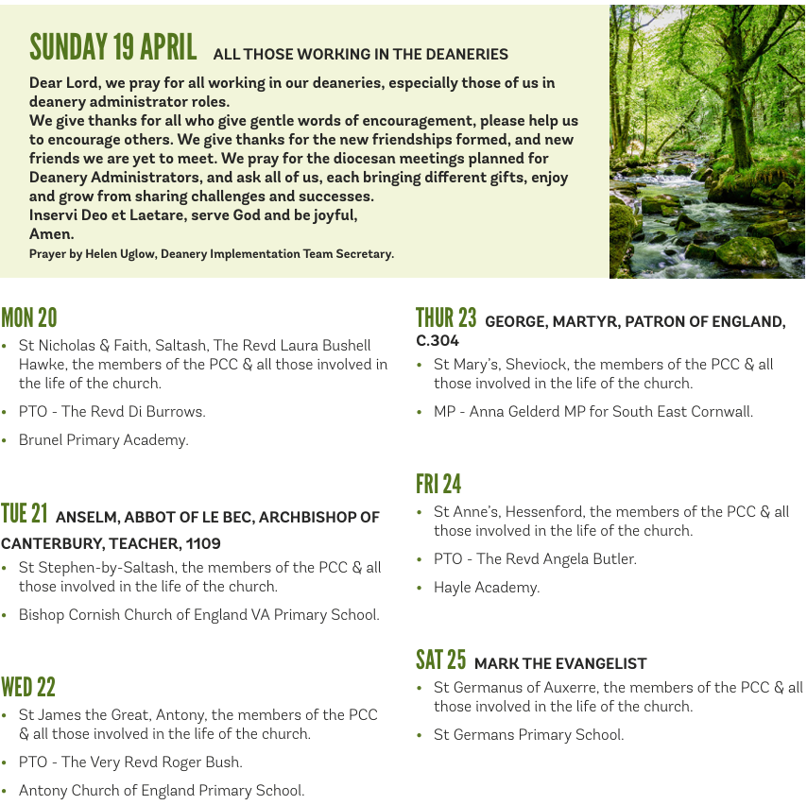

On the Way Prayers
Let us just spend a moment glancing out of the window and marvelling at God’s creation.

God of the rising green, God of the sweeping blue,
God of the long bright day, may we too, give glory to you.
God eternally awake, may your energies flow through us.
God of the rising sap, may we be your sap today.

We give thanks for the growth of sunlit days.
We offer you the first of our crops and the best of our lives – all that we have, all that we are – for all things come from you and of your own do we give you.

Dear Lord we are blessed to live in a lovely place. As blossom blooms all around us, may our faith also blossom and bloom. We give thanks for all our Easter celebrations and the fact that visitors are gradually coming back to our communities and churches. And when it rains, as it must, and as it does a lot, help us to be grateful for the gift of water – the water of life. And when the sun shines help us to get out and enjoy it.

During this season, as we hold our APCMs, let us give thanks for all who are prepared to stand for office – our churchwardens, our PCC secretaries, our treasurers, electoral roll officers and everyone else who volunteers to take on some kind of responsibility. We pray that, in time, more people will come forward to share these duties. Let us pray for all the clergy within our Deanery and for those who have had a break after the busyness of Easter. May they come back restored and refreshed. As our Deanery Implementation Team meets regularly, so we pray for each member of that group.

Now let us pray for our communities – for the role we have in building them up and providing services and support, for our schools, for all children preparing for exams this coming term, for all the parents who cope with the stress and for all our teachers who are so important in the development of young people. And now let’s pray for all who look after our elderly – our health and social services, pharmacists, carers, our nursing homes and all the staff who work in them. Let us now bring before you the names of anyone who needs the comfort of our collective prayers today.

Our world seems to be in turmoil because of the war in Iran. Let us pray for sense, for compromise and for peace. We pray too for anywhere else where war is raging or where regimes are oppressive.

And let us finish with John Wesley’s Rule –
Do all the good you can, by all the means you can,
In all the ways you can, in all the places you can,
At all the times you can, to all the people you can, as long as ever you can.

Amen.

